JVM
Account.main()
Return nothing(void)
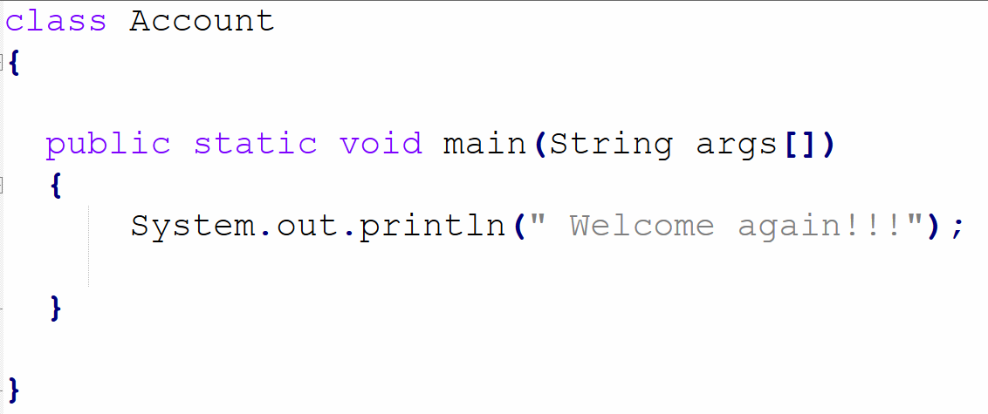

Start JVM and Account class will be loaded. Then main method will be called by JVM

…Dir1/Dir2>java Account 45

Develop a class and expect customer’s details like first name, last name, email and full address.

