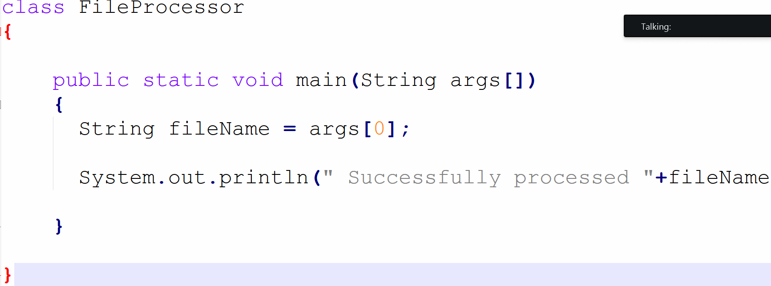

Identifier
Name given to Class, Method, Variable, Array……
Identifiers

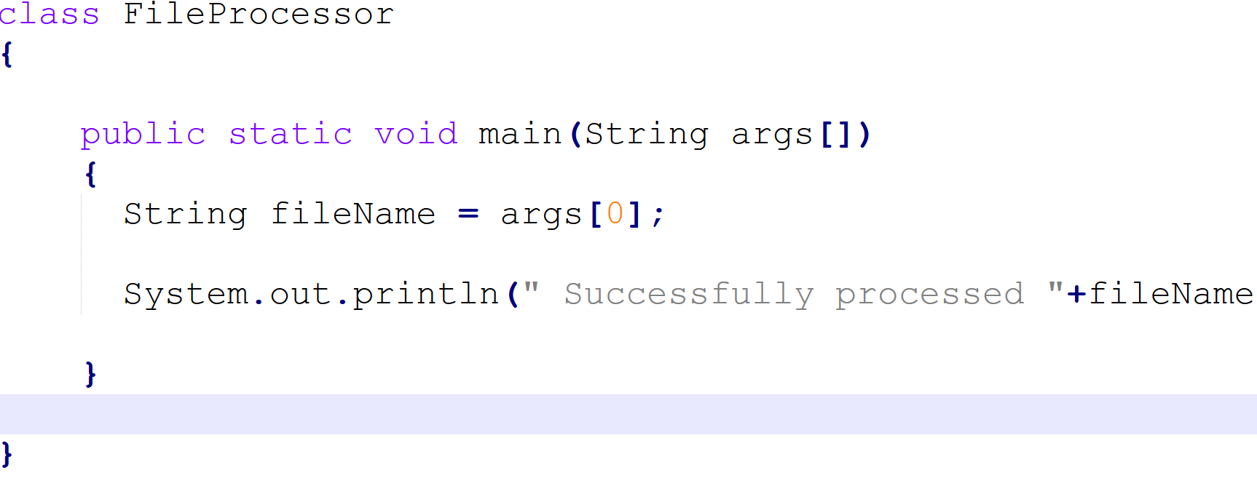

[A-Z][a-z][0-9]

Write a program and explain the java identifier used in the program.

