Scope
- Private private int amount = 100;
Private members are accessible with in the class only.
- int amount= 100; // With in package
- Protected protected int amount = 100;
Same class , Same package and sub classes outside package.

- Public public int amount = 100;
Anyone can access…
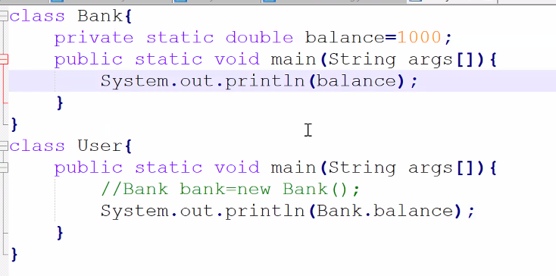
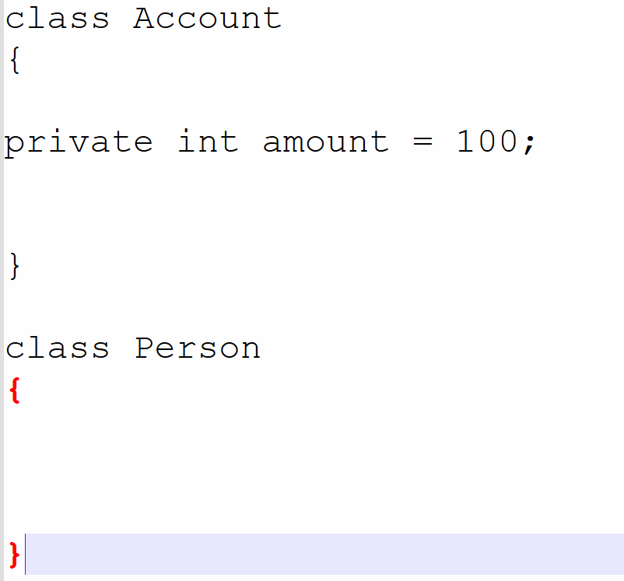

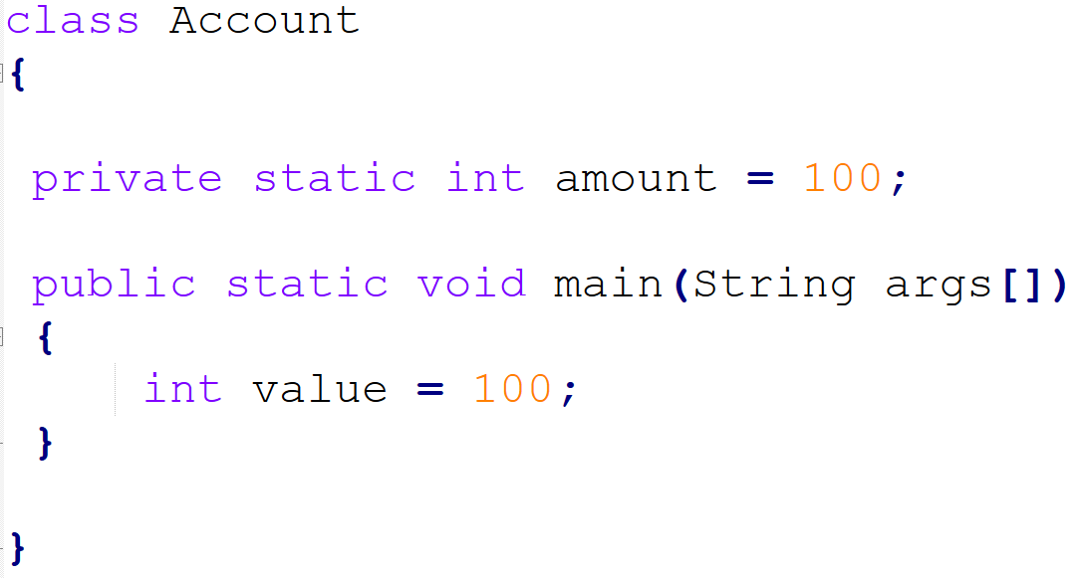

Write a program and explore the access modifier
- Private
- Default
- Public
Need to create different classes.

Follow java naming convention.

Private < default < protected < public
With in class with in package package + sub class in diff package anywhere

