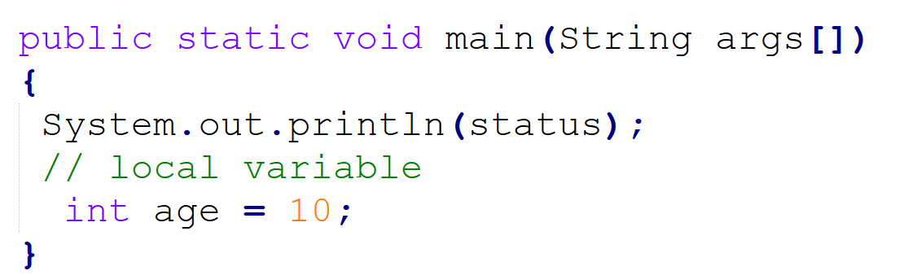

Non primitive
Any Object
String, Arrays , Person, Employee, Bank, Account, Order, Payment etc…
Default null

Develop an application to display Order details.
Application Name: Zepto Delivery App
Requirement:
- Develop a class to display the order details like:
- Order id
- Order status i.e A , D, C etc
- Item Name
- Order by
- Address
- Delivered by etc.

