<Datatype> <identifier> = <value>
int amount = 100;
amount = 100;
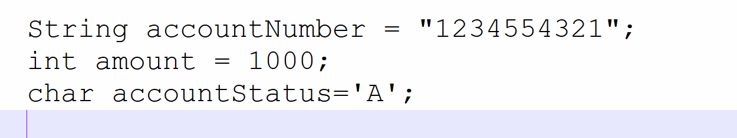

Non Primitive

String
Object
System
Util…
Any Object type

Byte (8 bits) -128 to 127
short (16 bits)
int (32 bits)
Long (64 bits)
Double (64 bits)
float(32 bits)
Char
boolean(8 or 1 bits)
Non Primitive
Primitive

byte amount = -100;

Write a program(Application) and perform credit and debit functionality.
- Debit from your account.
- Credit to your friends account.
- Print the balance for both(your and your friends balance)
- Use proper java naming convention

