**Lab 3: Use of Commit and Rollback**

1. **Create a database, connect to it and create a table named student**

*CREATE DATABASE LAB3*

*USE LAB 3;*

*CREATE TABLE student(*

*sid int identity(1,1) primary key,*

*sname varchar(20) NOT NULL,*

*saddress varchar(20),*

*DOB DATE,*

*Marks float*

*);*

1. **Display Student table**

*SELECT * FROM Student;*

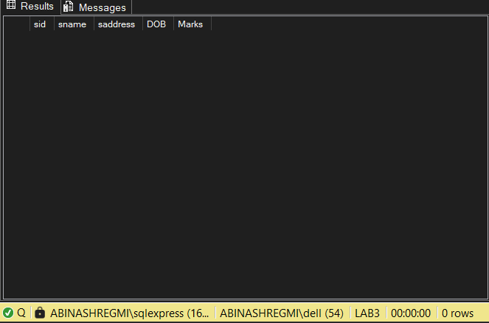

1. **Rollback**

*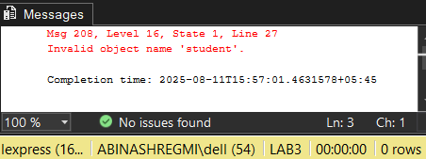ROLLBACK*

1. **Create Student Table again**

*CREATE TABLE student(*

*sid int identity(1,1) primary key,*

*sname varchar(20) NOT NULL,*

*saddress varchar(20),*

*DOB DATE,*

*Marks float*

*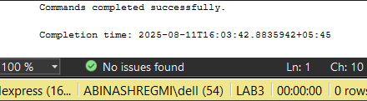);*

1. **Commit**

*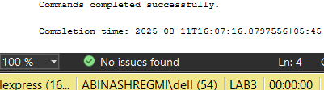COMMIT*

1. **Display Student Table**

*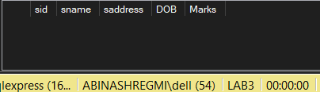SELECT * FROM student;*

1. **Insert Data**

*INSERT INTO student (sname, saddress, DOB, Marks) VALUES*

*('Aarav Sharma', 'Kathmandu', '2005-03-15', 85.5),*

*('Sita Thapa', 'Lalitpur', '2004-07-22', 78.0),*

*('Ramesh Karki', 'Bhaktapur', '2005-11-05', 92.3),*

*('Anjali Rai', 'Pokhara', '2006-01-30', 88.7),*

*('Bikash Gurung', 'Biratnagar', '2004-09-12', 74.5),*

*('Nisha Shrestha', 'Dharan', '2005-06-18', 81.2),*

*('Prakash Lama', 'Butwal', '2006-04-25', 69.8),*

*('Meena Raut', 'Besisahar', '2004-11-11', 89.4),*

*('Bibek Regmi', 'Jumla', '2006-01-05', 77.8),*

*('Laxmi Bhandari', 'Ilam', '2005-08-19', 86.6);*

1. **Check Rollback, Commit**

*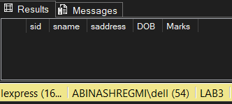Rollback*

*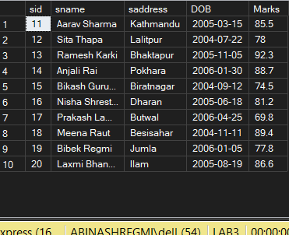COMMIT*

1. **Delete records**

*DELETE FROM student WHERE saddress = 'kathmandu';*

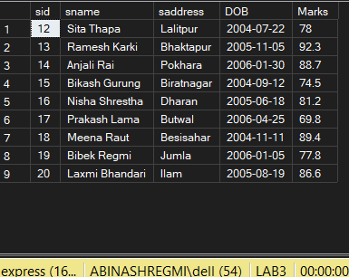

1. **Check Rollback, Commit**

*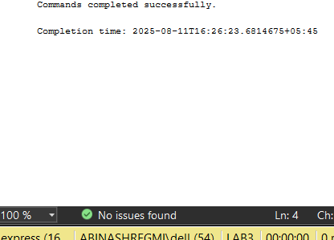ROLLBACK*

*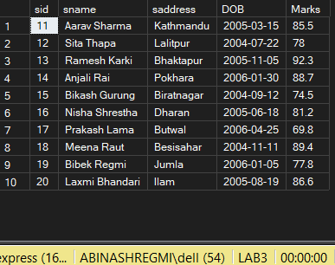COMMIT*

1. **Update Data**

*UPDATE student*

*SET saddress = 'Bhaktapur'*

*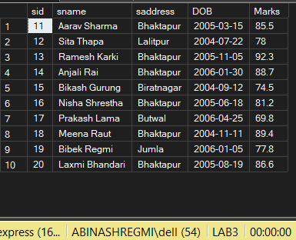WHERE Marks > 80*

1. **Check Commit, Rollback**

*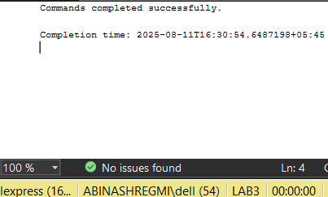COMMIT*

*ROLLBACK*

*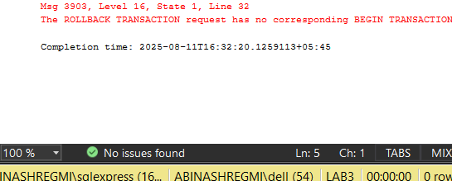ROLLBACK*

1. **Drop Table**

*DROP TABLE student;*

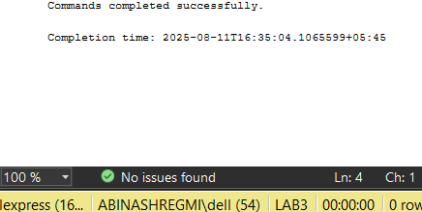

1. **Check Roll, Commit**

*ROLLBACK*

**

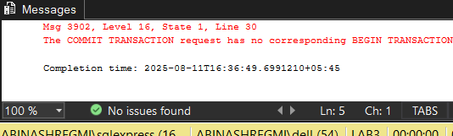COMMIT