Lab 1: Use of Single Table

CREATE DATABASE Lab1;

USE Lab1;

CREATE TABLE STUDENT (

SID INT PRIMARY KEY,

SNAME VARCHAR(25),

GENDER CHAR(1),

AGE INT,

CLASS VARCHAR(20),

MARKS INT,

EMAIL VARCHAR(30),

ADDRESS VARCHAR(35)

);

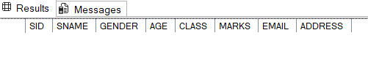

1. Insert 15 students with full details including Email and Address.

INSERT INTO STUDENT VALUES

(1, 'Hari Acharya','M', 18, '12B', 87, 'acharya@gmail.com', 'Shantinagar'),

(2, 'Rea Sharma', 'F', 19, '11A', 92, 'sharma@yahoo.com', 'Pokhara'),

(3, 'Anisha Chaulagain', 'F', 20, '12A', 79, 'anisha.c@gmail.com', 'Dharan'),

(4, 'Babita Dhungana', 'F', 18, '11B', 83, 'babita.dhun@hotmail.com', 'Baglung'),

(5, 'Bijaya Thapa', 'F', 17, '11A', 68, 'bijayathapa88@gmail.com', 'Chitwan'),

(6, 'Pujan Subedi', 'M', 20, '12B', 96, 'pujan.subedi@yahoo.com', 'Bhaktapur'),

(7, 'Sarojani Karki', 'F', 19, '11B', 72, NULL, 'Makwanpur'),

(8, 'Manisha Joshi', 'F', 18, '11A', 89, 'mj.official@gmail.com', 'Kailali'),

(9, 'Dipesh Rautey', 'M', 20, '12B', 94, 'dipeshraut@outlook.com', 'Rupandehi'),

(10, 'Sitashma Neupane', 'F', 17, '11B', 76, 'sitaneupane123@gmail.com', 'Tanahun'),

(11, 'Roshan Regmi', 'M', 18, '12A', 85, 'roshan.regmi@gmail.com', 'Butwal'),

(12, 'Sweta KC', 'F', 19, '11A', 91, 'swetakc@gmail.com', 'Lalitpur'),

(13, 'Karan Maharjan', 'M', 17, '12B', 90, 'karan.mj@yahoo.com', 'Kathmandu'),

(14, 'Nishan Rijal', 'M', 20, '11A', 74, NULL, 'Dhading'),

(15, 'Saurav Basnet', 'M', 19, '12A', 82, 'sauravbasnet@gmail.com', 'Syangja');

2) Display all student records with all columns.

SELECT * FROM Student;

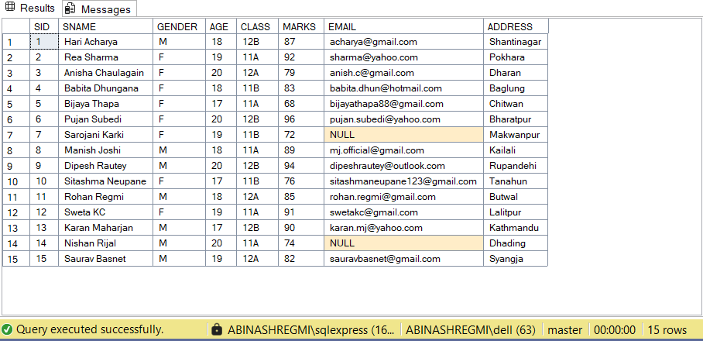

1. Display only SName, Email, and Marks.

SELECT SName, Email, Marks FROM Student;

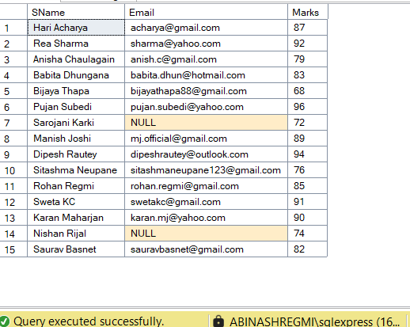

1. Find students who live in a specific city (use LIKE on Address).

SELECT * FROM Student WHERE Address LIKE '%Kathmandu%';

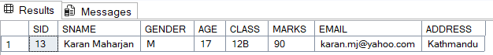

1. Find students whose email ends with '@gmail.com'.

SELECT * FROM Student WHERE Email LIKE '%@gmail.com';

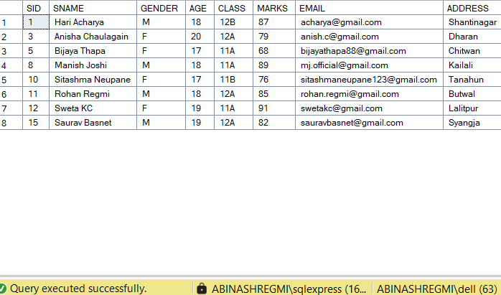

1. Update the Address of a student with a specific StudentID.

UPDATE STUDENT SET ADDRESS = 'Aargakachi' WHERE SID = 9;

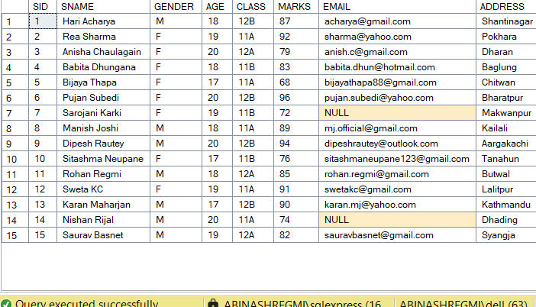

1. List all students who scored more than 80 and are under 20 years old.

SELECT * FROM Student WHERE Marks > 80 AND Age < 20;

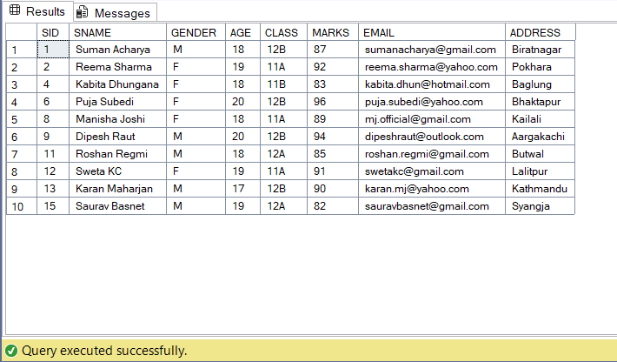

8)Count how many students have email addresses from 'yahoo.com'.

SELECT COUNT(*) FROM Student WHERE Email LIKE '%@yahoo.com';

SELECT COUNT(*) AS YahooEmailCount

FROM Student

WHERE Email LIKE ['%@yahoo.com';](mailto:'%25@yahoo.com';)

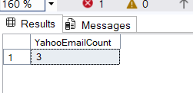

9)Find students who have not provided an email (Email IS NULL).

SELECT * FROM Student WHERE Email IS NULL;

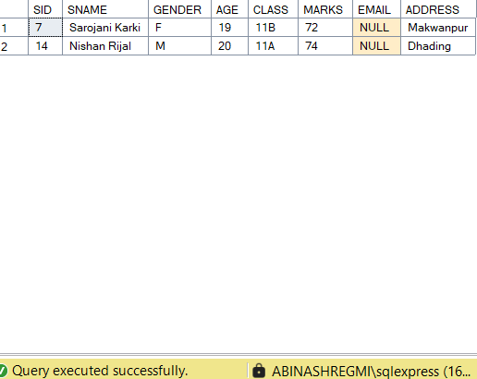

10. Display all students ordered by SName alphabetically

SELECT * FROM STUDENT ORDER BY SNAME ASC;

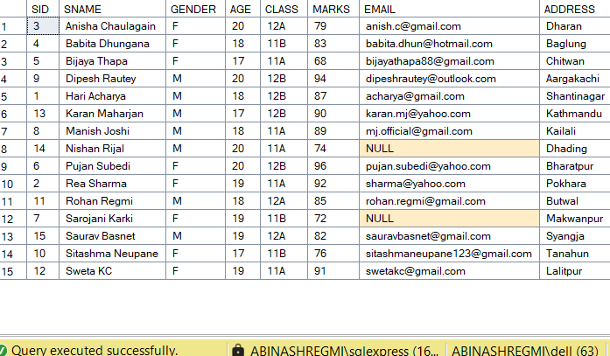

1. Group students by Class and show the highest marks in each class

SELECT CLASS, MAX(MARKS) AS HIGHESTMARK FROM STUDENT GROUP BY CLASS;

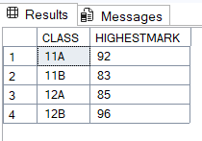

12)Delete students whose address is 'NULL' or not specified.

DELETE FROM STUDENT WHERE ADDRESS IS NULL;



Before



After

1. Add a new column PhoneNumber to the student table.

ALTER TABLE Student ADD PhoneNumber VARCHAR(20);

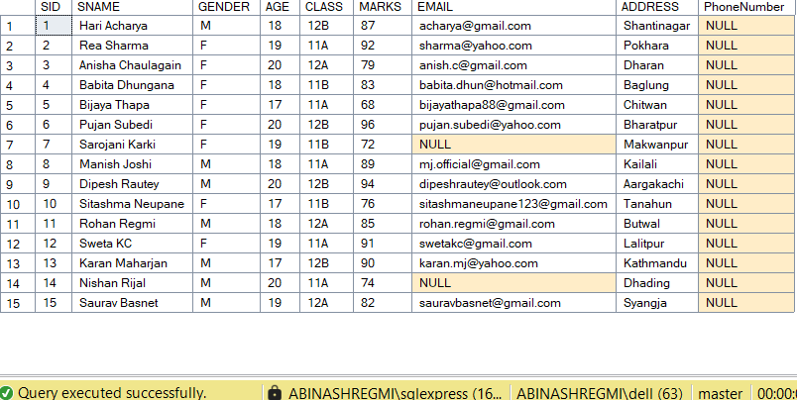

14. Create a view ContactList to display SName, Email, and PhoneNumber.

CREATE VIEW ContactList AS

SELECT SName, Email, PhoneNumber FROM Student;

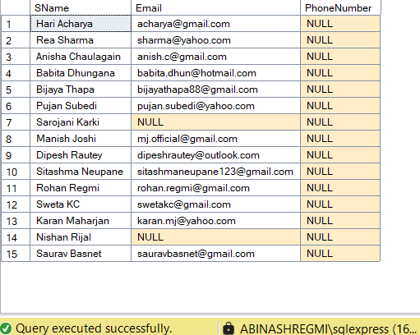

15. Display students whose name starts with 'R' and ends with 'a'.

SELECT * FROM STUDENT WHERE SNAME LIKE 'R%' AND SNAME LIKE '%a';



16. Find the number of students per city (GROUP BY Address).

SELECT ADDRESS AS CITY, COUNT(*) AS STUDENTCOUNT FROM STUDENT GROUP BY ADDRESS;

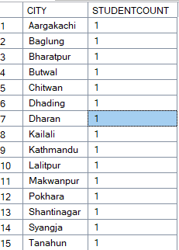

17. Count how many male and female students exist (GROUP BY Gender).

SELECT GENDER, COUNT(*) AS GENDERCOUNT FROM STUDENT GROUP BY GENDER;

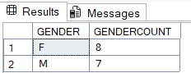

1. Find students who have the same address but different names.

SELECT * FROM STUDENT WHERE ADDRESS IN (

SELECT ADDRESS FROM STUDENT GROUP BY

ADDRESS HAVING COUNT(DISTINCT SNAME) > 1

)



20) Rename the column Marks to TotalMarks.

EXEC sp_rename 'STUDENT.MARKS', 'TOTALMARKS', 'COLUMN';

