SERVERLESS EXPENSE TRACKER
Personal expense tracker Using
AWS Lambda, API Gateway, Amazon S3 & DynamoDB
A Major Project Report
Submitted by: Abinaya S
Institution: Login360
Academic Year: 2026

Introduction

Managing personal expenses manually using notebooks or spreadsheets is time-consuming and error-prone. This project automates expense tracking using a fully serverless web application deployed on AWS. Users can record their daily spending, categorize it — all without the developer having to manage a single server.
Objectives
- Design a web application to record, view, update, and delete personal expenses.
- Implement backend logic using a serverless compute service (AWS Lambda) with no server management.
- Expose the backend functionality through a RESTful API using Amazon API Gateway.
- Persist expense records in a NoSQL database (Amazon DynamoDB).
- Host the frontend as a static website using Amazon S3.
Problem Statement
Many individuals use notebooks or spreadsheets to maintain their expenses, which often results in data loss, calculation errors, and difficulty tracking spending patterns. A cloud-based serverless solution provides better accessibility, security, and simplified expense management without these overheads.
System Architecture
The application follows a simple, fully serverless request-response pipeline:
User
│
▼
Amazon S3 (Static Frontend)
│
▼
Amazon API Gateway
│
▼
AWS Lambda
│
▼
Amazon DynamoDB

Implementation

Hosting the Frontend on Amazon S3
- Created an S3 bucket and enabled Static Website Hosting.

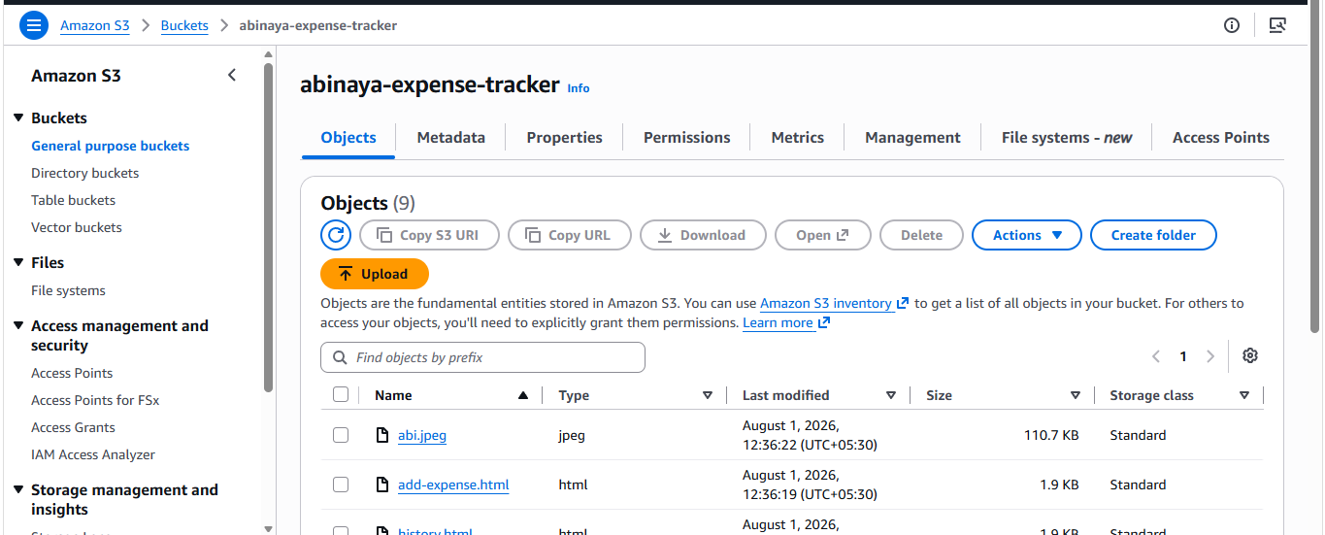

Creating the DynamoDB Table
- Created a table named ExpenseRecords with partition key expense_id (String).

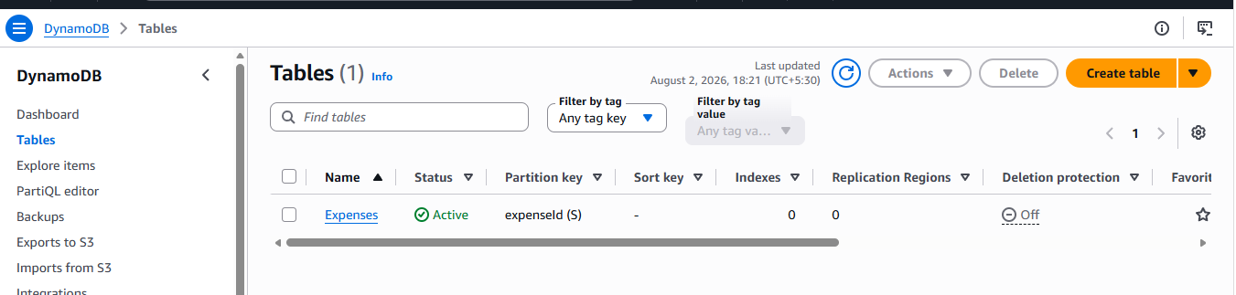

Creating the AWS Lambda Function

Lambda function is created with a name of expenses.

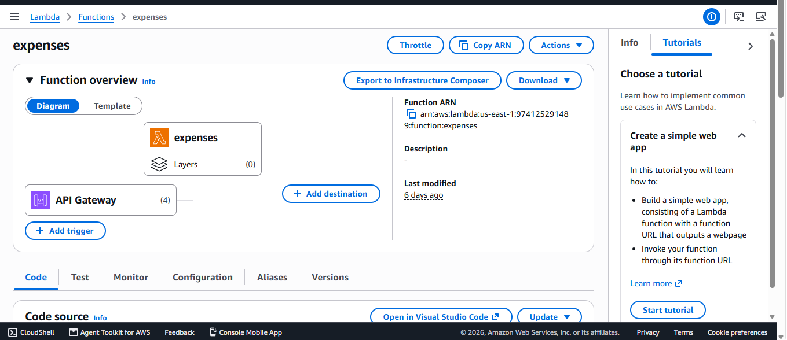

Configuring Amazon API Gateway
- Created a new REST API in API Gateway.

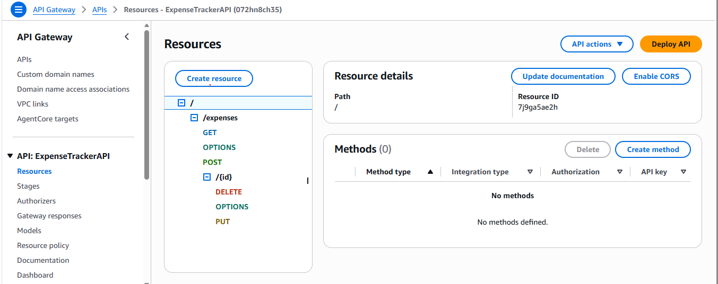

Granting Permissions (IAM)
- AmazonS3FullAcess
- AmazonDynamoDBFullAccess
- AmazonAPIGatewayInvokeFullAcess
- AWSLambdaBasicExecutionRole

Testing
- Go to the dashboard
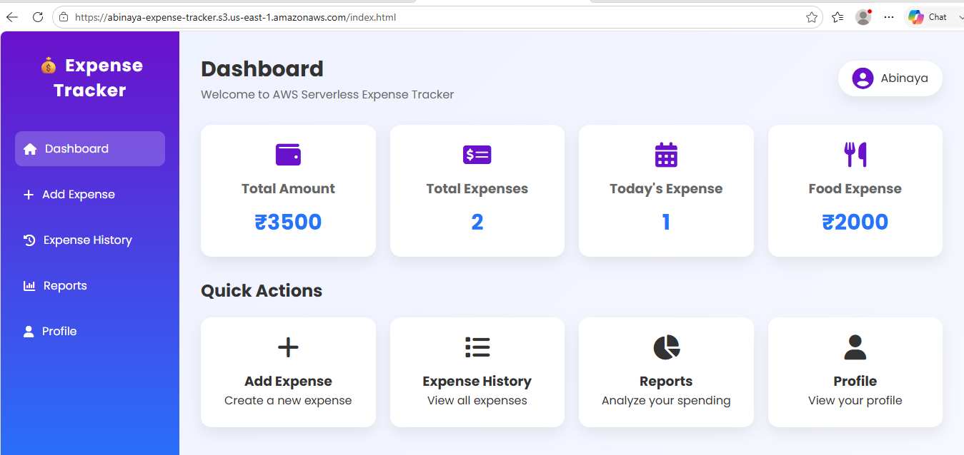

- Go to the add expense tab
- Enter the expense details (Title, Category, Amount, Date, Description).
- Click the “Add Expense” button.
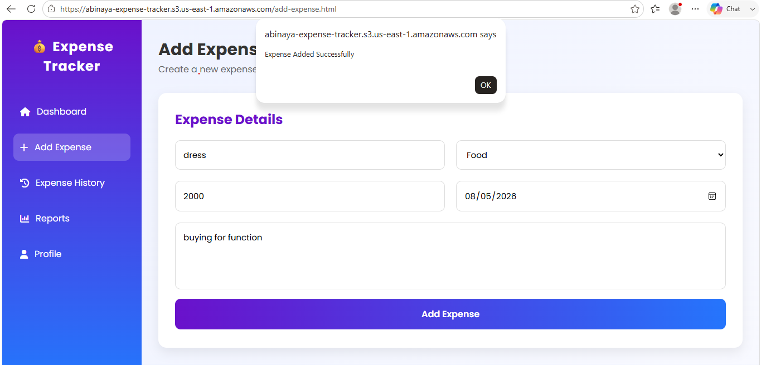

- Go to the Expense History tab.
- Verify that the newly added expense is displayed in the list.
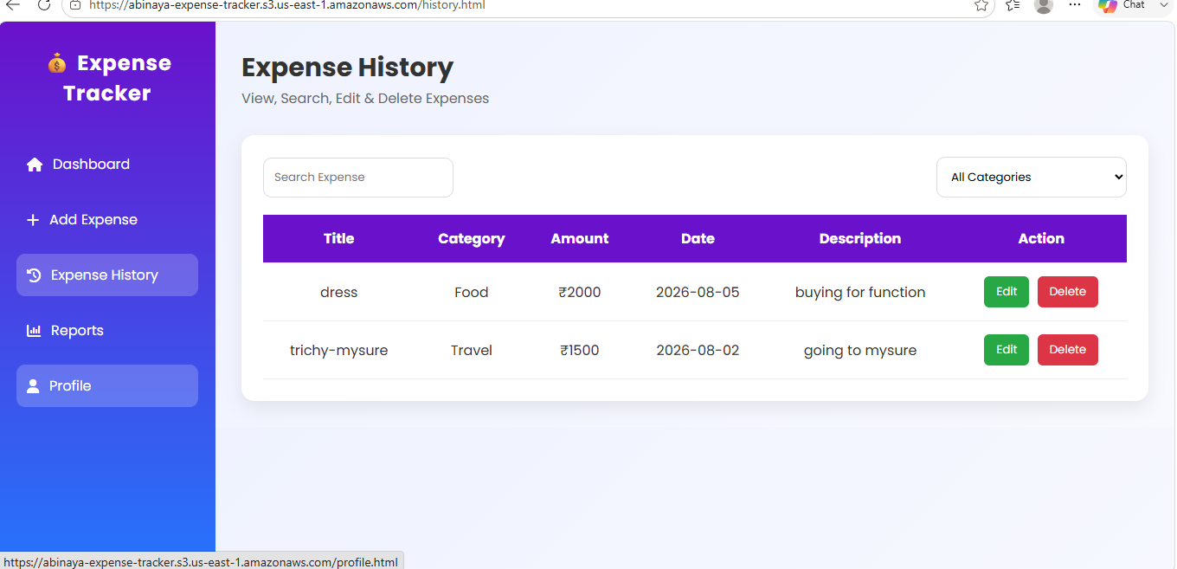

- Next go to the Reports tab. Here we can view the total expenses and category-wise
expense report.

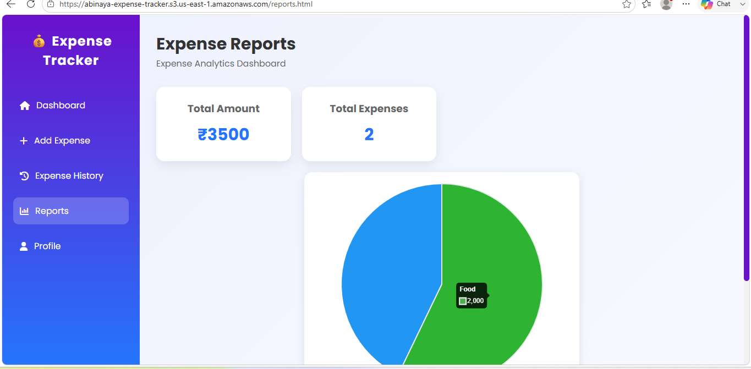

- Finally, go to the Profile tab. Here, the project details are displayed.
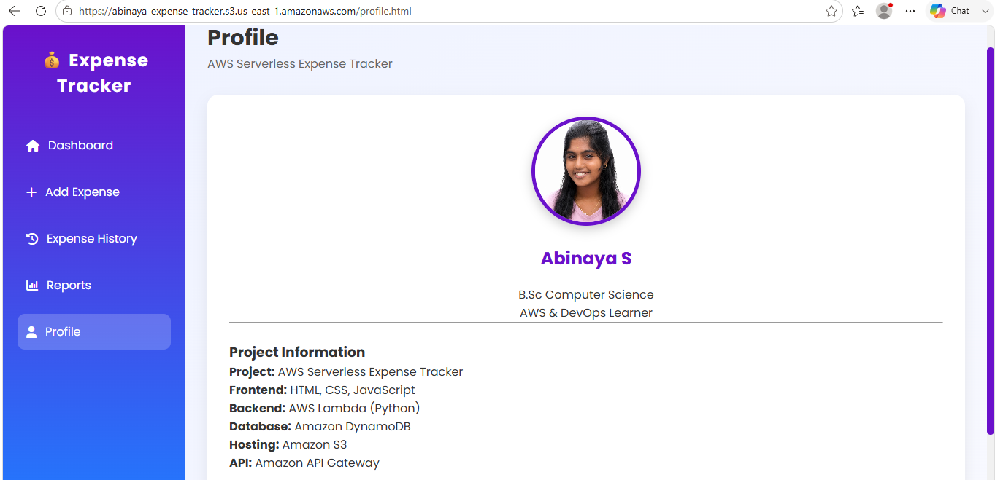
Applications

- Personal expense management
- Student budget tracking
- Household finance management
- Small business expense recording
- Monthly financial reporting

Conclusion

This project successfully demonstrates a fully functional, serverless personal expense tracker built using Amazon S3, API Gateway, AWS Lambda, and Amazon DynamoDB.

