BANKING APPLICATION
Secure CI/CD and Kubernetes Deployment
1. Project Overview
This project is a banking application developed using DevOps tools. Users can register, login, check balance, transfer money, and view transaction history.

2. Objective
The main objective is to build, deploy, manage, and monitor a banking application using DevOps practices.

3. Tools Used
- GitHub – Stores and manages the project source code.
- Jenkins – Automates the CI/CD process.
- Docker – Packages the application into containers.
- Kubernetes – Deploys and manages containers.
- Ansible – Automates server configuration.
- Terraform – Automates infrastructure management.
- Prometheus – Collects system monitoring data.
- Grafana – Shows monitoring data in dashboards.
- MySQL – Stores user and transaction data.

4. Easy Explanation of Each Tool

GitHub:
Used to store project code and manage code changes.
Jenkins:
Used to automate build and deployment activities.
Docker:
Used to package the application into containers.
Kubernetes:
Used to deploy and manage application containers.
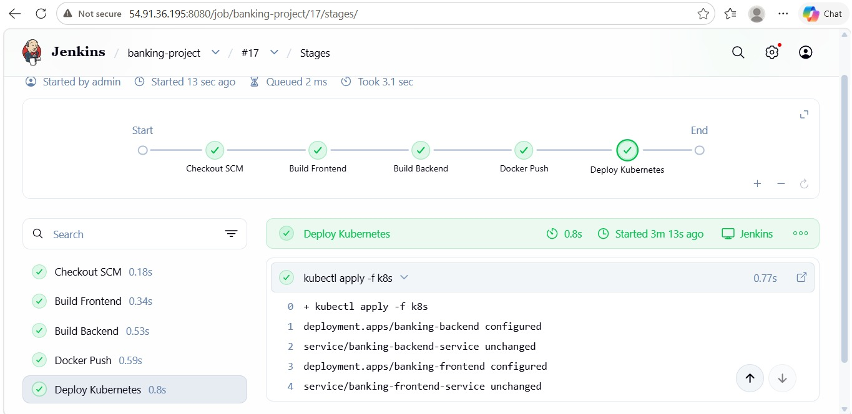
Terraform: Used to create and manage cloud infrastructure.
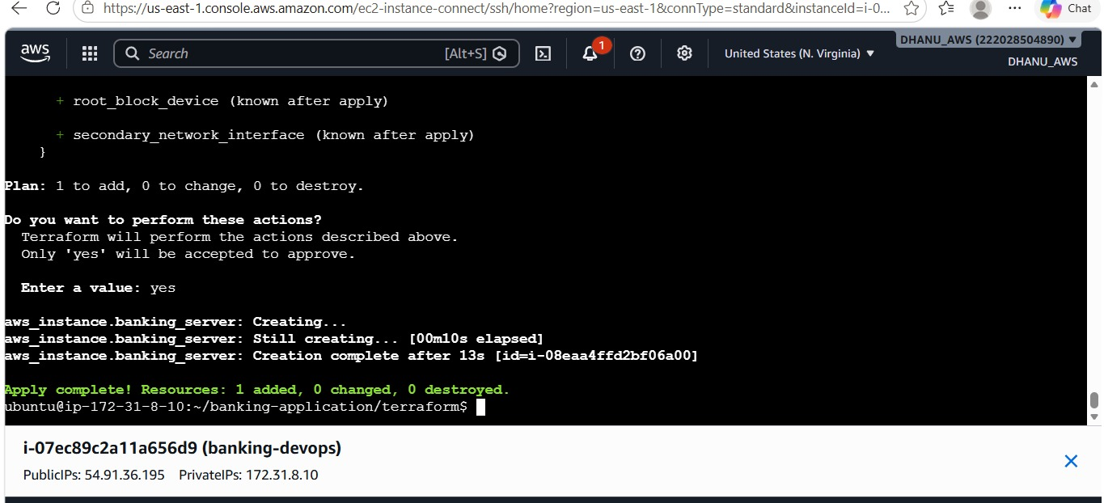

Ansible: Used to configure servers and install required software automatically.

Prometheus: Used to collect CPU, memory, disk, and other metrics.
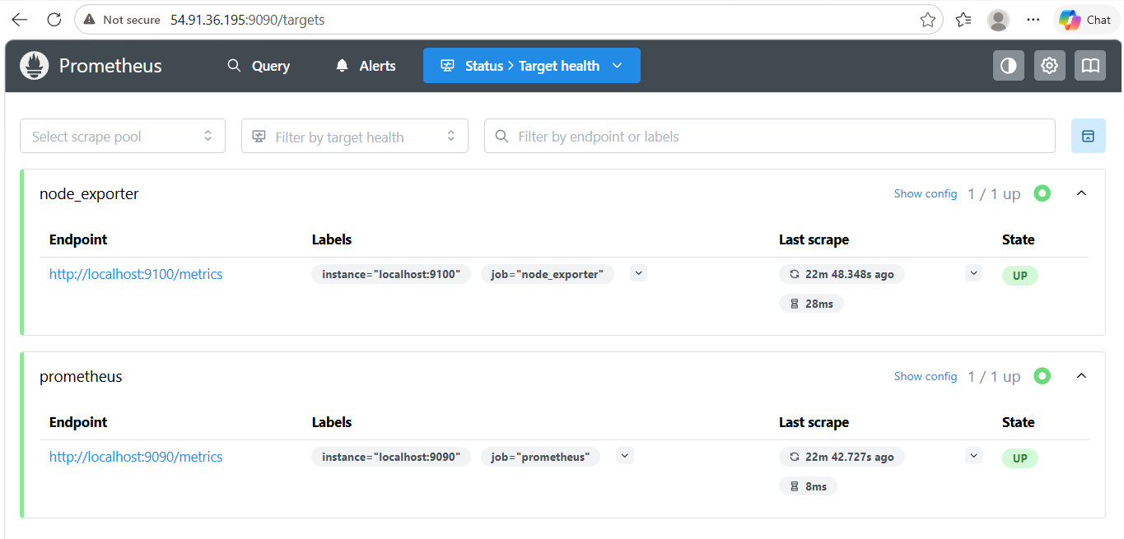
Grafana: Used to display monitoring information in easy-to-understand dashboards.
CPU USAGE
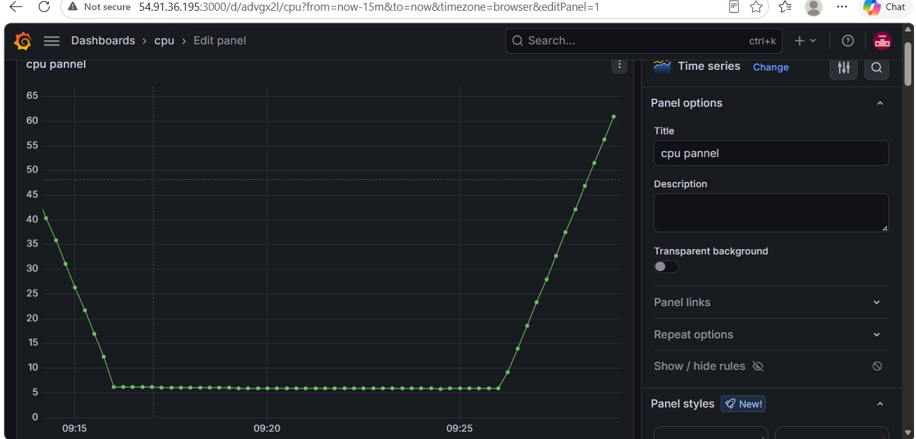

DISK USAGE
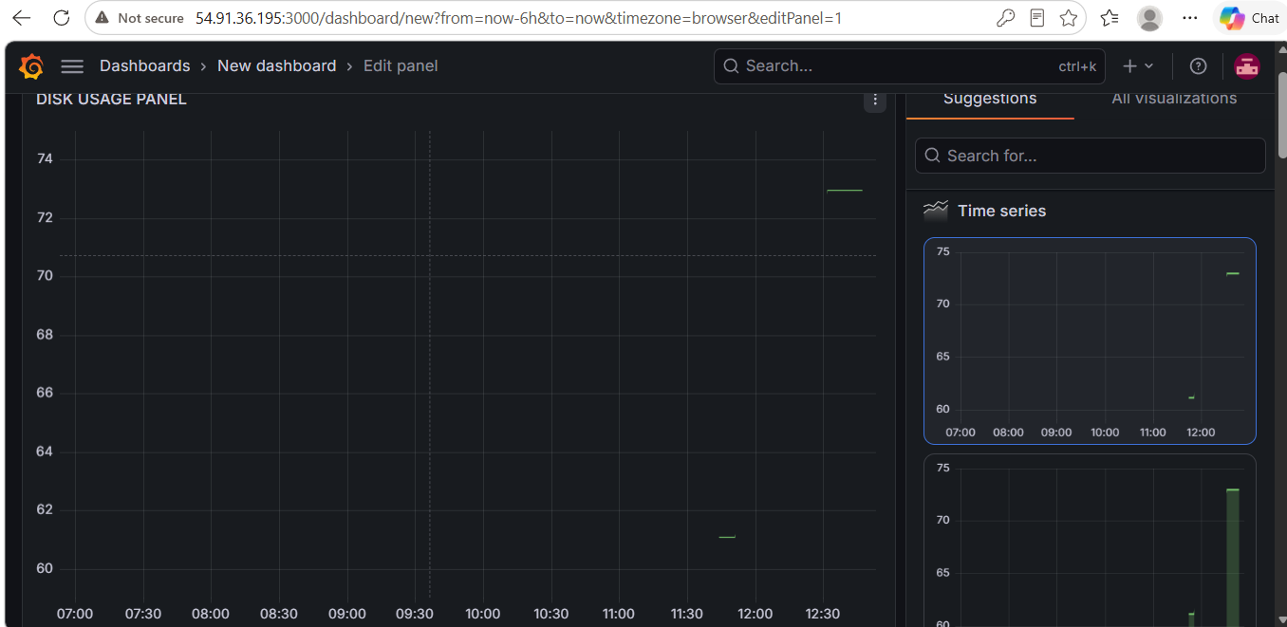
RAM USAGE
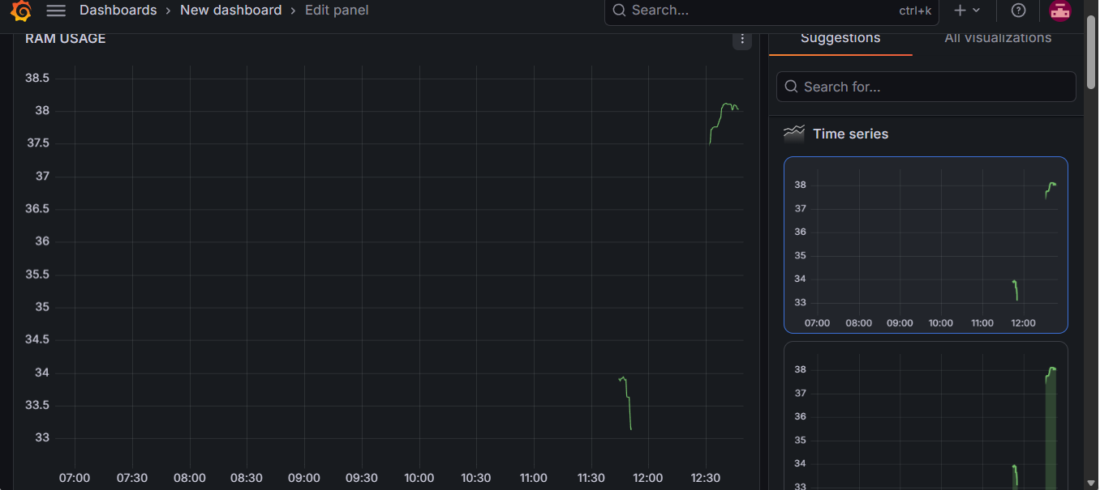

MySQL: Used to store user details, account balance, and transaction details.
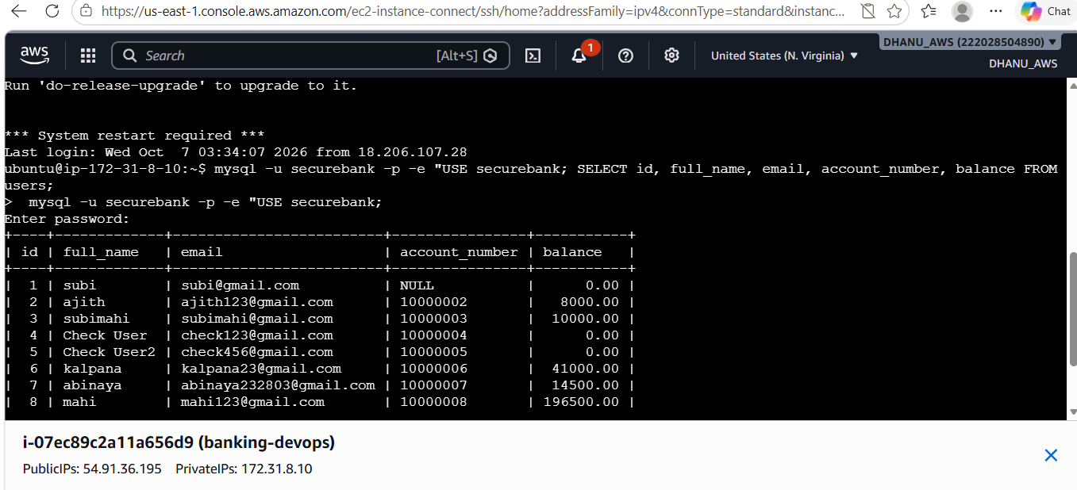

5. Application Features
- User Registration
- User Login
- Account Balance
- Money Transfer
- Debit and Credit Transactions
- Transaction History

6. Project Workflow
GitHub → Jenkins → Docker → Kubernetes → Prometheus → Grafana
Ansible is used for server configuration and Terraform is used for infrastructure management.
7. Transaction Flow
- Sender transfers money to another account.
- Sender gets a Debit transaction.
- Receiver gets a Credit transaction.
- Transaction details are stored in MySQL.
- Users can view their transaction history.

8. Project demonstration

User registration:
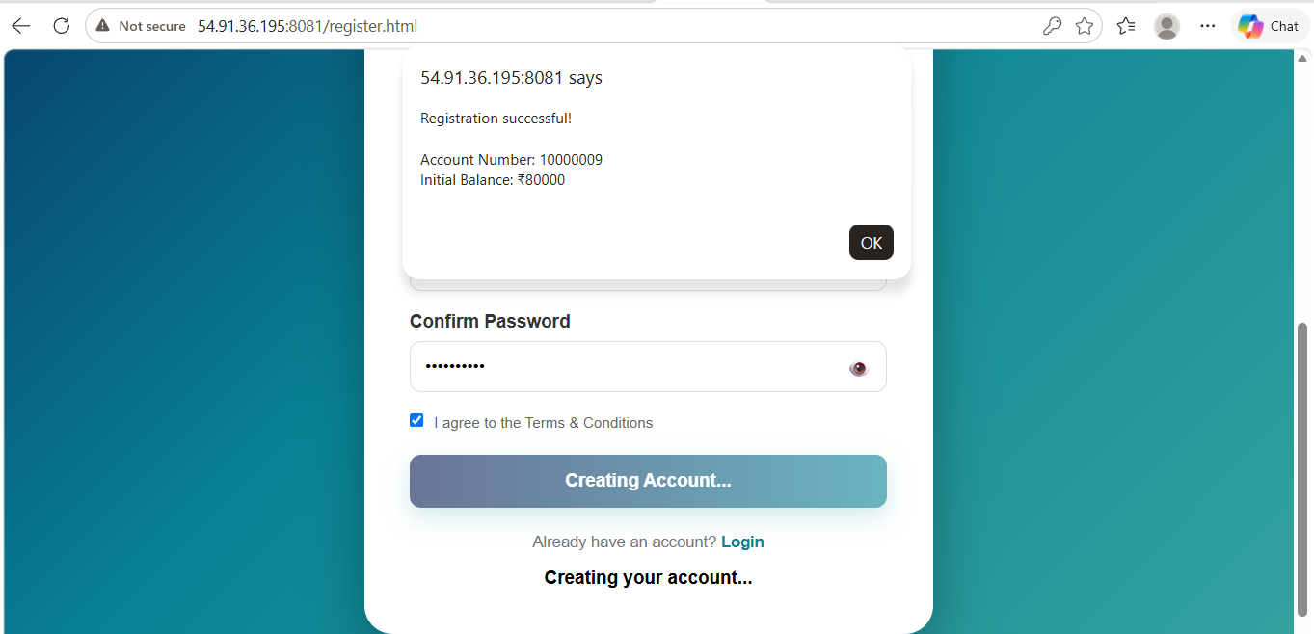
User Login:
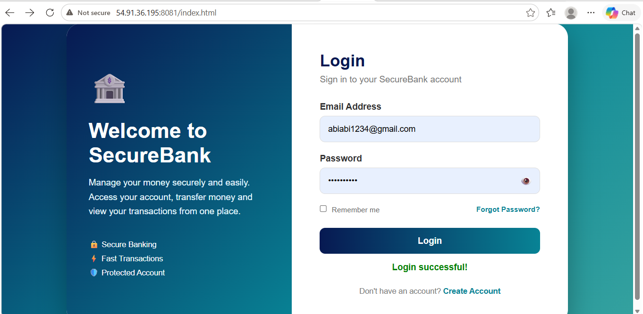

Dashboard:
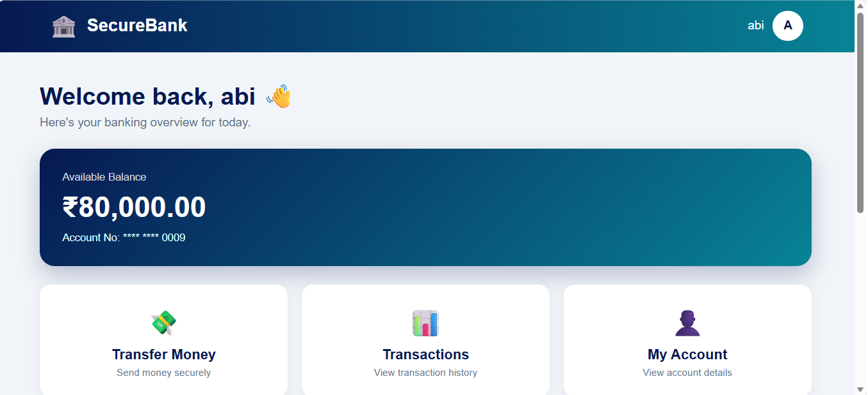

Transaction History:
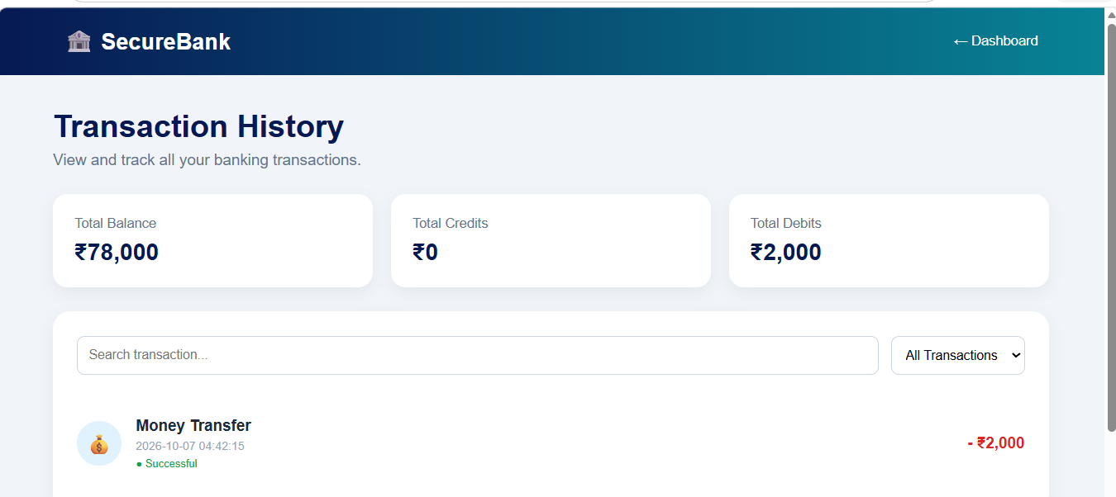

Transfer:
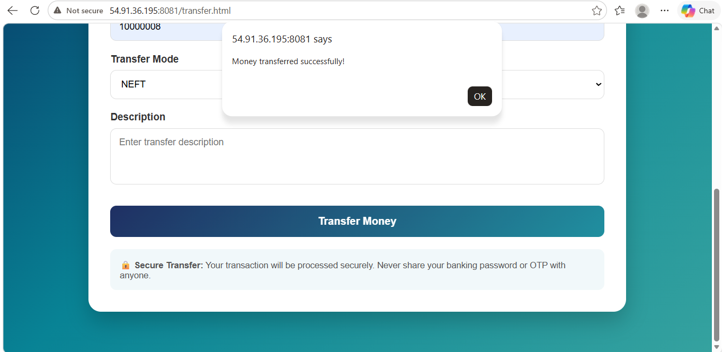

My Account:
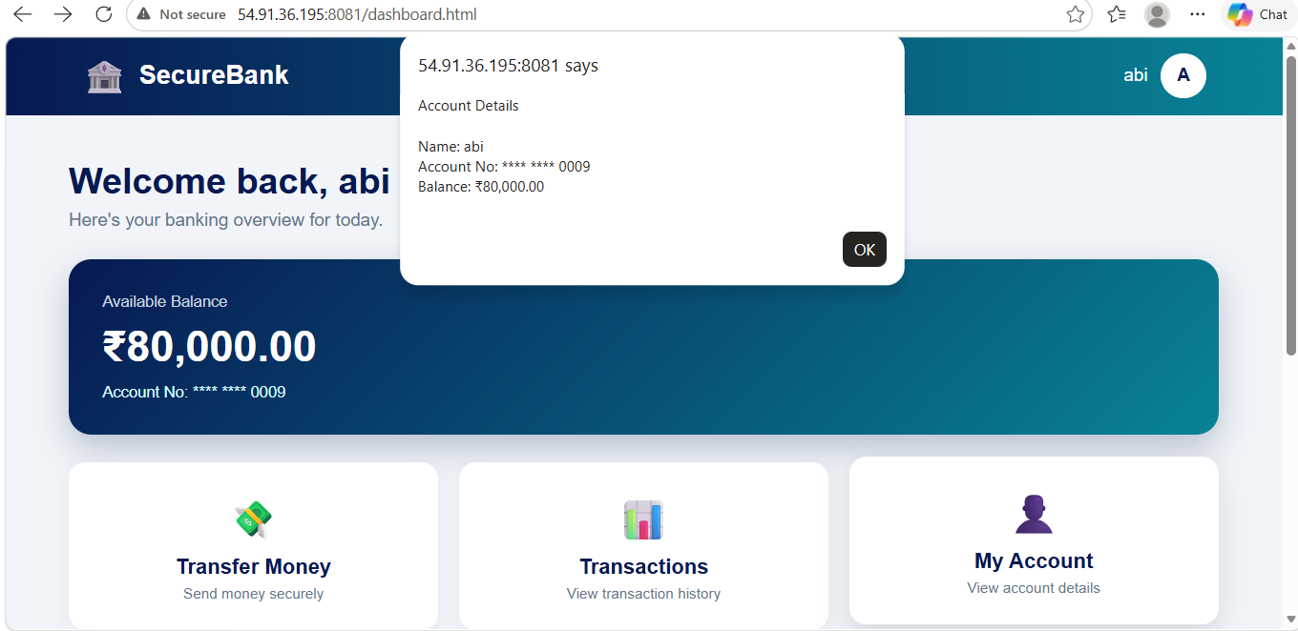
9. Conclusion
This project demonstrates the practical use of DevOps tools for application deployment, infrastructure management, and monitoring.

