EduGenie
Project Development Phases with Screenshots
Phase-wise documentation and visual evidence of the EduGenie Learning Assistant

Project Overview
EduGenie is a learning-assistance application that brings together concept explanation, question answering, quiz generation, text summarization, and learning-path recommendation. The following document describes the eight project-development phases and connects the relevant screenshots to the work demonstrated in each phase.

Project Development Phases
- 1. Brainstorming & Ideation Phase
- 2. Requirement Analysis Phase
- 3. Project Design Phase
- 4. Project Planning Phase
- 5. Project Development Phase
- 6. Project Testing Phase
- 7. Project Documentation Phase
- 8. Project Demonstration Phase

1. Brainstorming & Ideation Phase
The ideation phase focuses on identifying a practical learning problem and proposing EduGenie as an AI-assisted solution.

Phase Details
- Identify common student needs such as understanding concepts, getting answers, practicing through quizzes, summarizing study material, and planning a learning path.
- Combine these activities into one simple learning-assistant application.
- Choose an easy workflow in which the learner selects a task, enters content, and receives a useful result.

Related Screenshots
Explain a Concept – Input Screen
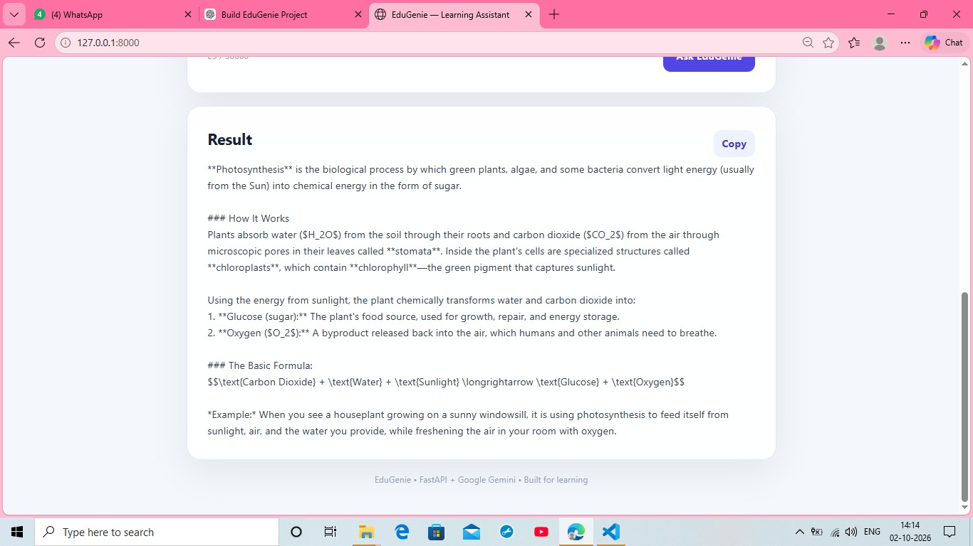
Explain a Concept – Generated Result
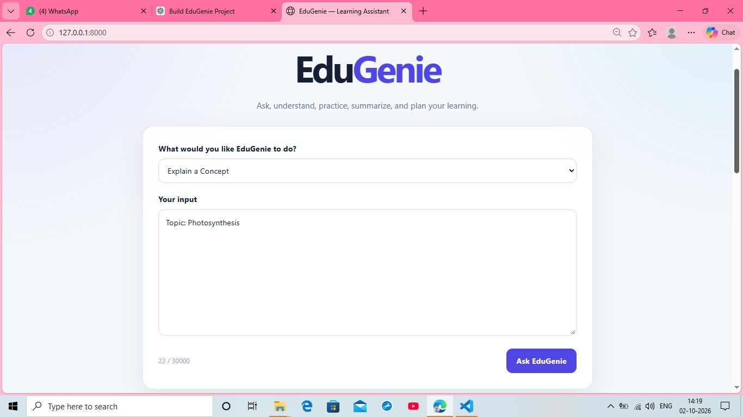
Ask a Question – Input Screen
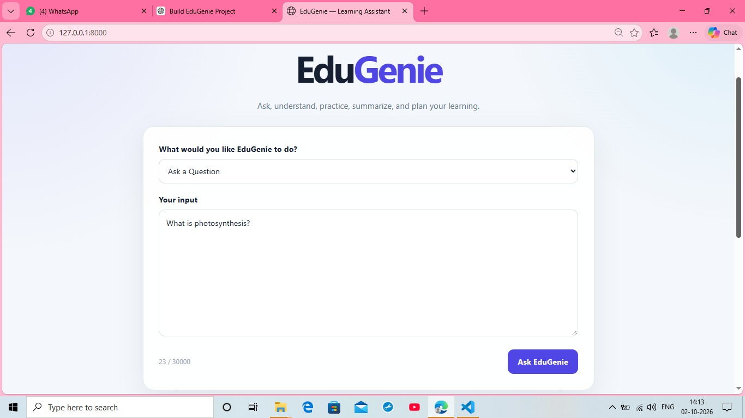

2. Requirement Analysis Phase
The requirement-analysis phase converts the initial idea into clear functional and interface requirements.

Phase Details
- The application needs a task-selection control for different learning activities.
- The learner needs a large input area for topics, questions, or text.
- The system should provide generated results in a readable result section.
- The major functions include concept explanation, question answering, quiz generation, summarization, and learning-path recommendation.
- A copy control should be available for generated results.

Related Screenshots
Ask a Question – Input Screen
Generate a Quiz – Input Screen
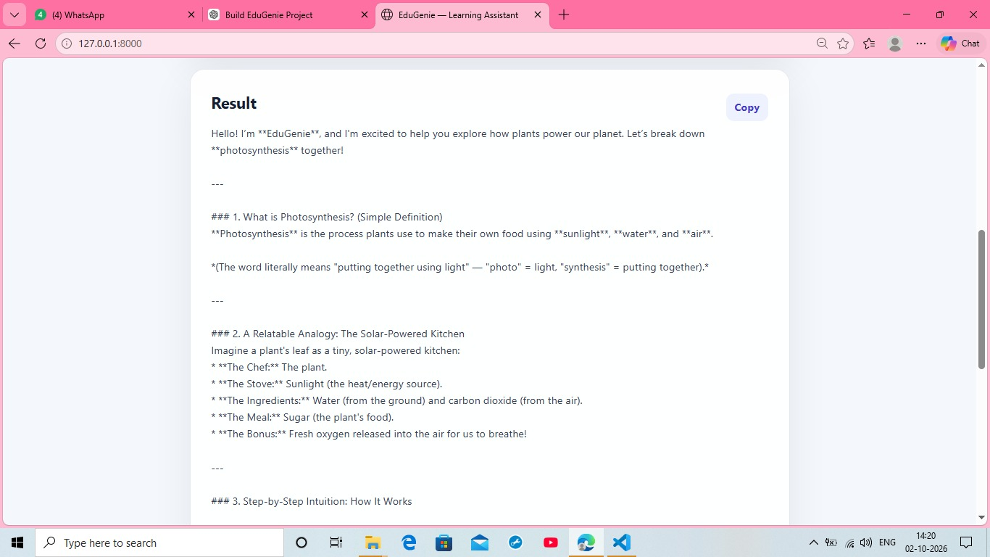
Summarize Text – Input Screen
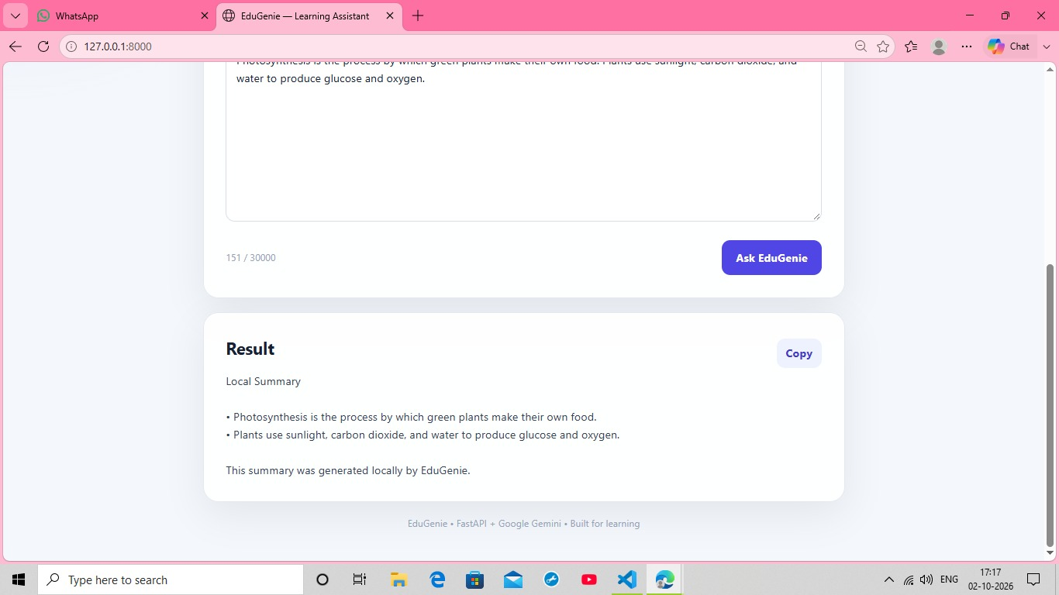
Recommend a Learning Path – Input Screen
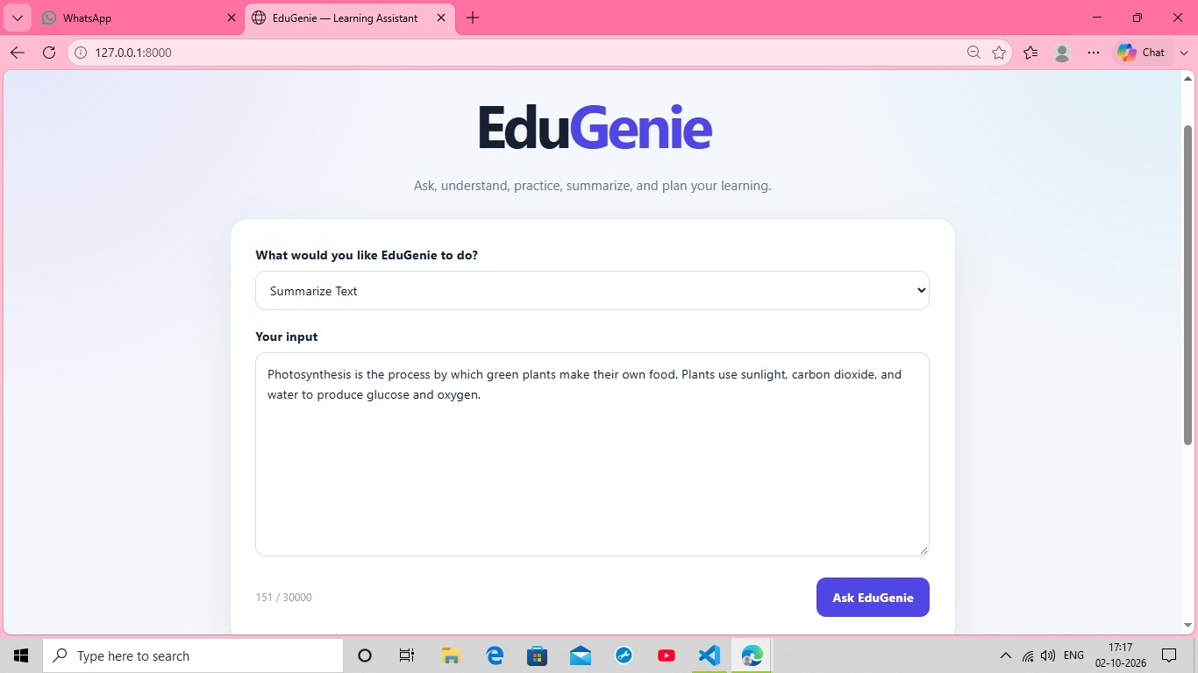

3. Project Design Phase
The design phase defines the learner workflow and the structure of the application.

Phase Details
- Frontend: a centered EduGenie interface with a heading, task selector, input area, action button, and result section.
- Backend: receives the selected operation and learner input and returns the corresponding result.
- AI/LLM integration: supports natural-language educational tasks.
- The design keeps the interaction consistent across all learning modes.

Related Screenshots
Explain a Concept – Input Screen
Ask a Question – Input Screen
Generate a Quiz – Input Screen
Summarize Text – Input Screen
Recommend a Learning Path – Input Screen

4. Project Planning Phase
The planning phase organizes implementation, testing, documentation, and demonstration into manageable activities.

Phase Details
- Set up the development environment and project structure.
- Implement the main interface and backend connection.
- Integrate the AI/LLM functionality.
- Implement feature-specific processing and result formatting.
- Test each major feature using representative educational inputs.
- Prepare screenshots, documentation, and a final demonstration sequence.

Related Screenshots
Explain a Concept – Input Screen
Generate a Quiz – Input Screen
Summarize Text – Input Screen
Recommend a Learning Path – Input Screen

5. Project Development Phase
The development phase implements the planned EduGenie features and connects the interface with the application logic.

Phase Details
- Build the EduGenie web interface.
- Implement the learning-mode selection and input handling.
- Implement backend/API processing.
- Integrate AI-generated explanations and learning content.
- Implement quiz generation and answer feedback.
- Implement text summarization.
- Implement structured learning-path generation.
- Format generated results so they can be read and reviewed in the browser.

Related Screenshots
Explain a Concept – Input Screen
Explain a Concept – Generated Result
Ask a Question – Input Screen
Ask a Question – Generated Explanation
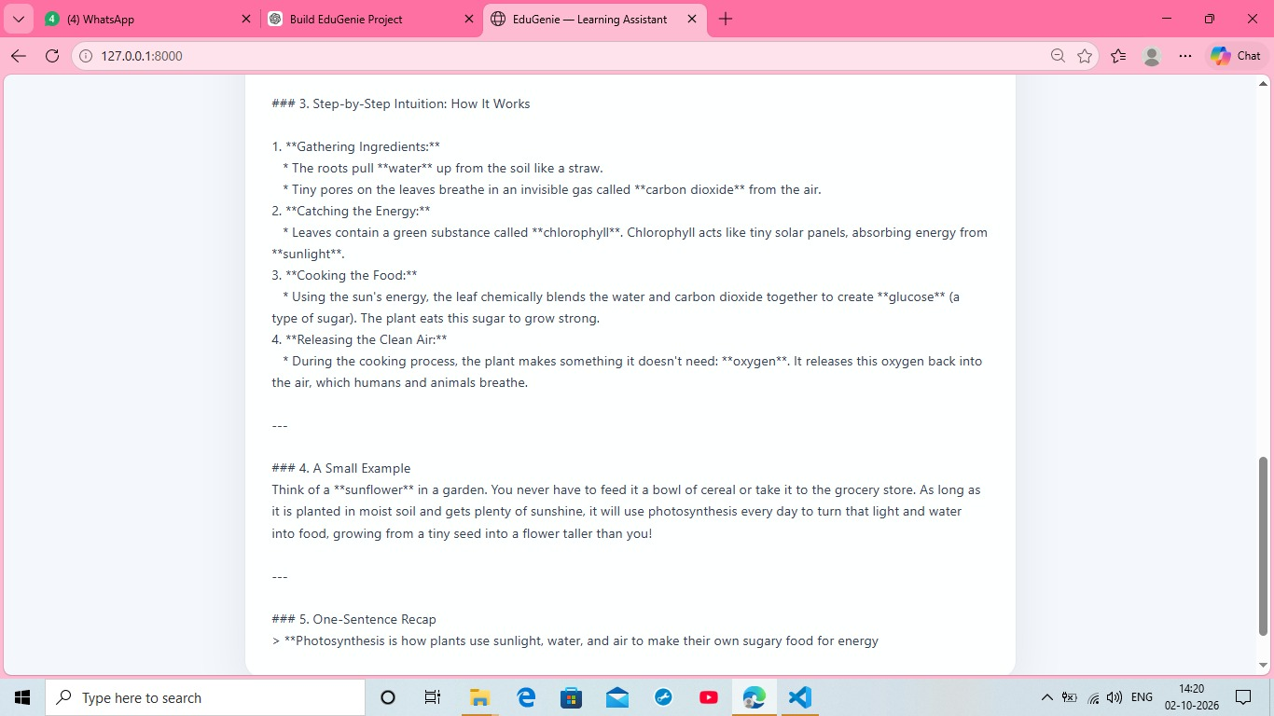
Generate a Quiz – Input Screen
Generated Quiz Questions
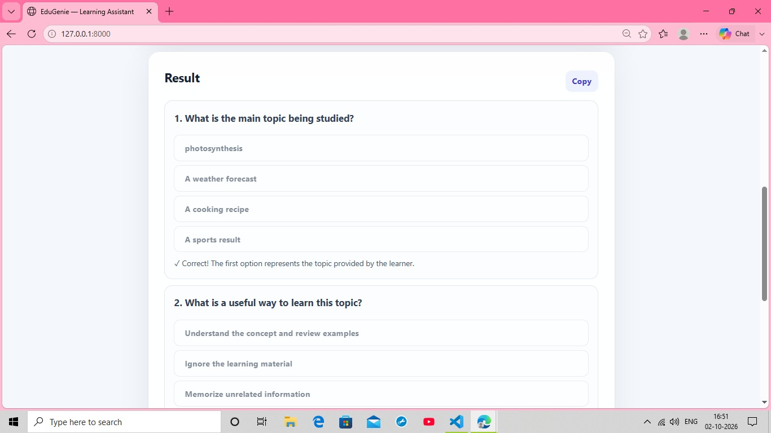
Quiz Answer Feedback
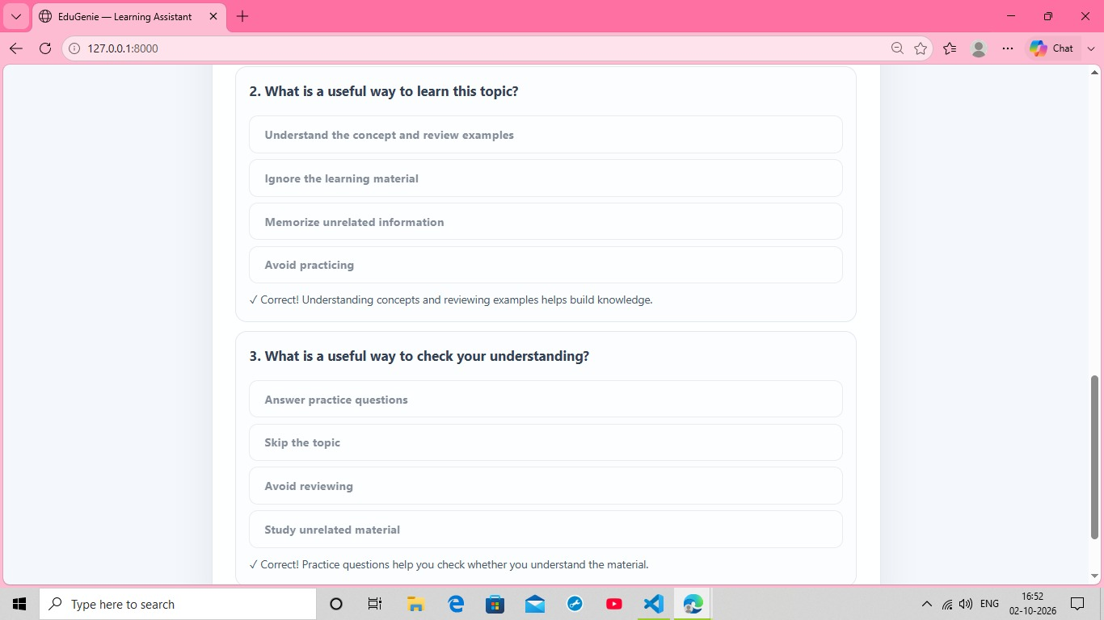
Summarize Text – Input Screen
Local Summary Result
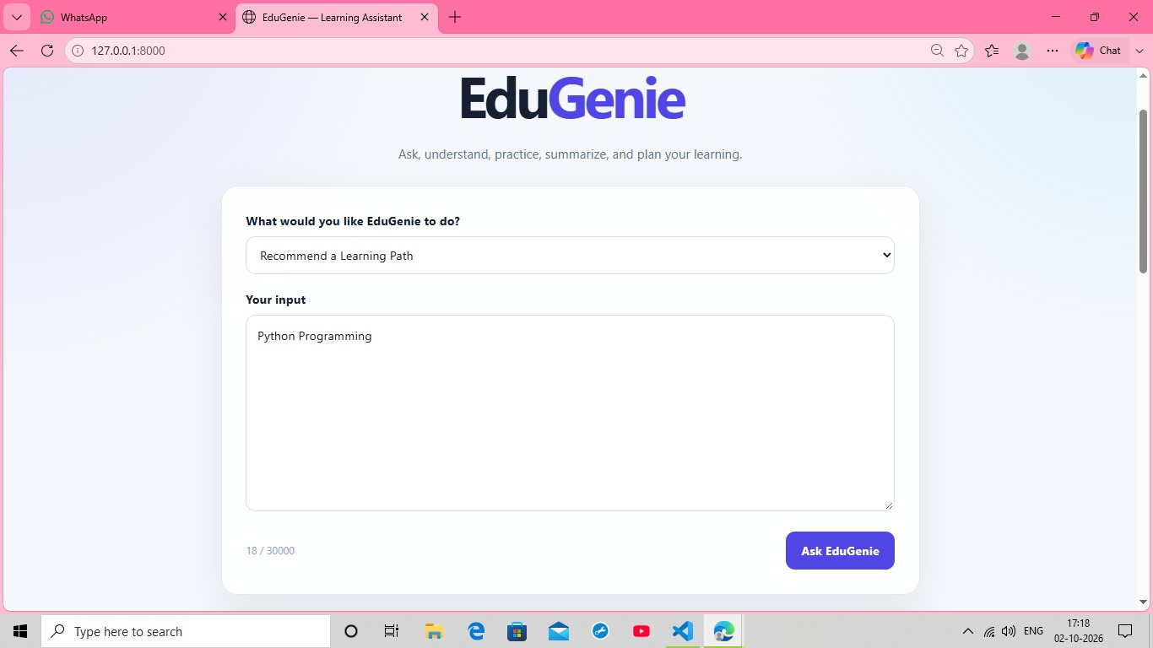
Recommend a Learning Path – Input Screen
Learning Path Result
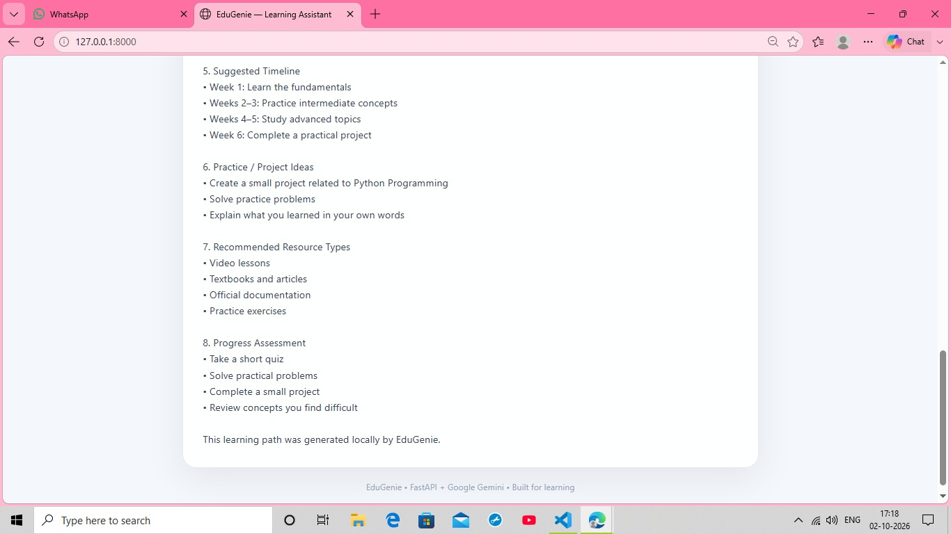

6. Project Testing Phase
The testing phase verifies the main workflows from user input through generated output.

Phase Details
- Test concept explanation with Photosynthesis.
- Test question answering with an educational question.
- Test quiz generation and verify the generated options.
- Select quiz answers and verify correctness feedback.
- Test text summarization using educational content.
- Test learning-path generation using Python Programming.
- Verify that long results can be scrolled and reviewed.
- Verify that generated results include the expected content and controls.

Related Screenshots
Explain a Concept – Generated Result
Ask a Question – Generated Explanation
Generated Quiz Questions
Quiz Answer Feedback
Local Summary Result
Learning Path Result
Learning Path Timeline, Practice Ideas, Resources, and Assessment
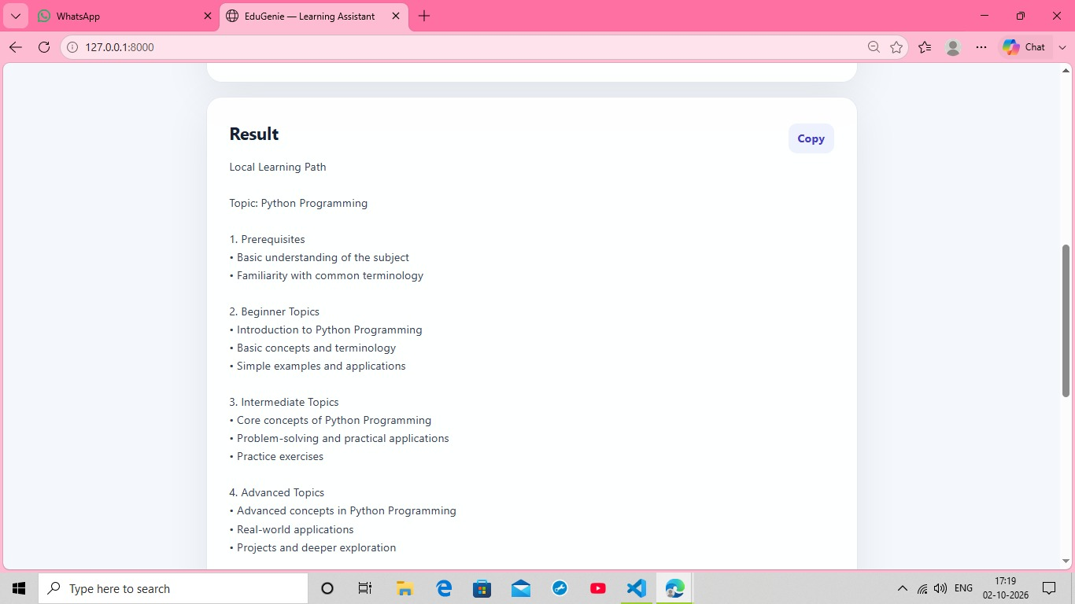

7. Project Documentation Phase
The documentation phase records the project idea, requirements, design, implementation, testing evidence, and demonstrated outputs.

Phase Details
- Document the purpose and objectives of EduGenie.
- Record the eight project-development phases.
- Include screenshots as visual evidence of the implemented features.
- Document the main input and result screens.
- Record quiz feedback, summary output, and learning-path output.
- Prepare the documentation for project review, evaluation, and presentation.

Related Screenshots
Explain a Concept – Input Screen
Explain a Concept – Generated Result
Ask a Question – Input Screen
Ask a Question – Generated Explanation
Step-by-Step Explanation and Intuition
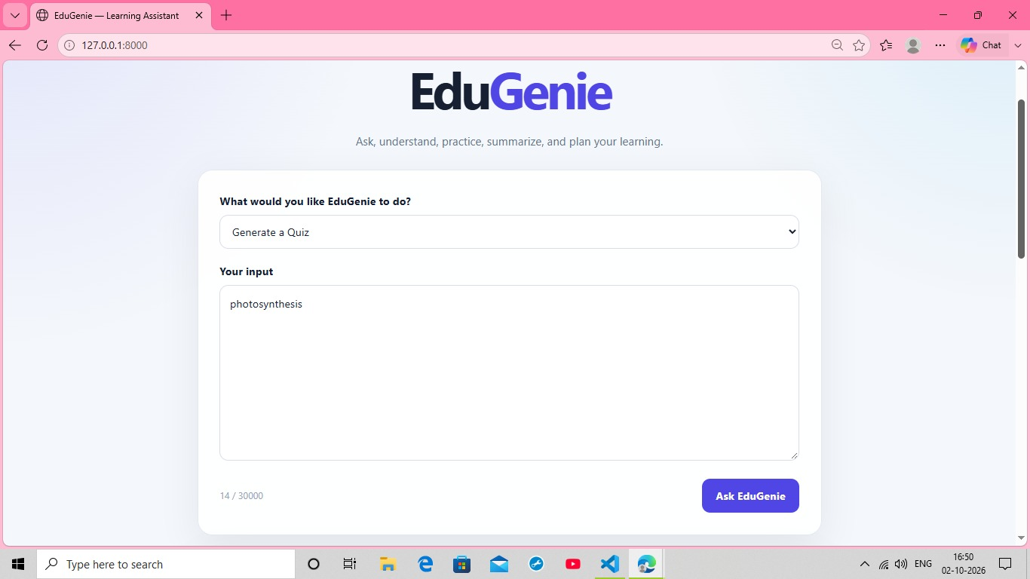
Example and One-Sentence Recap
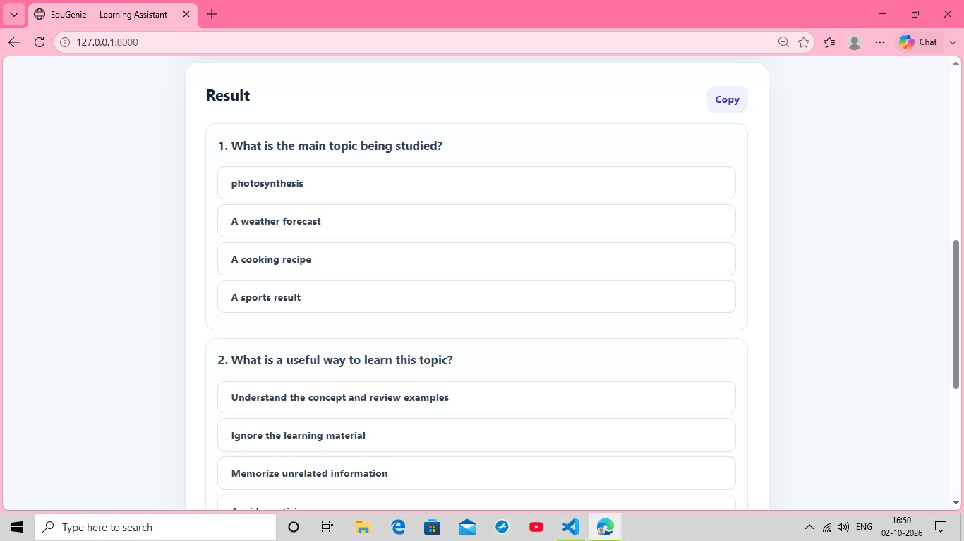
Generate a Quiz – Input Screen
Generated Quiz Questions
Quiz Answer Feedback
Quiz Practice and Correctness Feedback
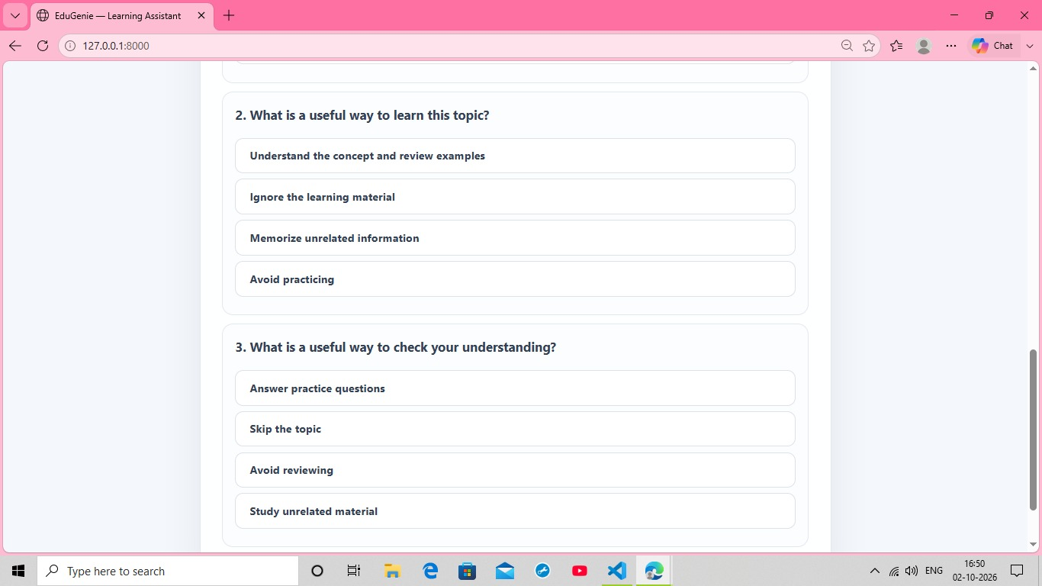
Summarize Text – Input Screen
Local Summary Result
Recommend a Learning Path – Input Screen
Learning Path Result
Learning Path Timeline, Practice Ideas, Resources, and Assessment

8. Project Demonstration Phase
The demonstration phase presents the working application and shows how a learner interacts with each major feature.

Phase Details
- Open the EduGenie application in the browser.
- Demonstrate Explain a Concept using Photosynthesis.
- Demonstrate Ask a Question and show the generated explanation.
- Demonstrate Generate a Quiz and show answer feedback.
- Demonstrate Summarize Text and show the local summary.
- Demonstrate Recommend a Learning Path using Python Programming.
- Explain how each feature supports a different part of the learning process.

Related Screenshots
Explain a Concept – Input Screen
Explain a Concept – Generated Result
Ask a Question – Input Screen
Ask a Question – Generated Explanation
Step-by-Step Explanation and Intuition
Example and One-Sentence Recap
Generate a Quiz – Input Screen
Generated Quiz Questions
Quiz Answer Feedback
Quiz Practice and Correctness Feedback
Summarize Text – Input Screen
Local Summary Result
Recommend a Learning Path – Input Screen
Learning Path Result
Learning Path Timeline, Practice Ideas, Resources, and Assessment

Final Conclusion
The screenshots provide visual evidence for the EduGenie development process, from the main learning interface through concept explanation, question answering, quiz generation and feedback, text summarization, and learning-path recommendation. Together with the eight phase descriptions, they document the project from ideation through final demonstration.

