1. Manager Home :

- After initial login, the valid user name is sent to route using redux API flow.

- In server, using ORM Model the get manager list if fetched based on the user name through sagas and reducer.

- The ManagerHOC file connects the request data, to the API and stores the result data in reducer state.

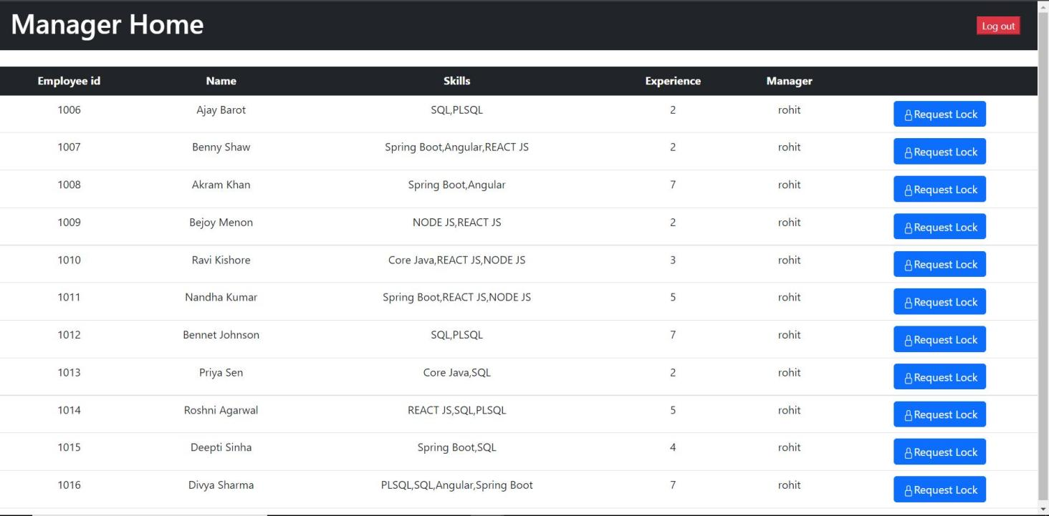

On Request Lock pop up, the employee id and message request are updated in database using redux API call.

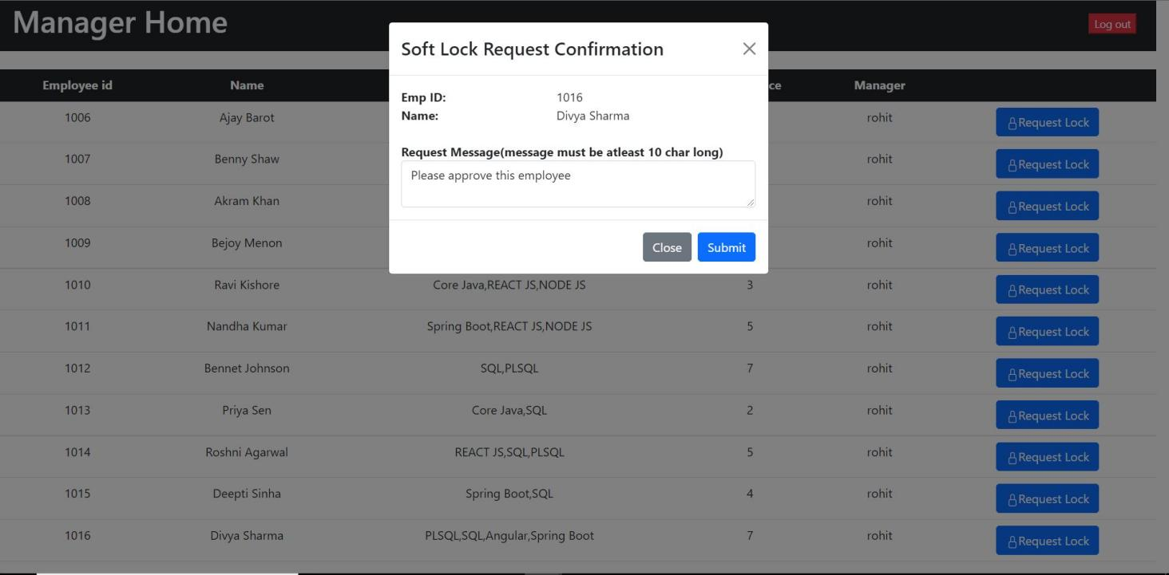

1. WFM Manager Home:

- The requested employee details are fetched for the logged-in WFM manager based on redux flow and after changing the employee status the data is updated on the database using WFM_ManagerHOC.

