**IDEA TO PRODUCT DEVELOPMENT - MSME**

**IDEA HACKATHON 4.0**

**Name : Abinaya A**

**Category : Student**

**Institution Name with Place : Anna University Regional Campus, Coimbatore**

**District and City : Coimbatore,Navavoor**

**Mobile No : 6379076960**

**AI-Driven Autonomous Filter Drones for Marine Waste Collection and Pollution Prevention**

# A. Details of Idea/Innovation

## 1. Title of proposed idea/innovation

AI-Driven Autonomous Filter Drones for Marine Waste Collection and Pollution Prevention

## 2. Idea Sector (Select from the SDGs)

Sustainable Development Goal 14: Life Below Water

## 3. Whether the idea involves use of existing intellectual property or not?

No, this idea does not involve existing intellectual property.

## 4. Briefly explain newness/uniqueness of the innovation

The innovation introduces AI-driven autonomous drones that mimic marine life, specifically designed to clean pollution without harming ecosystems. Unlike traditional waste collection methods, these drones operate independently in swarms, using real-time data to optimize their waste collection strategies.

## 5. Concept & Objective

The concept is to deploy autonomous drones powered by renewable energy to collect marine waste efficiently. The objective is to reduce marine pollution, particularly plastics and oils, while promoting sustainability through eco-friendly technology.

## 6. Specify the potential areas of application in industry/market in brief.

* Marine pollution control
* Waste management
* Environmental monitoring
* Marine ecosystem restoration

## 7. Briefly provide the market data for the potential idea/innovation.

The global marine waste management market is projected to grow significantly, with increasing awareness of marine pollution issues. Investment in technologies for waste collection and recycling is rising, indicating a strong market potential for innovations like AI-driven drones.

## 8. Current Development Status of innovation.

The innovation is currently in the conceptual phase, with initial designs and AI algorithms being developed for the prototype.

## 9. Expected time of completion of idea

The expected time for the completion of the prototype and initial testing is approximately 10 months.

# B. Financial Requirements (Activity-wise Break-up)

**Budget Breakdown**

1. **Research and Development (R&D): ₹2,00,000**
   * **Prototyping and Design:**
     + Design of drone structure and filtration system.
     + Prototyping with biodegradable materials.
2. **Materials and Components: ₹3,00,000**
   * **Biodegradable and Recycled Materials: ₹1,50,000**
     + **Bioplastics:** (e.g., PLA, PHA) for drone bodies.
     + **Recycled Ocean Plastics:** (e.g., HDPE, PET) for structural parts.
   * **Micro-Filtration System: ₹1,00,000**
     + **Nylon/Polypropylene Nets:** For capturing debris.
   * **Solar Panels and Energy Systems: ₹1,00,000**
     + **Flexible Solar Panels:** For energy collection.
     + **Hydrokinetic Turbines:** For additional power.
3. **Technology Development: ₹2,50,000**
   * **AI Software Development: ₹2,00,000**
     + **Machine Learning Algorithms:** For pollution detection.
   * **Communication Systems: ₹50,000**
     + **RF Modules:** For data transmission.
4. **Pilot Testing and Deployment: ₹1,50,000**
   * **Field Testing Equipment: ₹1,00,000**
     + **Monitoring Equipment:** For data collection.
   * **Operational Costs: ₹50,000**
     + Fuel and maintenance during testing.
5. **Waste Management Partnerships: ₹50,000**
   * **Partnership Development:** Engaging recycling facilities and NGOs.
6. **Marketing and Awareness Campaigns: ₹50,000**
   * **Outreach and Promotion:** Digital campaigns and community engagement.

**Total Estimated Budget: ₹10,00,000**

## 5. Please give name of other Faculty/Students/Entrepreneurs associated with this project/idea, if any.

**Students**

Abinaya A

Janet priya A

Apsara A

Subramaniya siva

# C. Summary of the Idea

## 1. (a) Is it a new concept?

Yes, it is a novel approach to marine waste collection utilizing AI and autonomous drone technology.

## 2. (b) Prior art on the concept/Literature Survey, if any.

Research on autonomous marine drones exists; however, this specific application focusing on AI-driven swarm technology for pollution cleanup is unique.

## 3. Main Problem Being Addressed in the Project

The project addresses the growing issue of marine pollution, particularly from plastics and oils, which threaten marine ecosystems and biodiversity.

## 4. Background for getting the idea?

a. Who is it for?  
Marine ecosystems and communities affected by pollution.

b. What will it do?  
Efficiently collect waste without harming marine life.

c. Any unique features? Explain?  
Drones operate autonomously in swarms, powered by renewable energy, with real-time communication for optimized waste collection.

## 5. How simple or complex will the idea’s execution or implementation be? What are the risk factors involved in executing the idea?

Implementation involves complexity in AI programming, drone construction, and testing in marine environments. Risk factors include technological failures, environmental challenges, and regulatory compliance.

## 6. How soon could the idea be put into operation? Technology Readiness Level (TRL) of prototype.

The prototype can be operational within 12 months, aiming for a TRL of 6 by the end of development.

## 7. How much investment would you need for prototyping of the Idea?

An estimated investment of ₹14,10,000 is required for prototyping.

## 8. (a) How do you intend to protect your idea (i.e., your intellectual property or IP)? Status of IPR (If any)

IP protection strategies will include patent applications for the unique technology and design aspects of the drones.

## 9. How is this project made and used?

The drones are constructed from biodegradable materials and designed to operate autonomously. They will utilize AI for navigation and pollution detection, collecting waste and docking for disposal at designated stations.

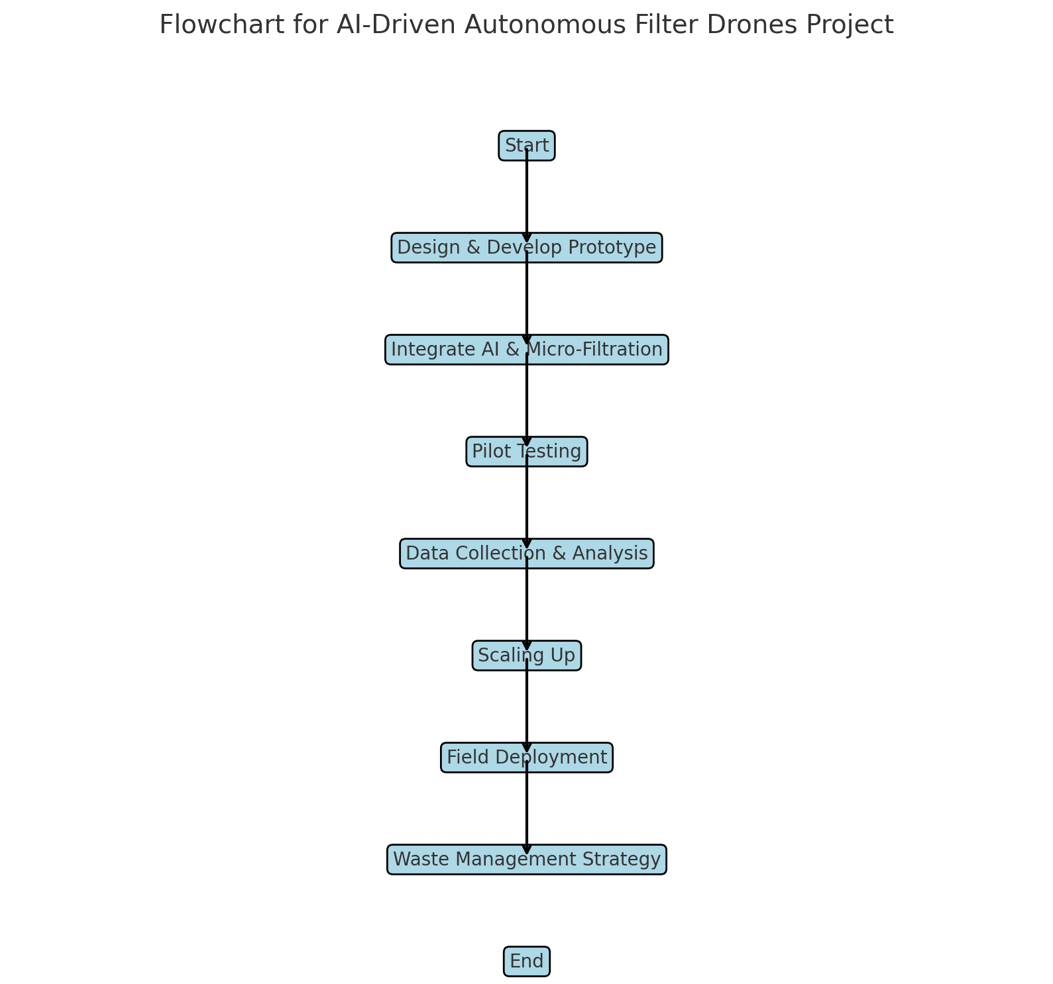

## 10. Conclusion / Summary:

The AI-Driven Autonomous Filter Drones present a groundbreaking approach to tackling marine pollution. By leveraging technology, these drones can efficiently collect waste, promoting sustainability and protecting marine ecosystems for future generations.