IDEA TO PRODUCT DEVELOPMENT - MSME

IDEA HACKATHON 4.0

Name : Abinaya A

Category : Student

Institution Name with Place : Anna University Regional Campus, Coimbatore

District and City : Coimbatore, Navavoor

Mobile No : 6379076960

AI BASED PRE-DISASTER ALERT SYSTEM FOR MOBILE PHONE

# Details of Idea/Innovation

## Title of Proposed Idea/Innovation:

AI-Based Pre-Disaster Alert System for Mobile Phones

## Idea Sector (Select from the SDGs):

Sustainable Cities and Communities (SDG 11) / Climate Action (SDG 13)

## Whether the Idea Involves Use of Existing Intellectual Property or Not?:

No, this idea is based on original concepts and data integration from publicly available sources.

## Briefly Explain Newness/Uniqueness of the Innovation:

This innovation combines real-time sensor data, machine learning algorithms, and a user-friendly mobile app to provide timely alerts for disasters. Unlike existing systems, it focuses on local community needs and integrates various environmental data sources.

## Concept & Objective:

The objective is to create a mobile application that alerts users about impending disasters using AI algorithms that analyze sensor data. The system aims to enhance community preparedness and response to disasters.

## Specify the Potential Areas of Application in Industry/Market in Brief:

Disaster Management Agencies, Local Government and Municipalities, NGOs focused on disaster response, Insurance companies assessing risk and claims.

## Briefly Provide the Market Data for the Potential Idea/Innovation:

The global disaster management market is projected to grow to $650 billion by 2027, with a significant push for technological innovations in disaster preparedness and response.

## Current Development Status of Innovation:

Conceptual stage; preliminary research on sensor technologies and machine learning models has been conducted. Prototype development is planned.

## Expected Time of Completion of Idea:

12-18 months for full development, testing, and deployment.

# Financial Requirements (Activity-Wise Break-Up)

## Technology-related Expenditure:

Sensors: ₹3.00 - 5.00 Lakh

Machine Learning Development: ₹2.00 - 3.00 Lakh Mobile Application Development: ₹3.00 - 4.00 Lakh

Miscellaneous (Electricity, Calibration, etc.): ₹1.00 Lakh

Total: Max: ₹10 Lakhs

## 2. Charges for Mentor/Handholding Supporting Team:

Max: ₹3 Lakhs

## 3.Travelling Expenses or Any Other Item Not Covered:

Max: ₹2 Lakhs

## 4.Total Idea/Project Cost:

Total: ₹15 Lakhs

## 5. Please Give Name of Other Faculty/Students/Entrepreneurs Associated with This Project/Idea, if Any:

Students

Janet Priya A

Apsara A

Subramaniya siva

# Summary of the Idea

## 1. (a) Is it a new concept?

Yes, it integrates multiple technologies and focuses on real-time disaster alerts.

## 2. (b) Prior Art on the Concept/Literature Survey, if Any:

Research on AI in disaster management and mobile alert systems exists, but this specific combination and local focus is innovative.

## 3.Main Problem Being Addressed in the Project:

Lack of timely disaster alerts leads to insufficient preparedness, resulting in increased damage and loss of life during disasters.

## 4.Background for Getting the Idea:

* 1. Who is it for?

Communities prone to natural disasters.

* 1. What will it do?

Provide real-time alerts to prepare individuals and communities for impending disasters.

* 1. Any unique features?

Integration of diverse sensor data for comprehensive alerts and a user- friendly app for community engagement.

## 5.How Simple or Complex Will the Idea’s Execution or Implementation Be? What are the Risk Factors in Executing Idea?

The execution will be moderately complex due to the need for sensor integration, data processing, and community engagement. Risks include sensor reliability, data privacy, and user adoption rates.

## 6.How Soon Could the Idea Be Put into Operation? Technology Readiness Level (TRL) of Prototype:

The system could be operational within 12-18 months. Current TRL is 2-3 (conceptual and experimental).

## 7. How Much Investment Would You Need for Prototyping of the Idea?

Total prototyping cost estimated at ₹10-15 Lakhs.

## (a) How Do You Intend to Protect Your Idea (i.e., Your Intellectual Property or IP)? Status of IPR (If Any):

Seek patents for unique algorithms and processes developed. Maintain confidentiality for proprietary technology.

## (b) Related Background:

Existing technologies include various disaster alert systems, but most do not leverage real-time environmental data integration and AI for localized alerts.

## How is This Project Made and Used:

The project involves installing sensors, collecting data, processing it through machine learning algorithms, and disseminating alerts via a mobile application. Users will receive notifications based on their location and preferences.

## Block Diagram/Flow Chart/Circuit Diagram/Pictures:

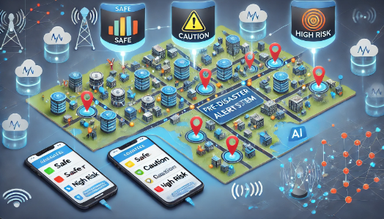

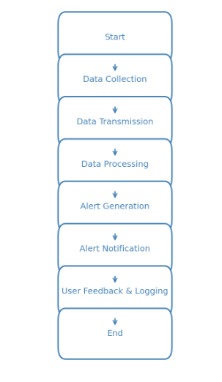

1. **Conclusion / Summary:**

The AI-Based Pre-Disaster Alert System aims to empower communities through timely disaster alerts, significantly improving preparedness and response capabilities, ultimately saving lives and reducing damage. With the projected budget and careful execution, the project has the potential for meaningful impact.