Reading CSV file in R using import dataset

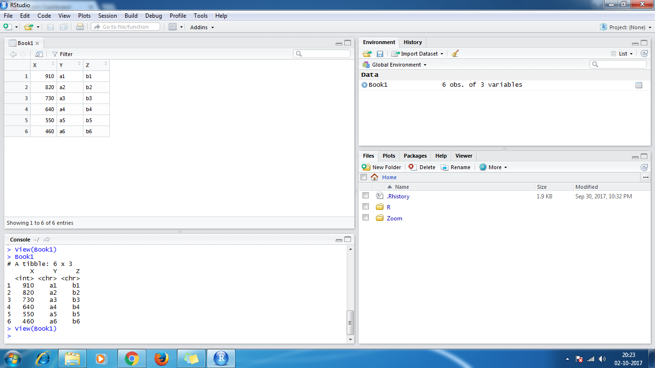

Reading CSV .xlsx in R using import dataset



Reading .txt file in R using using below code

read.table("D:\\DataAnalytics\\assignment15.txt")

