SecureBank Mobile
A Self-Directed Agile Simulation Project
Scrum Master Portfolio Case Study

Project Overview
SecureBank Mobile is a self-directed simulation project built to demonstrate hands-on Scrum Master skills using Jira, Confluence, and Python. The project simulates a mobile banking application release, covering the full Scrum lifecycle: backlog creation, sprint planning, active sprint facilitation, mid-sprint scope management, sprint review, retrospective, and custom reporting.
This project was built to bridge a background in mainframe QA testing with Certified Scrum Master (CSM) training, providing concrete, demonstrable artifacts rather than theoretical framework knowledge.

Product Backlog
The product backlog was structured into 4 epics covering the core functionality of a banking app: User Authentication & Security, Fund Transfer & Payments, Fraud Detection Alerts, and Account Dashboard & Statements. Each of the 24 user stories includes story point estimates (Fibonacci scale) and Given/When/Then acceptance criteria.
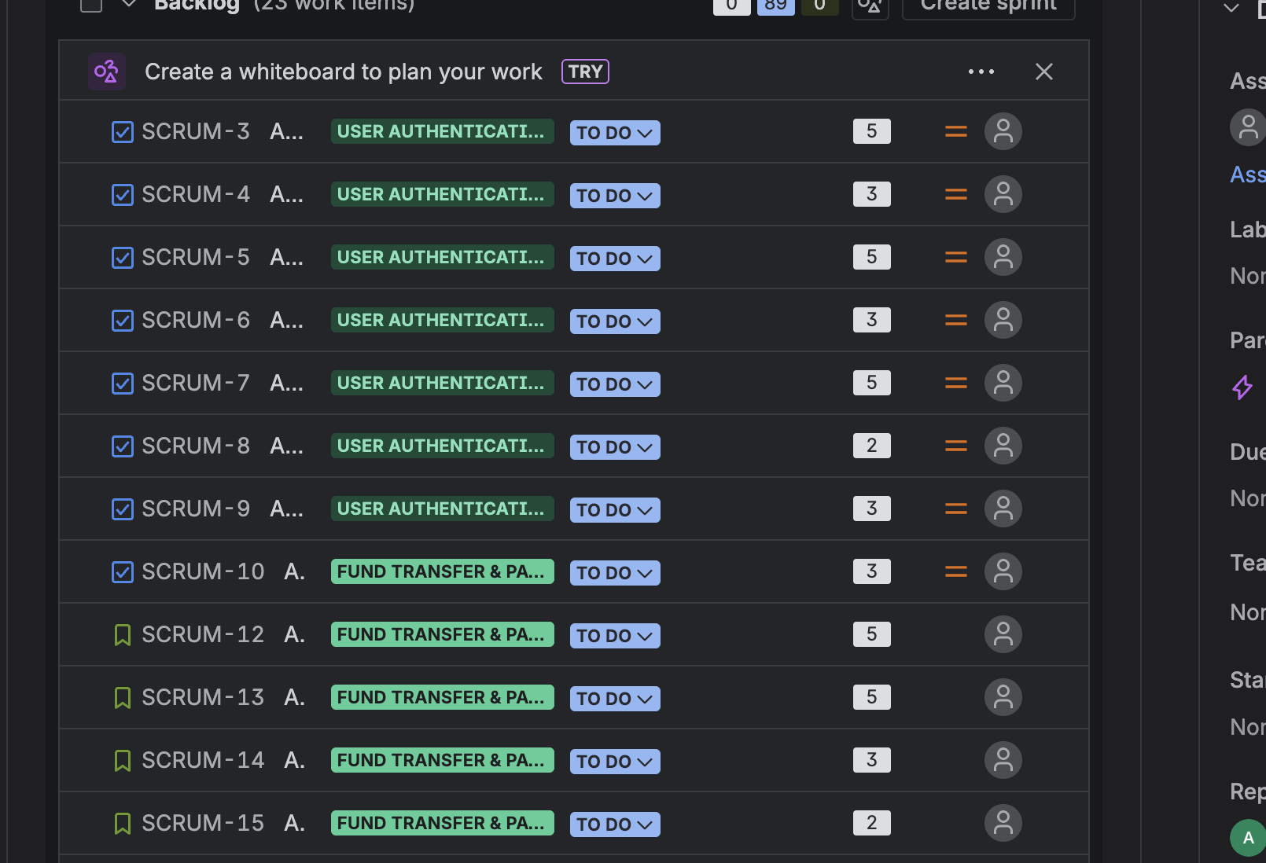
Full product backlog in Jira — 4 epics, 24 stories, story points assigned

Sprint 1 Planning
Sprint 1 focused on delivering core authentication functionality first, reflecting a dependency-first prioritization approach — security features were treated as a prerequisite for payment and fraud features built in later sprints.
Metric | Value
Sprint Length | 2 weeks (10 working days)
Team Composition | 5 Developers, 2 QA, 1 Product Owner
Estimated Capacity | 25–30 story points (first sprint, no prior velocity)
Committed Points | 26 story points (7 stories)

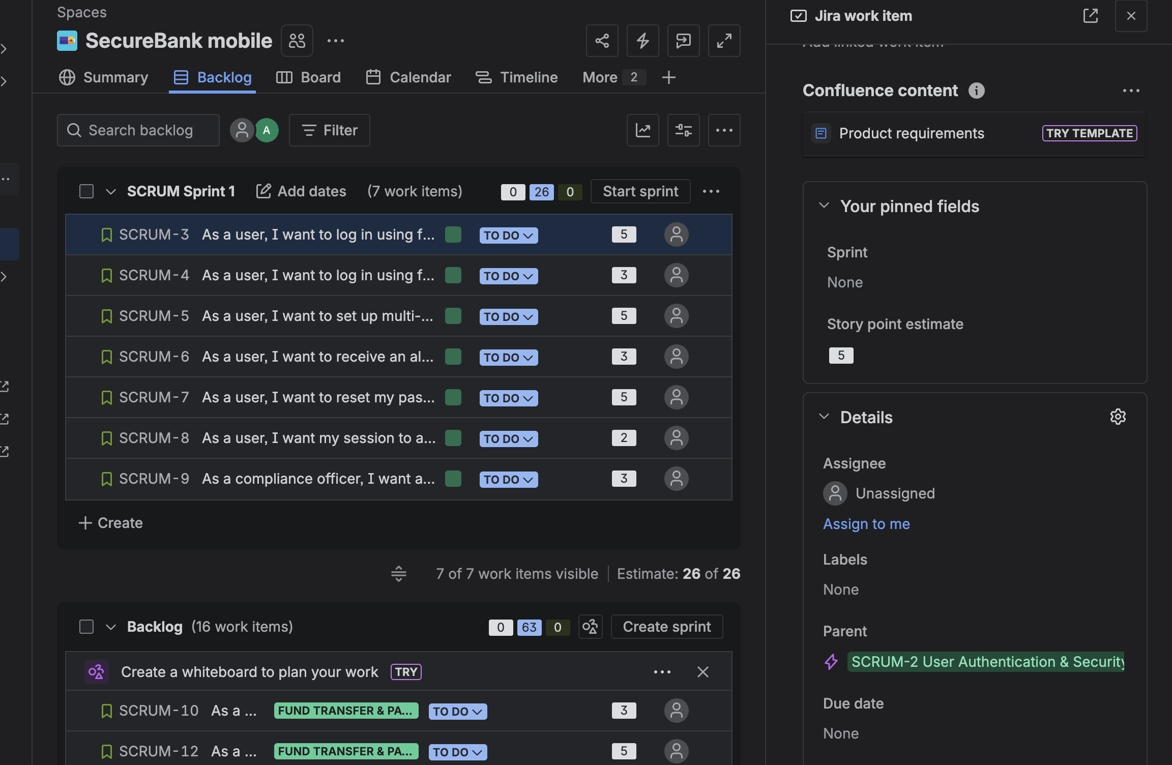
Sprint 1 backlog — 7 stories from the Authentication epic, 26 committed points

Mid-Sprint Scope Management
Partway through Sprint 1, a critical fraud-detection requirement was escalated by the Product Owner: flagging logins from unrecognized countries. As Scrum Master, I facilitated a scope discussion to protect the sprint goal without exceeding team capacity.
Resolution: SCRUM-6 (New Device Alert, 3 points — overlapping scope, lower urgency) was moved back to the backlog to make room for the new requirement, keeping the sprint's committed points unchanged at 26.
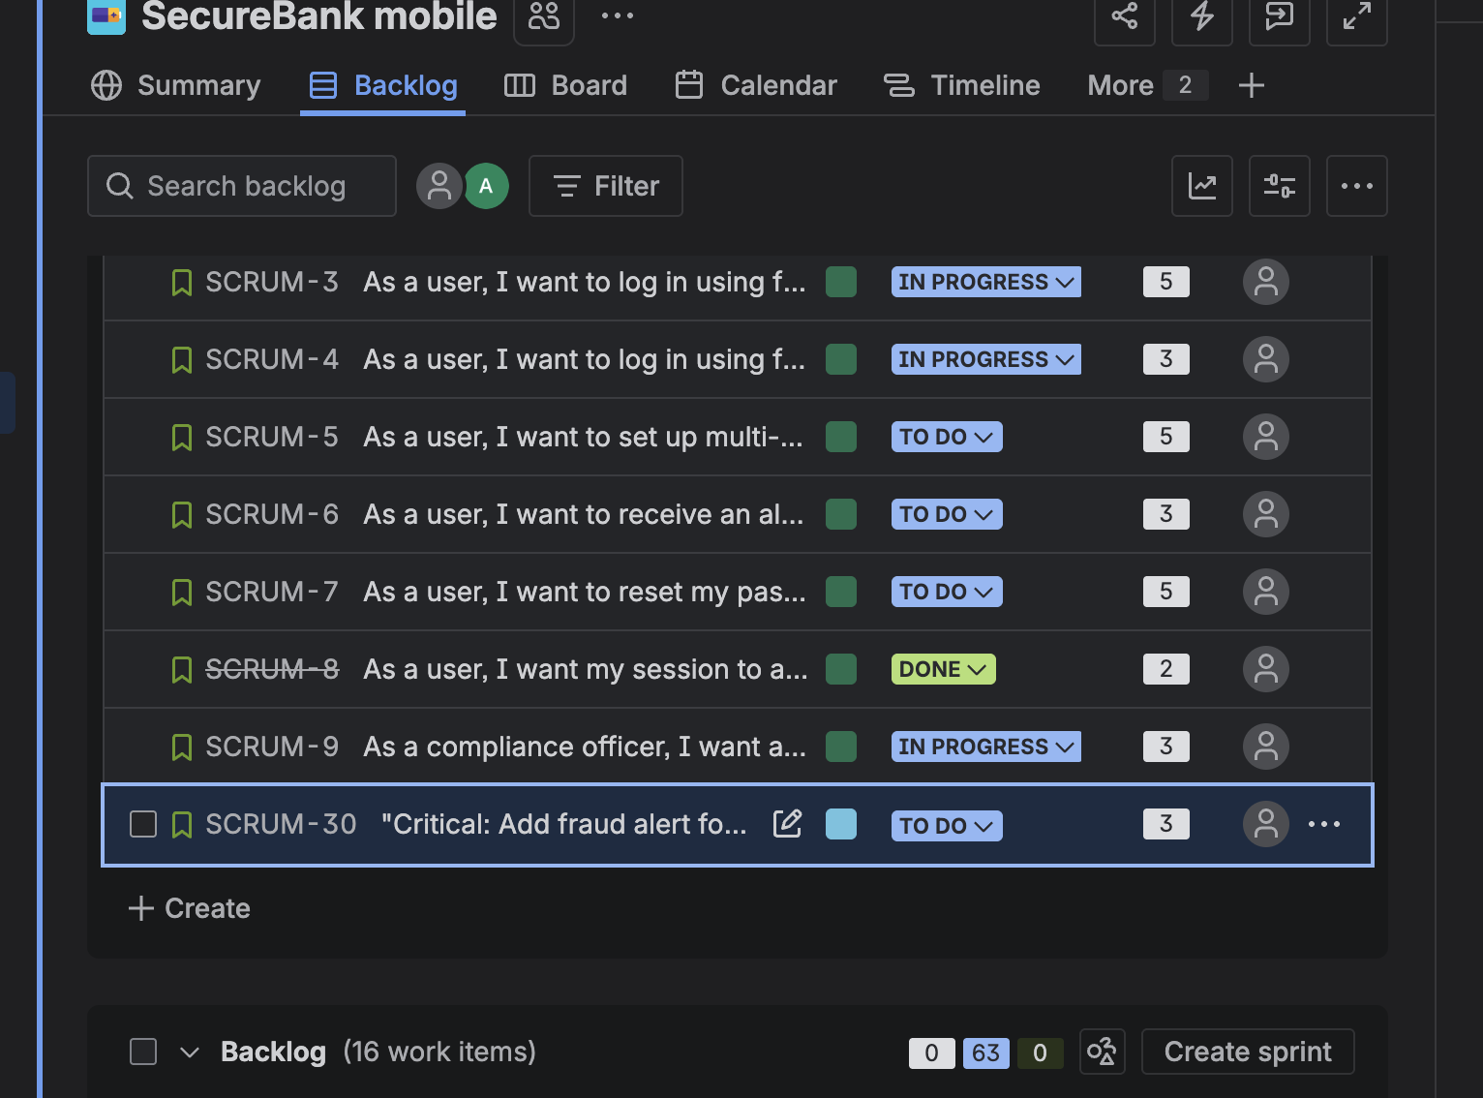
Sprint board mid-scope-change — new critical story added, lower-priority story swapped out

Sprint Completion & Results
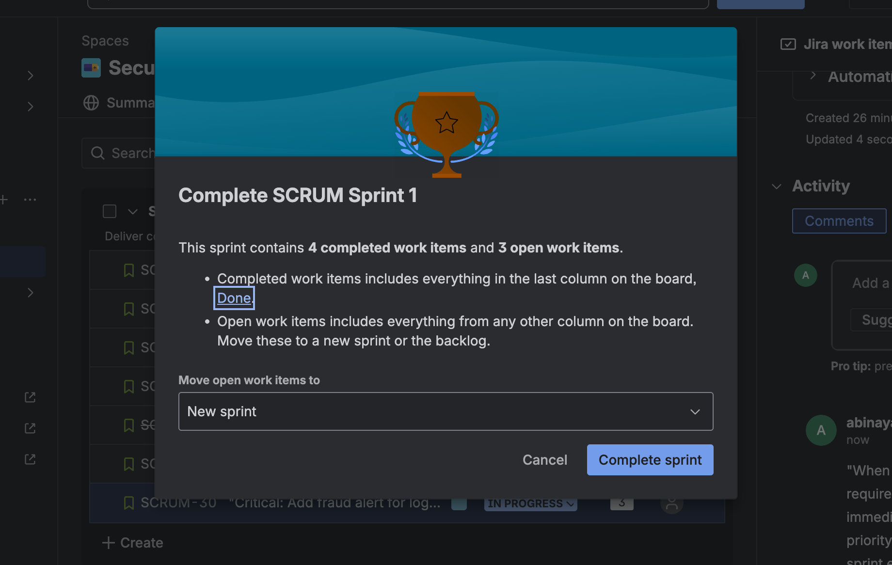
Sprint 1 completion summary — 4 completed items, 3 carried forward to Sprint 2
Metric | Result
Committed | 26 points (7 stories)
Completed | 13 points (4 stories)
Carried Over | 13 points (3 stories) → Sprint 2
Completion Rate | 50%

Custom Sprint Reporting (Python)
The team's Jira plan did not include native burndown or velocity reporting, so I built a lightweight Python reporting tool (matplotlib) to generate both charts directly from sprint data. The script is reusable — future sprints are added by updating a data dictionary and re-running the script.
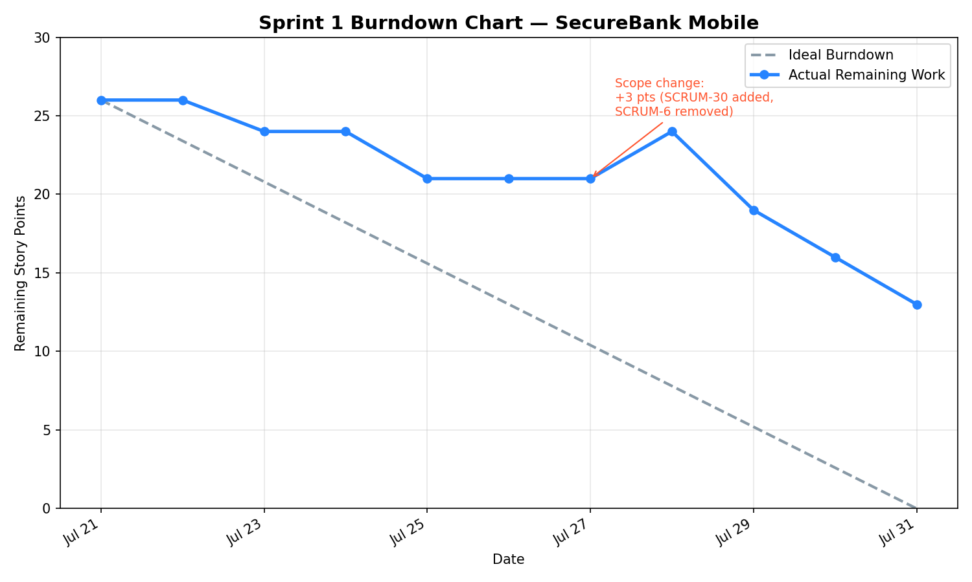
Sprint 1 burndown chart — ideal vs. actual, with the mid-sprint scope change annotated
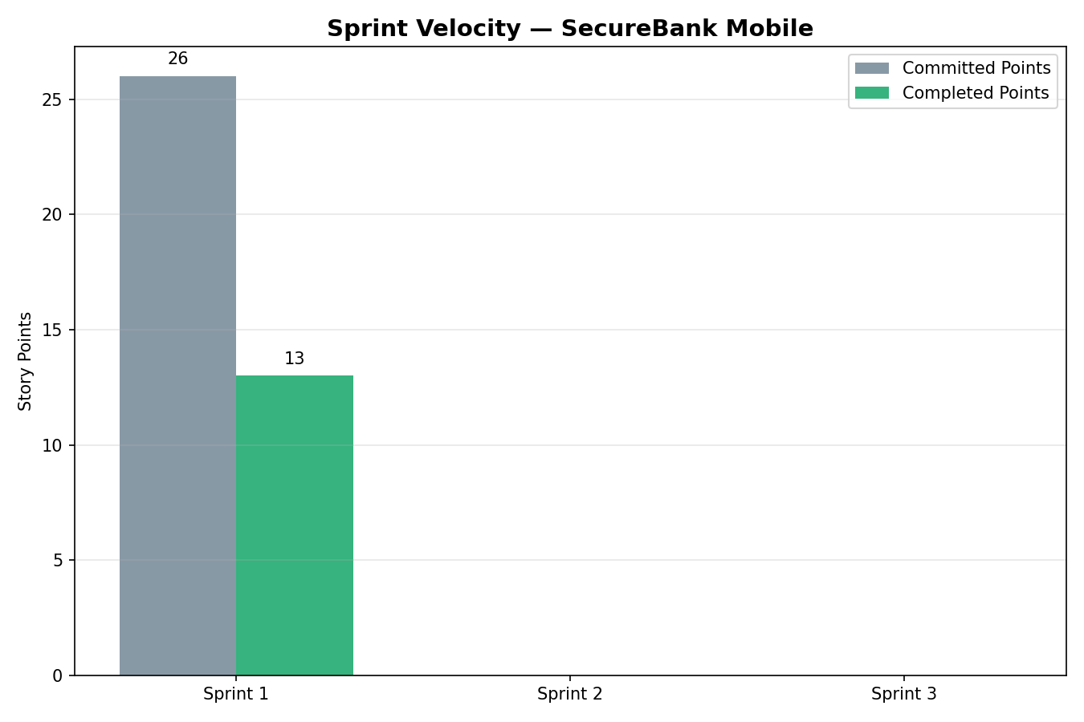
Sprint velocity chart — committed vs. completed points, extensible across future sprints

Retrospective Highlights
What went well:
- Core biometric authentication features (fingerprint, Face ID) delivered on schedule
- Team responded quickly to a mid-sprint critical security requirement without derailing the sprint goal
- Compliance-sensitive audit logging feature completed and verified
What didn't go well:
- Completion rate (50%) came in below the initial capacity estimate, largely due to the mid-sprint scope change
- Two originally planned stories (MFA setup, password reset) were not started
Action items carried into Sprint 2:
- Prioritize the 3 carried-over stories at the start of Sprint 2
- Reserve ~10% capacity buffer in future sprint planning to absorb urgent requirements
- Recalibrate Sprint 2 capacity using Sprint 1's actual velocity (13 points) instead of the initial estimate

Skills Demonstrated
- Sprint planning, backlog grooming, and story point estimation
- Facilitating mid-sprint scope trade-off decisions
- Sprint review and retrospective documentation
- Jira administration: epics, stories, sprints, and board management
- Confluence documentation for planning and review artifacts
- Python scripting for custom sprint metrics and reporting

Full backlog, planning docs, and reporting script available on request.

