Student Placement Data Analysis
Exploratory Data Analysis & Machine Learning Project Report

1. Project Overview
This project analyzes a dataset of 800 college students to understand the key academic, behavioral, and skill-based factors that influence campus placement outcomes. The workflow covers data generation, exploratory data analysis (EDA), and predictive modeling using machine learning classifiers to predict whether a student will be placed.
- Dataset size: 800 students, 18 features
- Target variable: Placement_Status (Placed / Not Placed)
- Additional target: Salary_LPA (for placed students only)
- Tools used: Python, Pandas, Seaborn/Matplotlib, Scikit-learn

2. Dataset Description
The dataset includes the following categories of features:
Category | Features
Academic | SSC_Marks, HSC_Marks, CGPA
Aptitude | IQ, Aptitude_Test_Score
Experience | Internships, Projects, Certifications, Work_Experience
Soft Skills | Communication_Skills, Extra_Curricular_Score
Risk Factors | Backlogs
Demographics | Gender, Branch
Support | Placement_Training
Targets | Placement_Status, Salary_LPA

3. Exploratory Data Analysis

3.1 Placement Distribution
The overall placement rate in the dataset is approximately 74%, giving a realistic but moderately imbalanced classification problem.
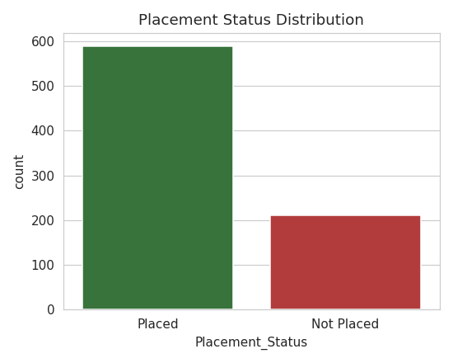
Figure 1: Placement Status Distribution

3.2 CGPA and Academic Performance
Students with higher CGPA show a clearly higher placement rate. The median CGPA of placed students is visibly higher than that of students who were not placed, confirming CGPA as one of the strongest academic predictors.
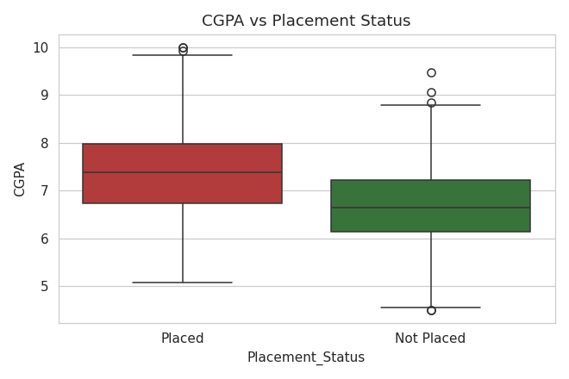
Figure 2: CGPA Distribution by Placement Status

3.3 Internship Experience
Students with more internships tend to have a higher chance of being placed, reflecting the value recruiters place on practical, hands-on experience.
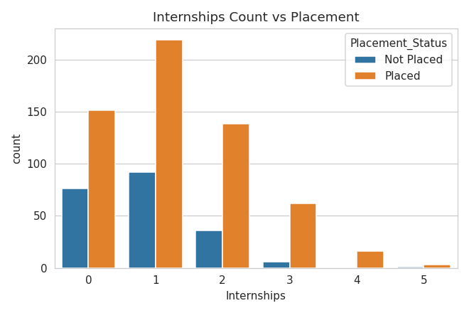
Figure 3: Internship Count vs Placement

3.4 Correlation Analysis
A correlation heatmap was generated across all numeric features to identify relationships and multicollinearity. CGPA, Communication Skills, and Certifications show the strongest positive correlation with placement, while Backlogs shows a negative correlation.
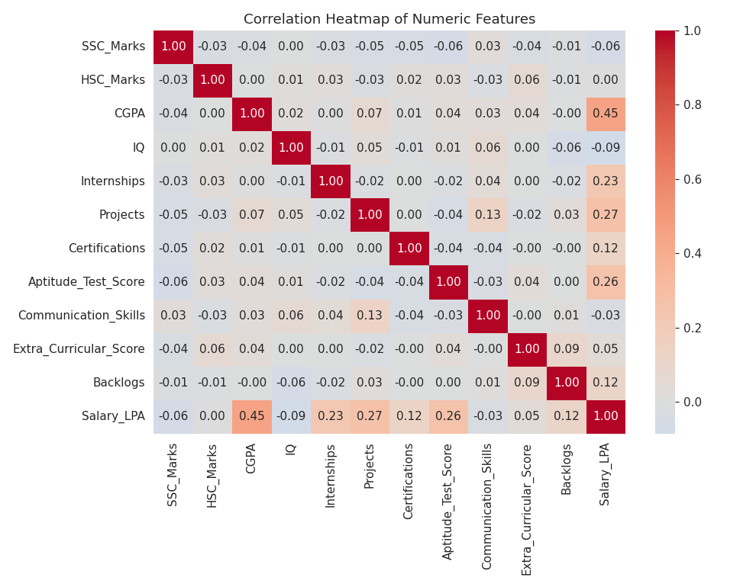
Figure 4: Correlation Heatmap of Numeric Features

3.5 Branch-wise Placement Rate
Placement rates vary across engineering branches, with CSE and IT branches generally showing higher placement percentages, consistent with current industry hiring trends.
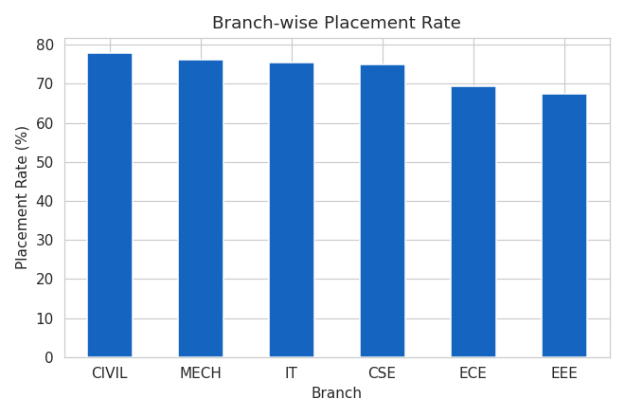
Figure 5: Branch-wise Placement Rate

3.6 Communication Skills
Communication skill ratings are noticeably higher among placed students, suggesting soft skills play a meaningful role in placement outcomes alongside academics.
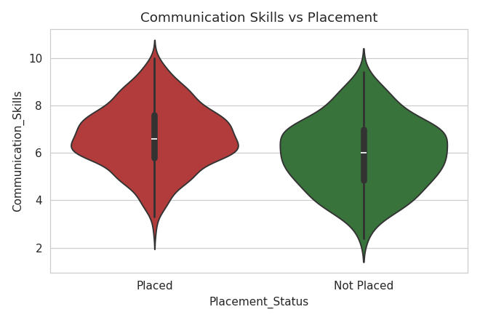
Figure 6: Communication Skills vs Placement

3.7 Salary Distribution
Among placed students, salary offers (in LPA) follow a roughly normal distribution, with most offers concentrated between 4 and 8 LPA and a smaller number of high-paying outliers.
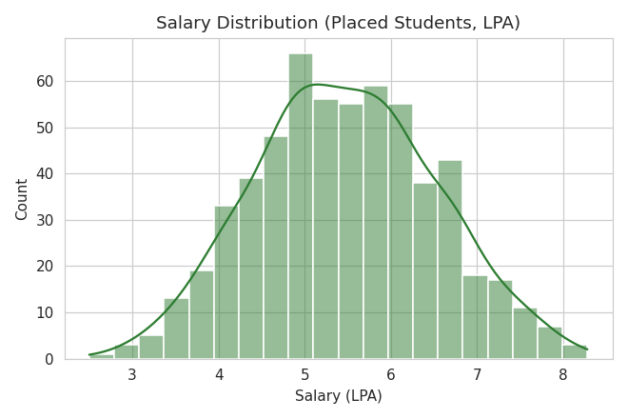
Figure 7: Salary Distribution (Placed Students)

3.8 Impact of Backlogs
Placement rate decreases sharply as the number of academic backlogs increases, confirming backlogs as a significant risk factor.
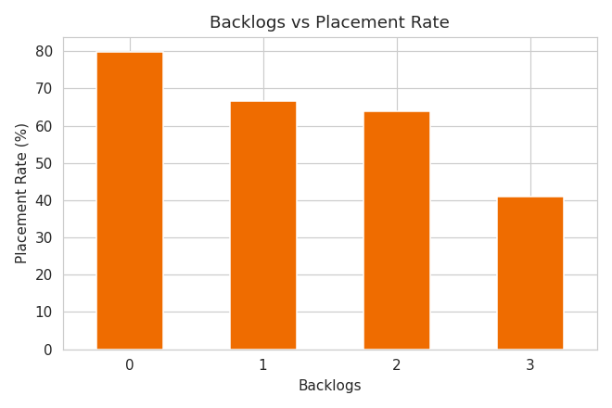
Figure 8: Backlogs vs Placement Rate

4. Predictive Modeling
Two classification models were trained to predict placement outcome: Logistic Regression (a linear baseline) and Random Forest (an ensemble model capable of capturing non-linear relationships). Data was split 80/20 into training and test sets with stratification on the target.

4.1 Model Performance Comparison
Model | Accuracy | ROC-AUC
Logistic Regression | 76.2% | 0.83
Random Forest | 79.4% | 0.77

Random Forest achieves higher overall accuracy, while Logistic Regression achieves a higher ROC-AUC, indicating strong and well-calibrated ranking of placement probability. In practice, either model provides a solid baseline; Logistic Regression is preferred when interpretability matters, while Random Forest is preferred when raw accuracy is the priority.

4.2 Confusion Matrices
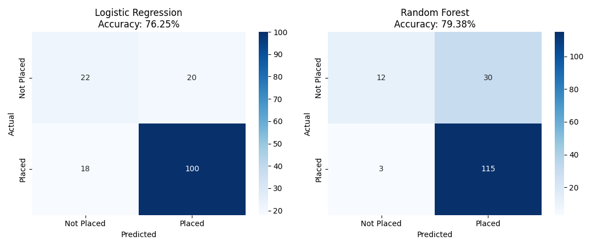
Figure 9: Confusion Matrices for Both Models

4.3 ROC Curve Comparison
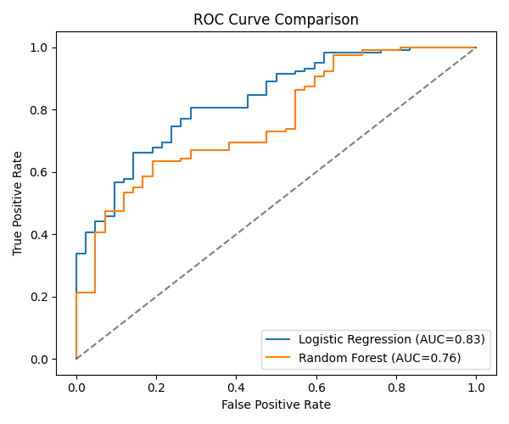
Figure 10: ROC Curve Comparison

4.4 Feature Importance
The Random Forest model's feature importance ranking confirms the EDA findings: CGPA, Communication Skills, Aptitude Test Score, IQ, and Backlogs are the top predictors of placement.
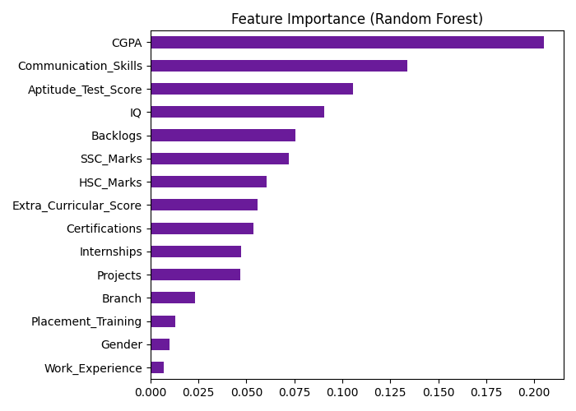
Figure 11: Feature Importance (Random Forest)

5. Key Insights
- CGPA is the single strongest predictor of placement outcome.
- Communication skills and aptitude scores meaningfully boost placement chances beyond academics alone.
- More internships, projects, and certifications correlate with a higher placement rate.
- Backlogs have a strong negative impact — students with 2+ backlogs see placement rates drop significantly.
- CSE and IT branches show the highest placement rates in this dataset.
- Salary offers for placed students cluster mainly between 4-8 LPA, with CGPA and internship count driving higher offers.

6. Conclusion & Recommendations
The analysis shows that placement success is driven by a combination of strong academic performance (CGPA), practical exposure (internships, projects, certifications), and soft skills (communication). Colleges and placement cells can use these insights to design targeted interventions:
- Provide focused academic support to students with backlogs early in the final year.
- Encourage internships and certification programs starting from the second year.
- Run structured communication and soft-skills training before placement season.
- Use the trained model to flag at-risk students for early, proactive placement counselling.

7. Project Files
File | Description
data/placement_data.csv | Synthetic student placement dataset (800 rows)
src/generate_data.py | Script that generates the dataset
src/eda_analysis.py | Exploratory data analysis + chart generation
src/model.py | ML model training and evaluation
charts/*.png | All EDA and model evaluation charts
data/model_results.csv | Model accuracy/AUC comparison

