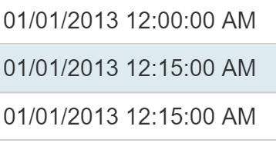

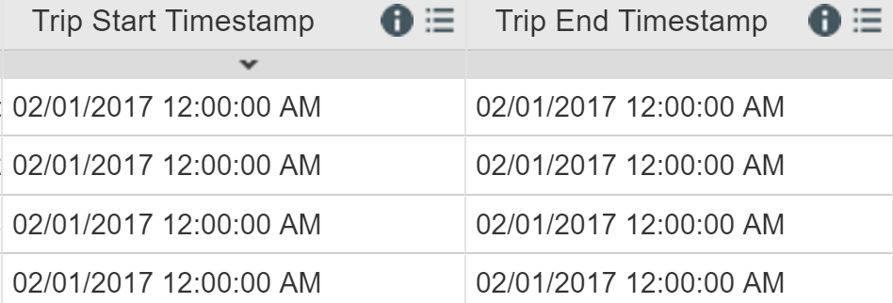

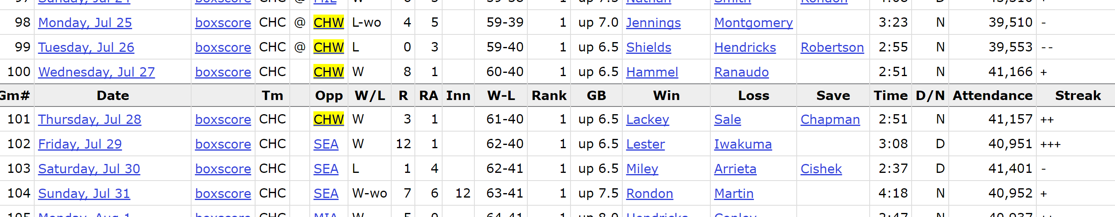

Cubs vs sox 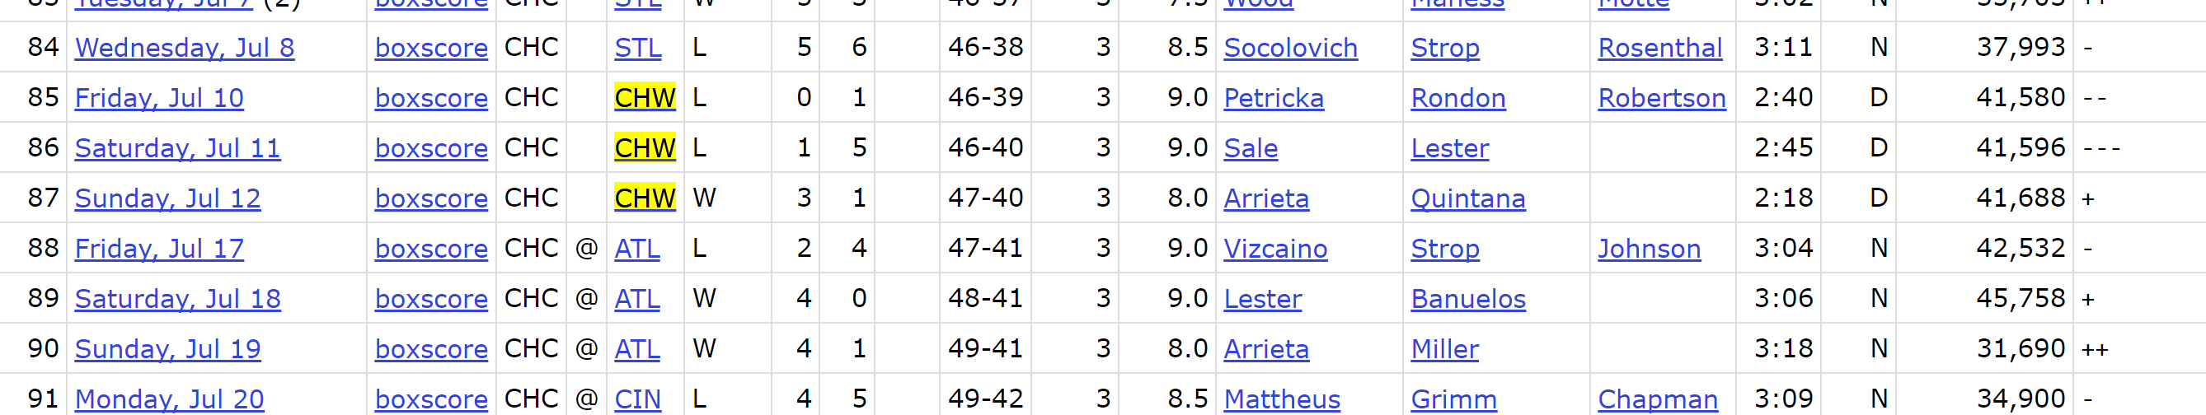

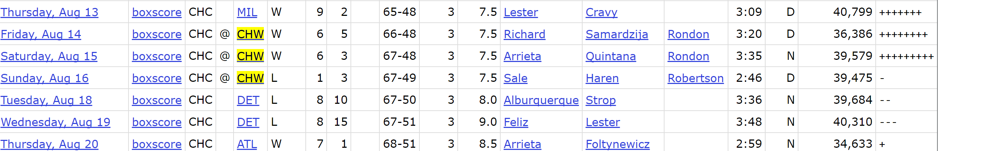

2013 data

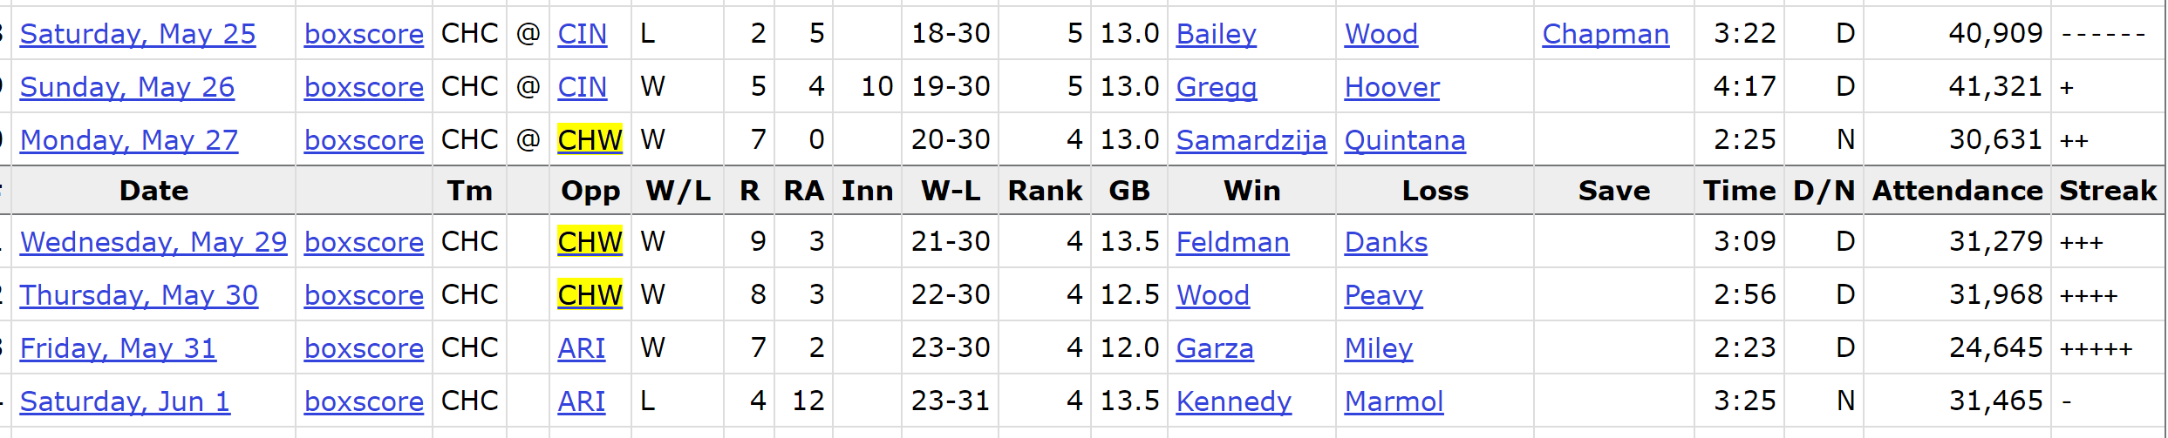

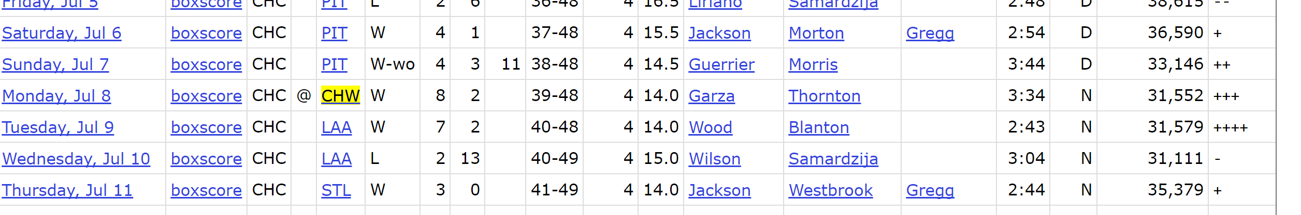

2014 data

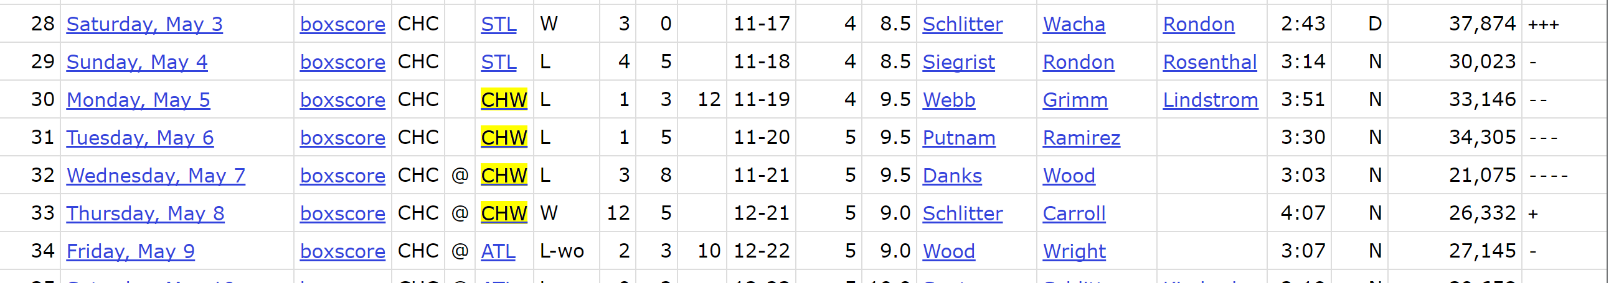

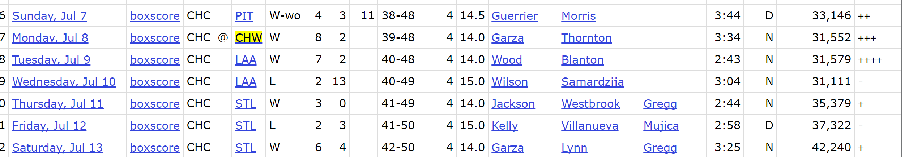

Lolapa

2014

2014  
1aug - 3aug  
2015  
jul31-aug2  
2016  
mar19-20  
2017  
mar25-26