**CHAPTER 1**

**INTRODUCTION**

**1.1 TELE MEDICINE**

Tele medicine is the process of transmitting medical information from one site to another via electronic communications to improve,maintain,or assist patients’ health status. “Tele health” is the term which is closely associated with Tele medicine which is often used to encompass a broader definition of remote health care that doesn’t always involve clinical services.Video conferencing,transmission of still images,e-health including patient portals,remote monitoring of vital signs,continuing medical education and nursing call centres are all considered part of Tele medicine and Tele health.

**1.2 TYPES OF TELE MEDICINE**

Tele medicine is practiced on the basis of two concepts:

a.Synchronous(Real time)

b.Asynchronous(Store-and-forward,Home Health)

**1.2.1 SYNCHRONOUS TELE MEDICINE**

Real time Tele medicine could be as simple as a telephone call or as complex as robotic surgery.It requires the presence of both parties at the same time and a communications link between them that allows a real time interaction to take place .Video-Conferencing equipment is one of the most common forms of technologies used in synchronous Tele medicine.There are also peripheral devices which can be attached to computers or the video-conferencing equipment which can aid in an interactive examination. For instance, tele-otoscope allows a remote physician to “see” inside a patient’s ear a tele-sthethoscope allows the consulting remote physician to hear the patient’s heart beat. Medical specialities conducive to this kind of consultation include psychiatry, family practice, internal medicine, rehabilitation, cardiology, paediatrics, obstretics, gynaecology,neurology,speech-language pathology and pharmacy.

**1.2.2ASYNCHRONOUS TELE MEDICINE**

Store-and-forward Tele medicine involves acquiring medical data(like medical images, bio signals etc) and then transmitting this data to a doctor or medical specialist at a convenient time for assessment offline.It does not require the presence of both parties at the same time.Dermatology,radiology and pathology are common specialities that are conducive to asynchronous Tele medicine.

Home health Tele medicine is undergone when the patient is in the hospital and he is placed under general observation after a surgery or other medical procedure,the hospital is usually losing a valuable bed and the patient would rather not be there as well.Home health allows the remote observation and care of a patient.Home health equipment consists of vital signs capture,video conferencing capabilities and patient stats can be reviewed and alarms can be set from the hospital nurse’s station,depending on the specific home health device.

**1.3 FUTURE OF TELE MEDICINE**

Personnel shortages and decreasing third-party reimbursement are significant drivers of technology-enabled health care in the industrialized world, particularly in the areas of home care and self-care. Technology has made it easy for doctors to detect various diseases. But it is restricted only to people in urban areas but Low cost Tele medicine made easy for people in rural areas with simple and standard healthcare infrastructure. Rapid growth in the availability of low-power, hand-held medical monitoring devices advanced the Tele medicine for poor and reduces travel costs by both parties for consultation, diagnosis, and follow up is the largest benefit.

**1.4 TELE CARDIOLOGY**

**1.4.1 INTRODUCTION**

Tele cardiology is a modern medical practice, which uses the power of telecommunications to achieve remote diagnosis and treatment of heart disease. This includes coronary heart disease, chronic and acute, as well as arrhythmias, congestive cardiac failure and sudden cardiac arrest.

In this situation, doctors and other healthcare providers use electrocardiographic data, which is transmitted remotely, in real time, for interpretation by a specialist. It enables specialist care to be accessed by people in remote locations. Advancing technology is making it easier and less expensive to set up wireless or satellite networks for this purpose, increasing their effectiveness and ease.

**1.4.2 LITERATURE SURVEY**

ECGs, or [electrocardiographs](https://en.wikipedia.org/wiki/Electrocardiography), can be transmitted using telephone and wireless. [Willem Einthoven](https://en.wikipedia.org/wiki/Willem_Einthoven), the inventor of the ECG, actually did tests with transmission of ECG via telephone lines. This was because the hospital did not allow him to move patients outside the hospital to his laboratory for testing of his new device. In 1906 Einthoven came up with a way to transmit the data from the hospital directly to his lab.

**1.4.3 TELE CARDIOLOGY-WORKING PRINCIPLE**

The practice of Tele cardiology depends upon the availability of a specialized device, which not only takes and records a 12-lead ECG in the primary care setting, but also transmits the ECG image in the form of a sound signal over the telephone line.

At the other end, the signalis converted back into an image on screen. After specialists interpret it, an oral report is quickly sent, while a written summary is emailed or faxed to the patient hub. All ECGs are stored in an electronic database at the Tele cardiology centre, to enable future comparison of ECGs for the same patient over time.

Single-lead ECG machines are available in the form of a watch-like device to enable quick monitoring when the patient needs it, while still at home. This allows for a better interpretation and diagnosis of the disease condition.

This device can store the images recorded, and transmit them once the patient reaches the GP’s office. The advantage is that the patient need not wait to reach the doctor’s office, but can record the ECG as and when symptoms are present.

**1.4.4 BENEFITS OF TELE CARDIOLOGY**

The primary use of Tele cardiology is the support, it gives to primary care practitioners in the area of correct diagnosis, thus empowering them to manage cardiac patients with increased confidence. This is good for the patient and thehealthcare system.

It also improves the clinical training of the average practitioner, by increasing the clinician’s level of knowledge at primary level. Thus it equips GPs to offer better care. This applies to the diagnosis and management of paediatric heart disease, chronic cardiac failure and emergency events like myocardial infarctions. It can cut down consulting time to a quarter, and afford high-quality care when it is most needed.Tele cardiology also helps enormously to reduce the percentage of missed cardiac events. For instance, the single-lead ECG device is more efficient at detecting or monitoring arrhythmias than a Holter machine, because it can be worn all the time, and because it can be easily switched on when the patient feels there is something wrong with the heartbeat. This helps to pick up arrhythmia, as well as to monitor them during the course of treatment.Tele cardiology is very useful for long-term monitoring of multiple coronary heart disease risk factors, such as hypertension or hypercholesterolemia. The results are comparable with those of face-to-face monitoring.

The availability of Tele cardiology has also been shown to dramatically cut down on the door-to-balloon time, which is the time that elapses between a patient’s hospital admission and angioplasty, when required. Tele cardiology makes a diagnosis to be made, and allows the required personnel to be prepared for the patient even before admission, cutting down on the time to surgery and preventing further muscle damage.

Tele cardiology devices are small and portable, which means they can be easily moved to the patient’s side to make a quicker and more accurate diagnosis. Tele cardiology has the proven ability to improve the quality of health care, increase cost-effectiveness and save lives.

It makes the diagnosis of acute coronary events faster and more convenient, increases access to specialist care, ensures greater efficiency of patient triage and management, and lowers the burden on secondary referral hospitals.

**1.5 BANDWIDTH**

A measure of the information carrying capacity of a communication channel, a practical limit to the size, cost and capability of a Tele medicine service.

**1.6 BLUETOOTH WIRELESS**

Bluetooth is an industrial specification for wireless personal area networks (PANs).Bluetooth provides a way to connect and exchange information between devices such as mobile phones, laptops, PCs, printers, digital cameras and video game consoles over a secure, globally unlicensed short range radio frequency. Bluetooth is also sometimes used for telemedicine application.

**1.7 BROADBAND**

Communications(e.g.,broadcast television, microwave and satellite) capable of carrying a wide range of frequencies;refers to transmission of signals in a frequency-modulated fashion, over a segment of the total bandwidth available, thereby permitting simultaneous transmission of several messages. Due to the spread spectrum modulation followed in the recent communication scenario ,the security and authenticity of the medical data transmitted is maintained.

**1.8 CLINICAL INFORMATION SYSTEM**

Relating exclusively to the information regarding the care of a patient, rather than administrative data, this hospital-based information system is designed to collect and organize data.

**1.9ELECTRONIC DATA INTERCHANGE(EDI)**

Electronic data interchange is an electronic communication method that provides standards for exchanging data via any electronic means. The process which allows to transmit the ECG signal from patient’s interface to doctor’s interface electronically via wireless technology.

**1.10 ELECTRONIC PATIENT RECORD**

An electronic form of individual patient information that is designed to provide access to complete and accurate patient data, alerts, reminders, clinical decision support systems, links to medical knowledge and other aids. It is the repository for active notations about a patients health.

**1.11HOME HEALTH CARE AND REMOTE MONITORING SYSTEM**

Home health care is care provided to individuals and families in their place of residence for promoting, maintaining or restoring health; or minimizing the effects of disability and illness, including terminal illness. Health care is delivered by health professionals. Healthcare systems are organizations established to meet the health needs of target populations.

**1.12INTERNET PROTOCOL**

The internet protocol(IP) is the protocol by which data is sent from one computer to another across a single network or a series of interconnected networks. Each computer on the internet has atleast one address that uniquely identifies it from all other computers on the internet.IP is a connection less protocol,which means that there is no established connection between the end points that are communicating. The vital sign are exchanged as datagrams, also known as data packets .

**1.13MEDICAL/NURSING CALL CENTER**

A call center is centralized office that answers incoming telephone calls from patients .Medical call centre has the technology to support patient information initiatives , enhance care coordination , and provide a seamless service that promotes a high dimension of patient centered care.

**1.14MOBILE TELE HEALTH**

Telehealth involves the distribution of health related services and information. Distribution is via electronic information and telecommunication technologies. It allows long distance patient/clinician contact and care, advice, reminders, education, intervention, monitoring and remote admissions. Telehealth includes two clinicians discussing a case over video conference ; a robotic ssurgery occurring through remote access ; physical therapy done via digital monitoring instruments ,live feed and application combinations.

**1.15TELEMONITORING**

Telemonitoring involves remotely monitoring patients who are not at the same locations . The patients vital sign results will be sent via GSM to the health care provider. It is the convenient way for patients to avoid travel.

Telemonitoring is the daily monitoring of vital sign including:

* Blood pressure
* Blood oxygen level
* Pulse
* Weight

**CHAPTER 2**

**LITERATURE REVIEW**

**2.1 AN INTEGRATED SYSTEM FOR HOME–CARE CARDIAC REHABILITATION**

Pisetta.V, Morganti.E, Mase.N, Marsili.I.A, Adami.A, Nollo.G(2016), IEEE,978-1-5090-1846-8/16/$31.00.

This paper deals with the concept of home care rehabilitation and the technological platform to enable it. The e-cardiac rehabilitation service is a Tele medicine service directed to cardiac patients, who need a structured rehabilitation in phase 3 (recovering phase) to be performed at home or at local clinics, with scheduled sessions of exercise remotely monitored.

In this paper the service is designed with an application oriented approach, in line with the needs and expectations of professionals and users. With the convenience of using a portable and wearable medical device, the safe transfer and storage of personal data and the possibility of a prompt response and support from professionals are essential to create a mobile service.

**2.2REAL TIME HEALTH MONITORING SYSTEM FOR REMOTE CARDIAC PATIENTS USING SMARTPHONE AND WEARABLE SENSORS**

PriyankaKakria, N.K.Tripathi and PeerapongKitipawang(2015), *International Journal of Tele medicine and Applications,*vol.2015,Article ID 373474,11pages.

This paper deals with the development and implementation of real-time monitoring system for remote patients using wireless technology. The developed system would inform the doctor in case of emergency through alarms; however, delay in alarms might occur due to weak signals of 3G networks in some remote areas. Furthermore, false alarms can be generated due to the battery issues of sensors and smart phone.

In this paper, a real-time heart monitoring system is developed considering the cost, ease of application, accuracy, and data security. The system is conceptualized to provide an interface between the doctor and the patients for two-way communication. The main purpose of this study is to facilitate the remote cardiac patients in getting latest healthcare services which might not be possible otherwise due to low doctor-to-patient ratio .The developed monitoring system is then evaluated for 40 individuals (aged between 18 and 66 years) using wearable sensors while holding an Android device (i.e., smart phone under supervision of the experts).

The performance analysis shows that the proposed system is reliable and helpful due to high speed. The analyses showed that the proposed system is convenient and reliable and ensures data security at low cost. In addition, the developed system is equipped to generate warning messages to the doctor and patient under critical circumstances.

**2.3 TELE CARDIOLOGY SYSTEM FOR FOURTH GENERATION**

**HETEROGENEOUS WIRELESS NETWORKS**

Hoe Tung Yew, YudhaAditya, HaikaSatrial, EkoSupriyanto and Yuan Wen Haul(2015), *ARPN Journal of Engineering and Applied Sciences*, vol.10, no.2, pp.600-607.

Tele cardiology system for 4G heterogeneous wireless networks is presented in this paper. The proposed system guarantees that users can always be connected to the most appropriate network based on user requirements at anytime and anyplace. Furthermore, the method to achieve seamless vertical handover in 4G heterogeneous wireless networks for Tele cardiology application is also discussed.

Tele cardiology allows healthcare professionals to monitor and interpret their patient’s electrocardiography (ECG) via information and communication technologies (ICT). It improves the cardiac patient’s life quality by bridging the gap between healthcare professionals and patients. With the rapid development of Information and Communication Technology, Tele cardiology systems now can support high quality medical image and video. However, the existing Tele cardiology systems are relying on a single wireless network. These systems are unable to guarantee that the users will be always connected to the wireless network.

Furthermore, these systems are less reliable due to poor network quality. Thus, a Tele cardiology system integrated with vertical handover algorithm for Fourth Generation (4G) heterogeneous wireless networks is proposed to compensate the imperfection of existing Tele cardiology systems. The proposed system allows users always connected to the best quality network at anytime and anywhere in seamless manner.

**2.4 WIRELESS ECG MONITORING SYSTEM USING 3G**

P.R.Manjare,M.S.Deshmukh, S.W.Puranik(2014), *International Journal of Electrical ,Electronics and Data Communication*, ISSN: 2320-2084, vol.2, issue.1*.*

In this paper a mobile, wireless enabled ECG device using digital signal acquisition circuitry and interface to analyze and monitor home based heart patients are discussed. This system provides heart patients home based monitoring facility as well as it also provides patient mobility in hospital premises to efficiently monitor ECG which is not possible due to wires.

This paper focuses on the development of a portable real-time system for analysis of ECG signals of a patient and also provides algorithms and techniques for buffering and analyzing the digitized signals. These methods are used for detecting sections of the ECG waveform like the P-wave and QRS complex, for primary diagnosis of heart disease of home-cared patients.

This paper mainly focused on a development platform for real-time analysis of ECG signals and also provides a capability for real time software to analyze the ECG signal.

**2.5 ECG BASED INTEGRATED MOBILE TELE MEDICINE SYSTEM FOR EMERGENCY HEALTH TRIBULATIONS**

Ramesh Gamasu(2014), *International Journal of Bio-Science and Bio-Technology*, vol.6, no.1, pp.83-94*.*

In this paper, the complete mobile Tele medicine, now at a prototype stage has been tested for acquiring and transmitting the ECG signal to the ECG analyser using simulation software. According to the software, the designed system was able to successfully transmit the ECG signals through Bluetooth device. For test purpose, test software has been used in the PC.

The ECG received by the Bluetooth enabled PC, was given as input to the simulated ECG analyser. The ECG analyser was tested for both tachycardia and Bradycardia symptoms. The mobile phone successfully initiated a call function for both tachycardia and Bradycardia conditions. The Bluetooth link between the system and mobile phone eliminates heavy cables and enables absolutely free mobility to the patient.

Moreover, Bluetooth has high privacy and security features, which eliminates any chance of user collision and interference. The cellular phone manufacturing companies have been increased manufacturing the 3G mobile phones and service providers have also been entering into the 3G communication. It is good sign to make these types of applications so that we can get more Tele medicine advantages. In this 3G service data transfer rate will be more and can get transfer of real time signals.

Monitoring systems that perform a complete ECG analysis in a local device near the patients are of great interest because they allow us to improve the quality of life for those who suffer from cardiac disorders. For an anywhere at any time monitoring system, devices used have to be actually mobile. Hence, the usage of mobile phones as the core of these kinds of monitoring systems has been recommended. In this dissertation, how mobile Tele medicine system and ECG analyser in the mobile phone, proves to be a life-saving tool for cardiac patients has been presented.

**2.6 MEDICAL ALERT SYSTEMS WITH TELE HEALTH&TELE MEDICINE MONITORING USING GSM AND GPS TECHNOLOGY**

J.Suganthi, N.V.Umareddy and NitinAwasthi(2012), *IEEE*-20180.

The purpose of this paper is to come up with a new idea where these lifesaving Tele medicine devices should become affordable for common people by making use of the latest prevailing technologies. In this paper we are going to introduce 'Portable Emergency System' which is based on FTC(Find-Treat-Care ) technique. This system is designed with the integration of various technologies such as GSM GPRS, GPS, sensors (wearable device) and P2P.

The portable Tele medicine is very useful in the event of life threatening situations like heart attack (Strokes), instant big body temperatures, or abnormal BP conditions etc. Now-a-days there are several Tele medicine systems available in the market. However, only a few are useful in the emergency situations. These systems are expensive and bulky and out of reach for most of the common people.

The proposed new system will be useful for common people, during the emergency situations to diagnose the mobile heart (Cardiac) patients, diabetic patients, elderly people as well as an accident victim. The prime objective of the proposed new system is to provide urgent provisional medication and shifting of patient to the nearby hospital in time which can save the life of many people before the first contact with an expert doctor.

**2.7ADVANCED TELE MEDICINE SYSTEMUSING 3G CELLULAR NETWORKS AND AGENT TECHNOLOGY**

GolamSorwar and AmeerAli(2010), *International Federation for Information Processing*, E-Health 2010, IFIP AICT 335, pp.187–197*.*

This paper has presented an advanced 3G network and agent-oriented approach to developing automatic architecture for a generic Tele medicine system to address the ever increasing complexity in next-generation Telehealth systems. The proposed system would provide flexible way of delivering care to patients than is currently available in a number of healthcare scenarios or service platforms in rural, remote and emergency settings as well as in ambulance and home care.

The world’s ageing population and prevalence of chronic diseases have lead to high demand for healthcare services. Tele medicine systems based on modern information and communication technology are expected to play a pivotal role in alleviating the pressure on health care services. Fortunately there have been a rapid advanced in technologies including wireless communication especially the third generation network (3G), Internet, software agent and health care devices in terms of mobility, speed and communication. However the current systems are limited in terms of mobility, flexibility and privacy issues. More over the existing solution does not provide any seamless integration of various healthcare providers to provide an effective and efficient team-based continuous care services for patients with chronic illness who prefer to stay in a community based setting.

In this paper, a generic mobile health monitoring system is proposed based on 3G mobile network and software-agent which involves a set of intelligent agents. These software agents will work as human agents in collaborating among different health care professionals for offering team-based medical services. The proposed system can be implemented in a number of situations in a mobile environment.

**2.8A TELE CARDIOLOGY SYSTEM DESIGN WITH REAL-TIME DIAGNOSIS AND TELE CONSULTATION**

NazifeOzen and BekirKarlik(2008),*IEEE*978-1-4244-2624-9/08/$25.00.

This paper deals about Tele-cardiology. Tele-cardiology is the practice of cardiology which utilizes telecommunications, and as such is a new alternate and cost-effective means of providing cardiac care. During the last few years there has been a constant increase in the incidence of cardiovascular chronic pathologies, mainly due to the aging of population. Tele-cardiology services enable patients suffering from these pathologies to communicate their clinical parameters (i.e. ECG) to specialists in order to receive a constant monitoring and quick support in case of an emergency. Tele-cardiology improves patients’ assistance and can reduce the number and duration of hospitalizations.

Tele-cardiology has two common goals among them first one is to reduce the healthcare costs of chronically ill patients while providing them access to healthcare providers and maintaining their quality of life. Second goal is to support with network software which satisfies share of necessary data and information for diagnosis of cardiology and to support communication between doctors who are in different locations.

**2.9 TELE MEDICINE AND THIRD GENERATION (3G) CELLULAR NETWORKS**

KonstantinosPerakis, GeorgiosKonnis, Sotiris Pavlopoulos(2006), *The Journal on Information Technology in Healthcare*, 2006; 5(3): 141–150*.*

In this paper, the significant role that third generation (3G) mobile telecommunications systems can play in Tele medical applications is focused. They describe the 2.5G to 3G telecommunications systems, and illustrate the benefits in a number of clinical scenarios.

Third generation telecommunications systems can play a significant role in Tele medical applications. A great potential benefit is better and more efficient use of medical resources with greater mobility and independence for both healthcare professionals and patients. 3G cellular systems enable users to obtain flexible and switch access to expert opinion, and can provide rapid responses to critical medical care regardless of geographical barriers. 3G cellular networks have the potential to significantly change the management and life-styles of patients with chronic diseases, and can enable the introduction of new value-added services for disease prevention.

Utilization of 3G networks achieves a significant reduction in the time required for the transmission of files (bio signals, images and video of the patients) from the side of the patient to the side of the expert. Furthermore, the support of the “soft hand-over” process guarantees the stability of flow of the transmitted data.

**2.10 MOBILE TELE MEDICINESYSTEMS USING 3G WIRELESS NETWORK**

Yuechun Chu and Aura Ganz(2005), *Business Briefing: US Healthcare Strategies2005.*

This paper has analyzed the challenges faced by the mobile Tele medicine systems and provided a number of design guidelines that should be followed by the system designers. Using commercially available 3G wireless data services, two mobile Tele medicine systems have been demonstrated that follow the proposed design guidelines. These systems can simultaneously transmit multiple types of medical information using 3G wireless networks. To overcome the most challenging factor of the limited and fluctuant bandwidth of the wireless link, for each system a software architecture that differentiates, prioritizes and transforms the medical data was implemented, such that critical data is delivered reliably, efficiently, and with high quality.

A mobile Tele medicine system provides a platform for data acquisition from numerous instruments and its harmonious transmission and delivery to healthcare providers through 3G-based wireless networks. Because this system can be used in any geographical area in which 3G networks provide coverage, it offers significant hope in reducing mortality and morbidity as well as presenting monetary savings.

**2.11 A SMART CLOTH FOR AMBULATORY TELEMONITORING OF PHYSIOLOGICAL PARAMETERS AND ACTIVITY: THE VTAMN PROJECT**

C.Corroy, R.Baghai, J.L.Weber, D.Blanc, F.Klefstat, A.Blinovska, S.Vaysse, B.Comet(2004), *IEEE*0-7803-8453-9/04/$20.00.

The prototype of a communicating undercloth for medical remote monitoring was realized in this paper. It delivers physiological information on the subject (Cardiac Frequency, Breathing Frequency, mid-temperature) as well as the environment and activity parameters (ambient temperature, fall detection). It also enables the automatic data transfer when an event occurs, with the localization of the subject. A real effort was made to reduce the overall power consumption. Still the batteries to be included were too large to be integrated in the garment, so it was decided to incorporate a belt to the under cloth in order to carry the batteries.

Considering all the above literatures it is concluded that Tele medicine systems faces many challenges, main among them is the reach of the system in remote urban and rural areas as the cost of the existing system is very high and speed and coverage area is very less. As there is no dedicated channel provided for Tele medicine system yet there is some interference. If separate channel is provided then the interference can be overcomed.

**CHAPTER 3**

**PROBLEM DESCRIPTION**

**3.1 CHALLENGES**

The main challenges of Tele medicine system are the decreased human interaction between medical professionals and patients, increased risk of error when medical services are delivered in the absence of a registered professional.

**3.2 OBJECTIVES**

The objectives of Tele medicine for cardiac assistance are

* To analyze 2G Tele ECG techniques
* To enhance it’s performance to make it suitable for 3G Tele medicine.

**CHAPTER 4**

**METHODOLOGY/EXPERIMENTAL SETUP**

**4.1 SYSTEM ARCHITECTURE**

The system consists of two main chips arduino chip and AD8232 chip.

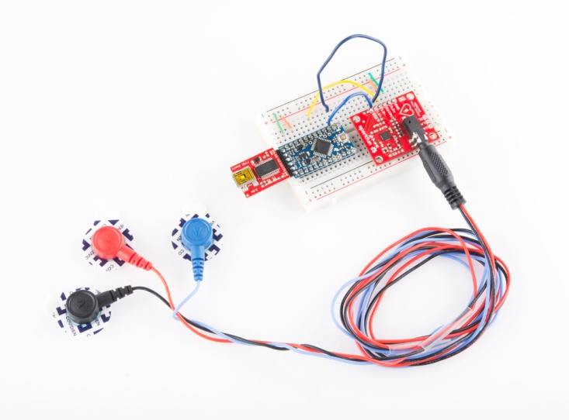

Figure 4.1 Tele ECG system architecture

**4.1.1 SENSOR AD8232**

This sensor is a cost-effective board used to measure the electrical activity of the heart. This electrical activity can be charted as an ECG or Electrocardiogram and output as an analog reading. ECGs can be extremely noisy, the AD8232 Single Lead Heart Rate Monitor acts as an op amp to help obtain a clear signal from the PR and QT Intervals easily.

The AD8232 is an integrated signal conditioning block for ECG and other biopotential measurement applications. It is designed to extract, amplify, and filter small biopotential signals in the presence of noisy conditions, such as those created by motion or remote electrode placement.

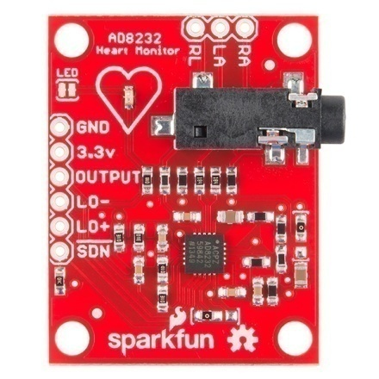

Figure 4.2 AD8232 chip

**4.1.2 PIN CONFIGURATION**

The AD8232 is an integrated signal conditioning block for ECG and other biopotential measurement applications. It is designed to extract , amplify and filter small biopotential signals by placing electrode .It allows for an ultralow power analog-to-digital converter(ADC) or an embedded microcontroller to acquire the output signal easily. We will connect five of the nine pins on the board to the arduino.

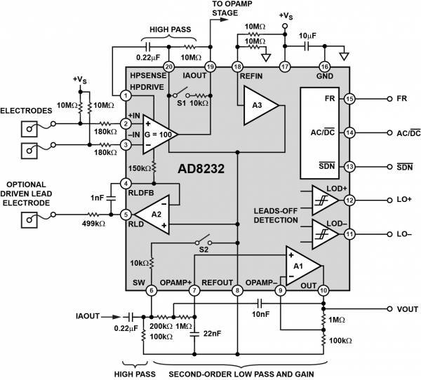

Figure 4.3 AD8232 Pin configuration

|  |  |  |
| --- | --- | --- |
| **BOARD LABEL** | **PIN FUNCTION** | **ARDUINO CONNECTION** |
| **GND** | Ground | **GND** |
| **3.3V** | 3.3V power supply | **3.3V** |
| **OUTPUT** | Output signal | **AO** |
| **LO-** | Leads-off detect- | **11** |
| **LO+** | Leads-off detect+ | **10** |
| **SDN** | Shutdown | **Not used** |

Table 4.1 AD8232 to Arduino connections

**4.1.3 ELECTRODES**

The 3 lead ECG is the most commonly used ECG in pre-hospital care and is most regularly utilised in continuous monitoring of the person who has had some form of cardiac event. This is because it is simple to use and requires a much less sensitive machine, therefore it is capable of picking up the specific electrical rhythm (or lack of rhythm) in the heart, without picking up as much interference as a much more detailed 12 lead ECG would**.**A 3 lead ECG is considered non-diagnostic, meaning that it does not provide a clear view of the entire heart, but instead a basic view of the electrical pathway of the heart triangulated between the 3 leads. These are the most common 3 lead ECG placements:

1. Right arm lead is white – forearm, proximal to the wrist.

2. Left arm lead is black and is considered the Earth lead, and is placed at the forearm, proximal to the wrist.

3. Left leg lead is red and is placed at the left lower leg, proximal to the ankle.

**4.1.4 ARDUINO UNO**

The Arduino Uno is a microcontroller board based on the ATmega328 ([datasheet](http://www.atmel.com/dyn/resources/prod_documents/doc8161.pdf)). It has 14 digital input/output pins (of which 6 can be used as PWM outputs), 6 analog inputs, a 16 MHz ceramic resonator, a USB connection, a power jack, an ICSP header, and a reset button. It contains everything needed to support the microcontroller; simply connect it to a computer with a USB cable or power it with an AC-to-DC adapter or battery to get started.

The Uno differs from all preceding boards in that it does not use the FTDI USB-to-serial driver chip. Instead, it features the Atmega16U2 (Atmega8U2 up to version R2) programmed as a USB-to-serial converter.

Revision 2 of the Uno board has a resistor pulling the8U2 HWB line to ground, making it easier to put into DFU mode. Revision 3 of the board has the following new features:

* 1.0 pinout: added SDA and SCL pins that are near to the AREF pin and two other new pins placed near to the RESET pin, the IOREF that allow the shields to adapt to the voltage provided from the board. In future, shields will be compatible with both the board that uses the AVR, which operates with 5V and with the Arduino Due that operates with 3.3V. The second one is a not connected pin, that is reserved for future purposes.
* Stronger RESET circuit.
* Atmega 16U2 replace the 8U2.

"Uno" means one in Italian and is named to mark the upcoming release of Arduino 1.0. The Uno and version 1.0 will be the reference versions of Arduino, moving forward. The Uno is the latest in a series of USB Arduino boards, and the reference model for the Arduino platform.

|  |  |
| --- | --- |
| **FEATURE** | **SPECIFICATION** |
| Microcontroller | ATmega328 |
| Architecture | AVR |
| Operating Voltage | 5V |
| Flash Memory | 32KB of which 0.5KB used by bootloader |
| SRAM | 2KB |
| Clock Speed | 16MHz |
| Analog I/O pins | 6 |
| EEPROM | 1KB |
| DC Current per I/O pins | 40 mA on I/O pins;50mA on 3.3V pin |
| Input Voltage | 7-12 V |
| Digital I/O pins | 20(of which 6 provide PWM output) |
| PWM Output | 6 |
| PCB Size | 53.4 x 68.6 mm |
| Weight | 25g |
| Product Code | A000066(TH);A000073(SMD) |

Table 4.2Arduino features and specifications

**4.2 ECG PROCESSING CODE**

A minimal Arduino C/C++ sketch, as seen by the Arduino IDE programmer, consist of only two functions:

* Setup: This function is called once when a sketch starts after power-up or reset. It is used to initialize variables, input and output pin modes, and other libraries needed in the sketch.
* Loop: After setup has been called, function loop is executed repeatedly in the main program. It controls the board until the board is powered off or is reset.

Most Arduino boards contain a [light-emitting diode](https://en.wikipedia.org/wiki/Light-emitting_diode) (LED) and a load resistor connected between pin 13 and ground, which is a convenient feature for many tests and program functions. A typical program for a beginning Arduino programmer blinks an LED repeatedly.

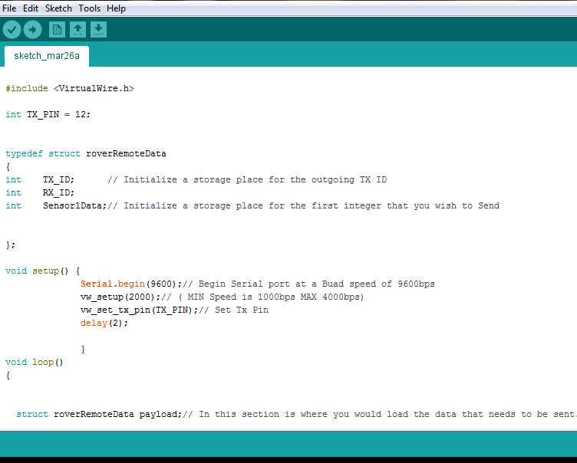

Figure 4.4.ECG processing code part 1

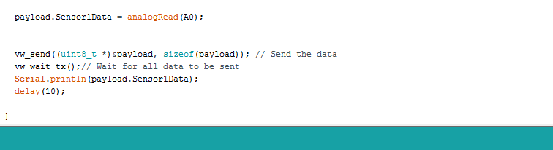

Figure 4.5.ECG processing code part 2

**4.3 SOLUTION/JUSTIFICATION FOR THE PROBLEM SORTED**

In the existing system the data is transferred via 3G technology which has many disadvantages like high cost of communication,low speed of transmission,less bandwidth and limited coverage area.To overcome that we are moving towards latest prevailing technology that is the 4G (LTE) technology.The comparison between 3G and 4G are done below.

|  |  |  |
| --- | --- | --- |
| **PARAMETERS** | **3G** | **4G** |
| **DATA THROUGPUT** | Upto 3.1Mbps with speed of 0.5-1.5Mbps | 2 to 12Mbps with speed of 100-300Mbps |
| **PEAK**  **UPLOAD RATE** | 5Mbps | 500Mbps |
| **SWITCHING TECHNIQUE** | Packet and Message switching | Packet switching |
| **NETWORK ARCHITECTURE** | Wide area cell based | Integration of wireless LAN and wide area |
| **SERVICES AND APPLICATIONS** | CDMA,UTMS,EDGE | Wimax 2 and LTE advance |
| **PEAK DOWNLOAD RATE** | 100Mbps | 1Gbps |
| **FREQUENCY BAND** | 1.8-2.5 GHz | 2-8GHz |

Table 4.3 3G and 4G comparison table

**4.4 TRANSMISSION MODEL**

The following is the transmission model of 3G network.Here the data is transferred from the mobile to base station via single path.So the data once lost is lost and cannot be recovered.

BASE STATION

MOBILE

Single path network

Figure 4.6Transmission model of 3G network

The following is the transmission model of 4G network.Here the data is transmitted from mobile to base station via multiple path.So the data lost via one path do not affect the transmission as the data will be transmitted via the remaining connected paths.

Multi path network

MOBILE

BASE STATION

Figure 4.7.Transmission model of 4G network

**4.5FEATURES OF 4G TECHNOLOGY**

4G provides support for multimedia services like teleconferencing and wireless internet.4G has wider bandwidths and higher bit rates.4G network is a entirely packet switched network.4G support high global mobility and service portability.4G provides support for previous wireless technologies.4G provides high speed internet and tight network security.

**4.6INTERNET PROTOCOL USED**

Internet protocol is the method in which data is sent from one computer to another on the internet.In the existing Tele cardiology system IPv4(Internet Protocol version 4) protocol is used,but in our enhanced system IPv6(Internet Protocol version 6)protocol is used,which includes 128 address bits which is four times more than 32 bits IP address in IPv4.

**CHAPTER 5**

**PRESENT WORK**

**5.1 HYPERTENSION**

As this project is based on Tele medicine for “cardiac assistance”,we concentrate more on detection of hypertension because hypertension is one of the major pre cardiac indication.If hypertension is detected earlier then cardiac emergencies can be treated easily.Hypertension also known as high blood pressure is a long term medical condition in which the blood pressure in the arteries is persistently elevated.High blood pressure usually does not cause symptoms.Long term high blood pressure, however, is a major risk factor for coronary artery disease, stroke, heart failure, peripheral vascular disease, vision loss and chronic kidney disease.

High blood pressure is classified as either primary high blood pressure or secondary high blood pressure.About 90-95% cases are primary, defined as high blood pressure due to nonspecific life style and genetic factors.Lifestyle factors that increase the risk include excess salt, excess body weight, smoking and alcohol.The remaining 5-10% of cases are categorised as secondary high blood pressure, defined as high blood pressure due to an identifiable cause, such as chronic kidney disease, narrowing of the kidney arteries, an endocrine disorder or the use of birth control pills.

Blood pressure is expressed by two measurements, the systolic and diastolic pressures, which are the maximum and minimum pressures respectively.Normal blood pressure at rest is within the range of 100-140millimeters mercury(mmHg) systolic and 60-90 mmHg diastolic.High blood pressure is present if the resting blood pressure is persistently at or above 140/90mmHg for most adults.Different numbers apply to children.Ambulatory blood pressure monitoring over a 24 hour period appears more accurate than office best blood pressure measurement.

Severely elevated blood pressure (equal to or greater than a systolic 180 or diastolic of 110) is referred to as a hypertensive crisis. Hypertensive crisis is categorized as either [hypertensive urgency](https://en.wikipedia.org/wiki/Hypertensive_urgency) or [hypertensive emergency](https://en.wikipedia.org/wiki/Hypertensive_emergency), according to the absence or presence of end organ damage, respectively.

In [hypertensive urgency](https://en.wikipedia.org/wiki/Hypertensive_urgency), there is no evidence of end organ damage resulting from the elevated blood pressure. In these cases, oral medications are used to lower the BP gradually over 24 to 48 hours.

In [hypertensive emergency](https://en.wikipedia.org/wiki/Hypertensive_emergency), there is evidence of direct damage to one or more organs. The most affected organs include the brain, kidney, heart and lungs, producing symptoms which may include confusion, drowsiness, chest pain and breathlessness. In hypertensive emergency, the blood pressure must be reduced more rapidly to stop ongoing organ damage, however, there is a lack of randomised controlled trial evidence for this approach.

|  |  |  |
| --- | --- | --- |
| **CATEGORY** | **SYSTOLIC ,mmHg** | **DIASTOLIC ,mmHg** |
| Normal | 90-119 | 60-79 |
| High normal(prehypertension) | 120-139 | 80-89 |
| Stage 1 hypertension | 140-159 | 90-99 |
| Stage 2 hypertension | 160-179 | 100-109 |
| Stage 3 hypertension (hypertensive emergency) | >=180 | >=110 |
| Isolated systolic hypertension | >=140 | <90 |

Table 5.1.Various threshold values of hypertension

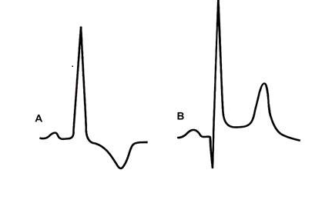

Figure 5.1.Hypertensive ECG signal

The above graph shows LVH in a systolic A and a diastolic B overload.In a systolic overload, the initial Q wave often disappears whereas in a diastolic overload, the initial Q wave becomes prominent.The amplitude of R wave is increased in both. The T wave is inverted with S-T segment depression in systolic overload, but in diastolic overload the S-T segment may be minimally elevated with upward concavity.

**5.2ECG SIGNAL**

The electrocardiogram (ECG or EKG) is a diagnostic tool that is routinely used to assess the electrical and muscular functions of the heart. The following graph denotes the normal ECG signal.

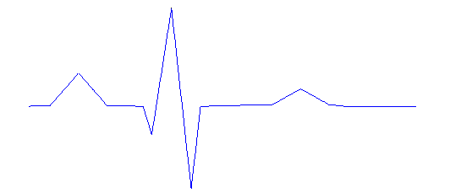

T

S

R

Q

P

PR Interval

QRS Interval

QT Interval

Figure 5.2.Normal ECG graph

The P- wave is generated by the activation of atria, the PR segment represents the duration of atrioventricular(AV) conduction, the QRS complex is produced by activation of both ventricles, the ST wave reflects ventricular recovery.

**CHAPTER 6**

**RESULTS AND DISCUSSION**

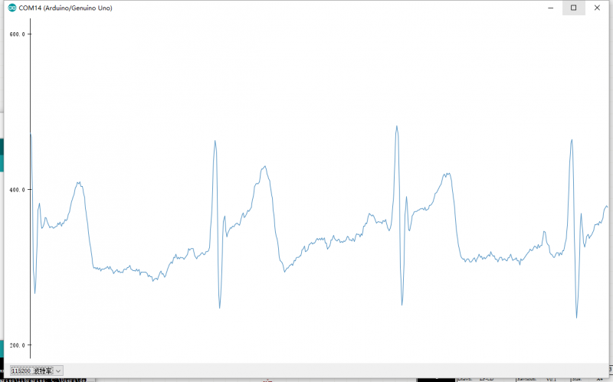

Figure 6.1.Arduino ECG output

The above result is the ECG signal of a normal person.As it is obtained via 3 lead ECG circuit the wave is not accurate but sufficient to detect whether hypertensive or not.

The obtained ECG signal is transmitted to the doctor’s system via 4G.As there is no dedicated channel provided yet there is some interference.If separate channel is provided then the interference can be overcomed.

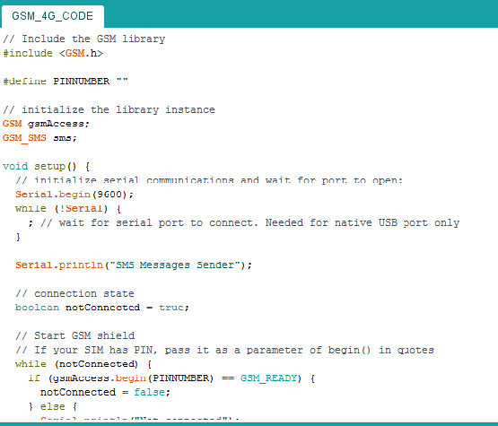

Figure 6.2.ECG transmission code part 1

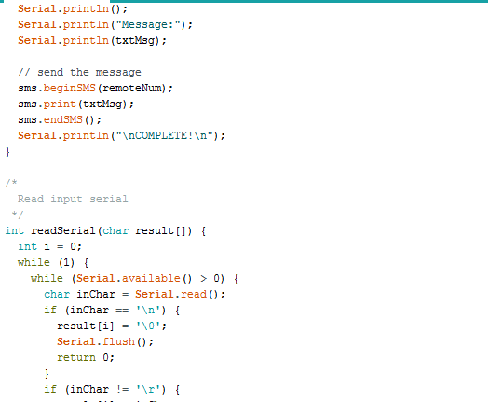

Figure 6.3 ECG transmission code part 2

**CHAPTER 7**

**CONCLUSION**

In our project the transmission of ECG signal from patient’s system to the web portal and reception of diagnostic report from web server to the patient’s system are analyzed through 2G technology.2G/3G has less bandwidth and coverage area.The cost of 3G is expected to be comparatively higher than 4G. In our project we are proposing a system that uses 4G which guarantees that users can always be connected.From this project we come up with an idea where the lifesaving Tele medicine devices should become affordable for common people at remote areas by making use of the latest prevailing technology 4G(LTE).Our project focuses on detection of high blood pressure using an ECG waveform , as hypertension is the most important pre cardiac abnormality indication.

**REFERENCES**

1. PriyankaKakria, N.K.Tripathi and PeerapongKitipawang(2015), “Real time health monitoring system for remote cardiac patients using smart phone and wearable sensors”, *International Journal of Tele medicine and Applications,*vol.2015,Article ID 373474,11pages.
2. Hoe Tung Yew,YudhaAditya, HaikaSatrial, EkoSupriyanto and Yuan Wen Haul(2015), “Tele cardiology system for fourth generation heterogeneous wireless networks”, *ARPN Journal of Engineering and Applied Sciences*, vol.10, no.2, pp.600-607.
3. A.M.Johansson, I.Lindberg and S.Soderberg(2014) ,“Patients’ experiences with specialist care via video consultation in primary healthcare in rural areas”, *International Journal of Tele medicine and Applications,*vol.2014, Article ID 143824,7 pages.
4. P.Pierleoni, L.Pernini, A.Belli and L.Palma (2014), “An android-based heart monitoring system for the elderly and for the patients with heart disease”, *International Journal of Tele medicine and Applications*, vol.2014, Article ID 625156,10 pages.
5. P.R.Manjare,M.S.Deshmukh, S.W.Puranik(2014), “Wireless ECG monitoring system using 3G”, *International Journal of Electrical ,Electronics and Data Communication*, ISSN: 2320-2084, vol.2, issue.1*.*
6. Ramesh Gamasu(2014), “ECG based integrated mobile Tele medicine system for emergency health tribulations”, *International Journal of Bio-Science and Bio-Technology*, vol.6, no.1, pp.83-94*.*
7. J.Suganthi, N.V.Umareddy and NitinAwasthi(2012), “Medical alert systems with Tele health and Tele medicine monitoring using GSM and GPRS technology”, *IEEE*-20180.
8. N.Petr(2012), “Smartphones for in-home diagnostics in Tele medicine”, *International Journal of Medical and Biological Sciences*, vol.6, pp.36-40.
9. S.Patel, H.Park,P.Bonato,L.Chan and M.Rodgers (2012), “A review of wearable sensors and systems with application in rehabilitation*”, Journal of NeuroEngineering and Rehabilitation*, vol.9, no.12,pp.1-17.
10. M.N.K.Boulos, S.Wheeler,C.Tavares and R.Jones (2011), “How smartphones are changing the face of mobile and participatory healthcare: an overview, with example from eCAALYX*”, BioMedical Engineering Online*,vol.10, Article 24.
11. GolamSorwar and AmeerAli(2010), “Advanced Tele medicine system using 3G cellular networks and agent technology”, *International Federation for Information Processing*, E-Health 2010, IFIP AICT 335, pp.187–197*.*
12. M.A.Pervez, G.Silva, S.Masrur et al. (2010), “Remote supervision of IV-tPA for acute ischemic stroke by Tele medicine or telephone before transfer to a regional stroke center is feasible and safe”, *Stroke* , vol.41, no.1, pp.e18-e24.
13. NazifeOzen and BekirKarlik(2008), “A Tele cardiology system design with real time diagnosis and teleconsultation”,*IEEE*978-1-4244-2624-9/08/$25.00.
14. G.Bobrie, N.Postel-Vinay, J.Delonca and P.Corvol (2007), “Self- measurement and self-titration in hypertension:a pilot Tele medicine study”, *American Journal of Hypertension*, vol.20, no.12, pp.1314-1320.
15. H.S.Ng, M.L.Sim, C.M.Tan and C.C.Wong (2006), “Wireless technologies for Tele medicine”, *BT Technology Journal*, vol.24, no.2, pp.130-137.
16. KonstantinosPerakis, GeorgiosKonnis, Sotiris Pavlopoulos(2006), “Tele medicine and third generation(3G) cellular networks”, *The Journal on Information Technology in Healthcare*, 2006; 5(3): 141–150*.*
17. W.Ping, W.Jin-Gang, S.Xiao-Bo and H.Wei (2006), “The research of Tele medicine system based on embedded computer”, in *Proceedings of the 27th Annual International Conference of the Engineering in Medicine and Biology Society(IEEE EMBS ’05)*, PP.114-117, IEEE, Shanghai,China.
18. S.Meystre (2005), “The current state of telemonitoring: a comment on the literature*”, Tele medicine Journal and e-health*, vol.11, no.1, pp.63-69.
19. Yuechun Chu and Aura Ganz(2005), “Mobile Tele medicine systems using 3G wireless network”, *Business Briefing: US Healthcare Strategies2005.*
20. C.Corroy, R.Baghai, J.L.Weber, D.Blanc, F.Klefstat, A.Blinovska, S.Vaysse, B.Comet(2004), “A Smart cloth for ambulatory telemonitoring of physiological parameters and activity:the VTAMN project, *IEEE*0-7803-8453-9/04/$20.00.