STUDENT PROJECT DOCUMENTATION

EduGenie
Google Gemini Powered Learning Assistant

A lightweight AI-powered educational assistant for question answering, concept explanation, summarization, quiz generation, and personalized learning recommendations.

STUDENT : ABINAYA M

Program: Bachelor of Computer Applications (BCA)

Institution: St Thomas College of Arts and Science Academic Year: 2026

Date of Submission: 30 September 2026

Project Team Details
This documentation records the design, implementation, and functional demonstration of EduGenie, a Google Gemini powered learning assistant developed as a student project in the Bachelor of Computer Applications Program.

Declaration
The team presents this document as the project documentation for EduGenie. The contents describe the application workflow, module design, backend API structure, frontend interface, and functional testing demonstrations included with the project.

Submitted by

Abinaya M.

Date: 30 September 2026

Table of Contents

Project Team Details
Declaration
Abstract
Key Features
- Project Description
2
. 2
4
. 4
5

Purpose of the Project 5
Core Functions 5
Scenarios 5
- System Architecture and Workflow 6
Architectural Flow 6
Backend API Modules 6
Technology Stack 6
- Project Architecture and Prerequisites 7
Folder Architecture 7
Pre-requisites 7

Model Selection
- Development Methodology
. 7
8

Milestone 1 - Model Selection and Architecture 8
Milestone 2 - Core Functionalities Development 8
Milestone 3 - Frontend Development 8

Milestone 4 - Functional Testing and Demonstration
- Frontend and Functional Demonstration
- Testing Summary and Observations
. 8
9
17

- Asking Questions 17
- Explanations 17
- Summarizing Paragraphs 17
- Generating Quizzes 17

Challenges and Handling
- Conclusion
. 17
18

References
Project Team 18
19

Abstract
EduGenie is a lightweight AI-powered educational assistant designed to simplify learning through generative AI. The system allows students to ask questions, understand difficult concepts through simplified explanations, summarize educational content, generate quizzes, and receive personalized learning recommendations.
The application uses a FastAPI backend with a simple HTML and CSS frontend. Cloud-based Gemini models are accessed through API calls, allowing the application to provide intelligent responses without requiring heavy local computing resources. The project also includes API-key pooling and error handling to manage rate limits more gracefully.
Key Features
- Question answering for general knowledge and academic queries.
- Step-by-step explanations of complex topics in student-friendly language.
- Automatic summarization of long educational passages.
- Generation of multiple-choice quizzes with answer validation.
- Structured learning recommendations from beginner to advanced levels.
- API-key pooling to reduce disruption caused by temporary rate limits.

- Project Description
EduGenie is a lightweight AI-powered educational assistant that simplifies learning through generative AI. Designed for students of different academic levels, it provides an interactive environment where learners can enter a topic, question, or paragraph and receive useful educational output.

Purpose of the Project
The purpose of EduGenie is to make common learning tasks faster and easier by bringing multiple study-support functions into one web interface. Instead of using separate tools for searching, explaining, summarizing, and quiz preparation, the user can access these functions from the same application.

Core Functions
  - Ask questions and receive concise answers.
  - Understand complex concepts through simplified explanations.
  - Generate quizzes from a topic or supplied content.
  - Receive structured learning recommendations.
  - Summarize large educational passages into readable notes.

Scenarios
  - Scenario 1: A student wants to know about oceans and rivers and asks, "Which is the largest ocean?".
  - Scenario 2: A student wants to check her understanding of the Pythagoras Theorem and uses the quiz-generation function.
  - Scenario 3: A learner exploring SQL requests a structured learning path covering beginner, intermediate, and advanced topics.

System Architecture and Workflow

Architectural Flow
The application follows a simple request-response architecture. The student interacts with the frontend, the FastAPI backend routes the request, and the selected module calls the Gemini service to generate an appropriate response.
  - Start: The user opens the EduGenie frontend and provides an input.
  - FastAPI Backend: The user selection is mapped to the appropriate API endpoint.
  - Module Processing: Requests are handled by the Explanation, Q&A, Quiz, Summarization, or Learning Path module.
  - End: The generated result is returned to the frontend and displayed to the user.

Backend API Modules

Function | Endpoint / Module | Purpose
Explanation | /explain/ | Provides simplified educational explanations.
Q&A | /qa | Answers direct questions and general knowledge queries.
Quiz | /quiz | Generates multiple-choice questions with four options.
Summary | /summarize/ | Condenses long text into a shorter readable summary.
Learning Path | /learn/recommendations | Builds structured recommendations for learning a topic.

Technology Stack
  - Python 3.10 or later.
  - FastAPI framework with Uvicorn ASGI server.
  - HTML and CSS for the frontend, with Jinja2 templating.
  - Google Gemini API access through Python SDKs.
  - Environment variables for securely storing API keys.

- Project Architecture and Prerequisites
Folder Architecture
EduGenie/
|-- main.py # FastAPI app
|-- explanation_module.py # Concept explanation logic
|-- qna.py # Question answering
|-- quiz_module.py # Quiz generation
|-- summary_module.py # Summarization
|-- learning_path.py # Learning recommendations
|-- templates/index.html # HTML frontend
|-- static/style.css # Styling
`-- requirements.txt # Python dependencies

Pre-requisites
- Python 3.10+: Required to run the application and its dependencies.
- FastAPI and Uvicorn: Used to expose and serve the backend API.
- HTML, CSS, and Jinja2: Used to create and render the web interface.
- Gemini API keys: Multiple keys can be configured as environment variables such as GEMINI_API_KEY_1, GEMINI_API_KEY_2, and GEMINI_API_KEY_3.
Model Selection
Gemini 3.8 Flash: Used for Q&A, explanations, summarization, and quiz generation because these functions benefit from fast responses.
Gemini 3.8 Pro: Used for more structured learning-path generation and deeper reasoning tasks.

- Development Methodology
Milestone 1 - Model Selection and Architecture
The initial milestone focused on selecting AI models, identifying the main application modules, and defining a modular folder structure. The design separates each educational capability into an individual Python module so that features can be maintained and improved independently.
Milestone 2 - Core Functionalities Development
Explanation Module: Uses a fast Gemini model to convert a topic into clear, educational breakdowns. The implementation includes a get_random_key() function to select from available API keys and an error-handling path for temporary rate-limit conditions.
QnA Module: Accepts a user question, authenticates with the selected API key, sends the question to Gemini, and returns the generated text to the frontend.
Quiz Module: Instructs the model to behave as a quiz generator. It requests valid JSON containing three multiple-choice questions, four options per question, and one correct answer. A clean_json_block function removes Markdown code fences before parsing the response.
Summary Module: Accepts large text blocks and generates simple summaries. It also uses protected API calling and exception handling to reduce application failures during rate limiting.
Learning Path Module: Generates structured recommendations for a topic. The prompt asks for key topics, learning order, and resources across beginner, intermediate, and advanced levels.
Milestone 3 - Frontend Development
The frontend is served using Jinja2 templates and provides a clean browser-based interface for the main functions. The user can enter a question, a topic for explanation, text for summarization, or a topic for quiz generation.
Milestone 4 - Functional Testing and Demonstration
The final milestone focused on running the application and validating that the main features produce visible results. The screenshots in the next section document the interface and example outputs produced during testing.

- Frontend and Functional Demonstration
The following screenshots were captured during project testing. They are included as evidence of the working user interface and the generated outputs from the Q&A, explanation, summarization, and quiz features.

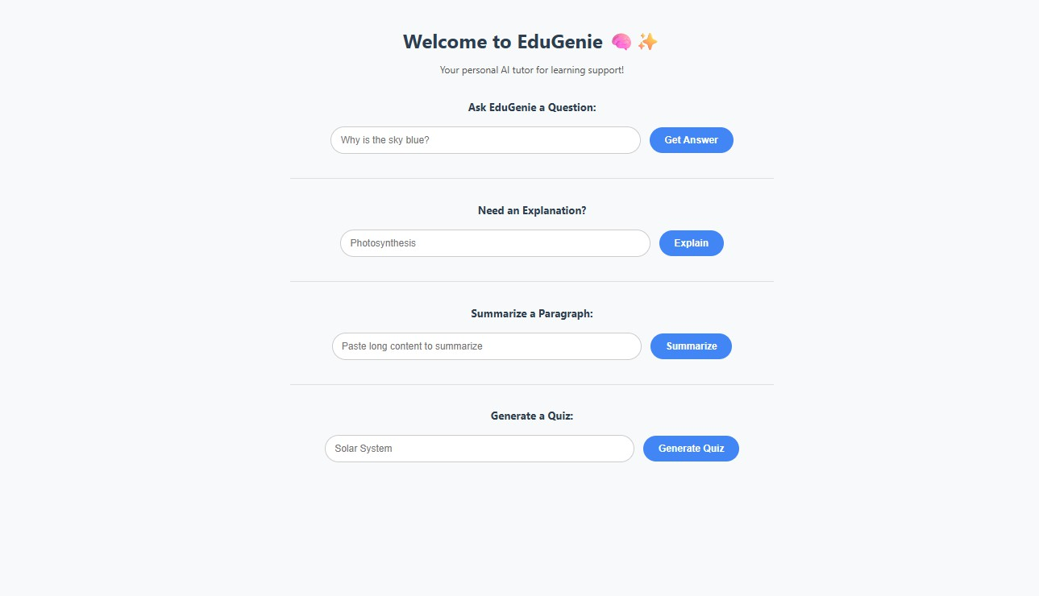
Figure 1. EduGenie home page and available learning features.

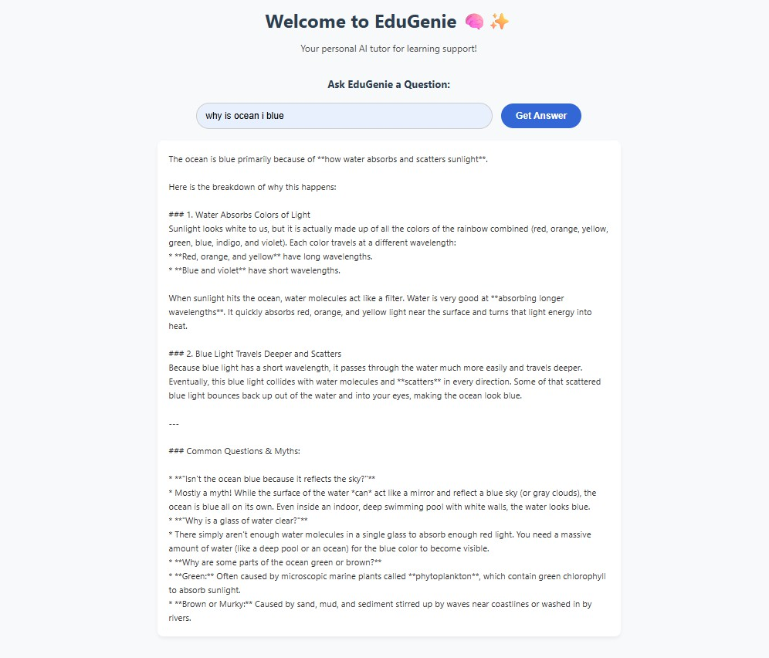
Figure 2. Question-answering response for an ocean-related query.

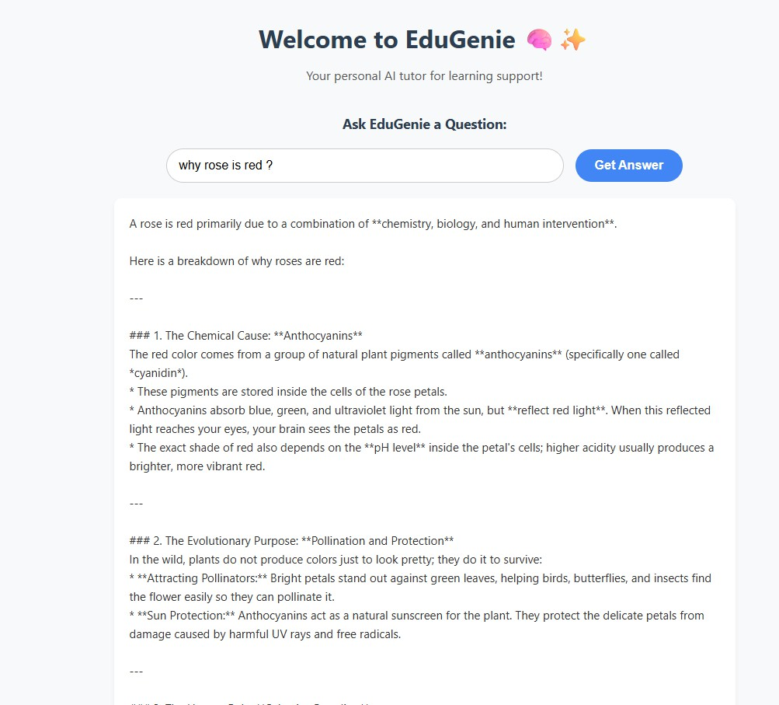
Figure 3. Question-answering response explaining why roses are red.

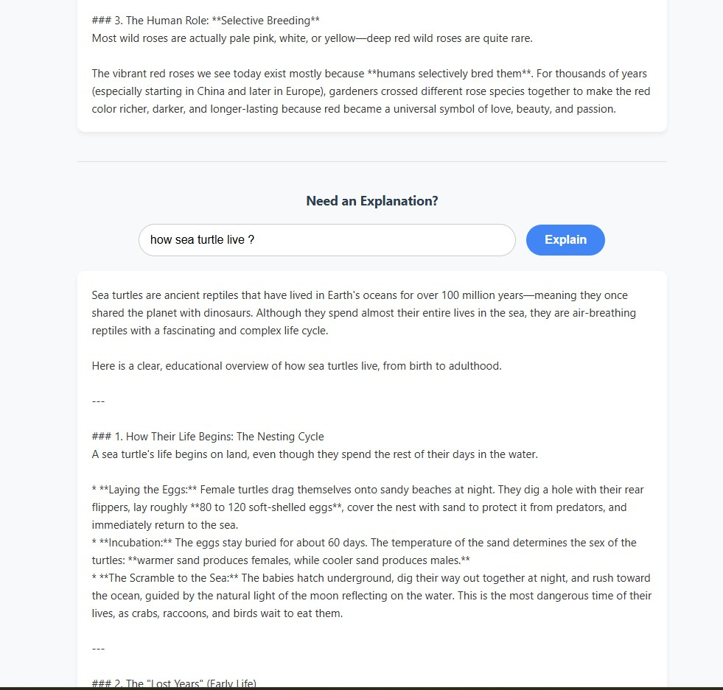
Figure 4. Explanation module response for the sea turtle life cycle.

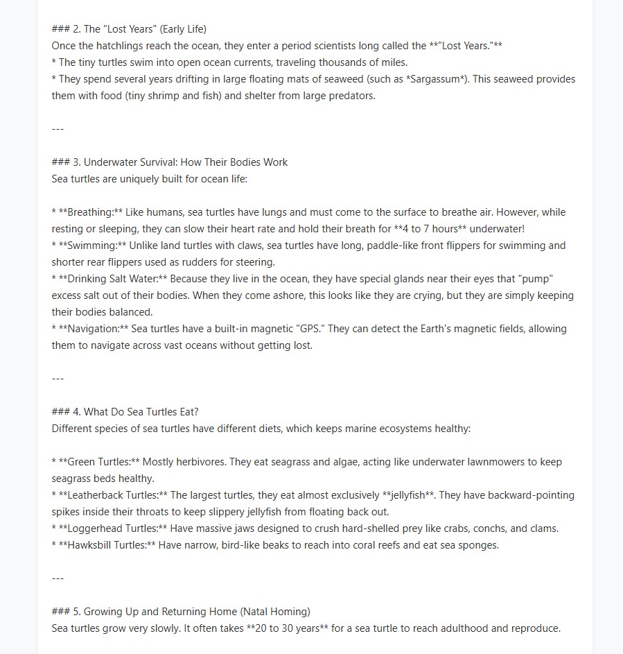
Figure 5. Continued sea turtle explanation showing early life and survival.

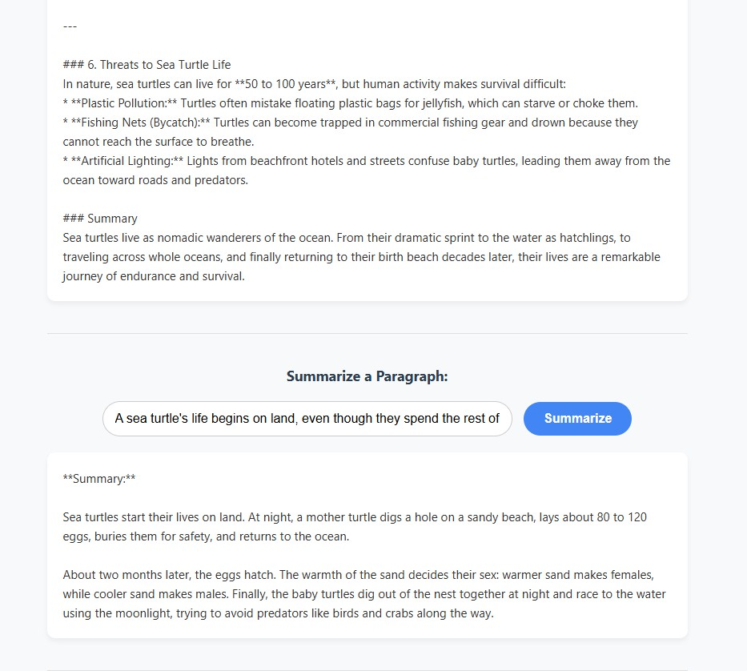
Figure 6. Continued explanation and generated summary of sea turtle nesting.

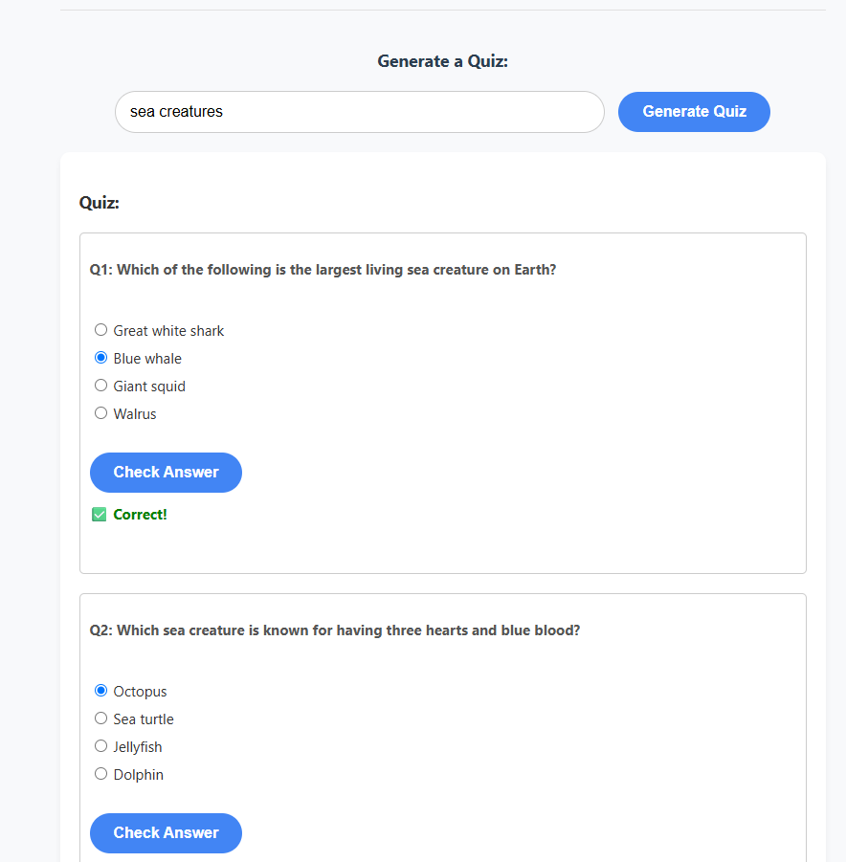
Figure 7. Quiz generation interface with multiple-choice questions.

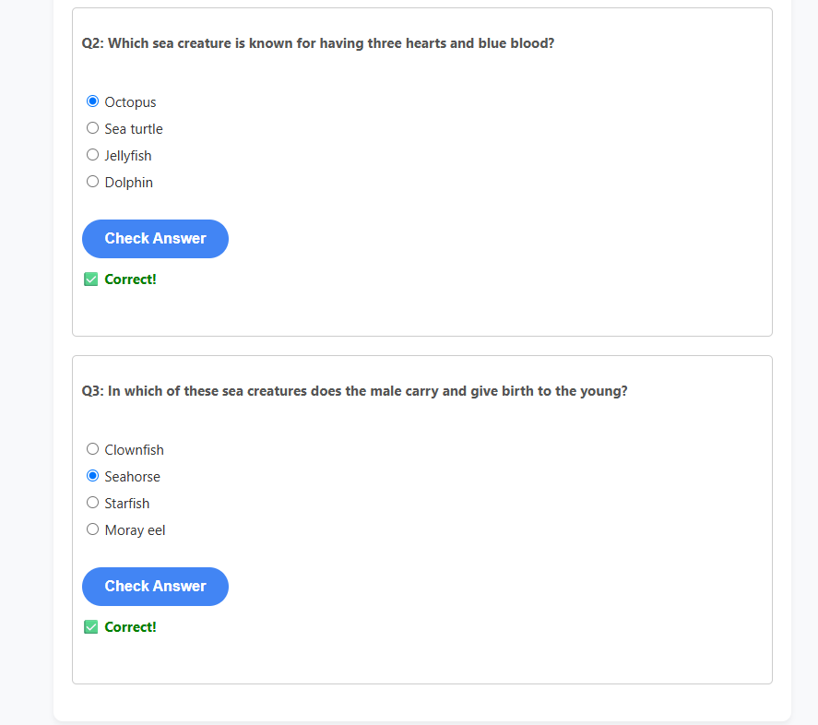
Figure 8. Quiz answer validation showing correct responses.

- Testing Summary and Observations

Asking Questions
The Q&A functionality accepted natural-language questions and displayed generated educational explanations. Example prompts included questions about the ocean and the color of flowers.

Explanations
The explanation feature produced structured, student-friendly responses. The sea turtle example demonstrated how a topic can be broken into life-cycle stages, survival features, diet, growth, and threats.

Summarizing Paragraphs
The summarization feature condensed a longer passage about sea turtle nesting into a shorter explanation while retaining the main ideas.

Generating Quizzes
The quiz module generated multiple-choice questions and displayed answer-validation feedback. The sea-creatures demonstration shows the correct-answer state for several questions.

Challenges and Handling
One of the main development challenges was handling API rate limits. The project addresses this by selecting from multiple configured API keys and returning a user-friendly cooldown message when the available keys are temporarily unavailable. This approach helps prevent the application from terminating unexpectedly when a request cannot be served immediately.

Conclusion
EduGenie has been developed as an accessible AI-powered educational assistant that combines cloud-based generative AI with a lightweight web interface. The modular structure supports question
answering, concept explanation, summarization, quiz generation, and learning recommendations within one application.
The project demonstrates how a FastAPI backend can be integrated with Gemini API services to build practical educational software. The inclusion of API-key pooling and exception handling also provides a more resilient user experience under temporary rate-limit conditions.
EduGenie provides a foundation for further enhancements such as richer quiz analytics, user progress tracking, more personalized study plans, authentication, persistent learning history, and additional educational modules.
Project Team

Student : Abinaya M

Program: Bachelor of Computer Applications (BCA) Institution: St Thomas College of Arts and Science Date: 30 September 2026

References
- FastAPI documentation - framework and API development reference.
- Uvicorn documentation - ASGI server reference.
- Jinja2 documentation - HTML templating reference.
- Google Gemini API / Google GenAI developer documentation - model integration reference.

End of Student Project Documentation

