POCKETSMART AI
Generative AI Budget & Recommendation Assistant
PROJECT DOCUMENTATION

Item | Details
Project Name | PocketSmart AI
Application Type | Generative AI Web Application
Backend | Python, FastAPI, SQLAlchemy
Frontend | HTML, CSS, JavaScript, Jinja2

Project Phases :

        - Phase 1 – Brainstorming & Ideation
        - Phase 2 – Requirement Analysis
        - Phase 3 – Project Design
        - Phase 4 – Project Planning
        - Phase 5 – Project Development
        - Phase 6 – Project Testing
        - Phase 7 – Documentation
        - Phase 8 – Demonstration

Phase 1 – Brainstorming & Ideation

1.1 Project Overview
PocketSmart AI is a web-based Generative AI assistant designed to help users create practical, budget-aware recommendation plans for home setup, party planning, and jewelry selection. The application combines a FastAPI backend, Jinja2 templates, SQLite persistence, a simulated product catalog, and optional Google Gemini multimodal generation. Users can register and log in, submit planner requirements, receive recommendations, and view or delete recommendation history.
The application is designed as an educational and project implementation. When a Gemini API key is available, the system generates structured recommendations. If Gemini is unavailable or mock mode is enabled, a deterministic local fallback engine keeps the application usable.

1.2 Problem Statement
Users may need to compare many options while planning a room setup, an event, or accessories for an occasion. Manually estimating quantities and costs is time-consuming. In addition, recommendations should remain within the user's stated budget and should be easy to understand.

1.3 Objectives
- Create a simple web interface for budget-based planning.
- Provide separate planners for home, party, and jewelry use cases.
- Use Generative AI to produce structured recommendations when configured.
- Support optional outfit-image analysis for broad jewelry color/style coordination.
- Keep recommendation totals budget-aware through post-processing.
- Store users and recommendation history in SQLite.
- Provide authentication, protected planner routes, and history management.
- Provide a local fallback mode for demonstrations without an AI API key.

1.4 Idea Generation and Proposed Solution
Planning purchases and events requires balancing preferences, quantities, and a fixed budget. The idea behind PocketSmart AI is to collect structured user requirements and transform them into budget-conscious recommendation plans using a layered web architecture.
The browser submits planner information to FastAPI. The recommendation service retrieves a local simulated catalog, prepares a prompt, and optionally sends the request to Gemini. The returned structured data is validated with Pydantic and normalized against the user's budget. Results are stored in recommendation history and returned to the frontend.

1.5 Key Features Identified
Feature | Description
User Registration & Login | Create an account and access protected planner features.
Home Planner | Plan room essentials and decor using budget, style, city, and room requirements.
Party Planner | Estimate food, venue, decoration, and optional accommodation for a specified guest count.
Jewelry Planner | Generate jewelry pairing suggestions based on occasion, style, metal preference, and outfit details.
Outfit Image Upload | Accept JPG/JPEG, PNG, or WEBP images for broad style/color coordination.
Gemini Integration | Generate structured AI recommendations using a configurable Gemini model.
Local Fallback | Provide deterministic recommendations if AI generation is disabled or fails.
Recommendation History | Store, view, and delete previous recommendation results.
Responsive Frontend | Browser pages for home, dashboard, planners, recommendations, and history.
API Documentation | FastAPI provides interactive documentation through /docs.

Phase 2 – Requirement Analysis

2.1 Functional Requirements
ID | Requirement
FR-1 | The system shall allow users to register, log in, and log out.
FR-2 | The system shall restrict planner endpoints to authenticated users.
FR-3 | The system shall provide Home, Party, and Jewelry planners with separate input forms.
FR-4 | The system shall generate structured recommendations using Gemini when configured.
FR-5 | The system shall accept an optional outfit image (JPG/JPEG, PNG, WEBP) for the Jewelry Planner.
FR-6 | The system shall keep displayed recommendation totals within the submitted budget.
FR-7 | The system shall fall back to a local recommendation engine if AI is disabled or fails.
FR-8 | The system shall store each successful result in history and allow users to view and delete entries.

2.2 Planner Input Requirements
Planner | Inputs Collected
Home Planner | Budget, style, city, notes, and one or more rooms (lights, ceiling fans, tables, chairs, decor items).
Party Planner | Budget, guest count, event type, city, venue preference, food preference, accommodation requirement, and notes.
Jewelry Planner | Budget, occasion, style, metal preference, outfit color, outfit description, and optional outfit image.

2.3 Non-Functional Requirements
- Security: Passwords are hashed; sessions use SameSite=Lax cookies; protected routes require authentication.
- Validation: Pydantic limits for ranges and string lengths; image MIME/filename checks and Pillow verification.
- Reliability: Local deterministic fallback keeps the app usable when Gemini is unavailable.
- Usability: Responsive browser interface with simple forms and clear recommendation output.
- Maintainability: Modular layers (routes, services, schemas, models) with pytest-based tests.
- Configurability: Behaviour controlled through .env / Pydantic Settings (API key, model, mock mode, image size limit).

2.4 Technology and Software Requirements
Technology | Purpose
Programming Language | Python 3.13 environment is present in the supplied project; Python 3.11+ is suitable for setup.
Backend | FastAPI, Uvicorn
Frontend | HTML, CSS, JavaScript, Jinja2
Database | SQLite with SQLAlchemy ORM
Validation | Pydantic / Pydantic Settings
Generative AI | Google Gemini via google-genai
Image Processing | Pillow
Authentication | Session-based protected pages plus JWT token endpoint
Testing | Pytest
Configuration | .env / Pydantic Settings

2.5 Constraints and Assumptions
- The product/vendor catalog is simulated; no live Amazon, Flipkart, IKEA, Swiggy, Zomato, or OYO partner API access is claimed.
- Platform links are search starting points, not guaranteed live prices or availability.
- AI recommendations depend on the configured Gemini API and model availability.
- Real-time inventory, payment processing, booking, and purchase execution are out of scope.

Phase 3 – Project Design

3.1 System Architecture
The major logical layers of the system are:
- Presentation Layer: Jinja2 HTML templates, CSS, and JavaScript.
- API Layer: FastAPI routes for authentication, sessions, planners, and history.
- Service Layer: RecommendationService, GeminiService, and CatalogService.
- Validation Layer: Pydantic input/output schemas and image validation using Pillow.
- Persistence Layer: SQLAlchemy models with SQLite.
- AI Layer: Google Gemini API for structured multimodal recommendation generation.
- Fallback Layer: Local deterministic recommendation engine and simulated catalog.
High-level flow: User → Web UI → FastAPI Route → Pydantic Validation → Recommendation Service → Catalog + Gemini (optional) → Budget Normalization → SQLite History → JSON/HTML Result
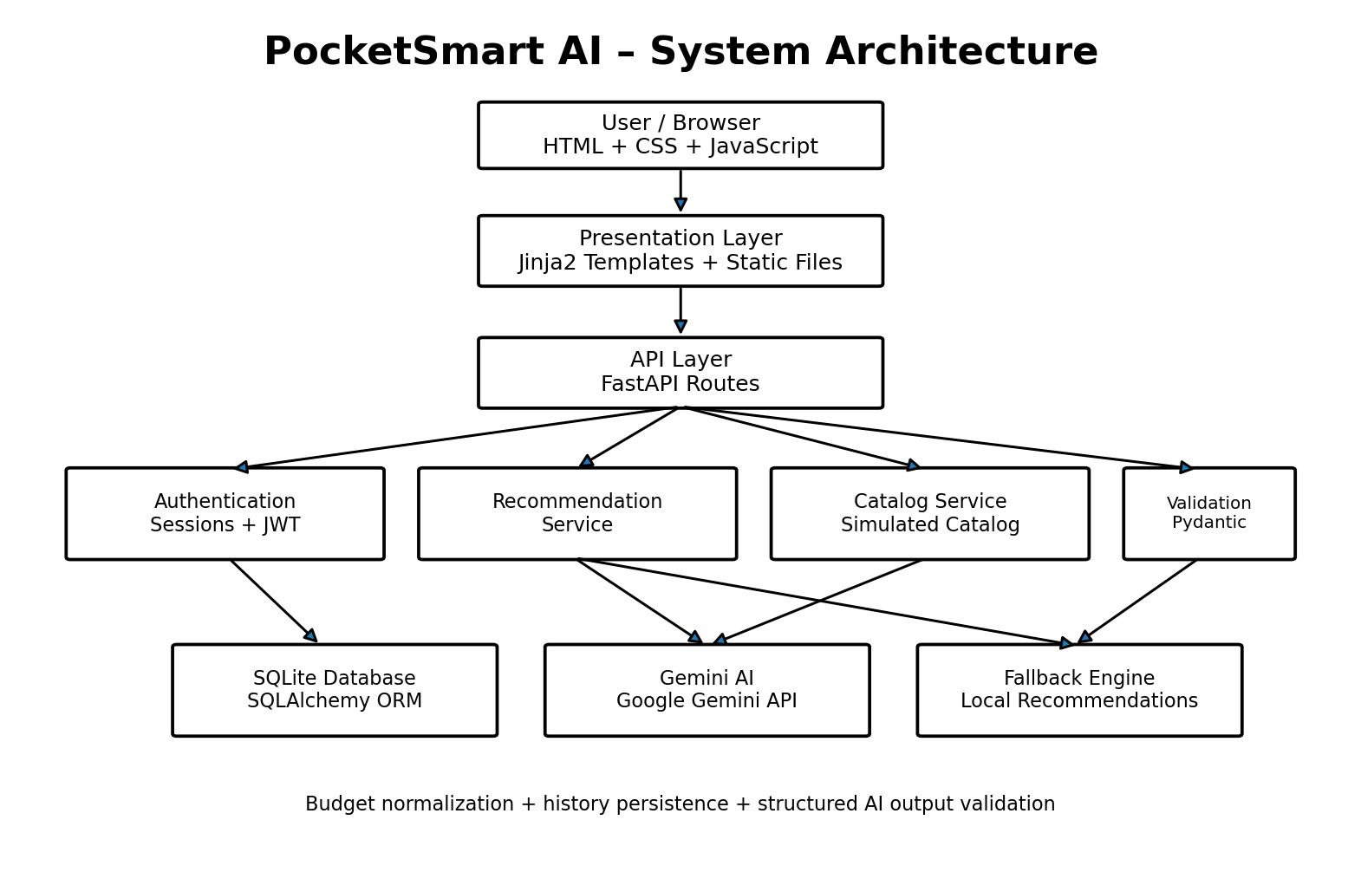
Figure 1. PocketSmart AI System Architecture

3.2 Functional Modules
Authentication Module. Supports registration, login, logout, token generation, and session-aware access. User records contain email, name, password hash, and creation time.
Home Planner. Accepts budget, style, city, notes, and one or more rooms. Room inputs can include lights, ceiling fans, tables, chairs, and decor items.
Party Planner. Accepts budget, guest count, event type, city, venue preference, food preference, accommodation requirement, and notes. The engine allocates budget across major party categories.
Jewelry Planner. Accepts budget, occasion, style, metal preference, outfit color, and outfit description. An optional image can be passed to Gemini for broad color/style coordination.
Recommendation & History Module. Every successful planner result can be saved as JSON in history. Users can retrieve recent results and delete individual records.

3.3 Database Design
The implementation defines two main SQLAlchemy entities:
Table | Important Fields | Purpose
users | id, email, full_name, password_hash, created_at | Stores registered users.
recommendation_history | id, user_id, planner_type, request_json, result_json, created_at | Stores generated planner requests and results.

3.4 Generative AI Integration Design
GeminiService builds a planner-specific prompt and sends it to the configured Gemini model. The implementation requests JSON output and validates the response against the RecommendationResponse Pydantic schema. For jewelry image uploads, the image bytes are supplied as an additional Gemini content part.
- API key is read from GEMINI_API_KEY.
- Model is configurable through GEMINI_MODEL.
- Temperature is configured at 0.35 in the Gemini request.
- The response is constrained to a structured JSON schema.
- Invalid AI output is rejected rather than silently accepted.
- If AI generation fails, the local fallback engine generates a usable result.

3.5 API Specification
Method | Endpoint | Purpose
POST | /api/auth/register | Register a user
POST | /api/auth/login | Authenticate a user
POST | /api/auth/logout | Clear the current session
POST | /api/auth/token | Return a JWT token
GET | /api/session-info | Return current session information
GET | /api/session-data | Return user session data and recent recommendations
POST | /api/generate-home | Generate a home recommendation plan
POST | /api/generate-party | Generate a party recommendation plan
POST | /api/generate-jewelry | Generate a jewelry plan; supports optional image upload
POST | /api/recommendations-details | Regenerate/retrieve recommendation details from planner data
GET | /api/history | List recommendation history
DELETE | /api/history/{history_id} | Delete a history entry
GET | /health | Health check

3.6 Workflow Design
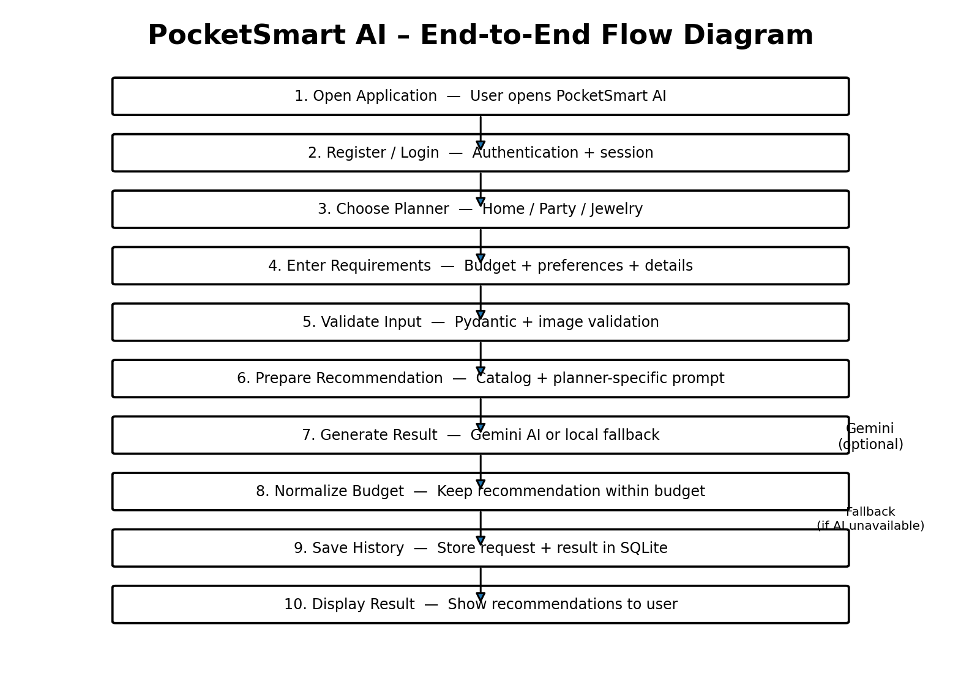
Figure 2. PocketSmart AI End-to-End Flow
Step | Description
1. User Access | User opens the application and registers/logs in.
2. Planner Selection | User selects Home, Party, or Jewelry planning.
3. Input Collection | The selected form collects budget and preference details.
4. Validation | FastAPI/Pydantic validates values and required fields.
5. Catalog Retrieval | The catalog service selects relevant simulated catalog entries.
6. AI Generation | If configured, Gemini receives the structured prompt and optional jewelry image.
7. Normalization | The recommendation service ensures displayed totals stay within the submitted budget.
8. Persistence | Request and result are stored in SQLite history.
9. Presentation | The recommendation result is displayed to the user.

3.7 Project Folder Structure
PocketSmart_AI_Project_clean/
├── app/
│ ├── main.py, config.py, database.py, models.py
│ ├── schemas.py, auth.py, dependencies.py, prompts.py
│ ├── routes/
│ │ ├── auth.py, pages.py, planners.py
│ └── services/
│ ├── catalog_service.py
│ ├── gemini_service.py
│ └── recommendation_service.py
├── templates/
│ ├── base.html, index.html, login.html, register.html
│ ├── dashboard.html, home_planner.html, party_planner.html
│ ├── jewelry_planner.html, recommendations.html
│ └── history.html, testimonials.html
├── static/ (css/style.css, js/app.js)
├── tests/ (conftest.py, test_api.py)
├── requirements.txt, pyproject.toml, .env.example
├── run.py, run_windows.bat, setup_windows.bat
└── README.md

Phase 4 – Project Planning

4.1 Development Approach
PocketSmart AI follows a modular, layered development approach. The backend is built first (configuration, database models, schemas, authentication), followed by the service layer (catalog, Gemini, recommendation logic), the planner routes, the Jinja2 frontend, and finally testing and documentation.

4.2 Milestones and Deliverables
No. | Milestone | Deliverable
1 | Project setup | Folder structure, requirements.txt, pyproject.toml, .env.example, run scripts
2 | Configuration & database | config.py, database.py, SQLAlchemy models (users, recommendation_history)
3 | Schemas & validation | Pydantic input/output schemas, image validation with Pillow
4 | Authentication | Register, login, logout, session handling, JWT token endpoint
5 | Service layer | CatalogService, GeminiService, RecommendationService, prompts, fallback engine
6 | Planner APIs | Home, Party, and Jewelry generate endpoints; history endpoints
7 | Frontend | Jinja2 templates, CSS, and JavaScript for all pages
8 | Testing | pytest API/service tests; health-check verification
9 | Documentation & demo | Project documentation, README, demo in mock mode

4.3 Risk Analysis and Mitigation
Risk | Mitigation
Gemini API key missing or model unavailable | Local deterministic fallback engine and MOCK_AI mode.
Invalid or malformed AI output | Response validated against the RecommendationResponse Pydantic schema; invalid output is rejected.
Totals exceeding the user's budget | Post-processing budget normalization in the recommendation service.
Malicious or oversized image uploads | MIME/filename checks, Pillow verification, and MAX_IMAGE_MB limit.
No live product data | Simulated catalog; platform links are clearly documented as search starting points.
Weak credentials in deployment | Passwords hashed; strong SECRET_KEY required outside development.

4.4 Environment and Configuration Plan
Setting | Purpose
GEMINI_API_KEY | API key used by GeminiService.
GEMINI_MODEL | Configurable Gemini model name available to the API account.
MOCK_AI | When true, uses the local fallback engine (no API key needed).
SECRET_KEY | Signing key for sessions/JWT; must be strong outside development.
MAX_IMAGE_MB | Maximum allowed size for uploaded outfit images.

Phase 5 – Project Development

5.1 Implementation Summary
Component | Responsibility
app/main.py | FastAPI application entry point and router registration.
app/config.py | Pydantic Settings loading configuration from .env.
app/database.py / models.py | SQLAlchemy engine/session and ORM models for SQLite.
app/schemas.py | Pydantic request/response schemas.
app/auth.py / dependencies.py | Password hashing, session and JWT handling, authenticated-user dependency.
app/prompts.py | Planner-specific prompt construction for Gemini.
routes/auth.py | Registration, login, logout, and token endpoints.
routes/pages.py | Jinja2-rendered browser pages.
routes/planners.py | Home/Party/Jewelry generation and history endpoints.
services/catalog_service.py | Selects relevant entries from the simulated catalog.
services/gemini_service.py | Calls Gemini with structured JSON output and optional image part.
services/recommendation_service.py | Orchestrates catalog, Gemini, fallback, budget normalization, and history.
templates/ and static/ | Frontend pages, CSS, and JavaScript.

5.2 Backend Development
The backend is built with FastAPI and served by Uvicorn. Routes are separated into authentication, pages, and planners. SQLAlchemy provides persistence to SQLite, and Pydantic validates all incoming and outgoing data.

5.3 Frontend Development
The user interface is built with Jinja2 templates extending a common base.html, with static CSS and JavaScript. Pages include home, login, register, dashboard, the three planners, recommendations, history, and testimonials.

5.4 Generative AI Implementation
GeminiService uses the google-genai SDK with a temperature of 0.35 and a constrained JSON schema. If generation fails or mock mode is enabled, the local deterministic engine produces the result. After generation, the recommendation service normalizes totals so they remain within the budget, then stores the result in history.

5.5 Security Implementation
- Passwords are stored as hashes rather than plain text.
- Protected planner endpoints require an authenticated user.
- Session cookies use SameSite=Lax; HTTPS-only cookies can be enabled through configuration.
- Planner fields have Pydantic limits for ranges and string lengths.
- Uploaded images are checked by MIME/filename and verified with Pillow, and limited by MAX_IMAGE_MB.
- For production: add HTTPS, CSRF protection for cookie-authenticated state changes, rate limiting, and centralized logging.

5.6 Installation and Execution
Windows PowerShell
python -m venv .venv
.\.venv\Scripts\Activate.ps1
python -m pip install --upgrade pip
python -m pip install -r requirements.txt
python run.py

Copy .env.example to .env. For a local demonstration without Gemini, set MOCK_AI=true. For Gemini generation, configure GEMINI_API_KEY and select an available model through GEMINI_MODEL.

Phase 6 – Project Testing

6.1 Test Strategy
The project contains a tests directory with pytest-based API/service tests (conftest.py and test_api.py). Testing combines automated API tests with manual runtime checks through the health endpoint and FastAPI's interactive documentation.
Verification command:
pytest -q

6.2 Test Cases
The following test cases are derived from the documented features. Record actual results after each test run.
ID | Test Case | Expected Result | Actual Result
TC-1 | GET /health | Returns a healthy status response | To be recorded
TC-2 | Register a new user | User created; password stored as hash | To be recorded
TC-3 | Login with valid credentials | Session established; access to protected pages | To be recorded
TC-4 | Access planner without login | Request rejected / redirected | To be recorded
TC-5 | POST /api/generate-home (valid data) | Structured recommendation within budget | To be recorded
TC-6 | POST /api/generate-party (valid data) | Budget allocated across party categories | To be recorded
TC-7 | POST /api/generate-jewelry with valid image | Recommendation generated; image accepted | To be recorded
TC-8 | Upload unsupported or oversized image | Upload rejected by validation | To be recorded
TC-9 | Submit out-of-range budget or long text | Pydantic validation error returned | To be recorded
TC-10 | MOCK_AI=true / Gemini failure | Fallback engine returns a usable result | To be recorded
TC-11 | GET /api/history | Lists the user's saved recommendations | To be recorded
TC-12 | DELETE /api/history/{id} | Entry removed from history | To be recorded
TC-13 | POST /api/auth/logout | Session cleared | To be recorded

6.3 Interactive API Testing
With the server running, all endpoints can be exercised manually from http://127.0.0.1:8000/docs, which provides FastAPI's interactive Swagger interface.

Phase 7 – Documentation

7.1 Documentation Deliverables
Document | Description
Project Documentation | This document: ideation, requirements, design, planning, development, testing, and demonstration.
README.md | Setup and run instructions bundled with the project source.
.env.example | Template of all configurable environment variables.
Interactive API Docs | Auto-generated by FastAPI at /docs.
Test Suite | pytest tests in the tests/ directory.

7.2 Limitations
- The product/vendor catalog is simulated; live partner API access is not claimed.
- Platform links are search starting points rather than guaranteed live prices or availability.
- AI recommendations depend on the configured Gemini API and model availability.
- The application is an educational/project implementation, not a production financial system.
- Real-time inventory, payment processing, booking, and purchase execution are outside the current scope.

7.3 Future Enhancements
- Integrate approved live partner/product APIs.
- Add real-time price and availability comparison.
- Add cloud database support and database migrations.
- Add richer user profiles and saved preferences.
- Add recommendation feedback and evaluation metrics.
- Add multilingual support.
- Add deployment using a secure cloud hosting architecture.
- Add observability, rate limiting, automated CI/CD, and stronger production security controls.

7.4 References and Project Notes
- Project source package supplied for PocketSmart AI.
- FastAPI framework documentation and project API conventions.
- Pydantic validation and settings configuration used by the application.
- SQLAlchemy ORM for persistence.
- Google Gemini API through the google-genai Python SDK.

Phase 8 – Demonstration

8.1 Demonstration Setup
For a reliable demonstration without depending on an API key or network access, copy .env.example to .env and set MOCK_AI=true. If a Gemini key is available, set GEMINI_API_KEY and GEMINI_MODEL to demonstrate live AI generation.
Resource | URL
Application | http://127.0.0.1:8000/
API documentation | http://127.0.0.1:8000/docs
Health check | http://127.0.0.1:8000/health

8.2 Demonstration Flow
Step | Action | What to Show
1 | Start the server | Run python run.py; open the health check URL to confirm the app is running.
2 | Register and log in | Create an account; show that planner pages require login.
3 | Home Planner | Enter budget, style, city, and rooms; show the recommendation and budget-compliant total.
4 | Party Planner | Enter guest count, event type, and preferences; show the budget split across categories.
5 | Jewelry Planner | Enter occasion, style, metal, and outfit details; optionally upload an outfit image.
6 | Fallback / AI mode | Explain mock mode vs Gemini mode and the local fallback.
7 | History | Open history; view a saved result and delete an entry.
8 | API docs | Open /docs and run a sample endpoint interactively.
9 | Run tests | Execute pytest -q and show the results.

8.3 Key Points to Highlight
- Budget-aware output: totals are normalized to stay within the submitted budget.
- Structured, validated AI output through Pydantic schemas.
- Multimodal input with optional outfit image analysis.
- Resilience through the local fallback engine.
- Secure design: hashed passwords, protected routes, validated uploads.

8.4 Conclusion
PocketSmart AI demonstrates how Generative AI can be integrated with a practical web application to produce structured, budget-aware recommendations. The project combines authentication, persistent storage, validation, multimodal AI input, a local fallback engine, and a responsive browser interface in one application. Its modular design provides a clear foundation for replacing the simulated catalog with approved live APIs and extending the application for production-oriented use.

Demo video Link : https://drive.google.com/file/d/1SPMoVrxI-G8fDgZJwz7UlQUPHUICPv-y/view?usp=sharing

