**INTRODUCTION**

The subject of sound radiation is of greater importance. It is imperative that designers of loudspeakers understand the mechanism of sound radiation so that they can improve the quality of the product.The designer of military ships and fishing vessels needs to reduce the radiation of sound from hull structures in order to minimise, respectively, the chances of detection or the disturbances of fish. A transducer is a process or device that converts energy from one form to another.The term SONAR (SOund Navigation And Ranging) is used for the process of detecting and locating objects by receiving the sounds they emit (passive sonar), or by receiving the echoes reflected from them when they are ensonified in echo-ranging (active sonar). Every use of sound in the water requires transducers for the generation and reception of the sound, and most of the transducers are based on electroacoustics.Acoustic communication between two submerged submarines requires a projector to transmit sound and a hydrophone to receive sound on each submarine; echo ranging requires a projector and a hydrophone usually on the same ship; passive listening requires only a hydrophone.

**GENERAL DESCRIPTION OF LINEAR TRANSDUCERS**

There are six major types of electroacoustic transduction mechanisms (piezoelectric, electrostrictive, magnetostrictive, electrostatic, variable reluctance, and moving coil), and all have been used as underwater sound transducers. Although the mechanisms differ considerably, the linear operation of all six can be described in a unified way.Three of the six involve electric fields; the other three involve magnetic fields. The piezoelectric, electrostrictive, and magnetostrictive mechanisms are called body force transducers since the electric or magnetic forces originate throughout the active material, while the electrostatic, variable reluctance and moving coil mechanisms are called surface force transducers since the forces originate at surfaces. The piezoelectric and moving coil transducers have linear mechanisms for the small amplitude of vibration. When the nonlinearities are ignored, an electroacoustic transducer can be idealized as a vibrator, with mass, $M$, stiffness, $K_{m}$, and internal resistance, $R$, subjected to an acoustic force, $F$, and also connected to a source of electrical energy that provides an electrical force as shown in Fig1. In the electric field case, the electric force is proportional to voltage, $V$, and can be represented by $N_{em}V$ where $N_{em}$ is a constant. The motion of the mass under the influence of these forces is given by Newton’s Law:

$$M\ddot{x}=-K_{m}x-R\dot{x}+F+N_{em}V$$

where x is the displacement of the mass.

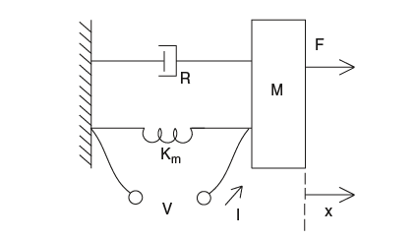

Fig1Assuming linear variation of Height and Breadth,

Height as a function of length as

Simple harmonic oscillator

**Euler-Bernoulli Equation of Beams**

Vibration is the source of the sound. Here the study is carried out to find the relation between sound and vibration of beams. The natural frequency, forced vibration response of beams under different boundary conditions are considered. Here a Euler-Bernoulli beam is studied. The vibration of beams was studied using Rayleigh Ritz method and Finite element method.A small element of a beam is considered.

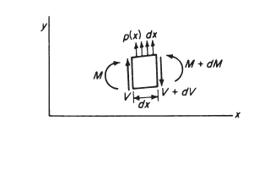

Fig 2.Free body diagram of a finitely small element of beam

*V and* M are shear and bending moments, respectively, and *p(x)* represents the loading per unit length of the beam.

By summing forces in the y-direction,

$dV-p\left(x\right)dx=0$ (1)

By summing moments about any point on the right face of the element,

 $$dM-Vdx-\frac{1}{2}p\left(x\right)({dx)}^{2}=0$$

(2)

In the limiting process, these equations result in the following important relationships:

and (3)

The first part of Eq. (3) states that the rate of change of shear along the length of the beam is equal to the loading per unit length, and the second states that the rate of change of the moment along the beam is equal to the shear.

From Eq. (3), we obtain the following:

** (4)

The bending moment is related to the curvature by the flexure equation,

** (5)

Substituting this relation into Eq. (4) we obtain

 (6)

For a beam vibrating about its static equilibrium position under its own weight, the load per unit length is equal to the inertia load due to its mass and acceleration. Because the inertia force is in the same direction as *p(x),* we have, by assuming harmonic motion,

 (7)

Where *p* is the mass per unit length of the beam. By using this relation, the equation for the lateral vibration of the beam reduces to

**(8)

Inthe special case where the flexural rigidity *EI* is a constant, the preceding equation can be written as

** (9)

On substituting

 (10)

we obtain the fourth-order differential equation

 (11)for the vibration of a uniform beam.

The general solution of Eq. (11) can be shown to be

 (12)

**EULER EQUATION OF BEAM ON FREE -FREE BEAM**

The boundary condition for a free-free are ,no external force or moments i.e

and (13)

Hence and  at x=0 and x=L

On substituting the boundary conditions in Eq (12) we obtain

 (14)

 (15)

Figure 3 indicates graphically the variation ofand 

From figure 3 it can be observed that the roots of the equation are located at the point of intersection between the two curves.

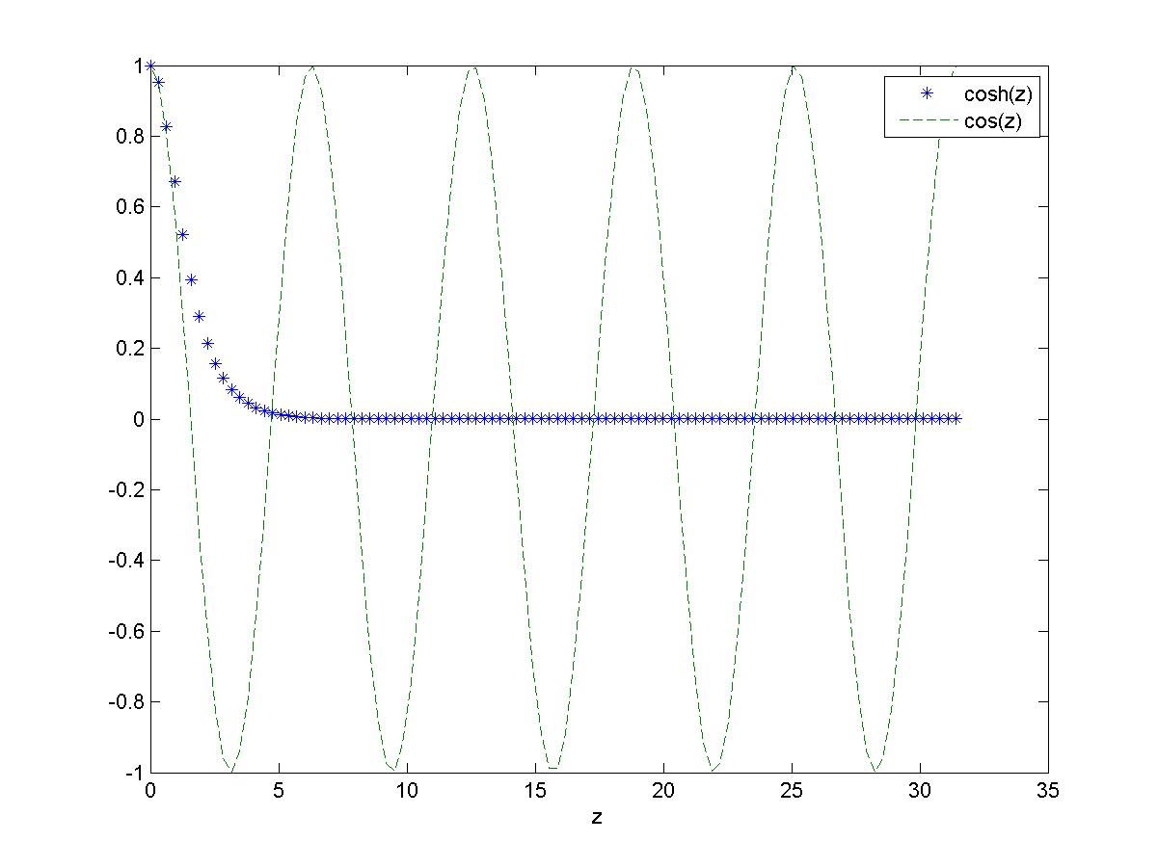

Fig .3 Graphical representation of and  as a function of z

The values of $βL$ are 4.73,7.853,10.995,14.137 ,17.27 …

Substituting the boundary conditions in equation 12 with the coefficient of  as unity , there exists a relation between A,B,C & D

A:B:C: D=

Where 

 (16)

**EULER BERNOULLI EQUATION OF BEAM ON FIXED-FIXED BEAM**

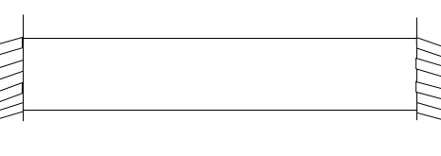

Fig 4. A fixed-fixed beam with a rectangular cross-section

The boundary condition of a FIXED-FIXED beam are :

and (17)

So  and  at x=0 and x=L

On substituting the boundary conditions in Eq (12)

 (18)



The values of $βL$ are 4.73,7.853,10.995,14.137 ,17.27 ….

And there exists a relation between A,B,C&Dwhere A,B,C & D are the coefficients of , , andin eq.12

A:B:C: D=

Where 



For an nth mode

$ϕ_{n}=A\cosh{β_{n}x+B\sinh{β_{n}x+C\cos{β_{n}x}+D}\sin{β_{n}x}}$ (19)

**PARAMETER VALUES OF THE BEAM**

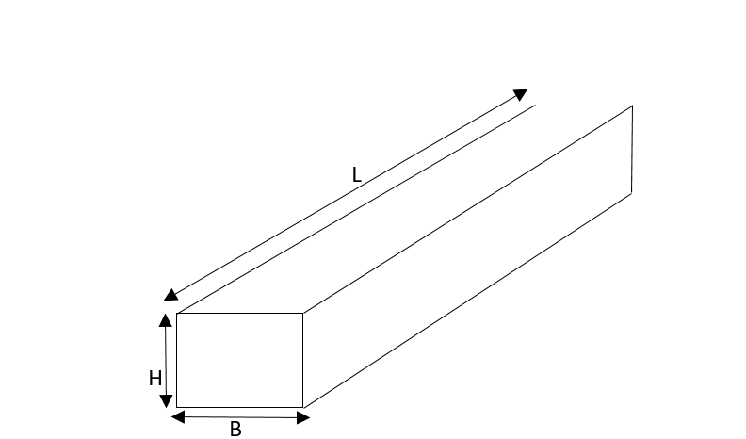

Fig5.A beam with a uniform rectangular cross section

|  |  |
| --- | --- |
| PARAMETERS | VALUES |
| Length(L) | .3m |
| Breadth(B) | .04m |
| Height(H) | .02m |
| Area(A) | .0008m2 |
| Second moment of Area(I) | .267e(-7)m4 |
| Youngs Modulus(Y) | 210e(9)Nm-2 |
| Density() | 8025Kgm-3 |

Table.1.Properties of the beam

**RAYLEIGH RITZ METHOD**

In the Rayleigh Ritz method, the ddisplacement profile of the beam is considered as a function of different trignometric functions satifying the boundary conditions.

 (20)

whereare any admissible functions satisfying the boundary conditions.

 (21)

*Umax*(maximum potential energy)and*Tmax (*maximum kinetic energy*)* are expressible in the form of

 (22)

 (23)

where  and 

The stiffness matrix formed withn the elemental entries consitingof and the generalized mass matrix formed from 



In case of the free-free beam, two rigid body modes of the beam translation motion and rotational motion of the spring will form the first two zero Hz natural frrequencies.

Eigenvalue problem is solved the eigenvectors obtained represent the mode shape and the natural frequency is square root of the eigenvalue..

For the free-free beam, the natural frequencies obtained are

|  |  |
| --- | --- |
| S.I NO | FREQUENCY(Hz) |
| 1 | 0 |
| 2 | 0 |
| 3 | 1169.2 |
| 4 | 3223.1 |
| 5 | 6318.5 |
| 6 | 10445 |
| 7 | 15603 |

Table 2.Natural frequencies of the beam with Free-Free boundary conditions

The first two mode shapes show the rigid motion of the free- free beam. They are the translational motion and rotational motion of the beam as a whole.

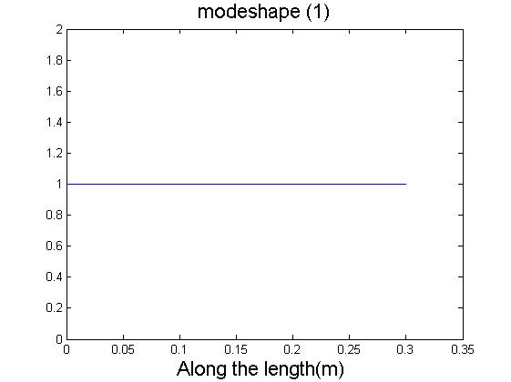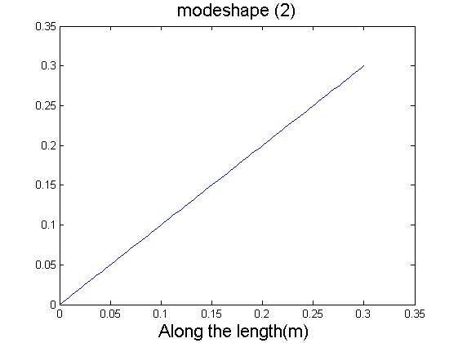

Fig 6.1.Modeshape corresponding to the first Fig 6.2.Modeshape corresponding to the second natural frequency natural frequency

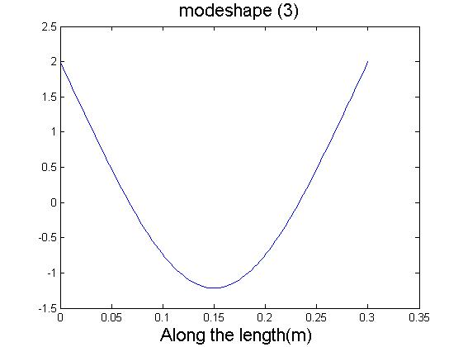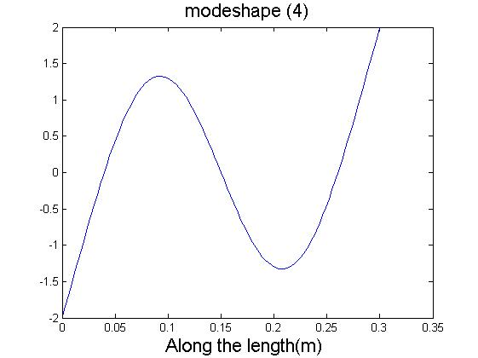 Fig 6.3.Modeshape corresponding to the third Fig 6.4.Modeshape corresponding to the fourthnatural frequency natural frequency

Fig 6.Modeshapes of Free-Free beam

However for the fixed-fixed beam, no zero frequnecy modes as expected are observed the natural frequencies obtained are

|  |  |
| --- | --- |
| S.I NO | FREQUENCY(Hz) |
| 1 | 1169.2 |
| 2 | 3222.9 |
| 3 | 6318.4 |
| 4 | 10444 |
| 5 | 15604 |

Table 3.Natural frequencies of the beam with Fixed-Fixed boundary conditions

The mode shapes of the fixed-fixed beam are given below.

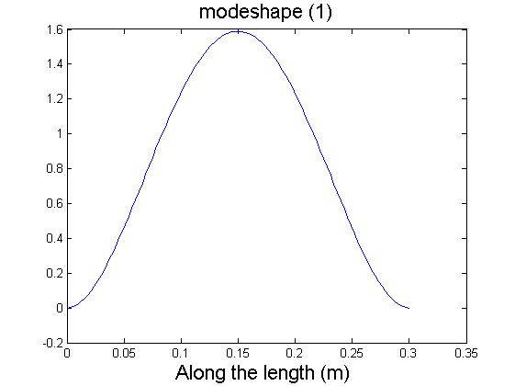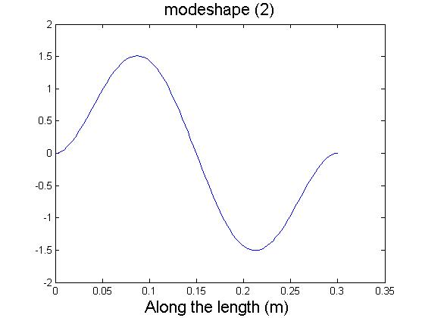 Fig 7.1.Modeshape corresponding to the first Fig 7.2.Modeshape corresponding to the second natural frequency natural frequency

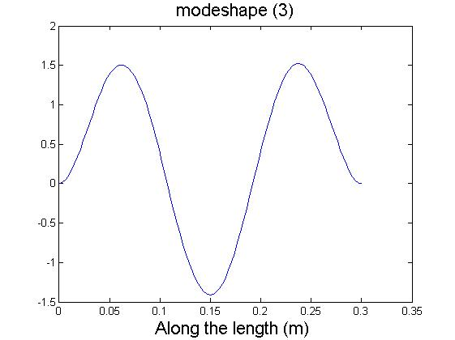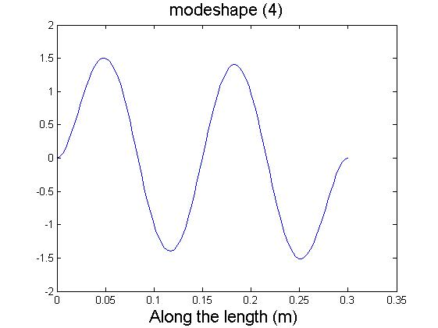

Fig 7.3.Modeshape corresponding to the third Fig 7.4.Modeshape corresponding to the fourth natural frequency natural frequency

Fig 7.Modeshapes of Fixed-Fixed beam

In fixed-fixed beam, both the translation and rotational degrees of freedom are restricted.This is evident by the zero slope observed on the mode shape near the boundary.

**FINITE ELEMENT METHOD**

Finite element method is another numericaltechnique to determine the dynamic behaviour of the structure. The beam is discritised into n elements. Each element consists of four degrees of freedomThe stiffness matrix, as well as the mass matrix, are determined from the potential and kinetic energy, provided the shape functions of the beam are known. The length of each element is

 (24)

whereis the length of the beam

The displacement profile is expressed in the form of a cubic polynomial

 (25)

where and constants

Differentiating of the equation yields Slope equation

 (26)

Let’s take the first element

If we apply the boundary conditions at = 0 and = 1, the boundary equations can be expressed by the following matrix equation:

 (27)

Multiplying the equation with the inverse of coefficient matrix of 

 (28)

This equation enables the determination of the for each of the displacements equated to unity with all the others equal to zero. That is, for  with all other displacements equal to zero, then the equation becomes

 (29)

 (30)

Substituting the values in equation in 25 gives the shape function

 (31)

Similarly substituting for and gives the shape functions as

 (32)

 (33)

 (34)

**GENERALISED STIFFNESS AND GENERALISED MASS**

Displacement is considered to be a superposition of the above 4 shape functions

 (35)

Where ’s are the end displacements. The kinetic energy of the system is given as:

 (36)

 (37)

Thus the elements of generalized mass matrix isobtained as:

 (38)

After substituting the four shape function and the below mass matrix is obtained

 (39)

The potential energy is obtained as:

 (40) (41)

Thus the elements of generalized stiffnessmatrix is given by

 (42)

The global mass and stiffness matrix is calulated by taking into consideration the elemental

connectivity.

The natural frequency is obtained by solving the eigenvalue problem.

In case of the free-free beam, a small stiffness is added to avoid unphysical complex eigenvalue. The magnitude of spring stiffnees is nearly negligle and does not alter the boundary condition significantly.

Table.4.The natural frequency of the beam under Free-Free boundary conditions

|  |  |
| --- | --- |
| SI NO | FREQUENCY(Hz) |
| 1 | 0 |
| 2 | 0 |
| 3 | 1169.2 |
| 4 | 3223.1 |
| 5 | 6318.5 |
| 6 | 10445 |
| 7 | 15603 |

For the fixed-fixed beam, the natural frequencies obtained are

|  |  |
| --- | --- |
| SI NO | FREQUENCY(Hz) |
| 1 | 1169.2 |
| 2 | 3234.1 |
| 3 | 6402.3 |
| 4 | 10667 |
| 5 | 17910 |

Table 5.Natural frequency of beam under Fixed-Fixed boundary conditions

When comparing free-free beam and fixed-fixed the first two frequency of the free-free beam comes out to be zero. The mode shapes of the free-free and fixed-fixed beam are given below

**Free -free beam**

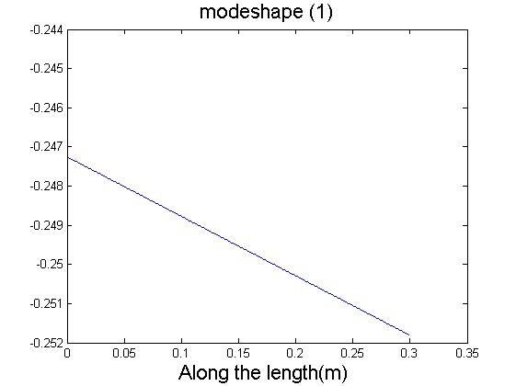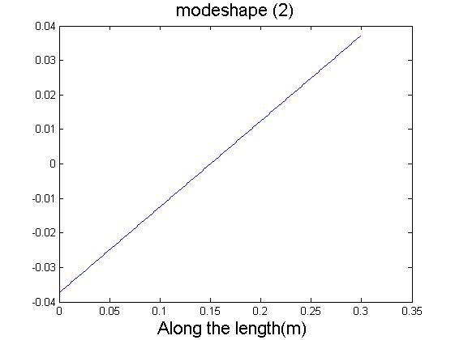

Fig 8.1.Modeshape corresponding to the first Fig 8.2.Modeshape corresponding to the second natural frequency natural frequency

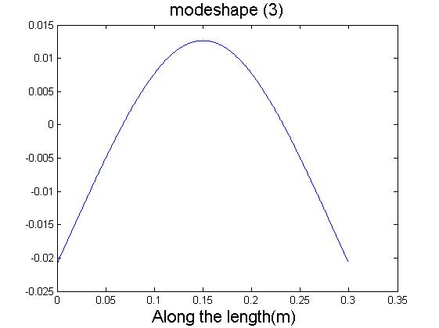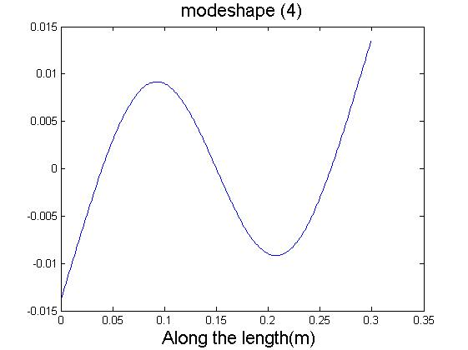

Fig 8.3.Modeshape corresponding to the thirdFig 8.4.Modeshape corresponding to the fourth natural frequency natural frequency

Fig 8.Modeshapes of Fixed-Fixed beam

The first two mode shapes show the rigid motion of the free-free beam. They are the translational motion and rotational motion of the beam as a whole.

**Fixed-Fixed beam**

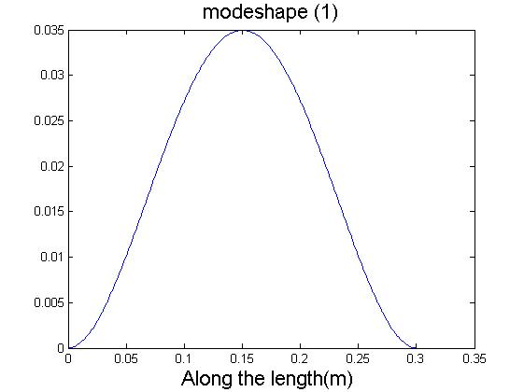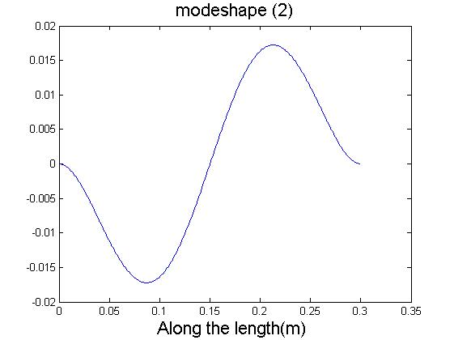

Fig 9.1.Modeshape corresponding to the first Fig 9.2.Modeshape corresponding to the second natural frequency natural frequency

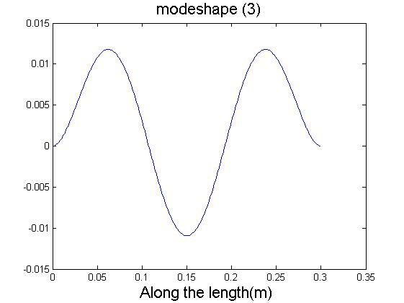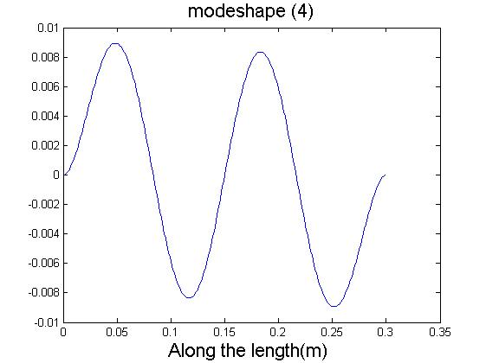

Fig 9.3.Modeshape corresponding to the third Fig 9.4.Modeshape corresponding to the fourth natural frequency natural frequency

Fig 9.Modeshapes of Fixed-Fixed beam

The above mode shapes satisfy the boundary conditions of the fixed-fixed beam. The slopes and translational displacements are both zero at the ends.

**TAPERED BEAM**

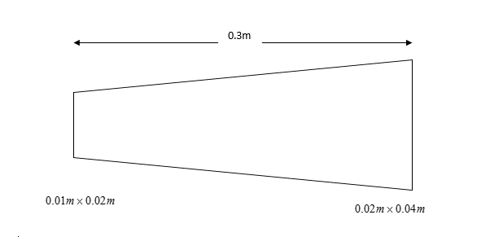

Fig10.A tapered beam with varying rectangular cross section as similar to the frustum of a pyramid

|  |  |
| --- | --- |
| PARAMETERS | VALUES |
| Length(L) | .3m |
| Youngs Modulus(Y) | 210e(9)Nm-2 |
| Density() | 8025Kgm-3 |

Table 6.Properties of the tapered beam

Tapering in geometry refers to gradual narrowing towards one side.Often in most cases, a rectangular beam cannot be used.The above is a tapered beam with a rectangular cross section. In structures like the ship , structural variations are more in the aft and fore part, mainly depends onhydrodynamics.Tapered beam will be a better solution compared to the usage of cuboidal beam

The beam has a rectangular cross section through out the length.Assuming linear variation of Height and Breadth,Height as a function of length as

and (48)

 (49)

The natural frequencies of the tapered beam are

|  |  |
| --- | --- |
| SI.NO | Frequency(Hz) |
| 1 | 0 |
| 2 | 0 |
| 3 | 892.02 |
| 4 | 2400.6 |
| 5 | 4659.6 |
| 6 | 7667.6 |

Table 7The natural frequency of the tapered beam under Free-Free boundary conditions

**COMPOSITE TAPERED BEAM**

Always beams cannot of same material. It can change depends on the usage

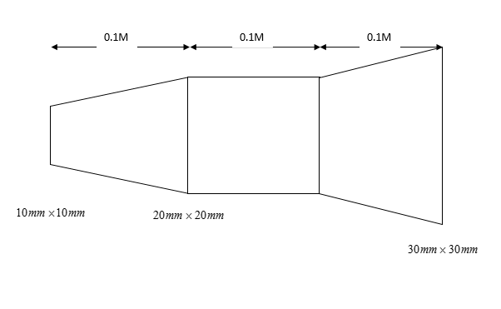

Fig11.A composite tapered beam comprises of two frustums of a pyramid and a cuboidal beam

FIFURE 11 shows a complex beam The first portion is a frustum of a pyramid, the second one is cuboid and third one is again a frustum of a pyramid.

Using Rayleigh-Ritz method the natural frequency obtained for the FREE-FREE beam are

|  |  |
| --- | --- |
| S.I NO | FREQUENCY(Hz) |
| 1 | 0 |
| 2 | 0 |
| 3 | 3006.6 |
| 4 | 7130 |

Table 8.The natural frequency of the tapered beam under Free-Free boundary conditions

The mode shapes of the beam are

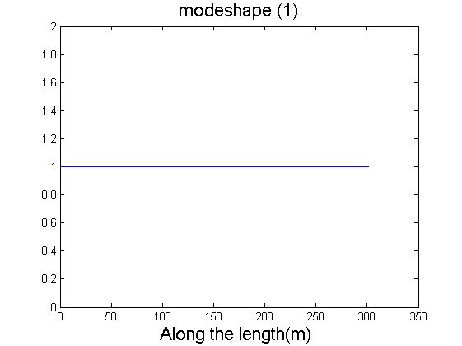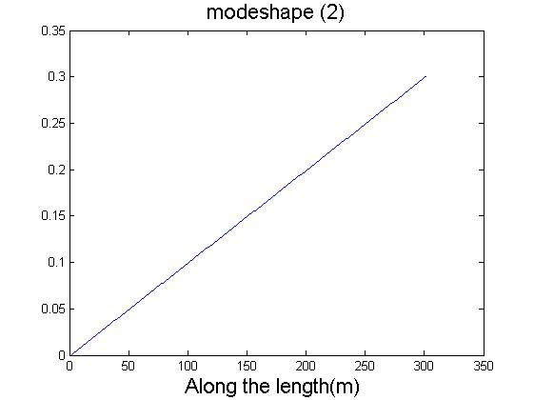

Fig 12.1.Modeshape corresponding to the first Fig 12.2.Modeshape corresponding to the second natural frequency natural frequency

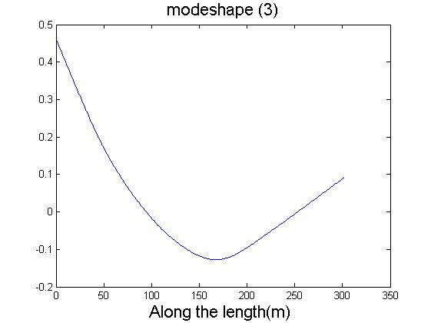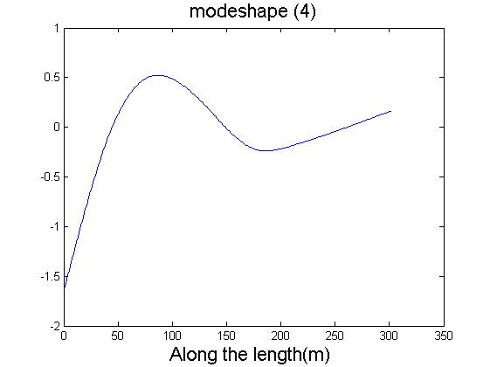

Fig 12.3.Modeshape corresponding to the third Fig 12.4.Modeshape corresponding to the fourth natural frequency natural frequency

Fig 12.Modeshapes of Fixed-Fixed beam

**RESPONSE**

The Free Free beam is divided into 6 elements and a unit force F=1000 Newton is applied to the fourth node as shown in the fig.13. Eventhough the loading is static due the inertial effect the system undergoes an oscillatory behaviour. The response of the 4th node as a function of time is shown in fig 13.

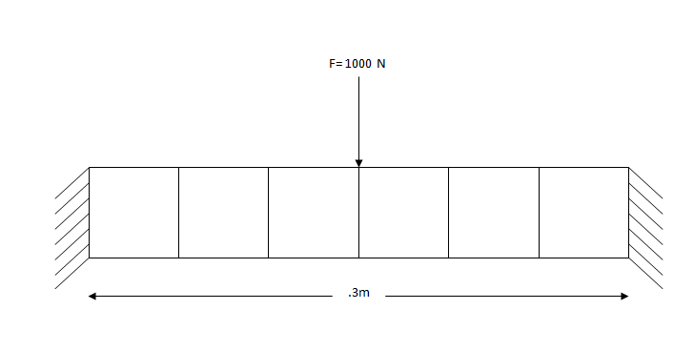

Fig 13. A free-free beam with 1000 Newton force at the 4th node

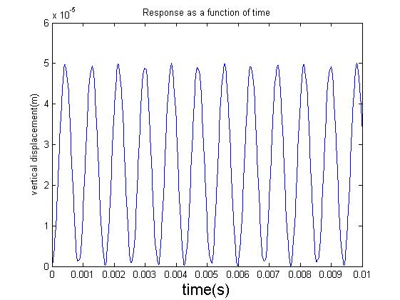

Fig 14.Response of the 4th node as a function of time

**Analysis of the system USING SOFTWARE PACKAGE**

To validate the natural frequency , we modelled the system using Ansys Mechanical APDL. Parameters and conditions of beam considered here are the same as above.We considered the 3 noded beam element 189.

**RESULTS FOR UNIFORM BEAM**

The parameters of the uniform beam considered here is same as in Tabel 1.

The natural frequencies obtained for the uniform beam under Free-Free condition are shown in Table 9. Free-Free boundary conditions are applied at the ends.

|  |  |
| --- | --- |
| S.I NO | FREQUENCY(Hz) |
| 1 | 0 |
| 2 | 0 |
| 3 | 1150 |
| 4 | 3083 |

Table 9.The natural frequency of the uniform beam under Free-Free boundary conditions.

The natural frequencies obtained for the uniform beam under Fixed-Fixed condition are shown in Table 10. Fixed-Fixed boundary conditions are applied at the ends.

|  |  |
| --- | --- |
| S.I NO | FREQUENCY(Hz) |
| 1 | 1134.5 |
| 2 | 3016.3 |
| 3 | 6218.3 |
| 4 | 9889.9 |

Table 10.The natural frequency of the uniform beam under Fixed-Fixed boundary conditions.

using for the both the boundary conditions provided earlier

**RESULTS FOR TAPERED BEAM**

Parameters of the considered tapered beam is same as that in Table.6 . Height and Breadth of the beam follows Eq 48 and Eq 49 respectively.

The natural frequencies obtained for the tapered beam under Free-Free condition is noted down in Table 11. Free-Free boundary conditions are applied at the ends

|  |  |
| --- | --- |
| S.I NO | FREQUENCY(Hz) |
| 1 | 0 |
| 2 | 0 |
| 3 | 883.84 |
| 4 | 2342.1 |

Table 11.The natural frequency of the tapered beam under Free-Free boundary conditions

**COMPOSITE TAPERED BEAM**

The parameters of the considered Composite Tapered Beam is same as in Fig .11.

The natural frequencies obtained for the composite tapered beam under Free-Free condition is noted down in Table 12. Free-Free boundary conditions are applied at the ends

|  |  |
| --- | --- |
| S.I NO | FREQUENCY(Hz) |
| 1 | 0 |
| 2 | 0 |
| 3 | 2999.2 |
| 4 | 7087.5 |

Table 12.The natural frequency of the composite tapered beam under Free-Free boundary conditions

**RESPONSE**

Transient analysis of the beam in fig 13 was conducted by using mechanical apdl for a load step time of .01 seconds . This is to simulate a condition of constant load. The step size is equal to the duration of analysis. Vertical displacement of the 4th node beam was ploted as a function of time.

The response of the 4th node as function of time is shown in fig 14.

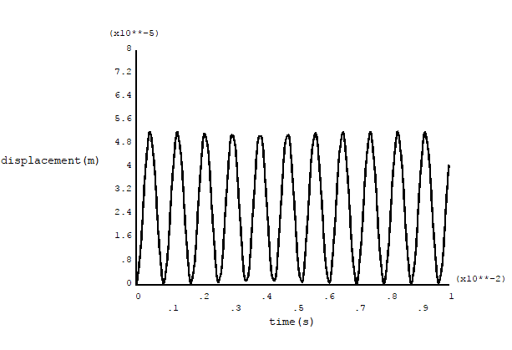

Fig 15. Response of the 4th node as a function of time

**DAMPING ANALYSIS**

AThe analysis carried out till now assumed the structure to be undamped. However it is know fact that practical most of the structures have an inherent damping. Therefore the beam analysis is extended by including the influence of damping. Initially the case of SDOF system is analysed. Depending on the damping, system can be classifeid as

Case 1: Over Damped

Case 2: Critical Damped

Case 3:Under Damped

We are considering only the under damped cases here.

**VISCOUSLY DAMPED FREE VIBRATION**

To get a better clarification , we first consider a damped single degree freedom system.

Viscous damping force is expressed by the equation

 (50)

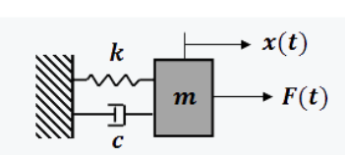

Fig 16. Viscously Damped Forced Vibration

where  is a constant of proportionality and  is the stiffness of the system.

The equation of motion is

 (51)

Assuming the solution to be  (52)

And substituting Eq (52) inEq (51), we obtain

 (53)

Since  cannot be zero we obtain

 (54)

Eq(54) is known as the characteristicequation , has two roots

 (55)

Hence the general solution is given by

 (56)

Where A and B are determined by appling the boundary conditions.

On substituting Eq. (55) inEq. (56) we get

 (57)

The three cases of damping are

Case 1: 

Exponent terms are real numbers and no oscillations are possible. This case is referred to as over damped.

Case 2: 

Exponent terms are complex numbers and it is oscillatory. This case is referred to as under damped.

Case 3: 

The damping is called critical damping.

 (58)

Damping ratio can be expressed as

 (59)

For a Multi Degree of Freedom system,the damped vibration can be expressed as

 (60)

Where  and  represent mass matrix , damping matrix , stiffness matrix and force vector respectively.

and are the displacements , velocities and accelerations of the degress of freedom.

, and  (61)

One of the widely used approach to model damping is Rayleigh damping

**RAYLEIGH DAMPING**

In Rayleigh damping model , the damping matrix is expressed as a linear combination of mass matrix and stiffnesmatrix , i.e.,

 (62)

Where andare real scalars with 1/sec and sec units respectively.

The damping ratio for the nth mode of such a system is:

 (63)

Two methods were used to formulate Rayleigh Damping

1).Solving Using Quadratic Method

The eigenvectors of the undamped system follows orthogonality condition i.e.,

 (64)

 (65)

Where represents eigenvector

For a ‘n’ number of elements there are ‘2n+2’ degrees of freedom so ‘2n+2’ eigenvectors.

These eigenvectors can be assembled to form square matrix of size ‘2n+2’, where each normal node is represented by a column. This square matrix is called as modal matrix .

Considering the following damped free vibration equation

 (66)

Substituting  the Eq.66 becomes

 (67)

, and  (68)

Premultiply Eq.(66) with , we get

 (69)

From Eq.64 and Eq.65 ,andare diagonal matrices.Since damping matrix is proportional to sum of mass matrix andstiffness matrix, is also a diagonal matrix. Eq.68 can be written as



(70)

Where and  are the diagonal elements of and  respectively.

Thus instead of 2n+2 coupled equations ,we got 2n+2 uncoupled equation.

Here ‘n’ represents the number of nodes and 2n+2 is the total number of degrees of freedom.

For an eq of motion , we got the equation as

 (71)

Thus we have 2n+2 homogenous 2nd order equations.

On assuming the solution to  (72)

On substituting Eq.(72) in Eq.71 , we obtain

 (73)

Since  cannot be zero we obtain

 (74)

Eq.74 is known as the characteristic equation , has two roots

 (75)

On substituting the frequency values in Eq75 , we get



.

.

.

` .

 (76)

This is a non-homogenous system. The only way to solve this system is to equate all the equation and take the ratio of the coordinates as given eq. 77.

It can be easily shown that

 (77)

Assuming one of the dof say y1 gives the eigenvector of the system.

Assuming the rayleigh coefficients and  as

=.00001

=.00001

we obtain the natural frequencies as:

|  |  |
| --- | --- |
| SI NO | Eigenvalues |
| 1 | 0 |
| 2 | 0 |
| 3 | -43i 1169.76 |
| 4 | -330.24i3226.2 |
| 5 | -1273i6239.65 |

Table 12. The natural eigenvalues of the uniform beam under Free-Free boundary conditions

The complex part represents the decaying amplitude part and real part represents the natural frequency of the system.

|  |  |
| --- | --- |
| SI NO | Natural Frequency |
| 1 | 0 |
| 2 | 0 |
| 3 | 1169.76 |
| 4 | 3226.2 |
| 5 | 6239.65 |

Table 13. The natural frequencies of the uniform beam under Free-Free boundary conditions

Lets take the number of elements as 1 for the calculation purpose. The results might not converge, this is just for calculation purpose.

For n=1,

The results might not converge

For the uniform beam considered in the above cases under free-free boundarycondition,eigenvectors obtained are

|  |  |  |  |  |
| --- | --- | --- | --- | --- |
| SI.NO | First Mode | Second Mode | Third Mode | Fourth Mode |
| 1 | .01 0.013i | -.707 | -.104 | .034.009i |
| 2 | -.44-.556i | 0 | .699 | -.68.184i |
| 3 | -.01.014i | -.707 | .104 | .034+.009i |
| 4 | -.44.55i | 0 | .699 | .68.1844i |

Table 14.Eigenvector of the uniform beam under Free-Free boundary conditions

2).Transformation of 2nd Order system to First Order

Here we reformulate the problem in aslightly different form. Let Y be a 4n+4rows vector composed of velocities and displacements, i.e.

Y= (78)

Where  is a 2n+2 rows vector composed of the physical displacements and is a 2n+2 vectors composed of the physical velocities.

and (79)

Eq.66 can be written as

 (80)

Or

 (81)

Where

and (82)

PremultiplyingEq.(80) with and rearranging ,we get

 (83)

The entires system is now represented in terms of the linear function of .

Eigenvalues and eigenvectors can be easily found out from Eq83.

The eigenvalues found are

|  |  |
| --- | --- |
| SI NO | Eigenvalues |
| 1 | 0 |
| 2 | 0 |
| 3 | -42.4i 1171.76 |
| 4 | -327.24i3228.2 |
| 5 | -1275i6242.65 |

Table 15. The eigenvalues of the uniform beam under Free-Free boundary conditions

The complex part represents the decayed amplitude part and real part represents the natural frequency of the system.

|  |  |
| --- | --- |
| SI NO | Damped Natural Frequency(Hz) |
| 1 | 0 |
| 2 | 0 |
| 3 | 1171.76 |
| 4 | 3228.2 |
| 5 | 6242.65 |

Table 16. The natural frequency of the uniform beam under Free-Free boundary conditions

The eigenvectors obtained are

|  |  |  |  |  |
| --- | --- | --- | --- | --- |
| SI.NO | First Mode | Second Mode | Third Mode | Fourth Mode |
| 1 | .01 0.014i | -.706 | -.101 | .032.008i |
| 2 | -.43-.566i | 0 | .701 | -.68.19i |
| 3 | -.01.019i | -.706 | .101 | .032+.008i |
| 4 | -.41.58i | 0 | .701 | .68.19i |

Table 17. Eigenvector of the uniform beam under Free-Free boundary conditions

The values are reasonably comparable in both methods , small discreprencies could be due to numerical errors.

**RESPONSE**

Rayleigh damping is given to the system as shown in the fig.13.The response of the 4th node as a function of time is shown in fig 16.

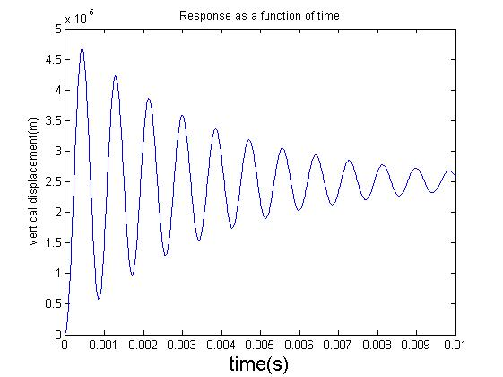

Fig 16.Response of the 4th node as a function of time

The transient analysis of the same system is carried out using Mechanical APDL for a loadstep time of .01 seconds.The response of the 4th node is shown in fig 17.

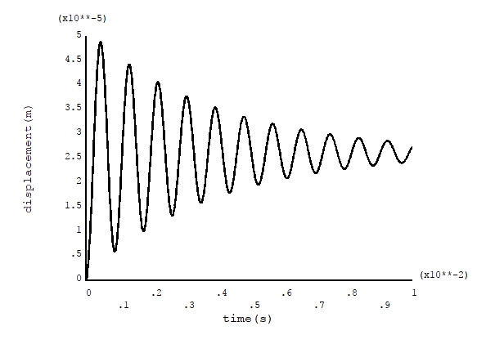

Fig 16.Response of the 4th node as a function of time in mechanical apdl