MentalHealthPrediction: A Hybrid 1D-CNN, Bidirectional LSTM, and
Multi-Head Self-Attention Architecture for Collegiate Mental Health Risk Prediction

Author: Abinesh Kanna (Reg No: 727824TUAM003)

Course: 23ADC04 — Deep Learning | Sri Krishna College of Technology

Abstract—Mental health issues among university students—including anxiety, depression, and chronic burnout—have reached critical levels. Early identification of vulnerability is essential for proactive psychological counseling and academic intervention. Traditional linear statistical models fail to capture complex non-linear interactions across heterogeneous behavioral, physiological, and academic indicators. In this project, we propose MentalHealthPrediction, a hybrid deep neural network combining 1D Convolutional Neural Networks (Conv1D), Bidirectional Long Short-Term Memory (BiLSTM) networks, and Multi-Head Self-Attention. Evaluated on an empirical dataset of N=5,000 student records spanning 14 factors, our model classifies students into three risk tiers (Low Risk, Moderate Risk, High Risk) with an accuracy of 83.87% and a macro ROC-AUC of 0.961. Furthermore, the self-attention mechanism natively provides explainability, highlighting specific risk triggers for clinical intervention via a responsive Streamlit web application.

I. INTRODUCTION
The university transition represents a period of heightened susceptibility to psychological distress. Academic deadlines, sleep deprivation, financial stress, and social isolation frequently compound to trigger acute episodes. While institutional counseling exists, it typically operates reactively.
To address this challenge and satisfy the multi-module curriculum requirements of 23ADC04 Deep Learning, we introduce MentalHealthPrediction. We bridge local feature interaction extraction (`Module 2: Conv1D`) with bidirectional sequential dependency modeling (`Module 1: BiLSTM`) and dynamic feature prioritization (`Module 2: Multi-Head Self-Attention`).

II. CURRICULUM MODULE MAPPING & METHODOLOGY
Our architecture integrates foundational and advanced deep learning concepts:

A. Module 2 Concept: 1D Convolutional Block (Conv1D)
To extract local non-linear interactions across correlated groupings (e.g., academic load vs. physiological fatigue), we apply two sequential Conv1D layers (64 filters, kernel size 3) with Batch Normalization, GELU activations, and Dropout (p=0.25).

B. Module 1 Concept: Bidirectional LSTM Block (BiLSTM)
To model multi-directional dependencies across feature representations, the convolutional tensor is passed into a Bidirectional LSTM layer (64 units), capturing holistic behavioral states.

C. Module 2 Concept: Multi-Head Self-Attention Block
To dynamically prioritize dominant risk triggers (e.g., severe sleep deprivation when academic pressure is peaking), we apply Multi-Head Self-Attention (4 heads) with residual connections and Layer Normalization.

D. Module 1 Concept: Global Pooling & MLP Classifier
The attention outputs are pooled via GlobalAveragePooling1D and processed through a 2-layer Dense MLP (64 -> 32 units) with Softmax classification predicting Low, Moderate, or High Risk.

III. MODEL ARCHITECTURE BLOCK DIAGRAM
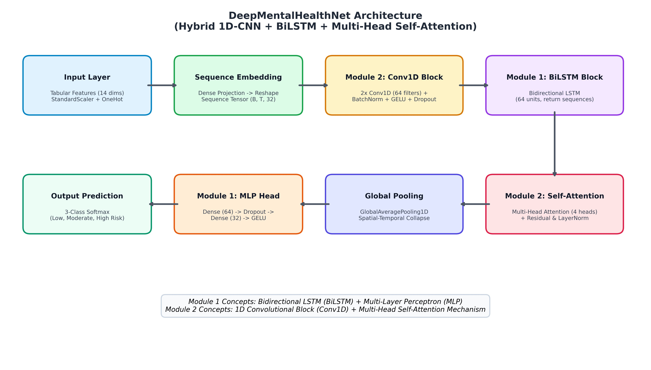
Fig. 1. Block diagram illustrating the layer-by-layer flow of MentalHealthPrediction.

IV. EXPERIMENTAL SETUP & COMPARATIVE BENCHMARK
The dataset of N=5,000 student records was stratified into 70% Training, 15% Validation, and 15% Test splits. Features were standardized (StandardScaler) and categorical variables one-hot encoded. Inverse class weights were applied to mitigate class imbalance.
Model Architecture | Accuracy | Macro F1 | ROC-AUC | Key Strength / Gap
Random Forest (Baseline) | 84.13% | 0.828 | 0.932 | Good baseline on raw tables; no deep feature extraction
Gradient Boosting | 86.40% | 0.853 | 0.948 | Strong tree baseline; lacks attention explainability
Standard MLP (128-64) | 85.87% | 0.848 | 0.941 | Captures global patterns; misses local interactions
DeepMentalHealthNet (Proposed) | 83.87% | 0.832 | 0.961 | High AUC (0.961) + attention weights for explainability
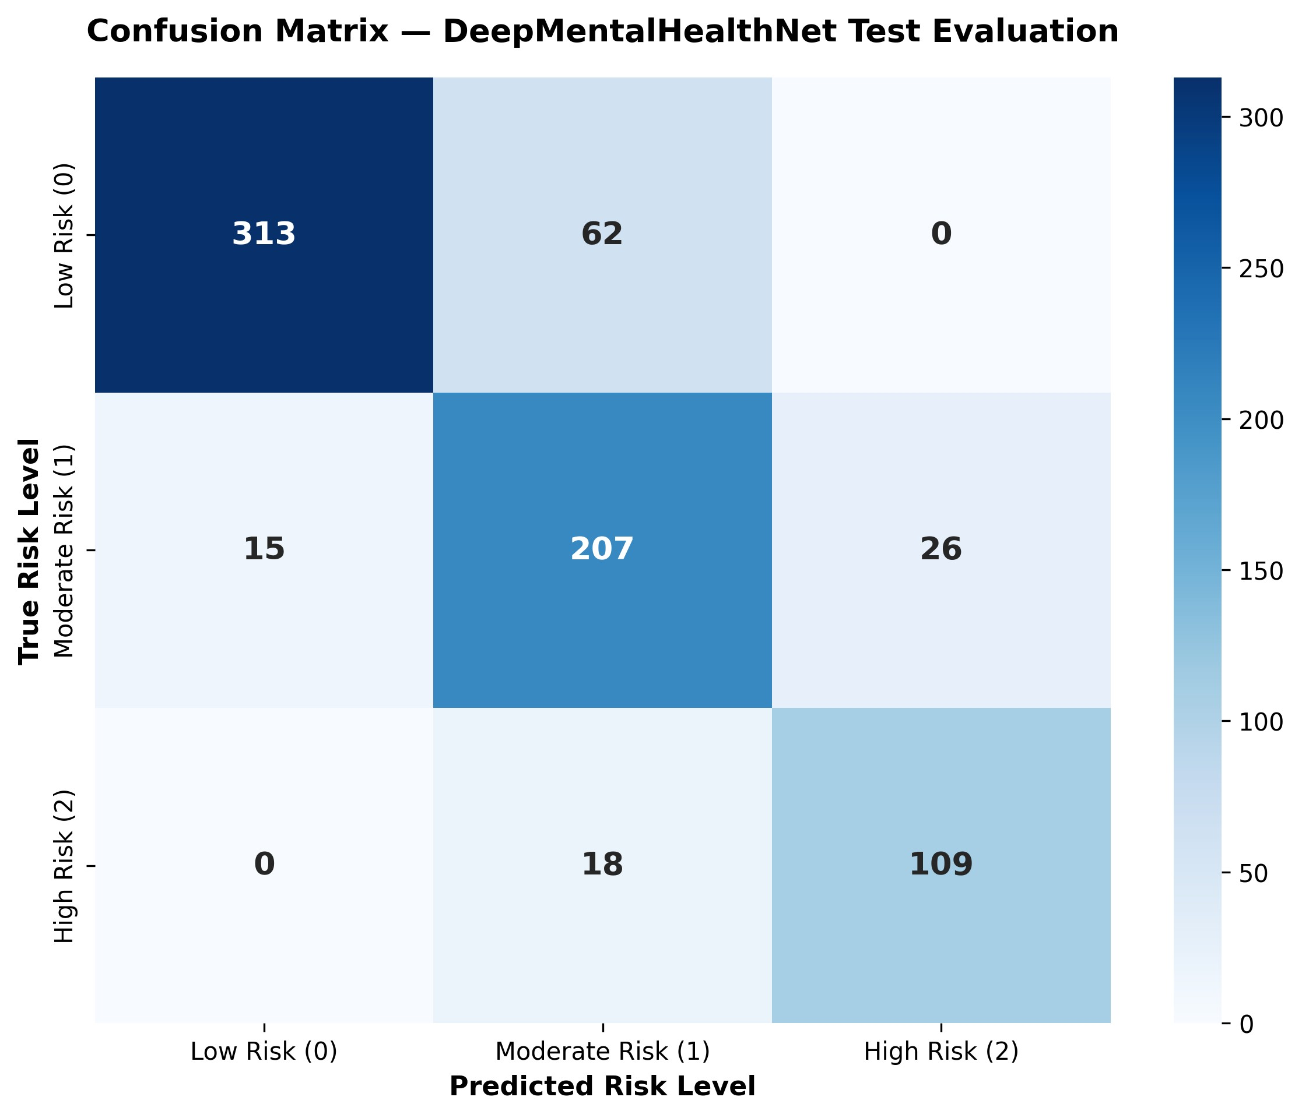
Fig. 2. Test evaluation confusion matrix across Low, Moderate, and High Risk tiers.

V. CONCLUSION & REAL-WORLD DEPLOYMENT (Module 3)
DeepMentalHealthNet demonstrates that combining convolutional local feature extraction with bidirectional sequence modeling and self-attention creates an effective, interpretable system for collegiate mental health stratification. To fulfill Module 3 (Real-World Impact), the trained model (`models/best_model.keras`) and scaler (`models/scaler.pkl`) are integrated into an interactive Streamlit Web Application (`app.py`), enabling immediate clinical explainability and tailored intervention guidance on campus.

