ACKNOWLEDGEMENT
First and foremost, we would like to express our sincere gratitude to Almighty God for granting us the strength, wisdom, and determination to prepare this project requirement document.
We would also like to extend our heartfelt appreciation to our advisors and instructors for their valuable guidance, constructive comments, and continuous support throughout the analysis and design phases of this project.
Our special thanks go to the Department of Computer Science and Engineering and our university for providing us with the knowledge, resources, and academic environment necessary for the preparation of this work.
We are also grateful to the staff members and stakeholders who shared their knowledge and experiences in inventory management, which greatly contributed to the requirement gathering and system design activities.
Finally, we would like to thank our families and friends for their encouragement, patience, and moral support during the preparation of this project proposal.
Although the implementation and testing phases of the Stock Management System are still in progress, we believe that the guidance and support we have received will contribute significantly to the successful completion of the project.

ABSTRACT
The Stock Management System is a web-based application designed to automate and improve inventory management activities within an organization. The system aims to replace traditional manual procedures with a computerized solution that increases efficiency, accuracy, transparency, and accountability in stock administration.
The existing inventory management process relies heavily on paper-based records, bin cards, stock record cards, and manual calculations. These methods are time-consuming and susceptible to human errors, data loss, stock shortages, overstocking, and delays in report generation. To address these challenges, the proposed system provides an integrated platform for managing inventory operations.
The system includes modules for user management, supplier management, stock classification, stock receiving, stock issuing, stock transfer, stock tracking, stock valuation, stock taking, report generation, and audit logging. The system also supports inventory valuation using the First-In-First-Out (FIFO) method and implements role-based access control to ensure data security.
The project follows the Agile software development methodology, which includes requirement gathering, system analysis, design, implementation, testing, deployment, and maintenance. Modern technologies such as React.js, Node.js, Express.js, and PostgreSQL will be used to develop the application.
The proposed Stock Management System is expected to reduce paperwork, minimize operational costs, improve decision-making, and provide real-time inventory information. Ultimately, the system will enhance the effectiveness of inventory management and contribute to better organizational performance.

Chapter One
Introduction
1.1 Background
Inventory management plays a vital role in the daily operations of organizations such as government institutions, universities, hospitals, warehouses, and private companies. Every organization depends on materials, equipment, and supplies to carry out its activities efficiently. Therefore, proper management of these resources is essential to ensure their availability whenever they are needed.
Traditionally, many organizations manage their inventories using manual methods such as paper records, stock cards, bin cards, and handwritten reports. Although these methods have been used for many years, they are time-consuming, difficult to maintain, and highly vulnerable to human errors. Problems such as loss of records, inaccurate calculations, stock shortages, overstocking, and delayed reporting frequently occur in manual systems.
With the advancement of information technology, computerized inventory management systems have become an effective solution for managing stock operations. A Stock Management System automates activities such as stock receiving, stock issuing, stock tracking, stock valuation, stock taking, report generation, and inventory control.
The proposed Stock Management System is a web-based application designed to improve inventory management by providing accurate, secure, and real-time information about stock movement and availability. The system will reduce paperwork, improve operational efficiency, and support effective decision-making.
1.2 Statement of the Problem
Many organizations still use traditional methods to manage their inventory. These methods create several operational challenges that negatively affect organizational performance.
The major problems of the existing system include:
- Difficulty in tracking stock movement.
- Human errors during data recording.
- Loss and duplication of inventory records.
- Delays in report generation.
- Overstocking and stock shortages.
- Inaccurate inventory valuation.
- Poor monitoring of damaged and obsolete items.
- Lack of transparency and accountability.
- Limited access to real-time inventory information.
- Difficulty in conducting stock taking and reconciliation.
Because of these problems, organizations require a computerized solution that can automate inventory management activities and improve the efficiency and reliability of inventory operations.
1.3 Purpose of the Project
The purpose of this project is to design and develop a web-based Stock Management System that automates inventory management processes and improves the overall efficiency of stock administration.
The system aims to provide a centralized platform for managing inventory operations, including stock receiving, stock issuing, stock classification, stock tracking, stock valuation, stock taking, and report generation.
The project also aims to minimize manual work, reduce human errors, improve transparency, and provide accurate and real-time inventory information.
1.4 Objective
1.4.1 General Objective
To design and develop a computerized Stock Management System that automates inventory management activities and improves operational efficiency.
1.4.2 Specific Objectives
The specific objectives of the project are:
- To develop a secure authentication and authorization system.
- To manage inventory categories and item codes.
- To register suppliers and manage supplier information.
- To record stock receipts and stock issues.
- To maintain bin cards and stock records.
- To implement FIFO inventory valuation.
- To monitor reorder levels and safety stock.
- To automate stock taking and reconciliation.
- To generate inventory reports and analytics.
- To manage damaged and obsolete stock.
- To maintain audit logs and activity records.
- To provide real-time inventory information.
1.5 Feasibility Study
A feasibility study was conducted to determine whether the proposed Stock Management System is technically, economically, operationally, and schedule-wise feasible.
1.5.1 Technical Feasibility
The proposed system can be developed using modern technologies such as:
- Frontend: React.js or Next.js
- Backend: Node.js and Express.js
- Database: PostgreSQL or MySQL
- API: REST API
- Version Control: Git and GitHub
The development tools and technologies are widely available and suitable for the implementation of the project.
1.5.2 Economic Feasibility
The project is economically feasible. The estimated development cost is 12,000 ETB (as detailed in the cost schedule). This cost is relatively low compared to the long-term benefits. The system is expected to reduce paperwork, minimize inventory losses caused by errors and poor tracking, decrease time spent on stock taking and report generation, and improve overall operational efficiency. The cost of continuing with the current manual system (including losses from stock shortages, overstocking, and delayed decision-making) is significantly higher than the investment required for the computerized system.
1.5.3 Operational Feasibility
The system is operationally feasible. It is designed to be user-friendly so that storekeepers, stock clerks, the Property Administration Officer, accountants, and department heads can use it with minimal training. The system supports the existing organizational workflow rather than completely changing it. Management support and the clear need to solve current inventory problems increase the likelihood of successful adoption. Resistance to change will be managed through training and gradual transition from the paper-based system.
1.5.4 Schedule Feasibility
The project is schedule-feasible. According to the planned task schedule, the total development period is approximately 13 weeks (requirement gathering – 1 week, analysis – 1 week, design – 2 weeks, database design – 1 week, implementation – 4 weeks, testing – 2 weeks, deployment – 1 week, and documentation – 1 week). This timeline is realistic given the scope of the system and the available team resources. Potential delays (such as late feedback from stakeholders) will be managed through regular communication and prioritization of core features.
1.6 Scope and Limitation
1.6.1 Scope
The system will provide the following functionalities:
- User management
- Supplier management
- Inventory classification
- Stock receiving
- Stock issuing
- Stock transfer
- Inventory tracking
- Stock valuation using FIFO
- Bin card management
- Stock record management
- Stock taking and reconciliation
- Report generation
- Audit logging
1.6.2 Limitation
The first version of the system will not support:
- Mobile application integration
- AI-based demand forecasting
- Barcode and RFID integration
- Offline synchronization
- Integration with banking systems
- Multi-organization support
1.7 Significance of the Project
The Stock Management System provides several benefits to organizations.
The significance of the project includes:
- Reducing paperwork and manual calculations.
- Improving inventory accuracy.
- Increasing operational efficiency.
- Improving transparency and accountability.
- Supporting better decision-making.
- Providing real-time inventory information.
- Reducing inventory losses.
- Speeding up report generation.
- Simplifying stock taking procedures.
- Improving inventory control.
1.8 Methodology
The project will follow the Agile software development methodology.
The development process includes:
- Requirement gathering.
- System analysis.
- System design.
- System implementation.
- System testing.
- Deployment.
- Maintenance.
1.8.1 Requirement Gathering
Requirements were collected through interviews with key stakeholders, direct observation of existing inventory processes, review of inventory management manuals, and analysis of paper-based records such as bin cards, stock record cards, and requisition forms.
Interviews were conducted with the Property Administration Officer (PAO), storekeepers, stock clerks, department heads, and the accountant. The interviews focused on current stock receiving and issuing procedures, problems faced with the manual system, reporting needs, user roles and responsibilities, and existing business rules.
From these activities, the following key information was obtained:
- Detailed description of the existing manual workflow
- Major operational problems (tracking difficulty, human errors, delayed reports, stock shortages and overstocking)
- User roles and access needs
- Required inventory reports and valuation method (FIFO)
- Business rules currently applied in the organization
This information formed the foundation for defining the functional and non-functional requirements of the proposed Stock Management System.
1.8.2 System Analysis and Design
System requirements, system architecture, database design, and user interfaces will be analyzed and designed.
1.8.3 Development Tools
Category | Tool
Frontend | React.js / Next.js
Backend | Node.js / Express.js
Database | PostgreSQL / MySQL
API Testing | Postman
Design Tool | Figma
IDE | Visual Studio Code
Version Control | Git and GitHub
Documentation | Microsoft Word
1.9 Testing Procedure
The following testing methods will be used to verify the system:
- Unit testing
- Integration testing
- System testing
- User acceptance testing
- Performance testing
- Security testing
The testing process ensures that the system satisfies all functional and non-functional requirements.

1.10 Team Composition
Role | Responsibility
Project Manager | Manages the project
System Analyst | Analyzes requirements
UI/UX Designer | Designs interfaces
Frontend Developer | Develops the user interface
Backend Developer | Develops APIs and business logic
Database Administrator | Designs and manages the database
Tester | Tests the system
Documentation Specialist | Prepares project documents

1.11 Task and Schedule
Task | Duration
Requirement gathering | 1 week
System analysis | 1 week
System design | 2 weeks
Database design | 1 week
Implementation | 4 weeks
Testing | 2 weeks
Deployment | 1 week
Documentation | 1 week

1.12 Cost Schedule
Item | Estimated Cost (ETB)
Internet and communication | 2,000
Transportation | 1,500
Documentation and printing | 2,500
Software tools | 1,000
Hosting and deployment | 3,000
Miscellaneous expenses | 2,000
Total | 12,000

Chapter Two
Overall Description of the Existing System
2.1 Description of the Existing System
The existing inventory management system is primarily based on manual procedures and paper-based documentation. Different departments request materials from the store by filling out requisition forms, while storekeepers record stock movements using bin cards, stock record cards, and other physical documents.
The system involves several activities, including stock receiving, inspection, storage, issuing, dispatching, stock taking, and report preparation. Most of these activities are performed manually, which requires significant time and effort.
When goods arrive at the warehouse, they are inspected and recorded in stock registers. Likewise, when a department requests materials, the request must be approved by the responsible authority before the items are issued. All transactions are documented using paper forms.
Although the current system provides basic inventory management functions, it lacks automation, real-time monitoring, and efficient reporting mechanisms.

2.2 Major Functions of the Existing System
The existing system performs the following major functions:
- Registration of inventory items.
- Classification and coding of stock items.
- Receiving and inspection of goods.
- Storage and arrangement of inventory.
- Issuing materials to departments.
- Dispatching materials outside the organization.
- Recording stock movement using bin cards.
- Maintaining stock record cards.
- Conducting stock taking and reconciliation.
- Preparing inventory reports.
- Managing damaged and obsolete items.
- Monitoring minimum and maximum stock levels.

2.3 Users of the Current System
The current inventory system involves different actors who perform different responsibilities.
Property Administration Officer (PAO)
The Property Administration Officer supervises all inventory activities and approves stock requests, stock transfers, and inventory reports.
Storekeeper
The storekeeper receives, stores, issues, and safeguards inventory items. The storekeeper also updates bin cards and maintains warehouse records.
Stock Clerk
The stock clerk maintains stock records, updates inventory transactions, and prepares reports.
Department Head
Department heads approve requests from their departments and ensure that materials are used appropriately.
Accountant
The accountant records the financial value of inventory and prepares financial reports.
Security Officer
The security officer controls the movement of materials entering or leaving the organization's premises.
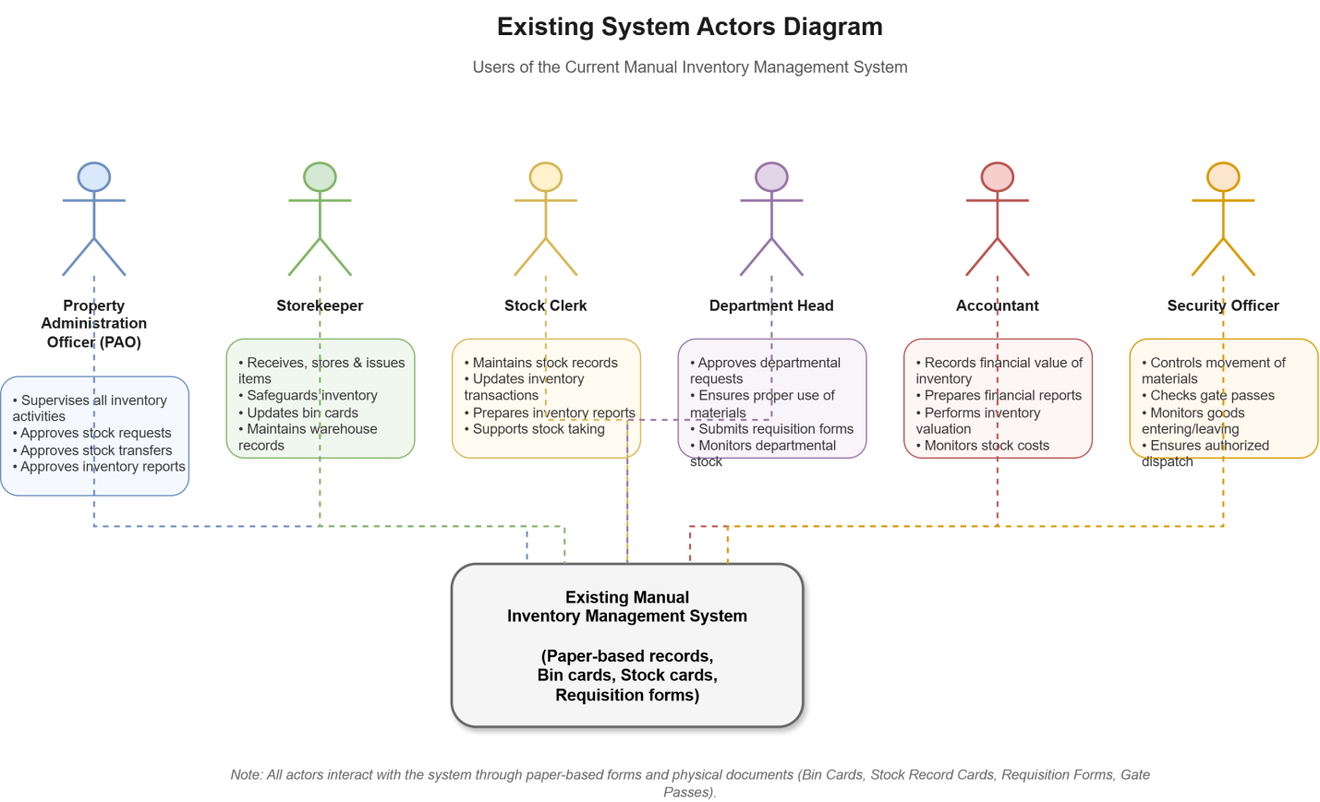
2.4 Drawbacks of the Current System
Although the current system supports inventory management activities, it has several limitations.
The major drawbacks include:
- Heavy dependence on paper documents.
- Time-consuming inventory operations.
- Difficulty in tracking stock movements.
- High possibility of human error.
- Duplicate or missing records.
- Delayed report generation.
- Difficulty in conducting stock reconciliation.
- Inaccurate inventory valuation.
- Limited access to inventory information.
- Lack of data security.
- Poor monitoring of damaged and obsolete items.
- Difficulty in monitoring reorder levels.
- Poor communication between departments.
- Lack of real-time updates.
Because of these limitations, organizations face operational inefficiencies and inventory management challenges.
2.5 Business Rules
Business rules define the policies and constraints that govern inventory operations.
The following business rules apply to the existing system:
- Every inventory item must have a unique item code.
- All received goods must be inspected before being stored.
- Only authorized personnel can approve inventory transactions.
- Inventory cannot be issued without an approved requisition form.
- Every inventory transaction must be recorded.
- Every stock item must have a corresponding bin card and stock record card.
- Stock records must be updated whenever goods are received or issued.
- Inventory valuation must follow the FIFO (First In, First Out) principle.
- Physical stock taking must be conducted at least once every fiscal year.
- Damaged and obsolete items must be identified and reported.
- Materials leaving the organization must be accompanied by an authorized gate pass.
- Stock discrepancies must be investigated and corrected.
- Users are responsible for materials issued to their departments.
- Reorder levels and safety stock must be maintained to avoid stock shortages.
- Only authorized users can access inventory information.
Chapter Three
Overall Description of the Proposed System
3.1 Functional Requirements
Functional requirements describe the services and operations that the proposed Stock Management System must perform.
The system shall provide the following functionalities:
User Management
- Register users.
- Update user information.
- Delete users.
- Assign user roles and permissions.
- Manage user accounts.
Authentication and Authorization
- User login and logout.
- Password management.
- Role-based access control.
- Session management.
Inventory Management
- Add new inventory items.
- Update inventory information.
- Delete inventory records.
- Categorize inventory items.
- Generate unique item codes.
Supplier Management
- Register suppliers.
- Update supplier information.
- Delete supplier records.
- Search suppliers.
Stock Receiving Management
- Record received goods.
- Verify and inspect received items.
- Update stock quantity automatically.
- Generate goods receiving notes.
Stock Issuing Management
- Record issued items.
- Validate requests.
- Generate issue reports.
- Update stock levels.
Inventory Tracking
- Monitor stock movement.
- View stock history.
- Check stock availability.
Stock Control
- Define minimum stock level.
- Define maximum stock level.
- Monitor reorder levels.
- Manage safety stock.
Stock Taking and Reconciliation
- Conduct physical stock counting.
- Compare physical stock with system records.
- Generate reconciliation reports.
Report Management
- Generate inventory reports.
- Generate stock movement reports.
- Generate supplier reports.
- Generate audit reports.
Audit Management
- Record all user activities.
- Maintain transaction history.
- Monitor system changes.
3.2 Non-Functional Requirements
Non-functional requirements define the quality attributes of the system.
Performance Requirements
- The system shall respond within three seconds.
- The system shall support multiple users simultaneously.
- The system shall process inventory transactions efficiently.
Security Requirements
- All users must authenticate before accessing the system.
- Passwords must be encrypted.
- Unauthorized users shall not access restricted resources.
- The system shall maintain audit logs.
Reliability Requirements
- The system shall operate continuously with minimum downtime.
- Data consistency must be maintained.
Availability Requirements
- The system shall be available twenty-four hours a day.
- Backup and recovery mechanisms shall be provided.
Usability Requirements
- The system interface shall be simple and user-friendly.
- The system shall support easy navigation.
Scalability Requirements
- The system shall support future expansion.
- Additional modules can be integrated.
Maintainability Requirements
- The source code shall be modular.
- The system shall support future updates and maintenance.
3.3 System Model
The system model describes how different components interact to achieve the required functionality.
The Stock Management System consists of the following components:
- User Interface Layer
- Business Logic Layer
- Database Layer
- Authentication Module
- Inventory Module
- Reporting Module
- Notification Module
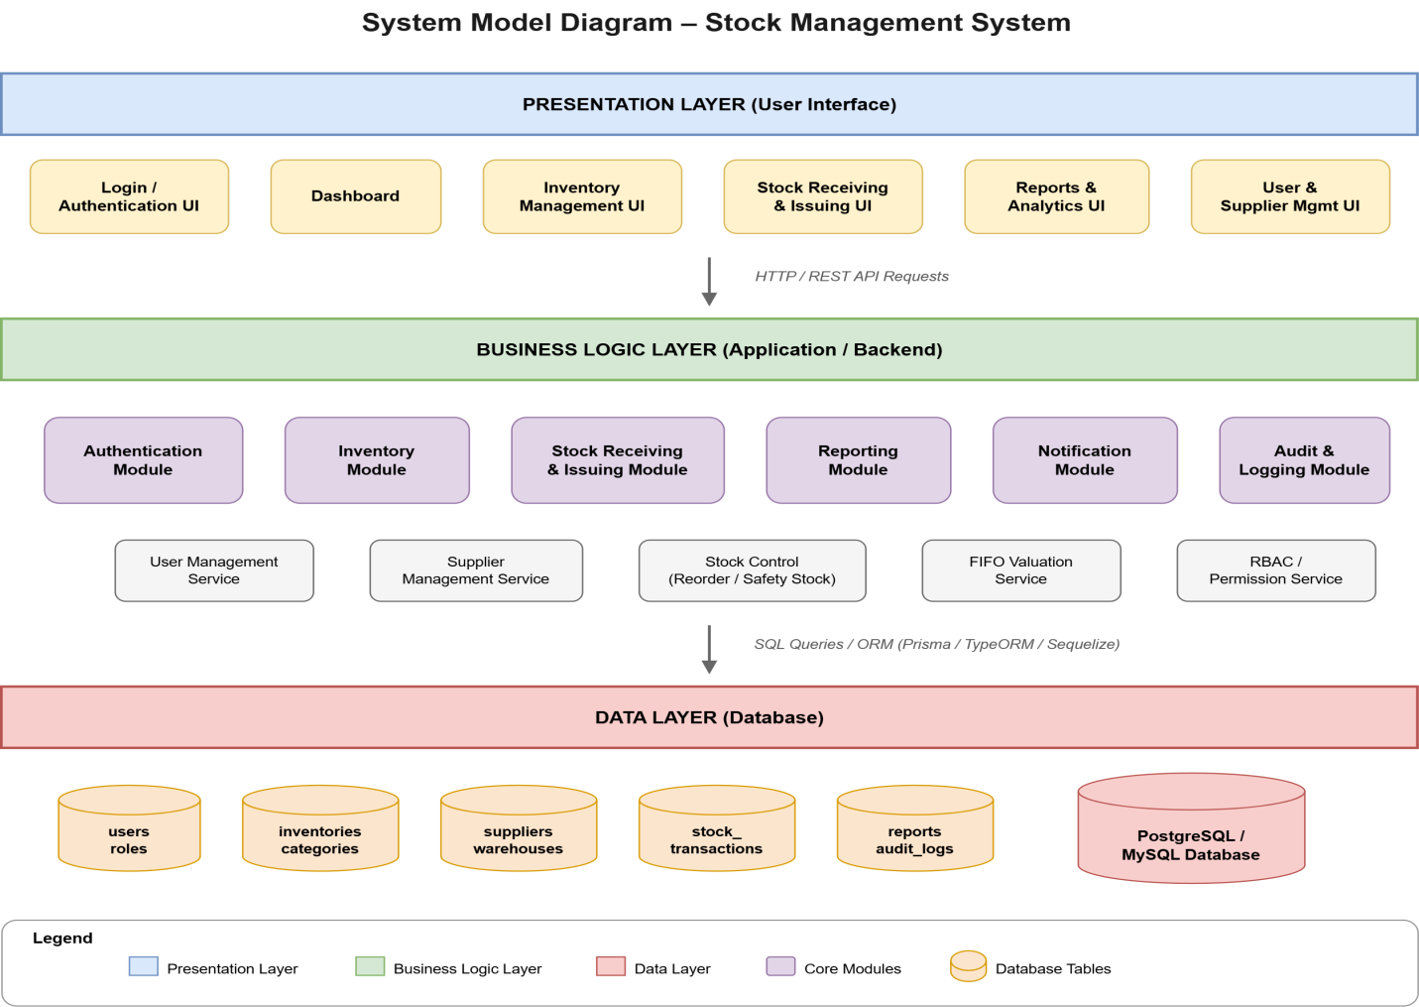
3.3.1 Scenario
The following scenario illustrates how the proposed system works.
- The user logs into the system.
- The system verifies the user's credentials.
- The user selects an operation.
- The system processes the request.
- The database is updated.
- The system generates confirmation.
- Reports are generated when required.
Example Scenario: Stock Receiving
- The storekeeper receives goods.
- The storekeeper logs into the system.
- The storekeeper enters the item details.
- The system verifies the information.
- The system updates the inventory.
- The system generates a receiving note.
3.4 Use Case Model
The use case model describes the interactions between users and the system.
3.4.1 Actor Identification
The following actors interact with the system:
- Administrator
- Property Administration Officer (PAO)
- Storekeeper
- Stock Clerk
- Accountant
- Department Head
- Supplier
- Security Officer
3.4.2 Use Case Identification
The major use cases are:
- Login
- Logout
- Manage users
- Manage suppliers
- Register inventory items
- Receive stock
- Issue stock
- Transfer stock
- Track inventory
- Perform stock taking
- Generate reports
- Manage damaged items
- Approve requests
- View audit logs
3.4.3 Use Case Diagram and Description
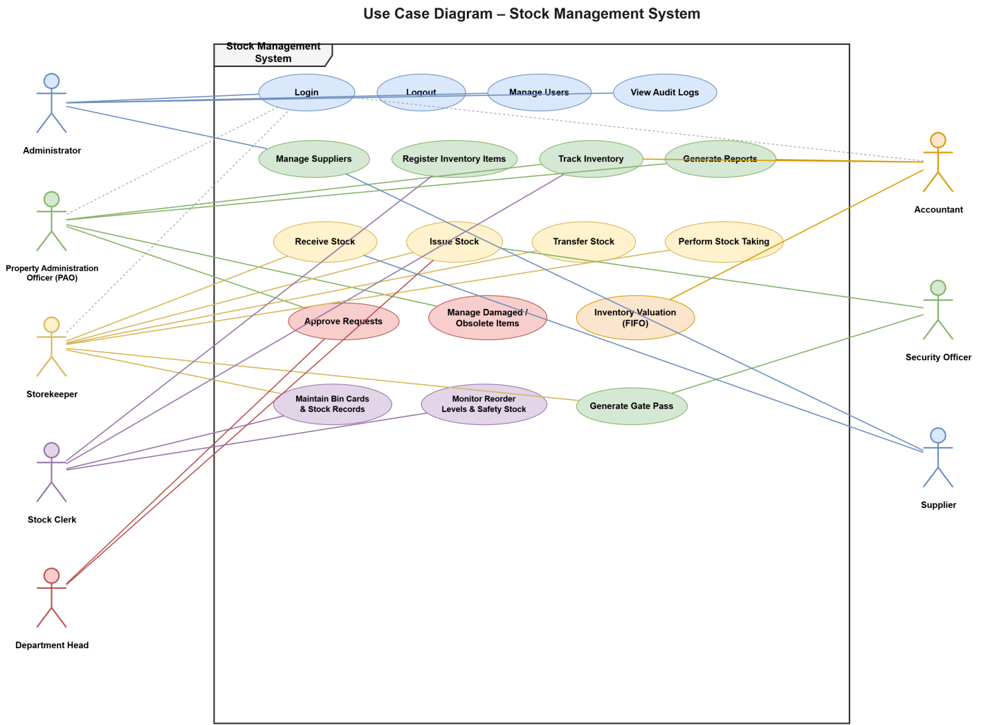
Use Case: Login
Actor: User
Precondition: User account exists.
Main Flow:
- User enters username and password.
- System validates credentials.
- System grants access.
Postcondition:
- User enters the system successfully.
Use Case: Receive Stock
Actor: Storekeeper
Precondition: Supplier delivers goods.
Main Flow:
- Storekeeper enters item information.
- System validates the information.
- Inventory quantity is updated.
- Goods receiving note is generated.
Postcondition:
- Stock records are updated.
Use Case: Issue Stock
Actor: Storekeeper
Precondition: Approved requisition exists.
Main Flow:
- User submits a request.
- Storekeeper verifies the request.
- System updates inventory.
- Issue report is generated.
Postcondition:
- Stock quantity decreases.
3.5 Object Model
The object model describes the structure of the system.

3.5.1 Data Dictionary
Entity | Description
User | Stores user information
Role | Stores user roles
Supplier | Stores supplier details
Category | Stores item categories
Inventory | Stores inventory data
StockTransaction | Stores inventory movement
Warehouse | Stores warehouse information
Report | Stores reports
AuditLog | Stores system activities

3.5.2 Class Diagram
The class diagram represents the classes, attributes, methods, and relationships of the system.
Main classes:
- User
- Role
- Supplier
- Inventory
- Category
- Warehouse
- StockTransaction
- Report
- AuditLog
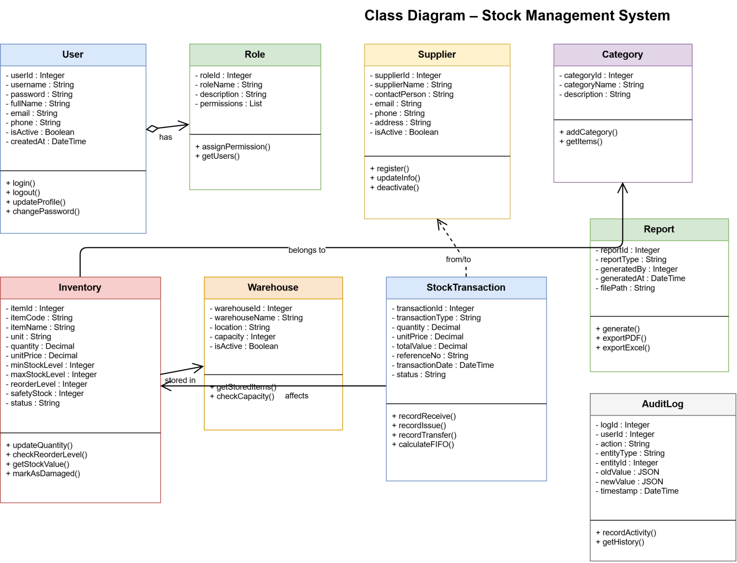
3.6 Dynamic Model
The dynamic model shows how the system behaves over time.
3.6.1 Sequence Diagram
As the name indicates, the sequence diagram shows the sequence of activities and how processes interact with one another.
Login Sequence
- User sends login request.
- System validates credentials.
- Database verifies information.
- System grants access.
Stock Receiving Sequence
- Storekeeper submits stock information.
- System validates data.
- Database updates records.
- System confirms success.
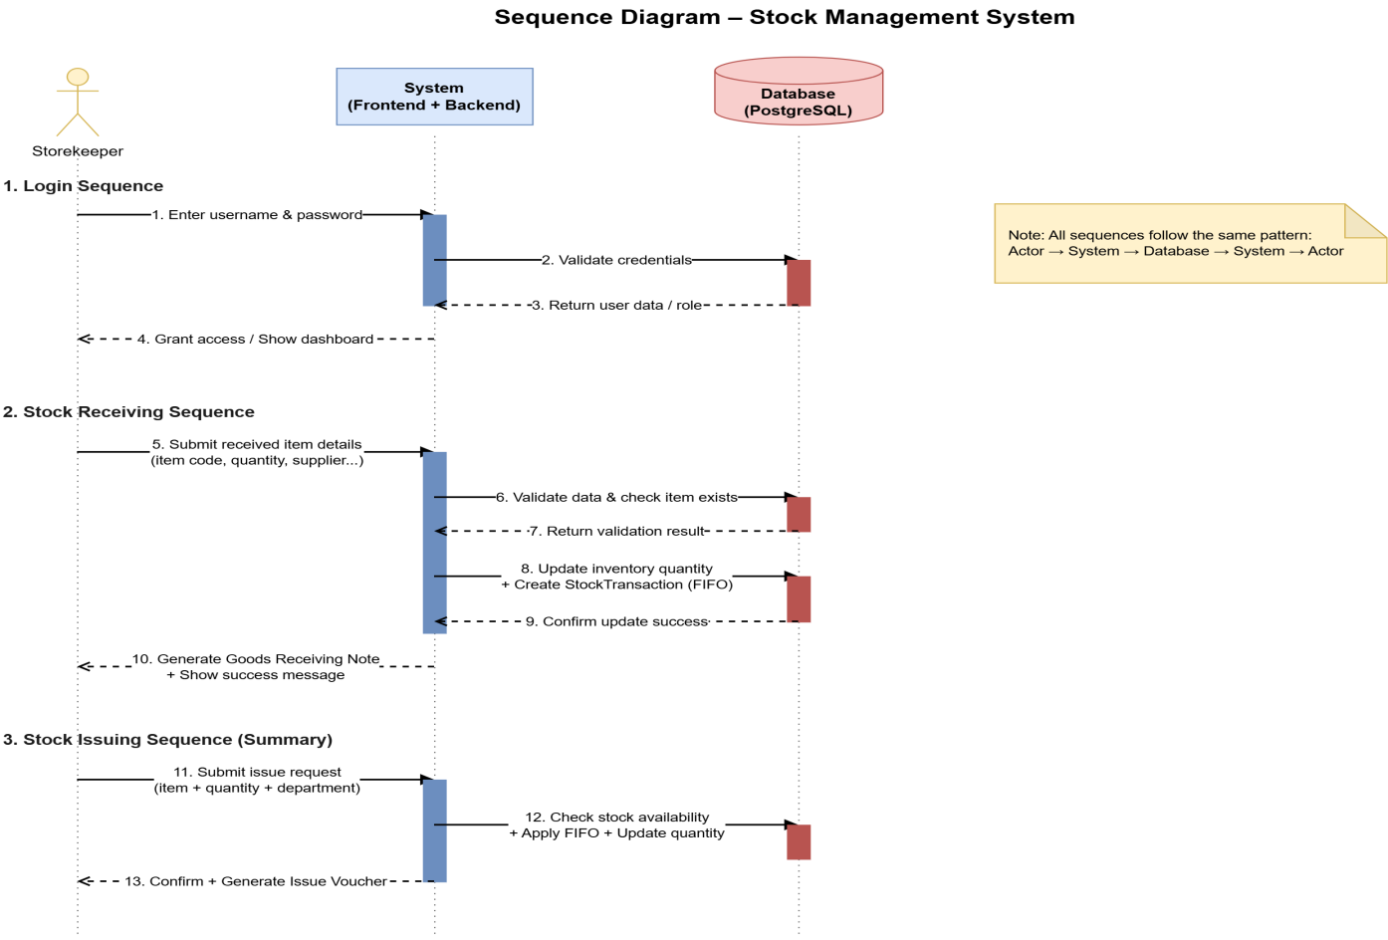
3.6.2 Activity Diagram
An activity diagram is used to understand the workflow performed by the system.
Activities include:
- Login
- Receive stock
- Issue stock
- Update inventory
- Generate report
- Logout
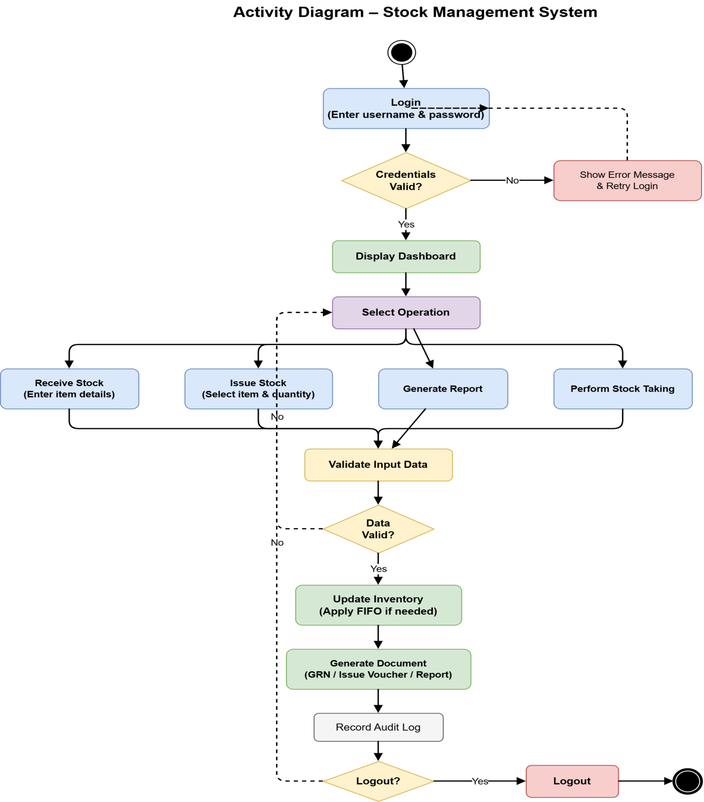

3.6.3 State Chart Diagram
The state chart diagram describes the states of an object and the transitions between those states.
Inventory States
- Created
- Available
- Reserved
- Issued
- Damaged
- Obsolete
- Disposed
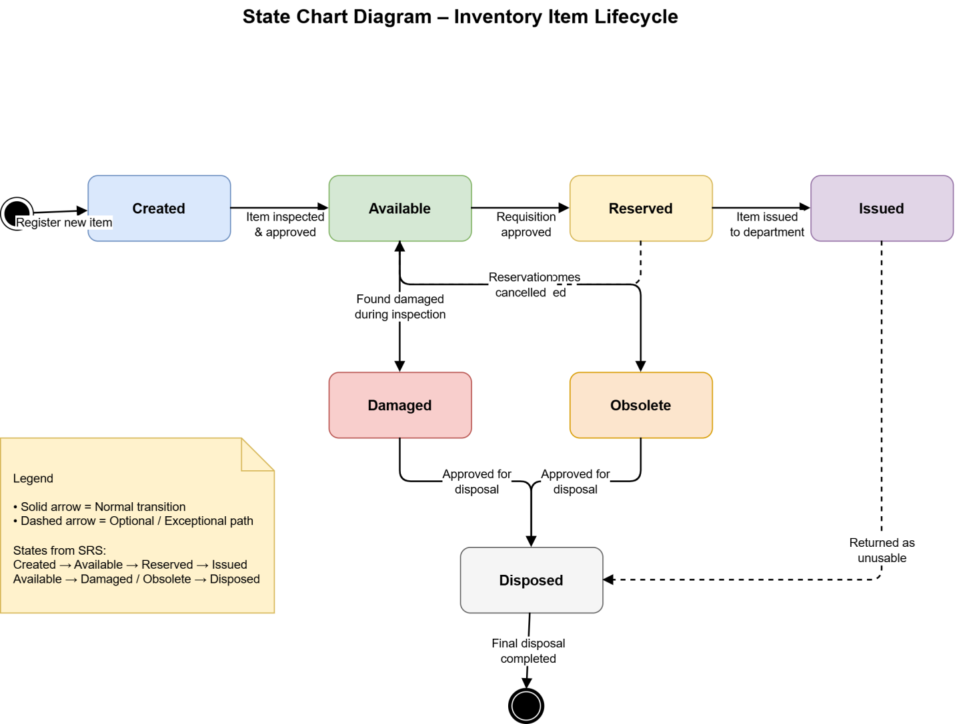
Chapter Four
System Design
4.1 Overview
System design is the process of transforming the requirements gathered during the analysis phase into a complete blueprint for the implementation of the Stock Management System. It defines the architecture, components, interfaces, database structure, and interactions among different modules of the system.
The proposed Stock Management System follows a three-tier architecture consisting of the presentation layer, business logic layer, and database layer. The system is designed to ensure security, scalability, maintainability, and reliability.
The design phase provides detailed specifications for developers and ensures that all functional and non-functional requirements are satisfied.
4.2 Purpose of the System Design
The purpose of the system design is to provide a detailed structure for implementing the Stock Management System.
The objectives of system design are:
- To transform system requirements into technical specifications.
- To define the architecture of the system.
- To identify system components and their interactions.
- To design the database structure.
- To improve system performance and security.
- To simplify future maintenance and upgrades.
- To ensure data consistency and integrity.
- To support scalability and flexibility.
4.3 Design Goals
The proposed system is designed based on the following goals:
Security
The system must protect user information and inventory data through authentication, authorization, and encryption mechanisms.
Reliability
The system must provide accurate and dependable inventory information.
Scalability
The system should support future expansion and additional functionalities.
Maintainability
The system architecture should support future updates and modifications.
Availability
The system should be available whenever users need access.
Performance
The system should process inventory operations efficiently.
Usability
The system interface should be simple and user-friendly.
4.4 Proposed System Architecture
The proposed Stock Management System follows a three-tier architecture.
The architecture consists of:
- Presentation layer (Frontend)
- Application layer (Backend)
- Data layer (Database)
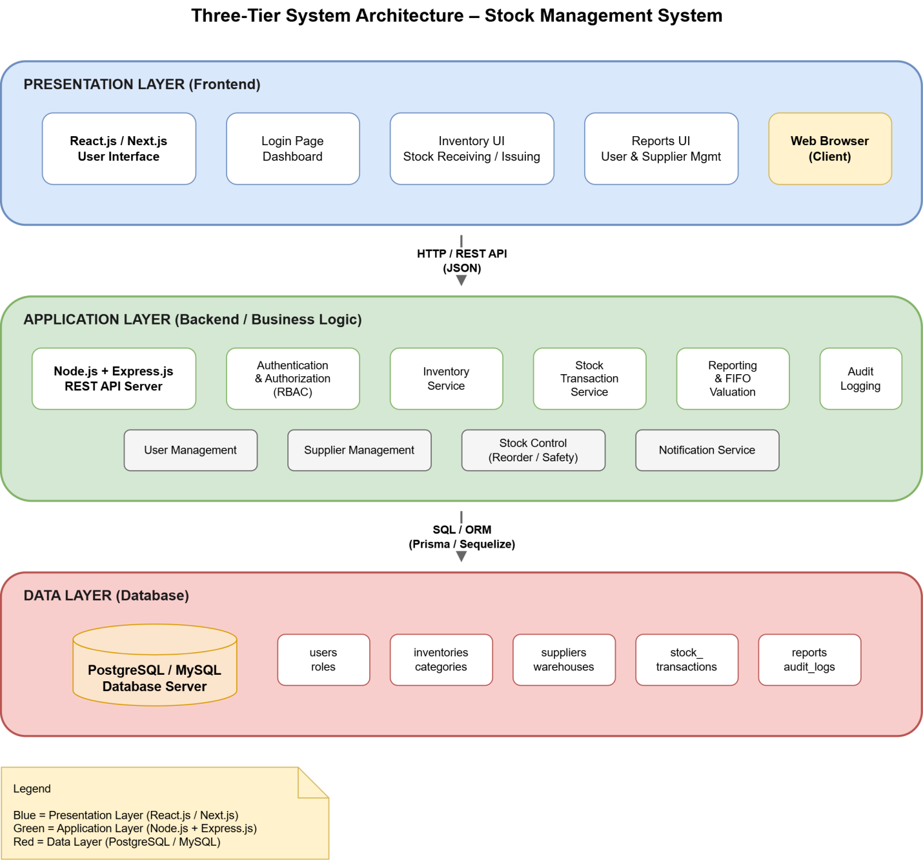4.4.1 System Process
The system process describes how users interact with the Stock Management System.
The process consists of the following steps:
- User logs into the system.
- System verifies user credentials.
- User selects a function.
- System processes the request.
- Database stores or retrieves information.
- System generates a response.
- User receives feedback.
Stock Receiving Process
- Storekeeper receives goods.
- Goods are inspected.
- Item information is entered.
- Database is updated.
- Stock quantity increases.
- Goods receiving note is generated.
Stock Issuing Process
- Department submits a request.
- Request is approved.
- Storekeeper issues items.
- Inventory is updated.
- Issue report is generated.
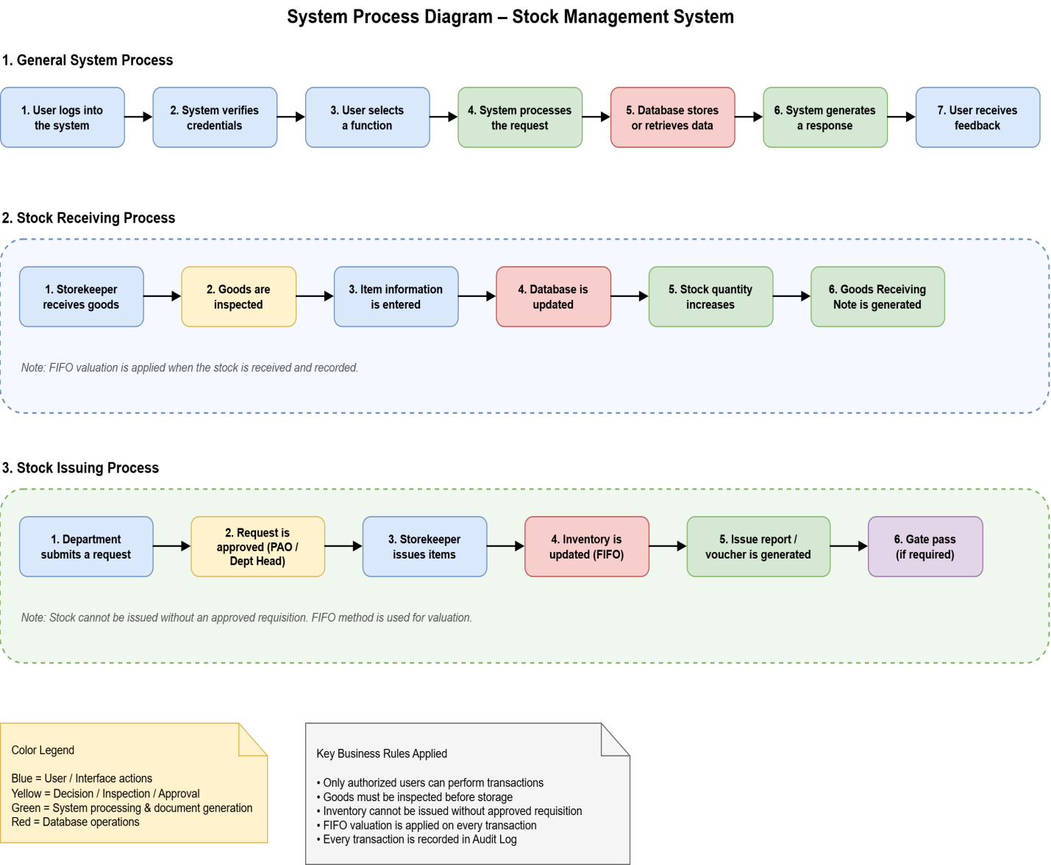4.4.2 Subsystem Decomposition and Description
The system is divided into several subsystems.
Authentication Subsystem
Responsible for:
- Login
- Logout
- Password management
- Session management
User Management Subsystem
Responsible for:
- User registration
- User update
- Role assignment
- Permission management
Inventory Management Subsystem
Responsible for:
- Inventory registration
- Inventory update
- Inventory deletion
- Inventory tracking
Supplier Management Subsystem
Responsible for:
- Supplier registration
- Supplier update
- Supplier search
Stock Receiving Subsystem
Responsible for:
- Goods receiving
- Inspection
- Quantity update
Stock Issuing Subsystem
Responsible for:
- Stock issuing
- Stock transfer
- Inventory reduction
Reporting Subsystem
Responsible for:
- Report generation
- Analytics
- Exporting reports
Audit Subsystem
Responsible for:
- Activity tracking
- Audit logs
- Security monitoring
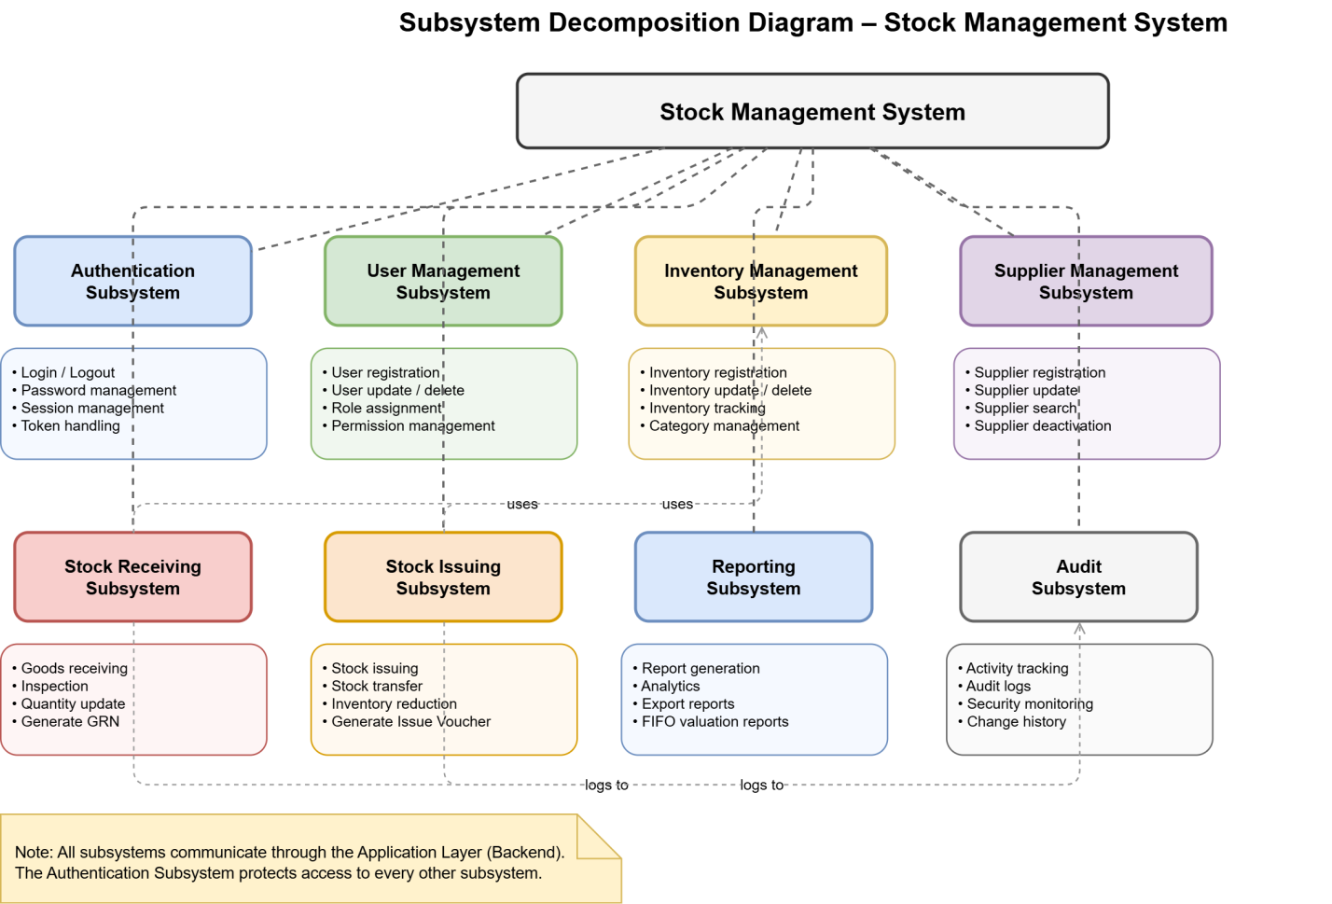4.4.3 Hardware–Software Mapping
Hardware–software mapping defines the relationship between software components and hardware resources.
Hardware Requirements
Component | Specification
Processor | Intel Core i5 or above
RAM | 8 GB minimum
Storage | 256 GB SSD
Network | Ethernet or Wi-Fi
Display | 1366 × 768 or higher
Software Requirements
Component | Technology
Operating System | Windows / Linux
Frontend | React.js / Next.js
Backend | Node.js / Express.js
Database | PostgreSQL / MySQL
API Testing | Postman
IDE | Visual Studio Code
Version Control | Git and GitHub

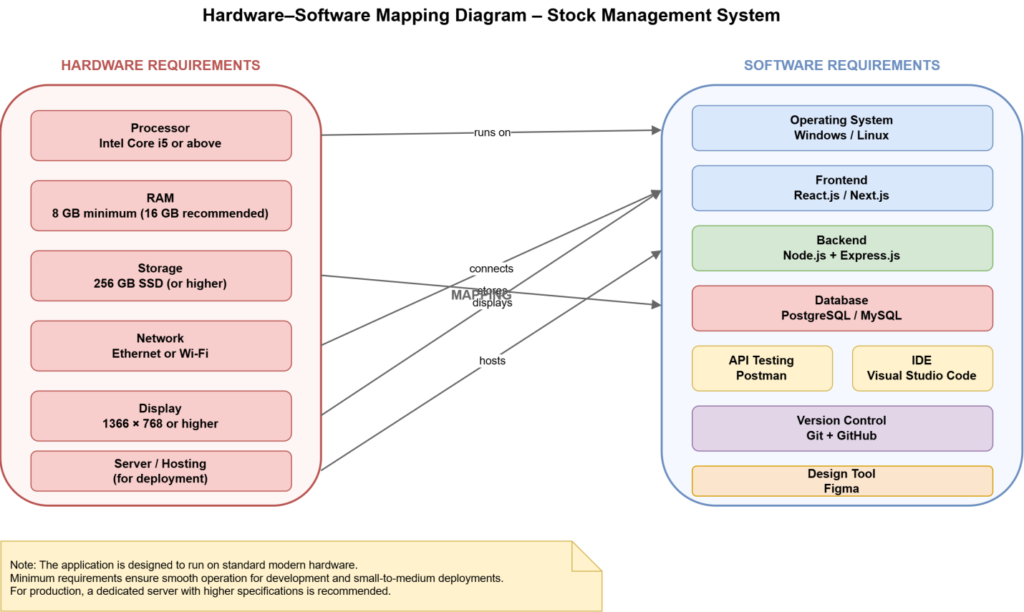
4.4.4 Persistence Data Management
Persistence data management describes how system objects are mapped into database tables.
The main database entities are:
- User
- Role
- Inventory
- Category
- Supplier
- Warehouse
- StockTransaction
- Report
- AuditLog
Database Mapping
Object/Class | Database Table
User | users
Role | roles
Inventory | inventories
Category | categories
Supplier | suppliers
Warehouse | warehouses
StockTransaction | stock_transactions
Report | reports
AuditLog | audit_logs
The system will use foreign keys and constraints to maintain data integrity.
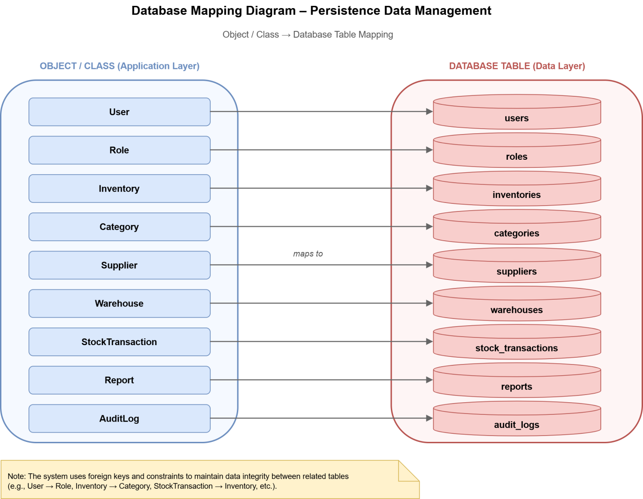4.4.5 Component Diagram
The component diagram illustrates the software modules and their relationships.
Main components include:
- User Interface Component
- Authentication Component
- User Management Component
- Inventory Component
- Supplier Component
- Reporting Component
- Database Component
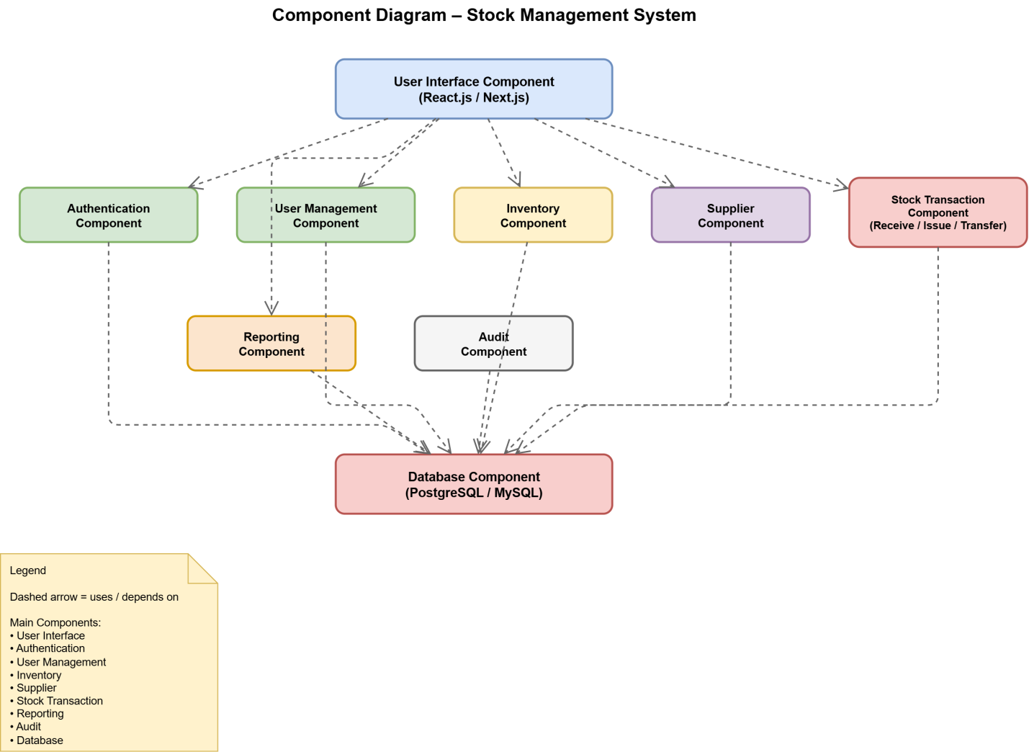
4.4.6 Deployment Diagram
The deployment diagram describes how the application is deployed.
The deployment environment includes:
- Client browser
- Web server
- Application server
- Database server
Deployment Flow
- User accesses the system through a web browser.
- Requests are sent to the web server.
- The application server processes the request.
- The database server stores and retrieves data.
- Results are returned to the user.
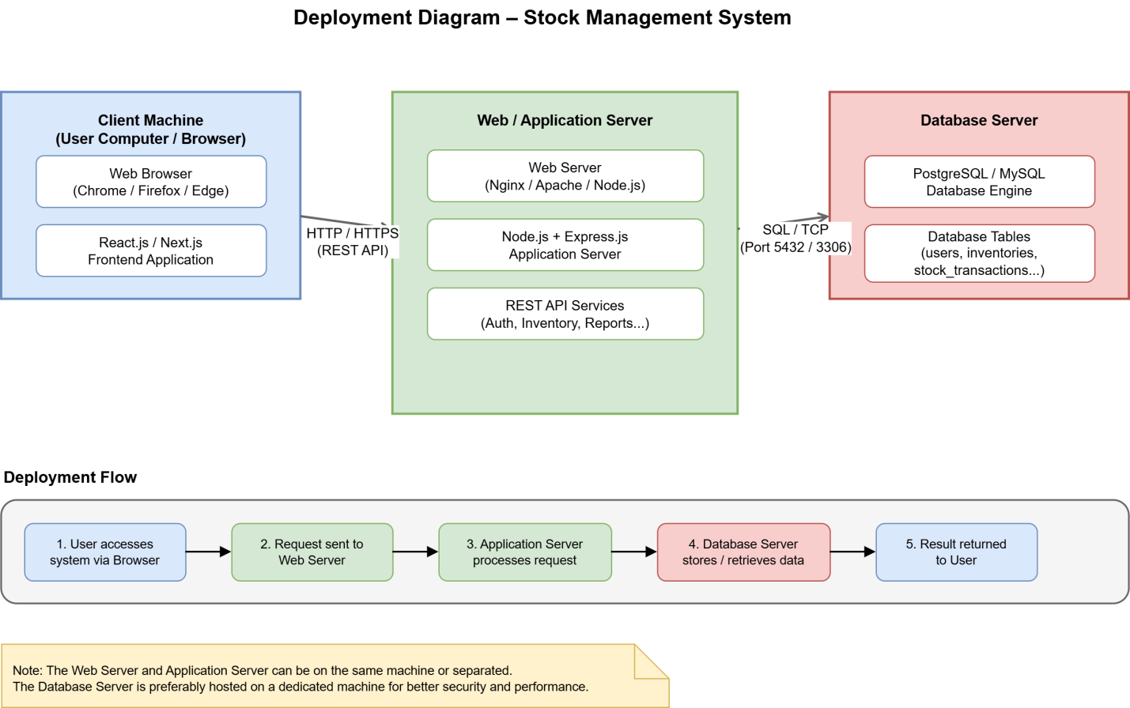4.4.7 Database Design
The database design defines entities, relationships, and constraints.
Main Tables
- users
- roles
- suppliers
- warehouses
- categories
- inventories
- stock_transactions
- reports
- audit_logs
Relationships
- One role can have many users.
- One supplier can supply many products.
- One category can contain many items.
- One warehouse can store many products.
- One inventory item can have many transactions.
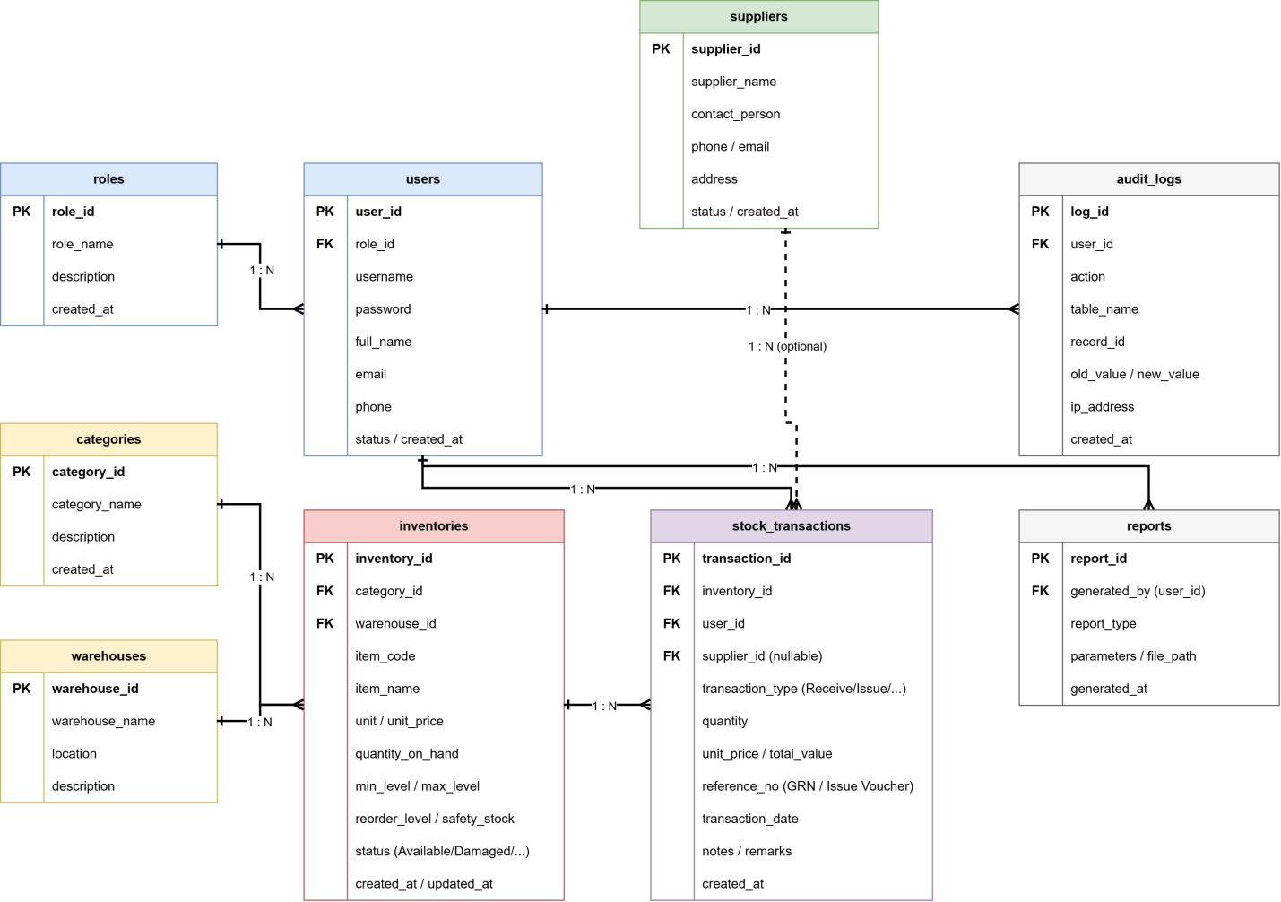
4.4.8 Access Control
The system uses Role-Based Access Control (RBAC).
Administrator
- Full access to the system.
Property Administration Officer
- Approves requests.
- Monitors inventory activities.
Storekeeper
- Receives and issues stock.
- Updates inventory records.
Accountant
- Views financial reports.
- Manages inventory valuation.
Department Head
- Approves requisitions.
Security Officer
- Monitors goods entering and leaving the organization.
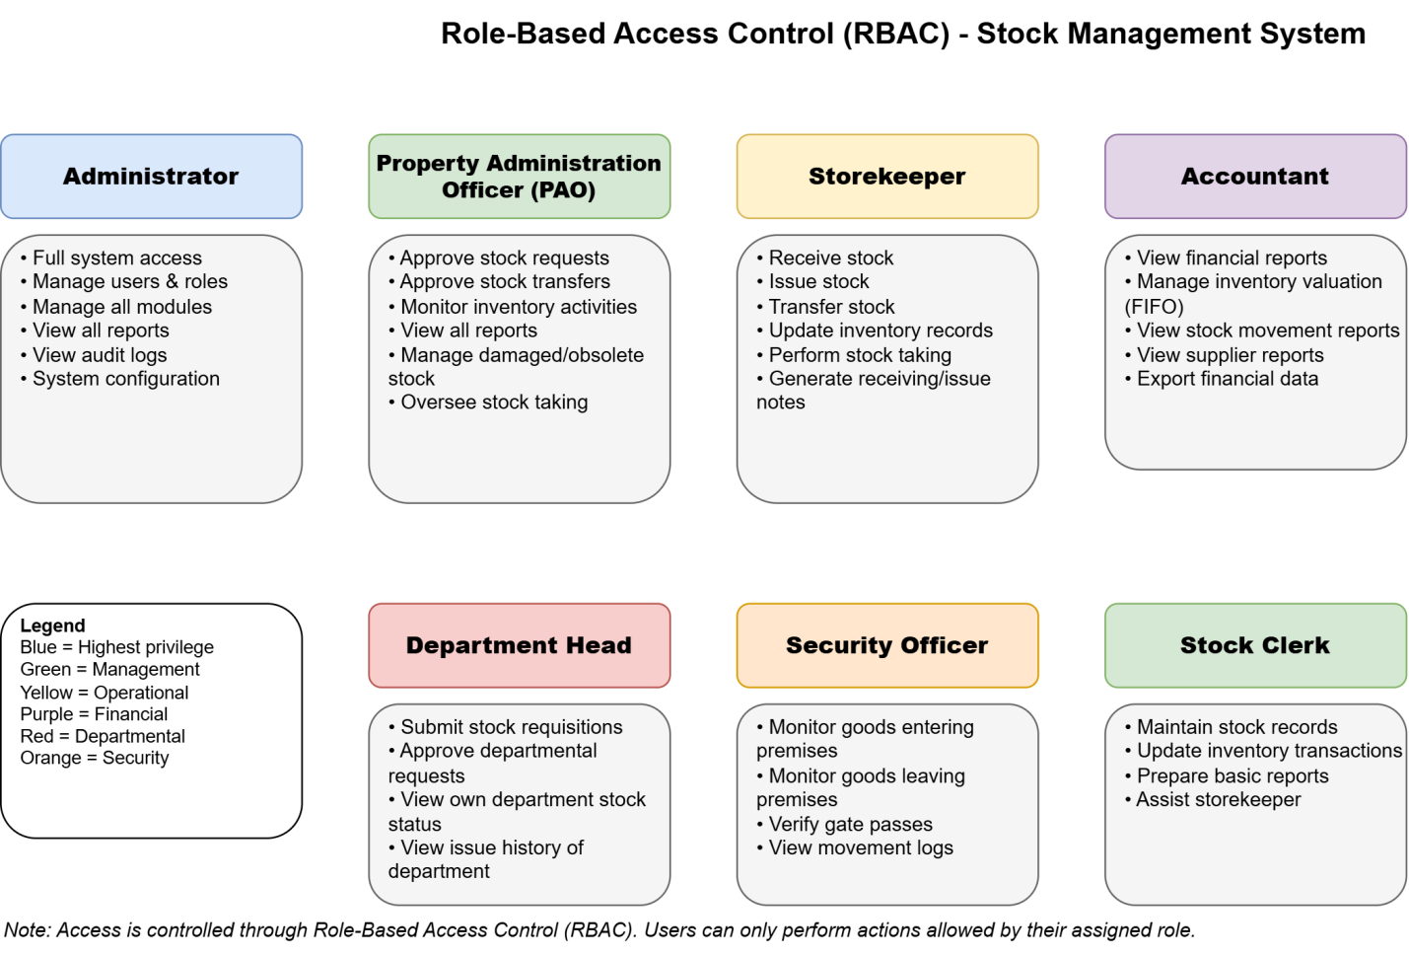
4.4.9 User Interface
The user interface provides interaction between users and the system.
Login Page
Features:
- Username field
- Password field
- Login button
[Image of Login Interface]
Dashboard
Features:
- Total inventory count
- Low-stock alerts
- Recent transactions
- Reports summary
[Image of Dashboard Interface]
Inventory Management Page
Features:
- Add inventory
- Update inventory
- Delete inventory
- Search inventory
[Image of Inventory Management Interface]
Stock Receiving Page
Features:
- Register goods
- Verify items
- Generate receiving notes
[Image of Stock Receiving Interface]
Stock Issuing Page
Features:
- Issue items
- Approve requests
- Generate issue reports
[Image of Stock Issuing Interface]
Reports Page
Features:
- Generate reports
- Export reports
- Print reports

References
- Ministry of Finance and Economic Development (MoFED). Stock Management Manual, Addis Ababa, Ethiopia, 2010.
- IEEE Computer Society. IEEE Recommended Practice for Software Requirements Specifications (IEEE 830-1998).
- Ian Sommerville, Software Engineering, 10th Edition, Pearson Education, 2015.
- Roger S. Pressman, Software Engineering: A Practitioner's Approach, 8th Edition, McGraw-Hill, 2014.
- Abraham Silberschatz, Henry Korth, and S. Sudarshan, Database System Concepts, 7th Edition.
- Official documentation for React.js, Node.js, Express.js, and PostgreSQL.
Appendix A: Glossary
Term | Meaning
FIFO | First In, First Out
SRS | Software Requirements Specification
RBAC | Role-Based Access Control
PAO | Property Administration Officer
API | Application Programming Interface
DBMS | Database Management System
Appendix B: Sample Forms
- Sample requisition form
- Sample goods receiving note
- Sample issue voucher
- Sample stock report
Appendix C: Abbreviations and Acronyms
- SMS — Stock Management System
- ERD — Entity Relationship Diagram
- UML — Unified Modeling Language
- UI — User Interface
- SQL — Structured Query Language
- CRUD — Create, Read, Update, Delete

