AGENTIC RULE OPTIMIZER
Agentic Rule Optimizer —
Simple Architecture and Workflow Explanation
A stakeholder-friendly guide to how false-positive cases trigger governed rule analysis, historical backtesting, and human-reviewed recommendations
TRIGGER  Final false-positive case | DECISION SUPPORT  Evidence-based recommendation | CONTROL  Human governance only
Audience: stakeholders, managers, product owners, business analysts, fraud teams, architects, and new team members.
Architecture status: logical design and proposed reference implementation for approval.
All example names, IDs, thresholds, and results in this document are fictional. They do not represent the supplied sample dump or production behavior.

0. How to read this document
This guide explains the system from the outside in. It first explains the business problem, then follows one fictional case through the complete architecture. Every phase states the input, component, processing method, technology, LLM use, output, and hand-off.
The one idea to remember
A false-positive case tells the optimizer which rule deserves attention. It does not prove the rule is bad. The optimizer uses the full eligible historical population to decide whether a change is supported.

What this document covers
Part | Question answered
1-3 | What problem are we solving, and what does 'agentic' mean?
4-5 | What is the architecture, and which component owns each job?
6 | What happens in each of the eight phases?
7-9 | How do the two modes, backtesting, LLM, and RAG work?
10-13 | What is the output, what data is used, and how is the system governed?
14-16 | What framework is confirmed, what is proposed, and how do we implement it?

Words used in this guide
Term | Simple meaning
Rule | A formal if/then condition used by the existing Rule Engine.
False positive | A case whose final institution-mapped outcome says the alert was not useful.
Agent | The complete controlled workflow that can gather evidence, choose permitted next steps, and produce a recommendation.
LLM | A language model used only for bounded reasoning and clear explanation.
Backtest | Running current or proposed rule logic on frozen historical inputs.
Candidate | A proposed rule change stored outside production for testing.
Evidence | Traceable rows, configuration snapshots, metrics, test results, and limitations that support a recommendation.

1. The problem in one minute
The existing EFRM Rule Engine already evaluates transaction and device events and creates alerts. The Rule Optimizer does not replace that engine and does not generate live alerts. Its job starts after an investigator has completed a case and the final outcome is classified as false positive.

Binary rule behavior does not mean binary rule quality
At runtime, a rule has a binary result: it matches or it does not match. But historical rule quality is a business and statistical question. A matching rule can still create too many false-positive cases, overlap with other rules, depend on poor data, or lose useful coverage after a threshold change.
Live Rule Engine question | Rule Optimizer question
Did the rule match this event? | Across a reliable historical population, is this rule producing useful and stable results?
Should the signal contribute to an alert? | Which matched rule actually contributed to the false-positive case?
What is the current rule logic? | Would a controlled change reduce burden without unacceptable loss of mature non-false-positive outcomes?

What the Agent will do
- Start when a finalized case maps to the canonical outcome FALSE_POSITIVE.
- Trace the case to alerts, results, rule matches, and exact rule versions.
- Select only rules that were primary or supporting contributors.
- Evaluate those selected rules using full eligible historical evidence.
- Diagnose threshold, overlap, data-quality, stability, and outcome patterns.
- Use the configured operating mode to test a candidate or provide recommendation only.
- Publish one evidence-linked recommendation for human review.

What the Agent will never do
- Generate live transaction alerts.
- Scan and optimize every rule merely because a schedule ran.
- Treat one false-positive case as proof that a rule is defective.
- Let an LLM directly query the database or invent metrics.
- Write a candidate into production rule tables.
- Modify, activate, retire, or delete a rule.
- Replace the existing approval and governance process.

2. Running example used throughout
The same fictional example is followed through every phase so the reader can see how the technical pieces connect.
Fictional case FP-1042
Example Bank has a mobile-transfer rule R-204 called 'Large transfer from a new device'. The current example logic is: amount >= 100,000 AND device age <= 7 days. A long-standing customer changes phone and sends money to a trusted beneficiary. The rule contributes to an alert, a case is created, and the investigator closes the final case as false positive.

Example item | Illustrative value
Institution | Example Bank
Channel | Mobile transfer
Case | FP-1042
Alert | A-781
Matched rule | R-204, historical version 5
Current condition | amount >= 100,000 AND device_age_days <= 7
Final outcome | Institution decision code mapped to canonical FALSE_POSITIVE
Possible hypothesis | The seven-day new-device window may be too broad for trusted beneficiaries.

Important: the hypothesis is not yet a recommendation. The system must first prove the lineage, load the correct configuration, analyze the full historical cohort, and check whether the issue still exists in the current active rule.

3. What makes this an agent
The word 'agent' describes the complete system behavior, not only the presence of an LLM. A durable orchestrator receives a goal, calls approved tools, checks results, chooses the next allowed action, stops when evidence is unsafe, and records an auditable outcome.
FALSE-POSITIVE TRIGGER
-> gather exact evidence
-> check lineage and sufficiency
-> calculate deterministic findings
-> choose the configured mode
-> test a candidate OR prepare advice
-> validate every claim
-> publish recommendation for human review

The Agent is a team of controlled components
Component | Job
Orchestrator | Controls the eight phases, retries, stop gates, mode branch, and audit state.
Data services | Retrieve exact case, alert, match, rule, configuration, and historical records.
Analytics engine | Uses SQL and deterministic Python to calculate trusted evidence.
Candidate and replay services | Create formal candidates and execute isolated Drools backtests in Candidate + Test mode.
Optional LLM | Interprets approved evidence, proposes bounded hypotheses, and explains the result in plain English.
Validator | Checks that every number and claim can be traced to evidence.
Human governance | Accepts, rejects, or changes the recommendation and performs any production action.

Why this is more consistent than asking an LLM to do everything
Databases, SQL, statistics, and the Drools engine give repeatable results from the same inputs. The LLM adds language reasoning where it is useful, but it is prevented from becoming the source of truth.

4. Complete architecture
The optimizer is deployed beside the existing EFRM platform, not inside the live transaction path. It reads governed information, stores its own immutable evidence, and sends recommendations to human review.
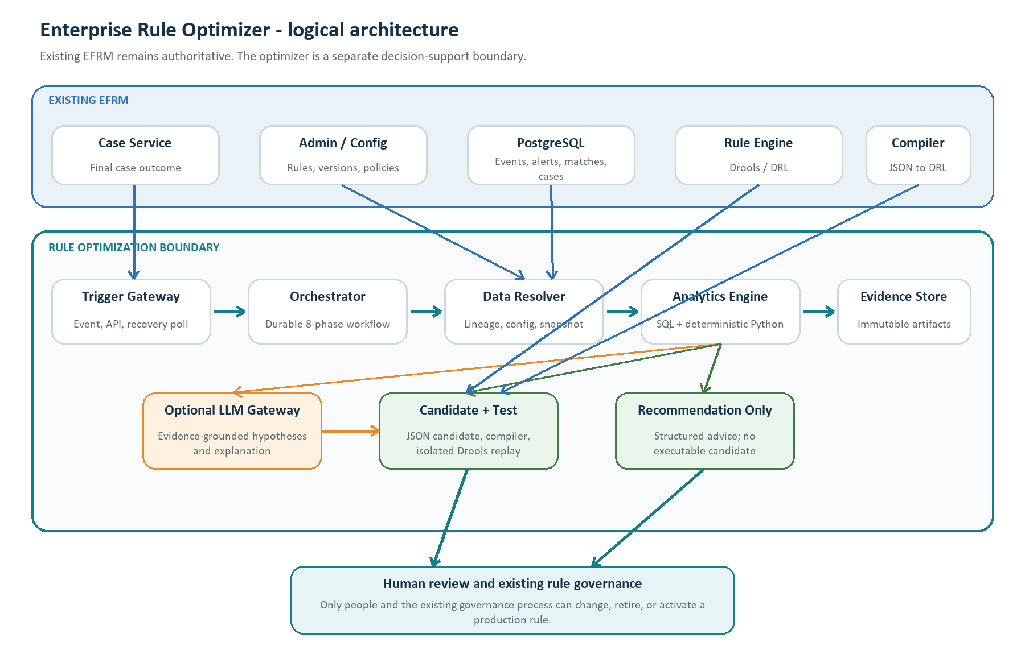
Figure 1. Logical architecture. Product names such as Kafka and Temporal are proposed reference choices, not confirmed current EFRM infrastructure.

The key boundaries
- Existing EFRM stays authoritative. Cases, rules, matches, and production execution remain owned by existing services.
- The service is institution- and channel-agnostic. Outcome mappings, thresholds, windows, modes, constraints, and analysis policy come from versioned configuration rather than hardcoded client logic.
- The optimizer has read-only EFRM access. Bulk history should come from approved APIs, a read replica, or an analytical store.
- Candidates stay outside production. Even in Candidate + Test mode, the proposed rule is an optimizer artifact.
- The LLM is behind a gateway. The gateway masks data, limits tools and tokens, and supports either a local model or an approved external API.
- The recommendation goes to people. Only the existing governance process can create or promote a production version.

5. Which technology performs the analysis?
No single technology is good at every job. The design assigns each kind of processing to the component that can do it most accurately and repeatedly.
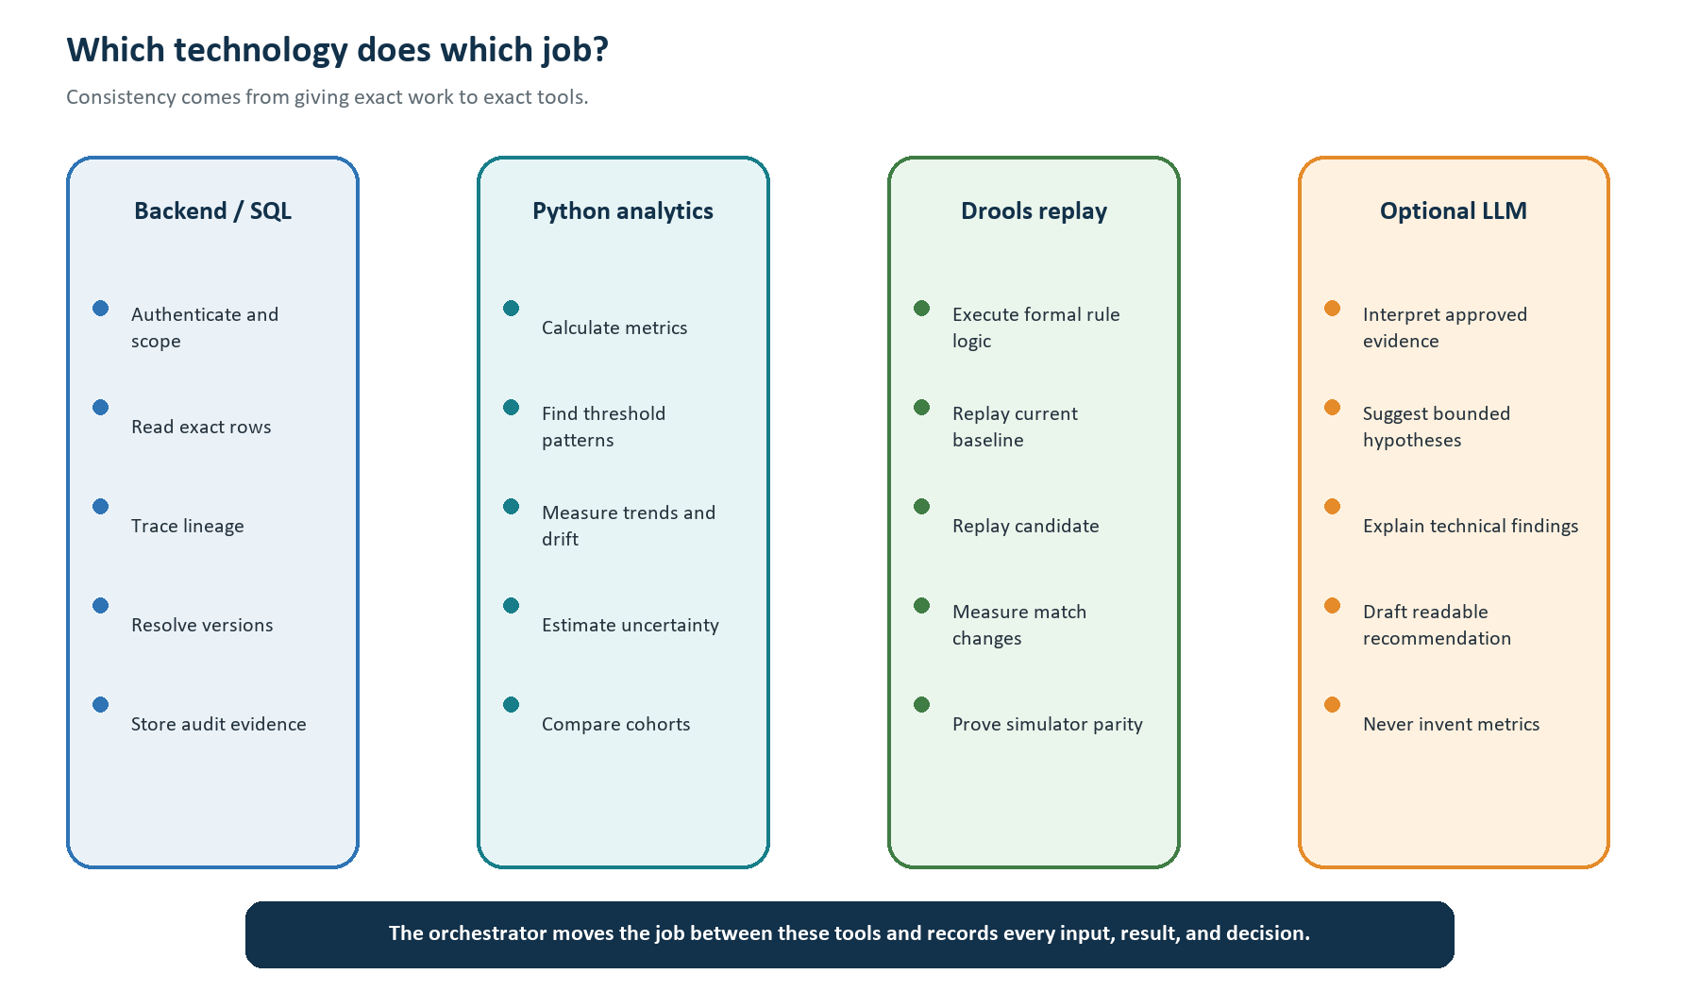
Figure 2. Division of responsibility between normal backend logic, analytics, rule replay, and the optional LLM.
Question | Authoritative component | Why
Which case outcome is final? | Backend lookup + institution mapping | The answer must match exact governed records.
Which rule contributed? | Lineage and attribution logic | Relationships, versions, and decision policy must be repeatable.
What are the metrics? | SQL + deterministic Python | Counts, rates, trends, and intervals must reproduce exactly.
What would the rule match? | Isolated Drools replay | The same formal rule semantics are required.
What might explain the pattern? | Optional LLM over verified evidence | Language reasoning can connect patterns and produce understandable hypotheses.
Should production change? | Human governance | This is a controlled business and risk decision.

6. The complete flow from Phase 1 to Phase 8
The diagram shows the full runtime flow. The detailed cards that follow explain exactly what happens in every phase.
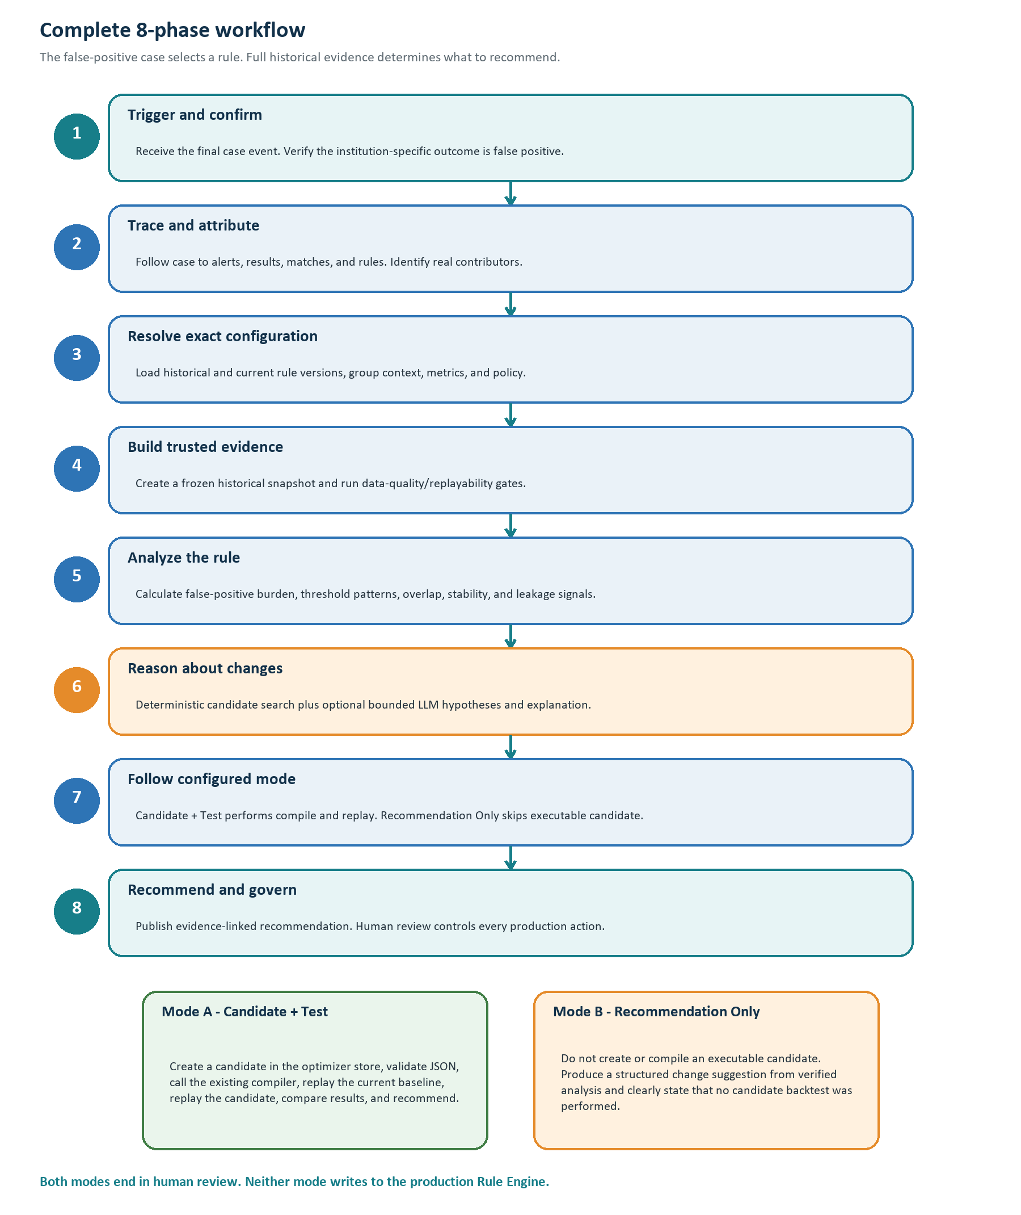
Figure 3. Eight-phase workflow with the configurable operating-mode branch.

PHASE 1 Receive, authenticate, and confirm the false-positive trigger
What this phase achieves
Create one reliable, idempotent analysis request only when the authoritative final case outcome maps to FALSE_POSITIVE.

Main component: Existing Case Service, transactional outbox publisher, Trigger Gateway, Trigger Inbox, and Case Outcome Resolver.
Input: Institution ID, case ID, decision/action identity or stable hash, final decision code, finalization time, event ID, and correlation ID.
Data comes from: The Case Service sends identifiers through an event or API. The Outcome Resolver re-reads the authoritative case through a Case Service API or approved read-only query.
Processing method: Normal backend logic: authenticate the service, authorize the institution, validate the event schema, deduplicate, load the effective outcome mapping, and verify the case is still final. Final case decision overrides alert-level decisions.
Concrete implementation: Proposed: Spring Boot trigger/control service, Spring Security, PostgreSQL inbox/outbox tables, Kafka event adapter plus REST adapter, and a reconciliation poller. The broker is replaceable if EFRM uses another standard.
LLM used? No. An LLM must not interpret institution decision codes.
Other AI/ML model? No.
Output: Accepted canonical false-positive trigger plus an immutable policy snapshot; or an explicit ignored/rejected reason.
How the next phase starts: The Orchestrator creates a case-analysis job and schedules lineage resolution.

Event, API, outbox, and polling in simple English
Method | What happens | Recommended role
Event | Case Service records that a case was finalized and continues. A consumer processes it asynchronously. | Primary target because case closure does not depend on the optimizer being online.
API call | Case Service directly calls the optimizer and receives an HTTP result. | Supported integration when event infrastructure is unavailable.
Transactional outbox | The case update and a small event row are committed in the same database transaction. | Prevents a closed case from losing its trigger event.
Polling | A worker checks new finalized decisions from a saved high-water mark. | Recovery/reconciliation, not repeated full-table scanning.

Running example
Case FP-1042 is finalized. The institution mapping says its decision code means FALSE_POSITIVE. The Trigger Inbox has not seen this decision identity before, so a new case-analysis job is created.

PHASE 2 Trace the case to alerts and contributing rules
What this phase achieves
Find the exact rule matches connected to the false-positive case and avoid blaming unrelated rules.

Main component: Case Lineage Resolver followed by the Rule Attribution Engine.
Input: Accepted case-analysis job, institution ID, case ID, and case-decision identity.
Data comes from: Case and alert read APIs or approved parameterized reads of case_master, case_alert_mapping, transaction/device alert, result, and match records.
Processing method: Deterministic joins reconstruct case -> alerts -> results -> matches -> rule references. Attribution labels each rule PRIMARY_CONTRIBUTOR, SUPPORTING_CONTRIBUTOR, COINCIDENTAL_MATCH, or UNRESOLVED. Missing or deleted rule references are recorded, never guessed.
Concrete implementation: Proposed: Spring Boot worker, JDBC/jOOQ-style parameterized repositories, read-only credentials, immutable lineage JSON with evidence IDs and checksums.
LLM used? No. Relational identity and rule contribution must be exact.
Other AI/ML model? No.
Output: CaseRuleLineage plus preliminary attributed rule targets and data-quality flags.
How the next phase starts: Only primary/supporting targets move to configuration resolution. Unresolved attribution can produce manual review but not an automatic candidate.

Transaction and device paths
TRANSACTION PATH
case_master -> case_alert_mapping -> transaction_alert
-> transaction_result -> transaction_match
DEVICE PATH
case_master -> case_alert_mapping -> device_alert
-> device_result -> device_match

Running example
The resolver follows FP-1042 to alert A-781 and its stored matches. R-204 is a primary contributor. Another rule appeared in the same case but did not influence this alert, so it is marked coincidental and is not analyzed.

PHASE 3 Resolve exact historical and current rule configuration
What this phase achieves
Reconstruct what actually ran, then check whether the same problem still exists in the current active rule.

Main component: Effective Configuration Resolver and Rule Identity Resolver.
Input: Attributed rule code/reference, event timestamps, institution/source/channel scope, policy snapshot, and configuration evidence from Phase 2.
Data comes from: Preferred source: Admin Service/Rule Engine read APIs. Fallback: approved read-only views over rule_master, rule_version, groups, bindings, decision policy, required data, metric_definition, and dependency tables.
Processing method: Resolve both database record IDs and business version numbers. Build a canonical point-in-time configuration bundle with structured JSON logic, DRL checksum, group context, source binding, required inputs, Metric Definition Custom SQL, and effective institution policy. Then compare the historical version with the current version.
Concrete implementation: Proposed: Spring service adapter behind typed ports such as RuleConfigurationPort and RuleCompilerPort; PostgreSQL read replica; canonical JSON serialization and SHA-256 bundle hash.
LLM used? No. Configuration resolution is a deterministic identity and versioning problem.
Other AI/ML model? No.
Output: Immutable HistoricalRuleBundle, CurrentRuleBundle, current-version relevance result, policy IDs, and checksums.
How the next phase starts: If the referenced rule was deleted and no immutable history exists, or if the issue no longer applies to the current rule, the workflow stops or publishes a limited review result. Otherwise it starts historical snapshot building.

Who provides the configuration?
The Agent does not ask the LLM to reconstruct a rule. A dedicated Configuration Resolver owns this task. It calls a governed Admin/Rule read service when one is available. If no sufficient API exists, an approved read-only adapter uses parameterized SQL against a replica. The existing compiler exposure is not yet known, so the design hides it behind RuleCompilerPort until the owning team confirms whether it is a library, service, or other controlled interface.
Running example
The historical match points to R-204 version 5. The resolver loads version 5 and the current version 6. Version 6 still uses the seven-day device window, so the issue is relevant. Both bundles receive immutable hashes.

PHASE 4 Build a frozen historical evidence snapshot
What this phase achieves
Create a trustworthy evaluation population before calculating any performance finding.

Main component: Historical Snapshot Builder, Metric SQL Executor, and Data Quality Gate.
Input: Selected current rule bundle, configured historical windows, institution/source/channel scope, required fields and metrics, and effective outcome mapping.
Data comes from: Approved bulk APIs, PostgreSQL read replica, or controlled analytical store. The builder reads eligible transaction/device events, results, matches, alerts, cases, and point-in-time metric inputs.
Processing method: Engineers provide reviewed query templates. The builder retrieves events where the rule fired and did not fire, attaches mature outcomes, reconstructs event-time Custom-SQL metrics, freezes the cohort, and writes a manifest. It checks lineage, tenant scope, label maturity, missingness, version consistency, and whether the eligible population can be reconstructed.
Concrete implementation: Proposed: asynchronous snapshot worker; parameterized SQL; read-only PostgreSQL; columnar Parquet snapshot in institution-isolated object storage; metadata/checksums in an optimizer PostgreSQL schema. Custom SQL must use an approved parameter contract and restricted execution boundary.
LLM used? No. The LLM neither writes nor executes SQL.
Other AI/ML model? No model is required. Data-quality rules and point-in-time reconstruction are deterministic.
Output: Immutable HistoricalSnapshot, manifest, row/exclusion counts, configuration hashes, and readiness status.
How the next phase starts: READY moves to analytics. Failures such as ELIGIBLE_POPULATION_NOT_RECONSTRUCTABLE, METRIC_NOT_REPRODUCIBLE, or INSUFFICIENT_EVIDENCE stop unsafe optimization and become explicit limitations.

Why the snapshot includes more than false-positive rows
If the Agent looked only at false-positive cases, every row would already show a problem and the analysis would be biased. It needs the full eligible population to compare fired versus non-fired events, false-positive versus mature non-false-positive outcomes, overlap with other rules, and the effect of a proposed change.
Running example
The snapshot contains every eligible mobile-transfer event in the configured window, not only FP-1042. It includes events that did not match R-204 and mature outcomes from other cases. The data-quality gate confirms which conclusions are safe.

PHASE 5 Calculate rule findings with deterministic analytics
What this phase achieves
Measure what is happening, how stable it is, and where the false-positive pattern is concentrated.

Main component: Rule Analytics Engine with health, threshold, decay/stability, overlap, and internal-leakage modules.
Input: Frozen historical snapshot, rule bundles, institution analysis policy, outcome mapping, and alert-volume constraint.
Data comes from: Only the immutable snapshot and its manifest are used. No worker silently re-queries changing live data during a run.
Processing method: SQL performs scoped extraction and aggregation. Deterministic Python calculates counts, rates, threshold-distance distributions, time buckets, cohort comparisons, confidence intervals, EWMA/CUSUM or change-point checks where data supports them, overlap/unique coverage, and sensitivity to unlabeled outcomes.
Concrete implementation: Proposed: Python analytics worker with Polars or pandas, NumPy, and SciPy; optional scikit-learn for approved clustering/change-point methods. Functions are versioned, unit-tested, seeded where randomness is used, and return structured JSON with evidence IDs.
LLM used? No LLM is needed for the authoritative calculations.
Other AI/ML model? Optional statistical/ML methods may discover cohorts or change points, but they do not approve a change. The initial release can operate without a trained ML model.
Output: RuleFindingSet: verified metrics, pattern cohorts, decay result, threshold sensitivity, overlap, internal leakage signals, uncertainty, and limitations.
How the next phase starts: The Orchestrator checks evidence strength. Insufficient evidence becomes a monitor/review recommendation. Sufficient evidence moves to bounded reasoning and candidate strategy.

Examples of measurements
Area | Example measurements | What it tells us
False-positive burden | False-positive count/rate among mature final outcomes; repeat-entity burden; alert-volume change | Whether selected rule alerts create avoidable work and how they affect the current alert limit.
Threshold behavior | Distance from threshold; outcome rate in threshold bands; sensitivity curve | Whether small threshold changes may separate useful and unnecessary matches.
Stability and decay | Fire-rate drift; outcome-yield drift; missingness; persistent time-bucket change | Whether performance is getting worse rather than showing normal variation.
Overlap | Matches shared with other rules; unique coverage | Whether the rule adds distinct value or mostly duplicates another control.
Internal leakage | Mature internally positive outcomes not captured by the selected rule; candidate coverage loss | Where available EFRM evidence may be missed. It is not proof of unknown fraud.

Running example
The analytics engine finds that false-positive outcomes are concentrated among established customers using trusted beneficiaries during device days 4-7. It also measures how many mature non-false-positive outcomes occur in that band. These are verified findings, not an LLM opinion.

PHASE 6 Form bounded hypotheses and change strategies
What this phase achieves
Turn verified patterns into safe, testable ideas without allowing free-form changes to the rule language.

Main component: Candidate Strategy Service, deterministic mutation/search engine, and optional LLM Reasoning Worker behind the Model Gateway.
Input: RuleFindingSet, structured current rule JSON, allowed mutation types, threshold ranges, alert-volume constraint, institution policy, and optional approved documentation context.
Data comes from: Verified evidence comes from Phase 5. Optional RAG can retrieve stable rule descriptions, glossaries, SOPs, and configuration documentation. It does not retrieve live transaction rows or authoritative current configuration.
Processing method: The deterministic generator enumerates allowed threshold/window variants and rule-template changes. If enabled, the LLM receives only masked aggregates, candidate schema, evidence IDs, and allowed actions. It may explain patterns or suggest a bounded scenario hypothesis. Every idea is converted into a typed proposal and validated against policy.
Concrete implementation: Proposed: Java strategy service plus Python search functions; provider-neutral Model Gateway using a local-model adapter or approved external-API adapter; JSON Schema/structured output; evidence-grounded prompt; token/data limits; deterministic fallback templates.
LLM used? Optional, and this is the first phase where it can add real value. It helps connect evidence into understandable hypotheses and drafts scenario-level ideas. It cannot calculate authoritative metrics, access raw data, write SQL/DRL, or decide approval.
Other AI/ML model? No additional trained model is required. Candidate search is deterministic or optimization-based.
Output: CandidateStrategySet. In Candidate + Test mode this contains typed candidate values to test. In Recommendation Only mode it contains structured human change proposals and explanations.
How the next phase starts: The Orchestrator applies the institution operating mode and sends the correct artifacts to Phase 7.

What happens if the LLM is unavailable or wrong?
- The workflow still has all verified analytics and can produce a deterministic template recommendation.
- Structured output validation rejects unknown fields and forbidden operations.
- A claim checker rejects numbers or evidence references that are not present in the verified input.
- Confidence comes from deterministic evidence strength, not from an LLM saying it is confident.
- The job records the model, prompt version, provider request ID, and whether fallback was used.
Running example
The bounded strategy service proposes testing a three-day new-device window and, if the formal rule model supports it, a trusted-beneficiary condition. The LLM may explain why these ideas match the pattern, but it does not decide that either idea is safe.

PHASE 7 Execute the institution's configured operating mode
What this phase achieves
Either create and test an executable candidate or produce analysis-only advice, according to client access and policy.

Main component: Mode Router. Candidate + Test uses Candidate Validator, RuleCompilerPort, Isolated Drools Replay Runner, and Result Evaluator. Recommendation Only uses the Structured Recommendation Builder.
Input: CandidateStrategySet, frozen snapshot, current rule/group context, compiler/replay availability, and configured operating mode.
Data comes from: All inputs are immutable artifacts created in earlier phases. Candidate + Test also calls the existing JSON-to-DRL compiler through its future confirmed interface.
Processing method: Candidate + Test: mutate structured rule JSON in the optimizer store; validate schema and dependencies; compile; run historical parity replay; run current baseline simulation; replace only the selected rule in the same group context; run candidate simulation; compare outcomes. Recommendation Only: skip executable candidate, compiler, and candidate replay; convert findings into a clear proposed human change with limitations.
Concrete implementation: Proposed: Java candidate validator; RuleCompilerPort adapter; isolated Java/Drools replay worker compatible with production semantics; versioned containers/build artifacts; Python result comparison. Recommendation Only is normal backend logic plus optional evidence-grounded wording.
LLM used? Optional for explanation only. The LLM does not compile or execute the rule.
Other AI/ML model? Drools is the formal rule execution engine, not an AI model. No trained ML model is required.
Output: Candidate + Test outputs executable candidate artifact plus simulation evidence. Recommendation Only outputs analysis evidence plus a proposed human change and the statement 'no executable candidate backtest performed'.
How the next phase starts: Validated result artifacts move to recommendation composition. Replay mismatch or unsupported full-context simulation produces a limited result rather than overstated impact.

The three different replay questions
Replay | Question | Why it matters
Historical parity replay | Can the isolated runner reproduce the stored historical result using the rule/configuration effective at each event? | Proves the simulator is trustworthy.
Current baseline simulation | How does today's current rule behave on the frozen evaluation cohort? | Creates the fair baseline for a current recommendation.
Candidate simulation | How does the candidate behave on the exact same cohort and full rule-group context? | Measures the candidate delta.

Claim boundary
If the runner can replay only the selected rule, the output may claim match-level changes only. It may claim alerts or cases prevented only when the full group, decision policy, and downstream alert/case logic are reproduced.

Illustrative simulation for R-204
Same frozen cohort | Current baseline | Example candidate | Illustrative change
Total alerts | 100 | 72 | -28
False-positive final outcomes retained | 60 | 35 | -25
Mature non-false-positive outcomes retained | 20 | 19 | -1
Unresolved/unlabeled alerts retained | 20 | 18 | -2

These numbers are fictional teaching values. They show the comparison format only. They are not a result from the sample database or a production performance claim.

PHASE 8 Publish one evidence-linked recommendation and wait for human governance
What this phase achieves
Give reviewers a concise answer: which rule is the issue, what change is proposed, why, what evidence supports it, and what is still uncertain.

Main component: Recommendation Composer, Claim Validator, Recommendation API/Event Publisher, future UI adapter, and existing Human Governance process.
Input: Verified findings, mode-specific artifacts, simulation results if available, policy/version provenance, evidence references, and mandatory limitations.
Data comes from: The optimizer Evidence Store supplies immutable artifacts. Optional LLM wording is accepted only after structured validation and claim checking.
Processing method: Build canonical recommendation JSON first. Check every number against evidence; attach IDs and checksums; calculate evidence-strength status; mark stale/superseded recommendations; create a plain-English view. Publish a RECOMMENDATION_READY event or expose a read API. Humans review and make any production change through the existing process.
Concrete implementation: Proposed: Spring Boot recommendation service and OpenAPI; PostgreSQL evidence metadata; object storage for large artifacts; optional LLM Model Gateway; deterministic template fallback; existing governance adapter to be confirmed.
LLM used? Optional. It can produce the readable 'why', summary, and limitations from approved structured evidence. It cannot add unsupported facts or decide whether production changes.
Other AI/ML model? No.
Output: One immutable recommendation object with status, rule/version, issue, proposed change, evidence, simulation or no-test statement, limitations, provenance, and HUMAN_REVIEW_REQUIRED.
How the next phase starts: The workflow ends in REVIEW_REQUIRED. A human accepts, rejects, asks for more evidence, or creates a governed draft through existing EFRM processes. The Agent never activates it.

Running example - Candidate + Test wording
Review R-204. The seven-day new-device condition is associated with a concentrated false-positive pattern among established customers using trusted beneficiaries. The tested three-day candidate reduced projected alerts in the frozen cohort while retaining the stated mature non-false-positive outcomes. Human review is required because hard optimization constraints are not yet fully defined.

Running example - Recommendation Only wording
Review reducing the new-device window or adding an approved trusted-beneficiary condition. The evidence shows concentration during device days 4-7. No executable candidate was created or backtested, so projected alert reduction is not claimed.

7. The two configurable operating modes
The mode is resolved from the effective institution policy. It is not chosen casually by the LLM or by a developer at runtime.
Decision point | Mode A - Candidate + Test | Mode B - Recommendation Only
When to use | Client permits candidate compilation and isolated testing. | Client does not permit executable candidate creation or compiler access.
Candidate artifact | Yes, stored only in the optimizer boundary. | No executable candidate.
Existing compiler | Called through RuleCompilerPort. | Not called.
Drools backtest | Yes, after replay parity is proven. | Normally no candidate backtest.
Output | Recommendation plus candidate diff and simulation evidence. | Recommendation plus analysis evidence and explicit no-backtest limitation.
Production write | Never. | Never.
Human approval | Required. | Required.

Both modes may still recommend 'no change', 'monitor', 'review the rule', or 'review for retirement'. A retirement recommendation is advice only; the Agent cannot retire or delete the rule.

8. Exactly where the LLM is used, and why
An LLM can make the optimizer easier to understand and better at proposing explainable hypotheses. It should not be used for work that requires exact records or repeatable calculations.
Phase | LLM use | Reason
1-4 | No | Security, decision mapping, lineage, configuration, SQL retrieval, and data quality must be exact.
5 | No for metrics; optional after metrics | Authoritative calculations are deterministic. The LLM may receive only the verified result.
6 | Optional and useful | Connect verified patterns into bounded hypotheses and explain why a change might help.
7 | Explanation only | Formal JSON validation, compilation, and Drools replay are deterministic.
8 | Optional and useful | Turn structured evidence into simple English and summarize limitations.

Recommended LLM contract
- Input only approved aggregates, masked cohort descriptions, candidate diffs, limitations, and evidence IDs.
- Require structured JSON output with allowed fields and allowed recommendation types.
- Block raw customer, account, card, device, investigator note, secret, and unrestricted SQL data.
- Validate every numeric claim and evidence reference after generation.
- Use a local hosted model or an approved external API through the same Model Gateway.
- Fall back to deterministic templates when the model is unavailable or disallowed.
Would using an LLM make the rule optimization better?
It can improve hypothesis wording, scenario explanation, and reviewer usability. It does not make counts, joins, thresholds, or backtests more correct. The best design combines deterministic evidence with bounded LLM reasoning.

9. Is RAG useful?
RAG means the system searches an indexed collection of documents and gives only the relevant passages to the LLM. It is useful for slow-changing knowledge, but it is the wrong source for exact live rule or transaction data.
Information | Use RAG? | Correct source
Rule workflow documentation | Yes, optional | Versioned document knowledge base.
Business glossary and decision meaning documentation | Yes, optional | Versioned, effective-dated approved documents.
Rule-language and compiler documentation | Yes, optional | Approved technical documents.
Investigation SOP and governance policy | Yes, optional | Approved policy documents.
Current exact rule JSON/DRL | No | Admin/Rule read service or read-only configuration query.
Case, alert, match, and transaction rows | No | Approved operational read APIs or read replica.
Authoritative metrics and simulation results | No | Deterministic analytics and replay artifacts.

Recommendation: do not make RAG a dependency for the first working release. Build the event, lineage, configuration, snapshot, analytics, and recommendation flow first. Add RAG later if reviewers need richer explanations of rule intent, policies, or terms. Every retrieved passage should carry document version and source metadata.

10. How data and configuration retrieval actually work
The Agent's LLM does not freely browse tables. Purpose-built services and reviewed query components retrieve the exact data required by each phase.
ORCHESTRATOR REQUESTS A TOOL
-> tool authenticates institution scope
-> approved service API or parameterized SQL reads exact data
-> result is validated and given an evidence ID
-> immutable artifact and checksum are stored
-> orchestrator passes only the artifact reference to the next phase

Need | Preferred provider | Fallback | LLM involvement
Final case outcome | Case Service read API | Approved read-only case view/query | None
Case-alert-rule lineage | Case/Rule read APIs | Reviewed parameterized joins on read replica | None
Exact rule configuration | Admin/Rule configuration API | Approved read-only configuration adapter | None
Bulk historical population | Analytical/read service | Read replica or controlled historical store | None
Metric Definition Custom SQL | Governed Metric SQL Executor | No unsafe fallback | None
Stable explanatory documents | Optional RAG retriever | Direct approved document lookup | LLM may consume retrieved text

Custom SQL safety
The current product has Metric Definition Custom SQL but no dedicated optimizer controls. The design does not use aggregated_metric; derived and aggregate values come from governed Metric Definition Custom SQL. The production optimizer must require approved placeholders/parameters, read-only schemas, tenant enforcement, statement timeouts, row limits, and reproducibility checks. It must not try to inject filters into arbitrary SQL text.

11. What the Agent produces
The main user-facing output is a concise recommendation, not an unstructured report. Full evidence remains stored for audit and drill-down.
{
"recommendation_id": "REC-...",
"operating_mode": "CANDIDATE_AND_TEST | RECOMMENDATION_ONLY",
"institution_id": "scope",
"rule": {"rule_code": "R-204", "historical_version": 5, "current_version": 6},
"status": "CANDIDATE_FOR_REVIEW",
"issue": "Evidence-linked description of the problem",
"recommended_change": {"type": "...", "current": "...", "proposed": "..."},
"why": ["Plain-English explanation tied to evidence IDs"],
"evidence": {"analysis_run_id": "...", "snapshot_id": "...", "backtest_id": "..."},
"limitations": ["Missing constraints, unlabeled data, replay scope, or other limits"],
"action": "HUMAN_REVIEW_REQUIRED"
}

Minimum provenance stored with every recommendation
- Trigger and analysis job IDs; triggering case-decision identities.
- Institution, source/channel/fact scope, and operating/reasoning mode.
- Rule master/version IDs, business version numbers, historical/current checksums, group and binding context.
- Policy, outcome-mapping, and metric-definition versions.
- Snapshot ID/hash, extraction/query hashes, code versions, and evidence IDs.
- Attribution result, data-quality gates, replay parity, compiler/engine versions, and simulation scope.
- Limitations, stale/superseded state, creation time, and audit correlation ID.
Until business owners define the full optimization constraints, the safe status for a tested idea is CANDIDATE_FOR_REVIEW, not a claim that the change is policy compliant.

12. Risk leakage in basic English
Risk leakage asks: if the current or candidate rule does not match, what important internally observed outcomes might no longer be covered?
Because no independent fraud truth source is required for the current scope, the system must use careful wording. It can measure missed or delayed coverage against mature EFRM investigation outcomes. It cannot estimate fraud that no EFRM control ever observed.
Safe claim | Unsafe claim
The candidate did not retain 1 of 20 mature non-false-positive EFRM outcomes in the frozen cohort. | The candidate missed one real fraud.
The selected rule has little unique coverage because the same mature outcomes were captured by other rules. | This rule has no risk value.

13. Enterprise safety, consistency, and failure behavior
The workflow is designed to fail clearly instead of filling gaps with guesses.
Control | Technical behavior
Institution isolation | Every event, query, cache key, snapshot partition, artifact, and authorization decision includes institution scope.
Idempotency | Duplicate events or API retries do not create duplicate case-analysis jobs.
Immutable evidence | Each phase stores a content hash and never silently changes the inputs of an active run.
Case correction | A reopened or corrected case immediately cancels or supersedes active jobs and recommendations tied to the old decision.
Read-only EFRM access | Optimizer credentials cannot update production case, alert, match, or rule tables.
Data sufficiency gates | Missing lineage, configuration ambiguity, unreproducible metrics, or weak sample evidence produces an explicit stop status.
Replay parity gate | Candidate results are not trusted until the isolated runner can reproduce approved historical behavior.
LLM guardrails | Masked input, allow-listed tools, schema output, claim validation, timeouts, cost limits, and deterministic fallback.
Human control | No endpoint or worker can activate, retire, delete, or directly modify a production rule.

Typical stop states
State | Meaning
IGNORED_NOT_FALSE_POSITIVE | The final effective case outcome does not qualify.
LINEAGE_FAILED | The case cannot be reliably traced to contributing rules.
CONFIGURATION_AMBIGUITY | The exact rule/group/binding cannot be resolved.
METRIC_NOT_REPRODUCIBLE | A required point-in-time Custom-SQL metric cannot be safely rebuilt.
ELIGIBLE_POPULATION_NOT_RECONSTRUCTABLE | The full rule-eligible historical population cannot be identified.
INSUFFICIENT_EVIDENCE | There is not enough mature, reliable data for a change recommendation.
REPLAY_MISMATCH | The isolated runner cannot reproduce the approved baseline.
REVIEW_REQUIRED | A complete recommendation is ready for a human.

14. Application framework: confirmed facts and proposed implementation
The exact Rule Optimizer framework cannot honestly be called confirmed because the Agent has not been built and the existing service repositories are unavailable. The table separates facts we can prove from a concrete reference stack proposed for approval.

Confirmed from the supplied EFRM material
Confirmed item | What is not yet confirmed
PostgreSQL efrm schema and extensive JSONB usage | Production PostgreSQL version and final optimizer storage topology.
Spring-based controllers/services in the existing Rule Engine family | Exact Java, Spring, and Spring Boot versions.
Drools/DRL rule execution | Exact Drools version and deployment interface.
Structured rule logic in rule_version.logic and generated DRL | Exact compiler exposure: library, REST, gRPC, or build service.
Metric Definition Custom SQL | Production governance and historical execution controls.
Transaction/device result, match, alert, and case lineage | Final read APIs available to the optimizer.
Institution ID scoping and configurable decision meanings | First pilot institution or channel; none is selected.

Concrete reference implementation proposed for approval
Layer | Proposed technology | Why
Control/API | Java + Spring Boot, Spring Web/Security | Aligns with confirmed Rule Engine ecosystem and strong typed workflow contracts.
Durable orchestration | Temporal Java SDK | Retries, timers, cancellation, idempotent long-running workflows. Replaceable with a DB state machine if unapproved.
Trigger transport | Kafka + versioned schema; REST also supported | Reliable asynchronous events with an API integration path.
Metadata/evidence index | Separate PostgreSQL optimizer schema | Auditable jobs, policies, IDs, manifests, and recommendation JSON.
Historical snapshots | Parquet in S3-compatible object storage | Efficient, immutable, production-scale analytical data.
Analytics | Python workers using Polars/pandas, NumPy, SciPy | Strong deterministic statistics and cohort analysis.
Candidate compile/replay | Existing compiler behind RuleCompilerPort + isolated Java/Drools worker | Preserves formal production rule semantics.
LLM | Provider-neutral Model Gateway; local endpoint or approved external API | Supports client security choice without changing workflow.
Optional RAG | Versioned documentation index, provider to be selected | Adds stable business/technical context only when valuable.

15. How to implement the Agent in controlled stages
The safest path builds trusted data and workflow control before candidate generation or LLM features.
Stage | Build | Exit evidence
0. Contracts and decisions | Event/API schema; outcome-mapping policy; typed rule identity; optimizer policy; compiler port; data access and security design. | Representative transaction/device traces; owners approve contracts and scope.
1. Trigger and lineage MVP | Inbox/outbox/API adapters; false-positive eligibility; case -> alert -> result -> match -> rule; current-version gate. | Idempotent end-to-end jobs and correct lineage on sample test paths.
2. Historical evidence | Snapshot builder; full eligible population; Custom-SQL executor controls; data-quality gates; immutable manifests. | Reproducible frozen datasets and explicit failure states.
3. Deterministic analytics | False-positive burden, threshold bands, overlap, stability/decay, alert-volume and internal leakage analysis. | Metric tests, known-result fixtures, evidence-linked finding JSON.
4. Recommendation Only | Structured recommendation schema, templates, API/event, provenance, human review integration. | First useful production capability without compiler/write access.
5. Candidate + Test | JSON mutation engine; compiler adapter; historical parity/current baseline/candidate replay; result comparison. | Replay parity and safe candidate artifacts outside production.
6. Optional LLM and RAG | Model Gateway, masking, structured prompts, claim validator, deterministic fallback, optional documentation retrieval. | Security review, red-team tests, evidence fidelity, provider approval.
7. Controlled rollout | Shadow operation, UAT, SLO/load tests, observability, incident/recovery runbooks, phased institution configuration. | Business, risk, security, architecture, and operations sign-off.

Recommended first production value
Deliver Recommendation Only first. It proves the trigger, lineage, configuration, data, analytics, evidence, and governance flow without depending on compiler exposure. Candidate + Test can then be enabled per institution when the compiler/replay boundary and constraints are approved.

Inputs still needed before low-level production design
- Institution-configurable hard optimization constraints when product/risk owners define them.
- Existing infrastructure standards: broker, workflow engine, object store, identity, secrets, deployment, and observability.
- The actual exposure method of the existing JSON-to-DRL compiler.
- Available read APIs and the approved read-replica/analytical access pattern.
- Governance behavior for preserving immutable rule history when rules are changed or physically deleted.
- External-LLM vendor/data/retention approval if external mode will be enabled.

16. Complete example trace and final summary
This final trace brings the whole workflow together using the fictional R-204 example.
- An investigator closes case FP-1042. The institution mapping classifies the final decision as FALSE_POSITIVE.
- The Case Service publishes an event through the outbox, or calls the trigger API. The Trigger Inbox deduplicates it.
- The lineage resolver follows FP-1042 to alert A-781, its result, and stored rule matches.
- Attribution selects R-204 as the primary contributor and excludes a coincidental match.
- The configuration resolver loads historical version 5, current version 6, full group context, required metrics, and policy. The current relevance gate passes.
- The snapshot builder retrieves the full eligible historical mobile-transfer population and freezes it with checksums.
- Deterministic analytics finds a persistent false-positive concentration during device days 4-7 for established customers using trusted beneficiaries.
- The optional LLM explains the pattern and suggests only policy-allowed hypotheses. It does not change any metric.
- In Candidate + Test mode, a structured candidate is compiled and replayed after baseline parity. In Recommendation Only mode, executable candidate work is skipped.
- The claim validator produces one recommendation with evidence and limitations. A human reviews it and the existing governance process owns any production change.
The trust rule
Exact facts come from governed services, SQL, immutable snapshots, statistics, and Drools replay. The LLM may reason over and explain those facts, but it never becomes the source of the facts. Every production decision remains human governed.

One-sentence architecture explanation for management
When a final case is marked false positive, a controlled workflow traces the responsible rule, rebuilds its exact configuration, analyzes its full historical evidence, optionally tests a safe candidate using the existing rule semantics, and sends an evidence-linked recommendation to a human - without ever modifying production rules.

Source basis and status
This explainer is based on the supplied EFRM platform PRD, product database-flow reference, PostgreSQL sample schema/dump extracts, the current Rule Optimization architecture documents, and the user-confirmed behavior changes. The supplied chatbot PDF was used only as a teaching-style reference. Sample row counts and distributions were not used as production metrics or sizing assumptions.
Document status: stakeholder architecture explainer. It is not a low-level deployment specification and does not confirm unapproved infrastructure products.

