**EHS** | **Health & Safety Manual**

Table of Contents

1.0 Purpose of this Manual 3

2.0 Our Core Values 3

3.0 Valmont Safety Vision 3

4.0 Introduction to Intelex 4

5.0 Valmont Safety Index (VSI) 4

6.0 Training Guidelines 5

7.0 Health and Safety Toolbox 5

8.0 Valmont Health and Safety Standards 6

9.0 Frequently Used Tools 6

10.0 Effective Date 6

11.0 Revision History 7

# A person wearing a hard hat and grey shirt AI-generated content may be incorrect.1.0 Purpose of this Manual

The purpose this manual is to provide guidelines on vision, standards, safety performance measurement, training requirements, procedures, and more to ensure the safety of Valmont® employees, visitors, and contractors. It also provides an overview of Valmont’s Environmental, Health, and Safety (EHS) management system and the training required at each level. Additionally, it outlines the implementation of tools necessary to prevent accidents and injuries.

2.0 Our Core Values



**PASSION**

We have a passion for our products, services and customers.



**DELIVER RESULTS**

We consistently deliver results.



**CONTINUOUS IMPROVEMENT**

We strive for continuous improvement, removing waste everywhere with a true sense of urgency.



**INTEGRITY**

We operate with absolute integrity.

3.0 Valmont Safety Vision

Valmont’s safety vision is to achieve world-class safety performance, building a company culture focused on preventing all injuries in   
the workplace.

# 4.0 Introduction to Intelex

Valmont uses Intelex to capture and monitor EHS activities.

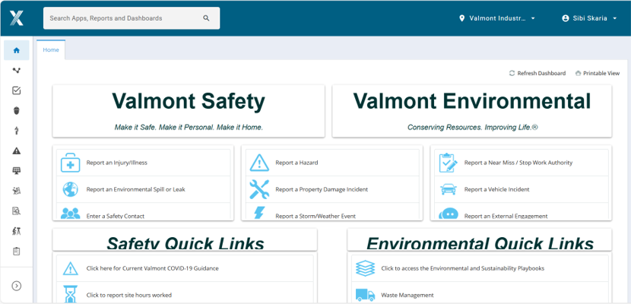Intelex is an integrated software solution for managing EHS programs. The platform stores, manages, and analyzes EHS data in one place. It offers audit management capabilities, centralized data storage, and collaboration tools.

[<https://clients.intelex.com/Login3/Valmont/Application/Home>](https://clients.intelex.com/Login3/Valmont/Application/Home)

# 5.0 Valmont Safety Index (VSI)

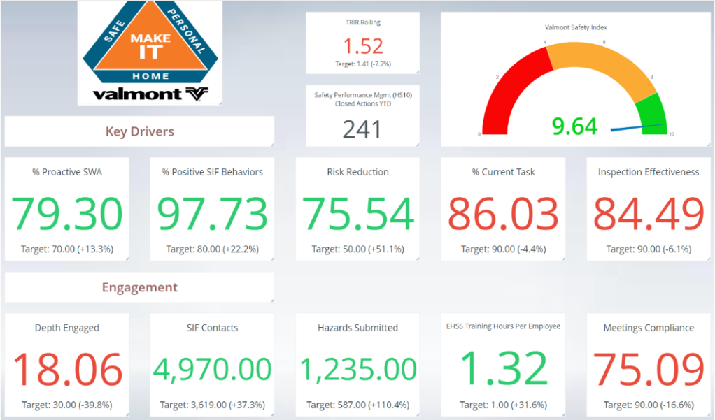

VSI is a single comprehensive, scalable metric that ranges from 0 to 10, this score evaluates the overall safety performance of any Valmont facility. It’s designed to be applicable across all organizational levels, the VSI provides a unified way to measure, monitor and improve safety outcomes.

Developed as part of our commitment to a world-class safety culture, the VSI blends proactive safety practices with real-time performance data. By comparing leading indicators (such as training, hazard identification and near miss reporting) with lagging results (such as recordable incidents or lost time) the VSI gives site leaders a clear and actionable snapshot of their safety health.

# 6.0 Training Guidelines

Effective and informative health and safety training are a cornerstone of our safety program. Training requirements are essential for quipping employees with the skills and knowledge to recognize hazards, operate safely and respond in emergency situations. Our training is a continuous process that adapts to changing conditions, technologies and job roles. Through regular assessments, refresher courses and hands-on learning, we ensure our workforce remains informed, engaged and prepared to work safely every day.

# 7.0 Health and Safety Toolbox

The health and safety toolbox are more than a set of tools; it’s a strategic framework designed to protect workers, uphold compliance, enhance performance, and foster a positive workplace culture.

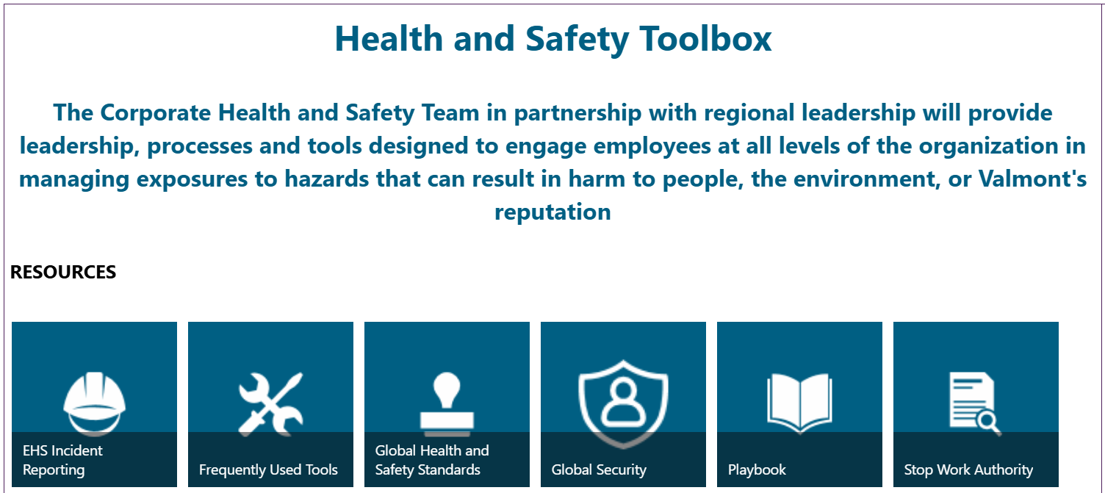

# 8.0 Valmont Health and Safety Standards

There are three categories of Valmont HS standards

8.1 Life Saving Standards

Life-saving standards are mandatory safety rules that focus on the most critical risks in Valmont facilities and are implemented to protect workers from life-threatening hazards.

8.2 Occupational Health Standards

Occupational Health Standards aim to prevent work-related injuries, illnesses, and fatalities by managing risks and ensuring safe working conditions.

8.3 EHS Business Continuity Standards

EHS Business Continuity Standards are formalized procedures and criteria that ensure EHS risks are effectively managed within Valmont to minimize harm, operational interruptions and maintain legal compliance.

[Pages - Global Health and Safety Standards](https://valmont.sharepoint.com/sites/corp-safety/Pages/ghss.aspx)

# 9.0 Frequently Used Tools

These tools are designed to ensure effective and consistent use of Intelex. By leveraging these tools, users can accurately capture key health and safety functions, document safety-related actions   
and monitor performance across all levels of the organization.

# 10.0 Effective Date

18-04-2025 - Original Document

# 11.0 Revision History

|  |  |  |
| --- | --- | --- |
| Date | Revision | Document |
| 18-04-2025 | 0 | New document |