ASSIGNMENT 2 OF 2 · TEAM DECLARATION · DUE FRIDAY 4 SEPTEMBER 2026, 23:59 SGT
A2 Team Declaration
ONE FILE PER TEAM. Fill this in together and CHECK IT INTO YOUR A2 SUBMISSION FOLDER — do not email it. Keep the file name TEAM_DECLARATION. A team that files nothing has an incomplete submission. Section 8 of the brief has the full rules.
1 · Team and problem
Team ID | Section | Problem chosen (A or B)
B5 | B | B
Your team is the group you were placed in at the start of the course — A-1 to A-9, B-1 to B-9, C-1 to C-10. Teams are not re-formed for A2.
2 · Members
# | Full name | Matriculation number
1 | Zhao Xiaonan | G2602304A
2 | Ge Jiayao | G2606405A
3 | Tan Jinxuan | G2606753C
4 | Kaivelikkal Abin Krishna | G2606565B
5 | Wang Hanfei | G2604794H
6 | Liu Siwen | G2603606D
7
Every member, including anyone who has not yet engaged. Delete unused rows.
3 · Repository
Repository URL: https://github.com/abinkrishnak/B5_Outpatient_referral_coordination _____________
Public, and created by your team. The same URL goes in your final submission.
4 · Who owns what
Names against work. The strands below are the suggested split from the FAQ — replace them with your own if you have divided the work differently. Two rows are not optional: everyone writes evaluation cases, and everyone runs one live model. Three models is the floor; N-1 for a team of N is what we expect, with the remaining member taking the v1 pass. Name the model beside each person.
Strand | Feeds | Owner(s)
The loop and the tools | D1, D2(a), D2(c) | Ge Jiayao, Zhao Xiaonan
Descriptors, the v1 to v2 rewrite, guardrail layer | D2(b), D3 | Tan Jinxuan, Kaivelikkal Abin Krishna
Evaluation harness and the scripted run | D4, D5(a) | Wang Hanfei
Cost model, ledger, sensitivity | D6 | Liu Siwen
Evaluation cases — everyone, 5 to 8 each | D4 | everyone
Live model battery — everyone, ONE model each | D5(b) | everyone
Report and demo assembly | Report sections 4 and 5 | everyone
5 · Contribution statement
THIS SECTION IS NOT OPTIONAL. Do not leave it blank.
State ONE of the following two things.
Tick one | Statement
√ | All members are contributing.
 | There is a problem. It is described below, by name.
If you ticked the second box: name the member, what was agreed, and what has happened. Dates help.
Naming a problem here is not an accusation and it does not by itself cost anyone marks. It starts a conversation with a deadline attached: the instructor issues a written warning and the member has nine days to remediate, which usually resolves it. SILENCE AT THIS CHECKPOINT IS READ AS “all members are contributing” — a team that says nothing on 4 September and raises the same problem on 13 September has a much weaker case.
6 · Signed off by
Name: ___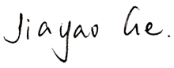___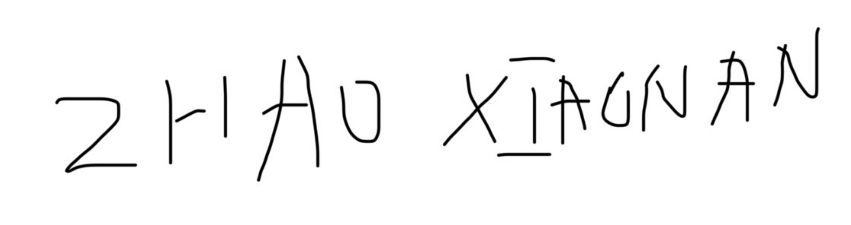_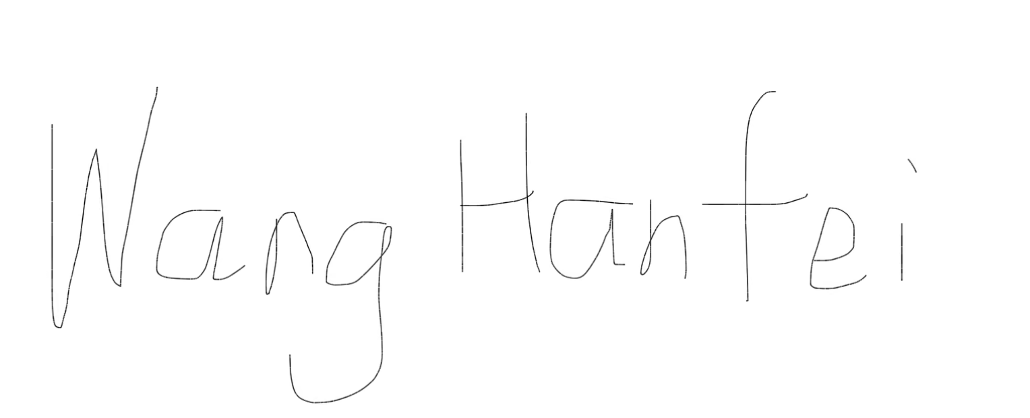_ 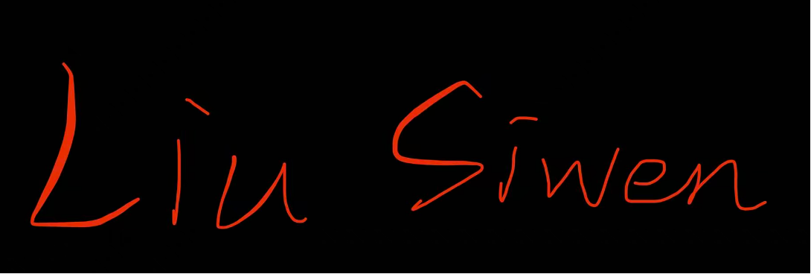 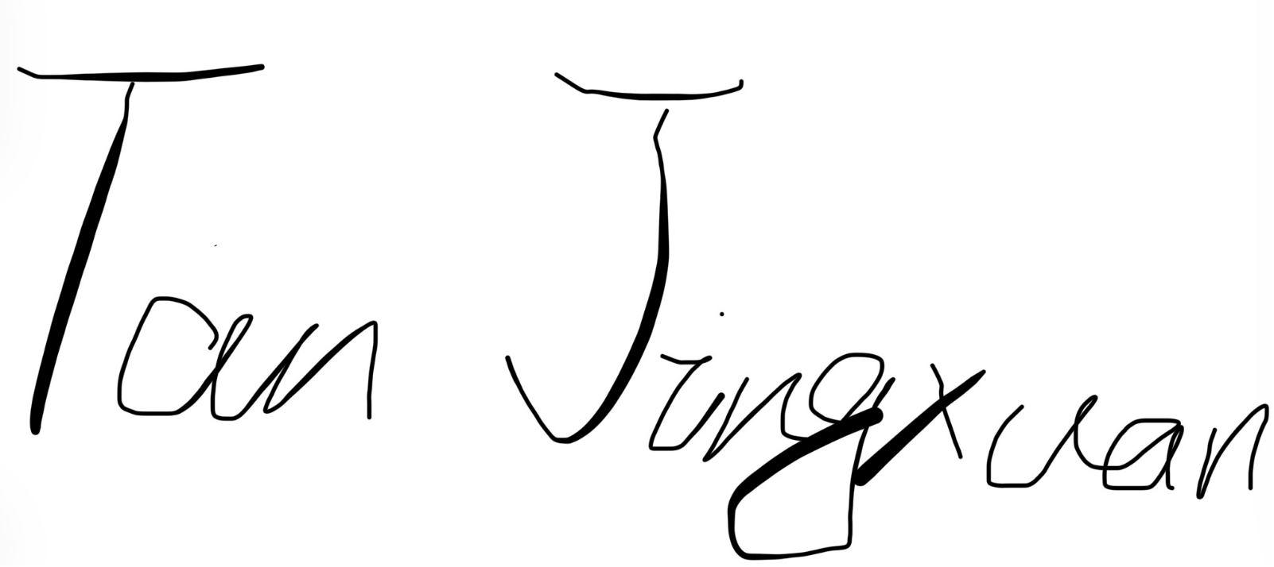 __ 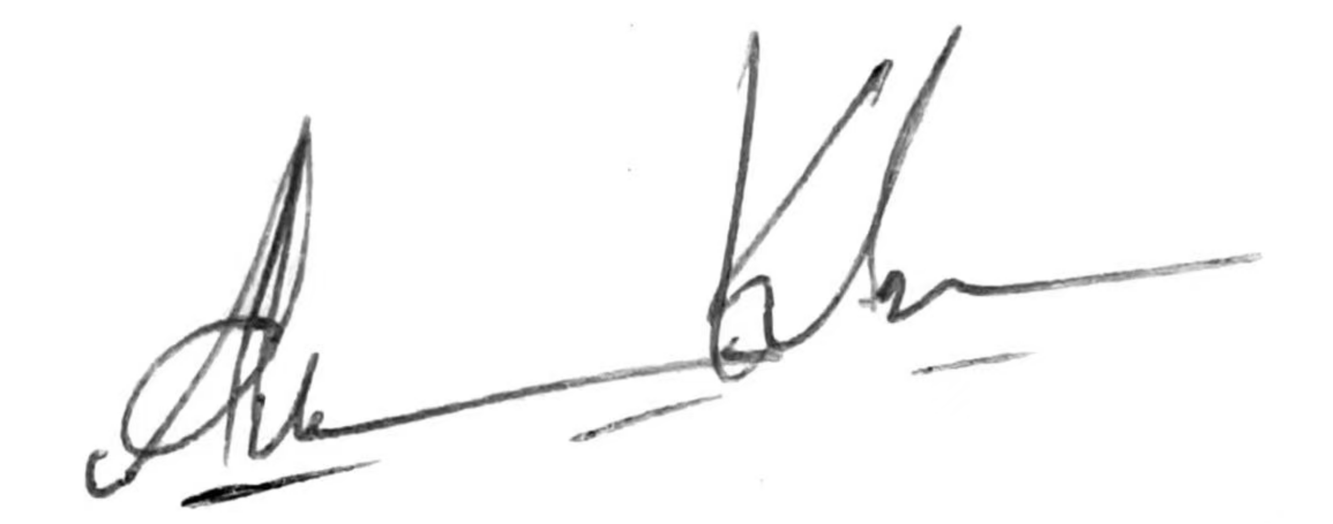 ___________ Date: __9.3.2026__________
One member submits on behalf of the team. Everyone should have read it first.

