EXECUTIVE HOTEL BOOKING
EDA REPORT

Data-Driven Insights for Hotel Revenue & Cancellation Management
Day 15 Assignment — Full EDA Workflow
Dataset: 25,180 hotel bookings across 10 global locations
Prepared: 30 August 2026

Executive Summary
This report presents a complete exploratory data analysis (EDA) of 25,180 hotel booking records spanning City and Resort hotels across 10 locations, undertaken to surface data quality issues and translate booking patterns into actionable insights for management.
The dataset was cleaned and standardized (duplicate removal, text normalization, date validation, missing-value treatment) before univariate, bivariate, group-wise, and correlation analysis was carried out. The headline finding is a very high overall cancellation rate of 72.2%, strongly associated with long booking lead times and, unexpectedly, with the "Non-Refund" deposit type. This exposes an estimated $9.6M in booked-but-unrealized revenue. Five key insights and seven management recommendations are detailed in Sections 6 and 7.
Metric | Value
Total Bookings (raw) | 25,180
Total Bookings (after cleaning) | 24,994
Duplicate Records Removed | 180
Overall Cancellation Rate | 72.2%
Estimated Revenue Realized | $3.78M
Estimated Revenue Lost to Cancellations | $9.60M
Hotel Types | City Hotel, Resort Hotel
Hotel Locations Covered | 10 cities (London, Lisbon, Dubai, Barcelona, Amsterdam, Maldives, Algarve, Bali, Phuket, Goa)

1. Dataset Overview
The raw dataset contains 25,180 records and 35 columns describing booking logistics (lead time, length of stay, room type), guest demographics (adults, children, country), commercial terms (market segment, distribution channel, ADR, deposit type), and outcomes (reservation status, cancellation flag, satisfaction score, estimated revenue).

1.1 Column Groups
- Booking logistics: Booking_Date, Arrival_Date, Lead_Time_Days, Weekend/Weekday_Nights, Total_Nights
- Guest profile: Adults, Children, Babies, Country, Is_Repeated_Guest, Customer_Type
- Commercial terms: Market_Segment, Distribution_Channel, Deposit_Type, ADR, Agent_ID, Company_ID
- Room details: Room_Type_Reserved, Room_Type_Assigned, Meal_Type, Special Requests
- Outcomes: Reservation_Status, Is_Canceled, Satisfaction_Score, Estimated_Revenue

2. Data Quality Assessment
Before analysis, the raw dataset was audited for missing values, duplicate records, incorrect data types, inconsistent categorical values, and outliers.

2.1 Missing Values
Column | Missing Count | Missing %
Company_ID | 20,729 | 82.3%
Country | 466 | 1.9%
Meal_Type | 245 | 1.0%
Agent_ID | 304 | 1.2%
Satisfaction_Score | 164 | 0.7%
Children | 121 | 0.5%
Hotel_Location | 106 | 0.4%
ADR | 82 | 0.3%

Company_ID is missing for 82.3% of bookings — this is expected, as it applies only to corporate accounts, and was treated as "no company" rather than deleted.

2.2 Duplicates & Logical Errors
- 180 fully duplicated rows (identical across all 35 fields) were identified and removed.
- 6 rows recorded an Arrival_Date earlier than the Booking_Date — a logical impossibility — and were removed.
- 2 Satisfaction_Score values fell outside the valid 1–5 scale and were clipped back into range.

2.3 Inconsistent Categorical Values
- Hotel_Type appeared in 5 variants of the same 2 categories (e.g. 'City Hotel', 'CITY HOTEL', 'city hotel').
- Market_Segment contained case/spacing variants of 'Online TA' (e.g. 'online ta', 'ONLINE TA', 'Online TA ').
- Meal_Type mixed valid codes with 'Undefined', 'Unknown', and inconsistent casing ('bb', 'BB ', ' B&B ').
- All of the above were standardized to a single consistent label per category.

2.4 Outliers (IQR Method)
Field | Outliers Found | % of Records
ADR | 360 | 1.4%
Total_Nights | 136 | 0.5%
Estimated_Revenue | 652 | 2.6%
Lead_Time_Days | 2 | 0.0%

Outliers were retained rather than removed, as they reflect legitimate long-stay / high-rate bookings rather than data errors; they were noted for awareness in downstream modeling.

3. Data Cleaning & Preprocessing Summary
- Removed 180 exact duplicate records.
- Removed 6 records with an arrival date earlier than the booking date.
- Standardized casing and whitespace in Hotel_Type, Market_Segment, and Meal_Type.
- Converted Booking_Date, Arrival_Date, and Reservation_Status_Date to proper datetime types.
- Imputed missing Children as 0, missing Country/Hotel_Location/Meal_Type as 'Unknown', and missing ADR / Satisfaction_Score with the column median.
- Flagged missing Agent_ID / Company_ID as binary Has_Agent / Has_Company indicators instead of deleting rows.
- Clipped 2 out-of-range Satisfaction_Score values back into the valid 1–5 scale.
Final analysis-ready dataset: 24,994 records × 37 columns (including two new indicator flags).

4. Key Visual Findings

4.1 Cancellation Patterns
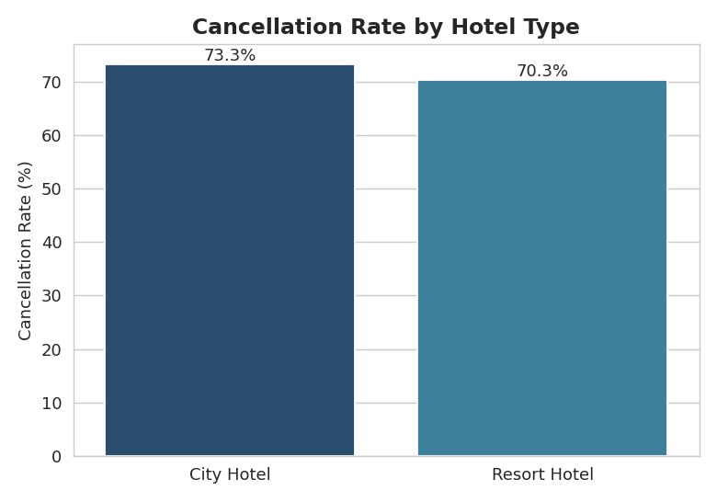
Figure 1 — City Hotels cancel more often than Resort Hotels (73.3% vs 70.3%).
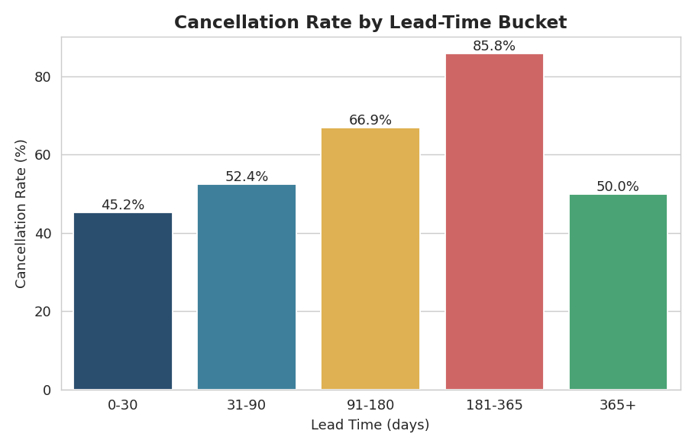
Figure 2 — Cancellation rate rises sharply with lead time, peaking at 85.8% for 181–365 days, then eases to 50.0% for bookings made a year or more out.
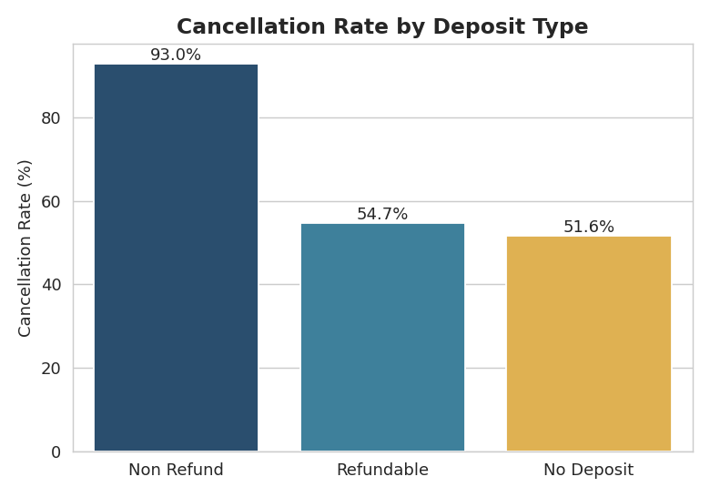
Figure 3 — Non-Refund bookings show a striking 93.0% cancellation rate.

4.2 Revenue & Segment Analysis
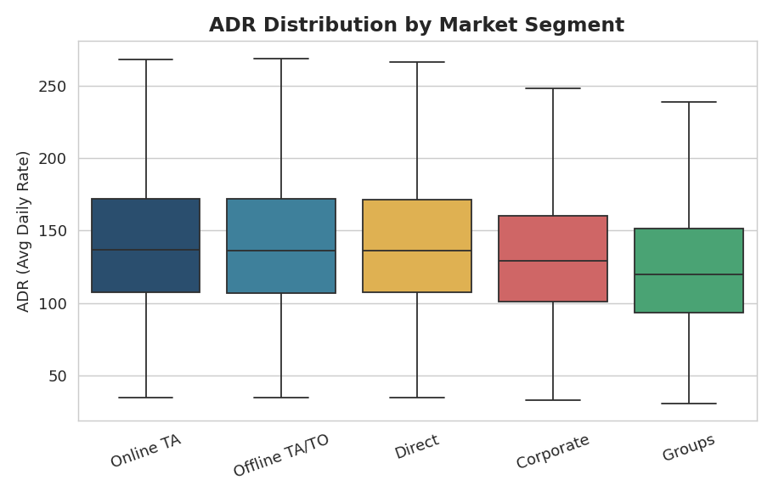
Figure 4 — Direct and Online TA channels command the highest ADR; Groups the lowest.
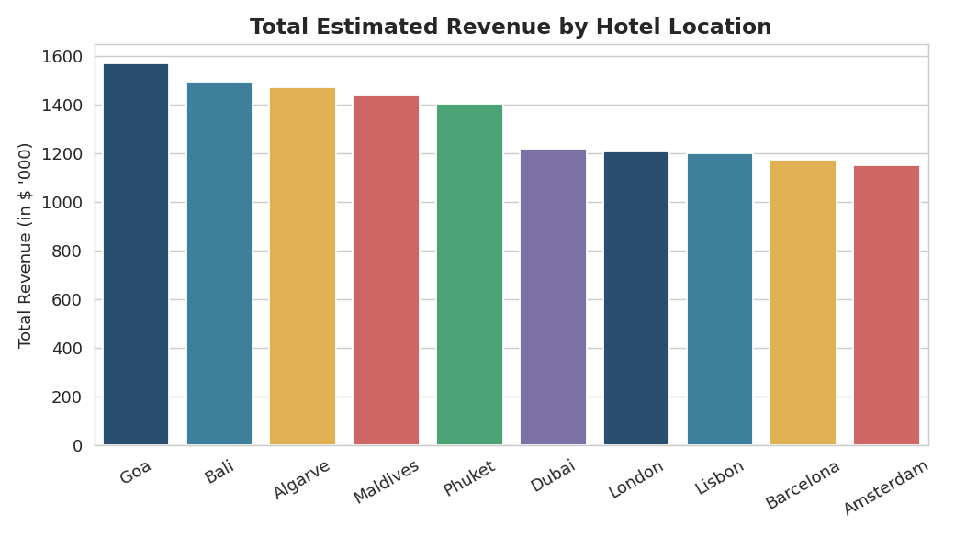
Figure 5 — London and Lisbon generate the highest total estimated revenue.

4.3 Trends & Correlations
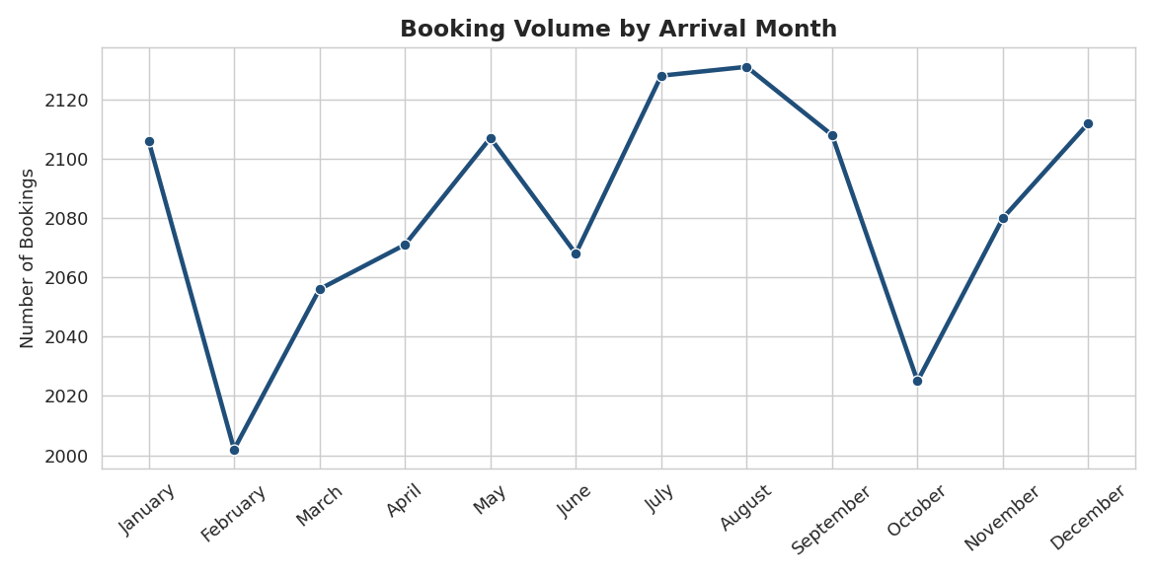
Figure 6 — Booking volume by arrival month shows clear seasonal peaks.
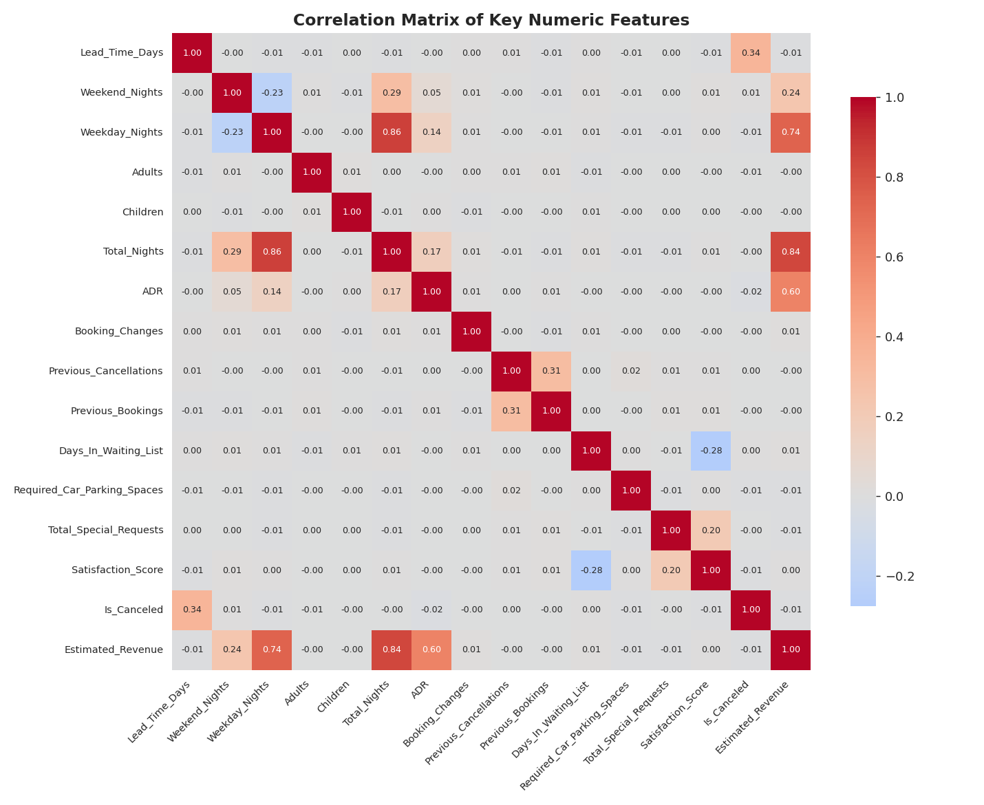
Figure 7 — Correlation matrix: Lead_Time_Days correlates with cancellation (+0.34); waiting-list days correlate negatively with satisfaction (-0.28).

5. Key Business Insights
- Cancellation rate is extremely high — 72.2% of all bookings end in cancellation or no-show, consistent across hotel types and market segments, pointing to a structural booking-process issue rather than an isolated segment problem.
- Longer lead time is the strongest driver of cancellation, up to a point. Cancelled bookings average ~205 days lead time vs. ~124 days for completed stays (correlation +0.34), and the cancellation rate climbs from 45.2% (0-30 days) to a peak of 85.8% (181-365 days) before easing to 50.0% for bookings made a year or more in advance — likely locked-in contract or corporate bookings.
- Deposit type is a near-perfect cancellation signal: "Non-Refund" bookings cancel at 93.0%, versus ~52–55% for "Refundable" and "No Deposit" — the opposite of the policy's intended effect, and worth a dedicated review.
- Revenue is heavily exposed to cancellations: $9.6M in booked revenue was never realized, versus $3.8M actually collected — a nearly 3:1 gap between booked and realized revenue.
- Guest satisfaction erodes with waiting-list delays (3.88 average with no wait, down to 3.19 at 51+ days), and the Online TA channel — the highest-volume segment — also carries the highest cancellation rate (75.1%).

6. Recommendations for Management
- Investigate the Non-Refund deposit anomaly immediately — a 93.0% cancellation rate on non-refundable bookings suggests either a data/labeling issue or a broken policy-enforcement process.
- Tighten cancellation policies for long-lead-time bookings — require partial pre-payment or confirmation call-backs for reservations made 180+ days in advance.
- Prioritize Online TA channel management — renegotiate cancellation-window terms with OTAs or add overbooking buffers specific to this channel.
- Reduce waiting-list dwell time — set an internal SLA to confirm or reject waitlisted requests within a defined window to protect satisfaction scores.
- Build a dynamic overbooking model using lead time and deposit type as leading predictors of cancellation risk to protect realized revenue.
- Standardize data capture at the booking-system level — inconsistent casing and 180 duplicate records point to input-validation gaps that should be fixed upstream.
- Focus retention and marketing spend on Corporate and Groups segments, which show the lowest cancellation rates (67.5% and 69.8% respectively) and more predictable revenue.

7. Conclusion
This EDA surfaces a hotel booking operation with strong top-line demand but a severe cancellation problem that is materially eroding realized revenue. The strongest available predictors of cancellation — lead time and deposit type — provide a practical starting point for a predictive overbooking or dynamic-deposit strategy, while the data quality issues identified point to process fixes that should be made at the point of booking capture rather than after the fact.

