2

SQL> CREATE TABLE SAILOR(sid NUMBER(3)PRIMARY KEY,sname VARCHAR(20),rating NUMBER(3),age NUMBER(3));

Table created.

SQL> INSERT INTO SAILOR VALUES(&sid,'&sname',&rating,&age);

Enter value for sid: 22

Enter value for sname: Dustin

Enter value for rating: 7

Enter value for age: 45

old 1: INSERT INTO SAILOR VALUES(&sid,'&sname',&rating,&age)

new 1: INSERT INTO SAILOR VALUES(22,'Dustin',7,45)

1 row created.

SQL> /

Enter value for sid: 29

Enter value for sname: Brutas

Enter value for rating: 1

Enter value for age: 33

old 1: INSERT INTO SAILOR VALUES(&sid,'&sname',&rating,&age)

new 1: INSERT INTO SAILOR VALUES(29,'Brutas',1,33)

1 row created.

SQL> /

Enter value for sid: 31

Enter value for sname: Lubber

Enter value for rating: 8

Enter value for age: 55

old 1: INSERT INTO SAILOR VALUES(&sid,'&sname',&rating,&age)

new 1: INSERT INTO SAILOR VALUES(31,'Lubber',8,55)

1 row created.

SQL> /

Enter value for sid: 32

Enter value for sname: Andy

Enter value for rating: 8

Enter value for age: 25

old 1: INSERT INTO SAILOR VALUES(&sid,'&sname',&rating,&age)

new 1: INSERT INTO SAILOR VALUES(32,'Andy',8,25)

1 row created.

SQL> /

Enter value for sid: 58

Enter value for sname: Rusty

Enter value for rating: 10

Enter value for age: 35

old 1: INSERT INTO SAILOR VALUES(&sid,'&sname',&rating,&age)

new 1: INSERT INTO SAILOR VALUES(58,'Rusty',10,35)

1 row created.

SQL> /

Enter value for sid: 64

Enter value for sname: Horatio

Enter value for rating: 7

Enter value for age: 35

old 1: INSERT INTO SAILOR VALUES(&sid,'&sname',&rating,&age)

new 1: INSERT INTO SAILOR VALUES(64,'Horatio',7,35)

1 row created.

SQL> /

Enter value for sid: 71

Enter value for sname: Zorba

Enter value for rating: 10

Enter value for age: 16

old 1: INSERT INTO SAILOR VALUES(&sid,'&sname',&rating,&age)

new 1: INSERT INTO SAILOR VALUES(71,'Zorba',10,16)

1 row created.

SQL> /

Enter value for sid: 74

Enter value for sname: Horatio

Enter value for rating: 9

Enter value for age: 35

old 1: INSERT INTO SAILOR VALUES(&sid,'&sname',&rating,&age)

new 1: INSERT INTO SAILOR VALUES(74,'Horatio',9,35)

1 row created.

SQL> /

Enter value for sid: 85

Enter value for sname: Art

Enter value for rating: 3

Enter value for age: 26

old 1: INSERT INTO SAILOR VALUES(&sid,'&sname',&rating,&age)

new 1: INSERT INTO SAILOR VALUES(85,'Art',3,26)

1 row created.

SQL> /

Enter value for sid: 95

Enter value for sname: Bob

Enter value for rating: 3

Enter value for age: 64

old 1: INSERT INTO SAILOR VALUES(&sid,'&sname',&rating,&age)

new 1: INSERT INTO SAILOR VALUES(95,'Bob',3,64)

1 row created.

SQL> CREATE TABLE BOAT(bid NUMBER(3)PRIMARY KEY,bname VARCHAR(20),color VARCHAR(20));

Table created.

SQL> INSERT INTO BOAT VALUES(&bid,'&bname','&color');

Enter value for bid: 101

Enter value for bname: Interlake

Enter value for color: Blue

old 1: INSERT INTO BOAT VALUES(&bid,'&bname','&color')

new 1: INSERT INTO BOAT VALUES(101,'Interlake','Blue')

1 row created.

SQL> /

Enter value for bid: 102

Enter value for bname: Interlake

Enter value for color: Red

old 1: INSERT INTO BOAT VALUES(&bid,'&bname','&color')

new 1: INSERT INTO BOAT VALUES(102,'Interlake','Red')

1 row created.

SQL> /

Enter value for bid: 103

Enter value for bname: Clipper

Enter value for color: Green

old 1: INSERT INTO BOAT VALUES(&bid,'&bname','&color')

new 1: INSERT INTO BOAT VALUES(103,'Clipper','Green')

1 row created.

SQL> /

Enter value for bid: 104

Enter value for bname: Marine

Enter value for color: Red

old 1: INSERT INTO BOAT VALUES(&bid,'&bname','&color')

new 1: INSERT INTO BOAT VALUES(104,'Marine','Red')

1 row created.

SQL> CREATE TABLE RESERVE(sid NUMBER REFERENCES SAILOR(sid),bid NUMBER REFERENCES BOAT(bid),day DATE);

Table created.

SQL> INSERT INTO RESERVE VALUES(&sid,&bid,'&day');

Enter value for sid: 22

Enter value for bid: 101

Enter value for day:

old 1: INSERT INTO RESERVE VALUES(&sid,&bid,'&day')

new 1: INSERT INTO RESERVE VALUES(22,101,'')

1 row created.

SQL> INSERT INTO RESERVE VALUES(&sid,&bid,'&day');

Enter value for sid: 22

Enter value for bid: 102

Enter value for day: 10-OCT-1998

old 1: INSERT INTO RESERVE VALUES(&sid,&bid,'&day')

new 1: INSERT INTO RESERVE VALUES(22,102,'10-OCT-1998')

1 row created.

Enter value for sid: 22

Enter value for bid: 103

Enter value for day: 10-AUG-1998

old 1: INSERT INTO RESERVE VALUES(&sid,&bid,'&day')

new 1: INSERT INTO RESERVE VALUES(22,103,'10-AUG-1998')

1 row created.

SQL> /

Enter value for sid: 22

Enter value for bid: 104

Enter value for day: 10-JULY-1998

old 1: INSERT INTO RESERVE VALUES(&sid,&bid,'&day')

new 1: INSERT INTO RESERVE VALUES(22,104,'10-JULY-1998')

1 row created.

SQL> /

Enter value for sid: 31

Enter value for bid: 102

Enter value for day: 11-OCT-1998

old 1: INSERT INTO RESERVE VALUES(&sid,&bid,'&day')

new 1: INSERT INTO RESERVE VALUES(31,102,'11-OCT-1998')

1 row created.

SQL> /

Enter value for sid: 31

Enter value for bid: 103

Enter value for day: 11-JUN-1998

old 1: INSERT INTO RESERVE VALUES(&sid,&bid,'&day')

new 1: INSERT INTO RESERVE VALUES(31,103,'11-JUN-1998')

1 row created.

SQL> /

Enter value for sid: 31

Enter value for bid: 104

Enter value for day: 11-DEC-1998

old 1: INSERT INTO RESERVE VALUES(&sid,&bid,'&day')

new 1: INSERT INTO RESERVE VALUES(31,104,'11-DEC-1998')

1 row created.

SQL> /

Enter value for sid: 64

Enter value for bid: 101

Enter value for day: 9-MAY-1998

old 1: INSERT INTO RESERVE VALUES(&sid,&bid,'&day')

new 1: INSERT INTO RESERVE VALUES(64,101,'9-MAY-1998')

1 row created.

SQL> /

Enter value for sid: 64

Enter value for bid: 102

Enter value for day: 9-AUG-1998

old 1: INSERT INTO RESERVE VALUES(&sid,&bid,'&day')

new 1: INSERT INTO RESERVE VALUES(64,102,'9-AUG-1998')

1 row created.

SQL> /

Enter value for sid: 74

Enter value for bid: 103

Enter value for day: 9-AUG-1998

old 1: INSERT INTO RESERVE VALUES(&sid,&bid,'&day')

new 1: INSERT INTO RESERVE VALUES(74,103,'9-AUG-1998')

1 row created.

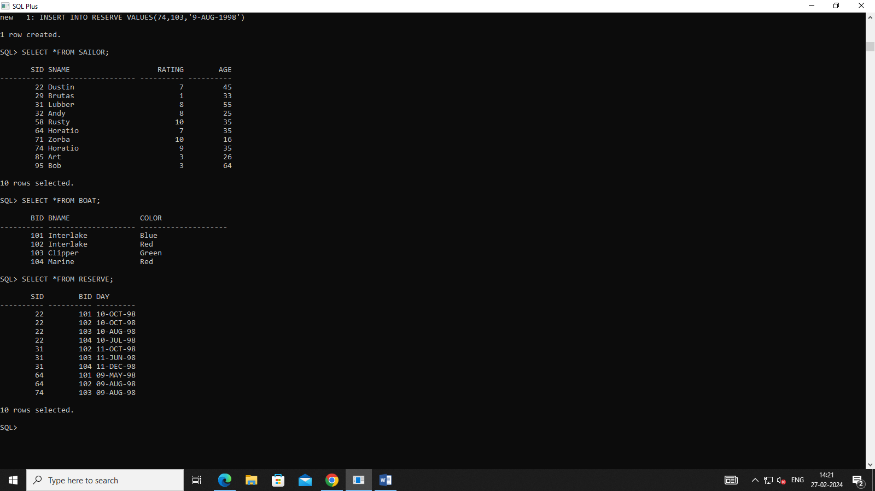

SQL> SELECT sname,age FROM SAILOR;

SNAME AGE

-------------------- ----------

Dustin 45

Brutas 33

Lubber 55

Andy 25

Rusty 35

Horatio 35

Zorba 16

Horatio 35

Art 26

Bob 64

10 rows selected.

SQL> SELECT \*FROM SAILOR WHERE sid IN(select SID FROM RESERVE WHERE bid=101);

SID SNAME RATING AGE

---------- -------------------- ---------- ----------

22 Dustin 7 45

64 Horatio 7 35

SQL> SELECT \*FROM SAILOR WHERE rating >7;

SID SNAME RATING AGE

---------- -------------------- ---------- ----------

31 Lubber 8 55

32 Andy 8 25

58 Rusty 10 35

71 Zorba 10 16

74 Horatio 9 35

SQL> SELECT sname FROM SAILOR WHERE sid IN(select SID FROM RESERVE WHERE bid=103);

SNAME

--------------------

Dustin

Lubber

Horatio

SQL> SELECT sname FROM SAILOR WHERE sid IN(SELECT sid FROM RESERVE WHERE bid IN(SELECT bid FROM BOAT WHERE color='Red'))ORDER BY age;

SNAME

--------------------

Horatio

Dustin

Lubber

SQL> SELECT sname FROM SAILOR WHERE sid IN(SELECT sid FROM RESERVE WHERE bid IN(SELECT bid FROM BOAT WHERE color='Red'OR COLOR='Green'));

SNAME

--------------------

Dustin

Lubber

Horatio

Horatio

SQL> SELECT DISTINCT COLOR FROM BOAT WHERE bid IN((SELECT bid FROM RESERVE WHERE sid IN(SELECT sid FROM SAILOR WHERE sname ='Lubber')));

COLOR

--------------------

Green

Red