**Name: Abin Sunil**

**Roll No: 1**

**Batch: MCA B**

**Date: 09-05-2022**

**NETWORKING & SYSTEM ADMINISTRATION LAB**

**Experiment No.: 14**

**Aim**

Write a shell script program to display current date and current year.

**Procedure**

#!/bin/bash

echo "current date: "$(date)

echo "current year calender: "

cal

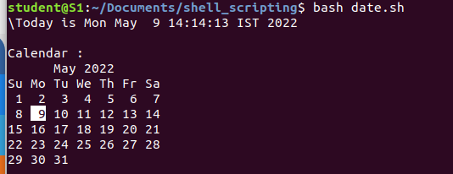**Output:**