20MCA136 – NETWORKING & SYSTEM ADMINISTRATION LAB Dept. of Computer Applications

# NETWORKING & SYSTEM ADMINISTRATION LAB

**Name: Abin Sunil**

**Roll No: 1**

**Batch: MCA B**

**Date: 09-05-2022**

**ExperimentNo.:16Aim**

Write a shell script to find the sum of first 10 numbers

# Procedure

#!/bin/bash

echo "Enter the first 10 numbers" read n

sum=0 for((i=0;i<=n;i++)) do

sum=$((sum + i)) done

echo -e "sum is $sum"

# Output:

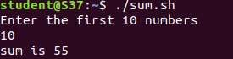

Amal Jyothi College of Engineering, Kanjirappally