Name: Abin Sunil
Roll No: 1
Batch: MCA B
Date: 23-05-2022

NETWORKING & SYSTEM ADMINISTRATION LAB

Experiment No.:

Aim
Docker installation

Procedure
1. Remove any Docker files that are running in the system, using the following command:
Syntax:- $ sudo apt-get remove docker docker-engine docker.io
Output:-
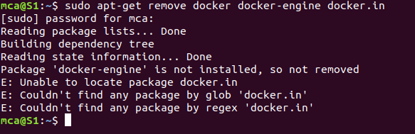

2. Check if the system is up-to-date using the following command:
Syntax:- $ sudo apt-get update

Output:-
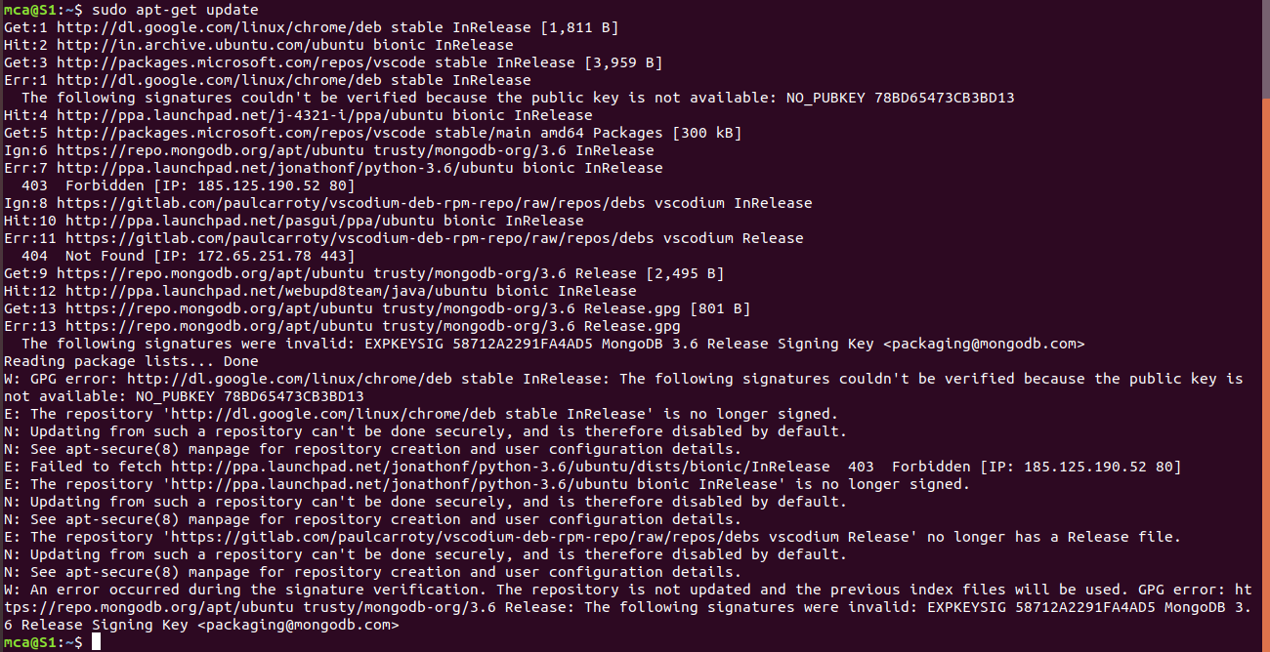
3. Install Docker using the following command:
Syntax:- $ sudo apt install docker.io
Output:-
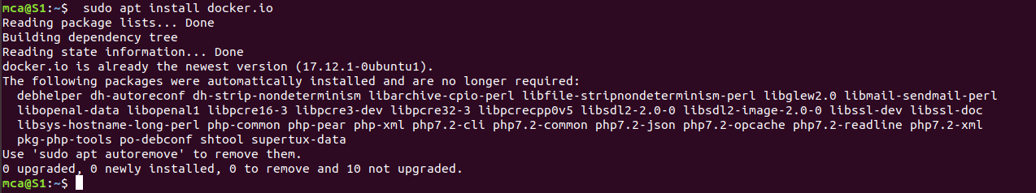

4. Install all the dependency packages using the following command:
Syntax:- $ sudo snap install docker
Output:-
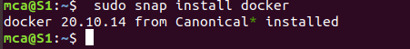

5. Before testing Docker, check the version installed using the following command:
Syntax:- $ docker --version
Output:-
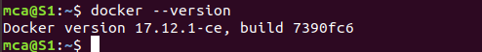

6. Pull an image from the Docker hub using the following command:
Syntax:-$ sudo docker run hello-world
Output:-
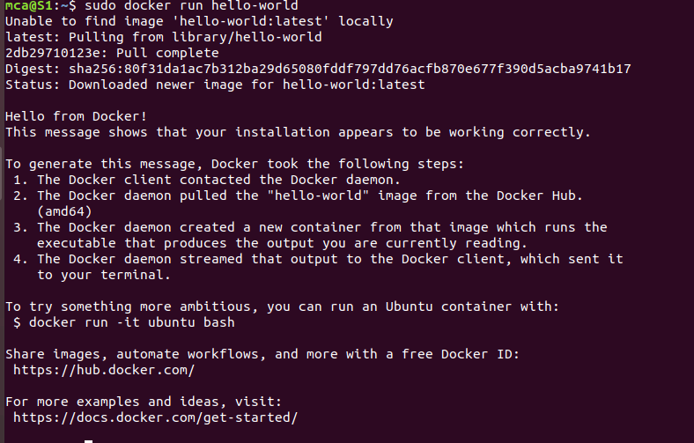

7.Check if the docker image has been pulled and is present in your system using the following command:
Syntax:-$ sudo docker images
Output:-

8. To display all the containers pulled, use the following command:
Syntax:-$ sudo docker ps -a
Output:-

9. To check for containers in a running state, use the following command:
Syntax:- $ sudo docker ps
Output:-

