MEDTRACE
AI-Based Clinical Intelligence And Patient Monitoring System

Mini Project Report

Submitted by

Abin Thomas
Reg. No.: AJC22MCA-I005

In Partial fulfillment for the Award of the Degree of
INTEGRATED MASTER OF COMPUTER APPLICATIONS

(INMCA)

APJ ABDUL KALAM TECHNOLOGICAL UNIVERSITY


AMAL JYOTHI COLLEGE OF ENGINEERING AUTONOMOUS
KANJIRAPPALLY

[Affiliated to APJ Abdul Kalam Technological University, Kerala. Approved by AICTE, Accredited by NAAC. Koovappally, Kanjirappally, Kottayam, Kerala – 686518]

2026-2027

DEPARTMENT OF COMPUTER APPLICATIONS

AMAL JYOTHI COLLEGE OF ENGINEERING AUTONOMOUS
KANJIRAPPALLY

CERTIFICATE

This is to certify that the Project report, “MEDTRACE” is the bona fide work of ABIN THOMAS (Regno: AJC22MCA-I002) carried out in partial fulfillment of the requirements for the award of the Degree of Integrated Master of Computer Applications at Amal Jyothi College of Engineering Autonomous, Kanjirappally, Affiliated to APJ Abdul Kalam Technological University. The project was undertaken during the period from July 01, 2026 to October 30, 2026.

Mr. Binumon Joseph Ms. Meera Rose Mathew

Internal Guide Coordinator

Dr. Bijimol T.K

Head of the Department

DECLARATION

I hereby declare that the project report “MEDTRACE” is a bona fide work done at Amal Jyothi College of Engineering Autonomous, Kanjirappally, Affiliated to APJ Abdul Kalam Technological University, towards the partial fulfilment of the requirements for the award of the Integrated Master of Computer Applications (INMCA) during the period from July 01, 2026 to October 30, 2026.

Date: ABIN THOMAS

KANJIRAPPALLY Reg: AJC22MCA-I005

ACKNOWLEDGEMENT

First and foremost, I thank God almighty for his eternal love and protection throughout the project. I take this opportunity to express my gratitude to all who helped me in completing this project successfully. It has been said that gratitude is the memory of the heart. I wish to express my sincere gratitude to our Director (Administration) Rev. Fr. Dr. Roy Abraham Pazhayaparampil and Principal Dr. Lillykutty Jacob for providing good faculty for guidance.

I owe a great depth of gratitude towards our Head of the Department Dr. Bijimol T.K for helping us. I extend my whole hearted thanks to the project coordinator Ms. Meera Rose Mathew for her valuable suggestions and for overwhelming concern and guidance from the beginning to the end of the project. I would also express sincere gratitude to my guide Mr. Binumon Joseph for his inspiration and helping hand.

I thank our beloved teachers for their cooperation and suggestions that helped me throughout the project. I express my thanks to all my friends and classmates for their interest, dedication, and encouragement shown towards the project. I convey my hearty thanks to my family for the moral support, suggestions, and encouragement to make this venture a success.

ABIN THOMAS

ABSTRACT

The increasing complexity of healthcare data and the need for continuous patient monitoring create a growing demand for intelligent systems that can assist healthcare professionals in making informed and timely clinical decisions. This project proposes MedTrace, an AI-Based Clinical Intelligence and Multi-Level Contactless Patient Monitoring System, designed for a single hospital environment. Unlike conventional hospital information systems that primarily focus on storing and managing patient records, MedTrace uses Artificial Intelligence and Machine Learning as its core components to analyze verified longitudinal clinical data, identify health patterns, retrieve similar historical cases, and detect potential anomalies in both patient health records and real time monitoring data. The system maintains a longitudinal health profile for patients based on verified clinical information generated during their visits within the hospital. Medical reports uploaded or generated during clinical encounters can be processed using Optical Character Recognition (OCR) and Natural Language Processing (NLP) techniques to extract relevant clinical information from structured and unstructured documents. The extracted information is analyzed alongside previous patient records to identify changes and trends in health parameters, detect abnormal patterns, and support selected health-risk prediction tasks using Machine Learning models. Explainable Artificial Intelligence techniques can further provide information about the major factors contributing to AI generated predictions, enabling healthcare professionals to better understand and interpret the results. A key feature of MedTrace is an AI-Based Similar Case Retrieval Engine, which allows healthcare professionals to compare a patient’s current clinical condition with appropriately verified and anonymized historical cases available within the hospital. When a doctor uploads or analyzes a new medical report or supported medical image, the system extracts relevant clinical features and uses semantic similarity and vector-based retrieval techniques to identify similar previous cases. The retrieved cases can provide information about previous clinical findings, diagnoses, treatments, and outcomes, allowing doctors to consider relevant historical experiences while making clinical decisions. The system is designed to support, rather than replace, professional medical judgment and does not automatically prescribe treatments or provide autonomous diagnoses. The proposed system is further extended with a multi-level contactless patient monitoring framework. At the individual patient level, an under-mattress sensing unit based on an ESP32 and suitable respiratory sensors can monitor breathing-related movements without requiring wearable devices. Signal-processing and Machine Learning techniques can be applied to estimate respiratory patterns and identify significant deviations or abnormal breathing events.
This feature is particularly intended for vulnerable patients such as infants, children, bedridden individuals, and patients requiring continuous observation. Appropriate alerts can be provided to nurses, caregivers, parents or guardians, and authorized healthcare professionals when potentially abnormal patterns are detected. At the ward level, the system explores Wi-Fi Channel State Information (CSI)-based contactless anomaly detection for monitoring patient activity and movement patterns without relying on cameras or wearable devices. Changes in Wi-Fi signal characteristics caused by human movement and environmental interactions can be collected and processed to identify unusual activity patterns, prolonged inactivity, or possible fall-like events. Machine Learning-based anomaly detection techniques can then generate alerts for healthcare staff to investigate. The Wi-Fi CSI module is intended as a ward-level monitoring and anomaly detection mechanism, while individual respiratory monitoring is handled through dedicated under-mattress sensing for selected patients. MedTrace incorporates multiple user roles, including patients, parents or guardians, doctors, nurses, caregivers, and hospital administrators, with role-based access to ensure that each user receives only the information relevant to their responsibilities. To address concerns regarding unreliable or unauthorized medical information, the system distinguishes between patient-submitted documents and verified clinical records. Only appropriately verified and authorized clinical information is considered for inclusion in the hospital’s historical case repository used by the AI-based similar-case retrieval module. The proposed system integrates OCR, NLP, Machine Learning, anomaly detection, semantic similarity search, case-based reasoning, Explainable AI, IoT-based respiratory sensing, signal processing, and Wi-Fi CSI-based contactless monitoring within a unified clinical intelligence framework. By combining longitudinal clinical analysis with individual and ward-level contactless monitoring, MedTrace aims to provide healthcare professionals with a more comprehensive understanding of patient conditions, support the identification of relevant historical cases, improve early detection of abnormal health patterns, and enhance continuous patient observation. The system is intended as a clinical decision-support and monitoring platform, with final diagnosis, treatment, and medical intervention remaining under the responsibility of qualified healthcare professionals.
.

CONTENT

SL. NO | TOPIC | PAGE NO
1 | INTRODUCTION | 1
1.1 | PROJECT OVERVIEW | 2
1.2 | PROJECT SPECIFICATION | 3
2 | SYSTEM STUDY | 7
2.1 | INTRODUCTION | 8
2.2 | EXISTING SYSTEM | 8
2.3 | DRAWBACKS OF EXISTING SYSTEM | 9
2.4 | PROPOSED SYSTEM | 10
2.5 | ADVANTAGES OF PROPOSED SYSTEM | 11
3 | REQUIREMENT ANALYSIS | 12
3.1 | FEASIBILITY STUDY | 13
3.1.1 | ECONOMICAL FEASIBILITY | 13
3.1.2 | TECHNICAL FEASIBILITY | 13
3.1.3 | BEHAVIORAL FEASIBILITY | 14
3.1.4 | FEASIBILITY STUDY QUESTIONNAIRE | 15
3.2 | SYSTEM SPECIFICATION | 21
3.2.1 | HARDWARE SPECIFICATION | 21
3.2.2 | SOFTWARE SPECIFICATION | 21
3.3 | SOFTWARE DESCRIPTION | 21
3.3.1 | REACT AND TYPESCRIPT | 22
3.3.2 | NODE.JS + EXPRESS | 22
3.3.3 | FIREBASE | 22
3.3.4 | GEMINI AND GENERATIVE AI | 23
4 | SYSTEM DESIGN | 24
4.1 | INTRODUCTION | 25
4.2 | UML DIAGRAM | 25
4.2.1 | USE CASE DIAGRAM | 27
4.2.2 | SEQUENCE DIAGRAM | 29
4.2.3 | STATE CHART DIAGRAM |  | 31
4.2.4 | ACTIVITY DIAGRAM |  | 32
4.2.5 | CLASS DIAGRAM |  | 34
4.2.6 | OBJECT DIAGRAM |  | 35
4.2.7 | COMPONENT DIAGRAM |  | 36
4.2.8 | DEPLOYMENT DIAGRAM |  | 37
4.3 | USER INTERFACE DESIGN USING FIGMA |  | 38
4.4 | DATABASE DESIGN |  | 41
4.5 | COLLECTION DESIGN |  | 43
5 | SYSTEM TESTING |  | 57
5.1 | INTRODUCTION |  | 58
5.2 | TEST PLAN |  | 59
5.2.1 | UNIT TESTING |  | 59
5.2.2 | INTEGRATION TESTING |  | 59
5.2.3 | VALIDATION TESTING |  | 59
5.2.4 | USER ACCEPTANCE TESTING |  | 60
5.2.5 | AUTOMATION TESTING |  | 60
5.2.6 | PLAYWRIGHT TESTING |  | 60
6 | IMPLEMENTATION |  | 77
6.1 | INTRODUCTION |  | 77
6.2 | IMPLEMENTATION PROCEDURE |  | 77
6.2.1 | USER TRAINING |  | 79
6.2.2 | TRAINING ON APPLICATION SOFTWARE |  | 80
6.2.3 | SYSTEM MAINTENANCE |  | 81
7 | CONCLUSION & FUTURE SCOPE |  | 84
7.1 | CONCLUSION |  | 85
7.2 | FUTURE SCOPE |  | 85
8 | BIBLIOGRAPHY |  | 87
9 | APPENDIX |  | 89
9.1 | SAMPLE CODE |  | 90
9.2 | SCREEN SHOTS |  | 99

List of Abbreviations
ML | Machine Learning
NLP | Natural Language Processing
SBERT | Sentence-Bidirectional Encoder Representations from Transformers
XAI | Explainable Artificial Intelligence
SHAP | SHapley Additive exPlanations
LIME | Local Interpretable Model-agnostic Explanations
API | Application Programming Interface
REST | Representational State Transfer
CRUD | Create, Read, Update, Delete
JSON | JavaScript Object Notation
JWT | JSON Web Token
CORS | Cross-Origin Resource Sharing
HTTP | HyperText Transfer Protocol
HTTPS | HyperText Transfer Protocol Secure
URL | Uniform Resource Locator

CHAPTER 1

INTRODUCTION

PROJECT OVERVIEW
MedTrace is an AI-based clinical intelligence and contactless patient monitoring system designed to make healthcare information management and clinical decision support more efficient by bringing patient records, medical reports, health observations, appointments, medications, test results and monitoring information into a unified platform. MedTrace focuses on improving accessibility of patient information, supporting healthcare professionals in understanding longitudinal health conditions and providing intelligent assistance during clinical workflows. It uses AI-based medical report analysis to extract and present important findings, abnormal values, recommendations and urgency information in a structured manner, while also providing patient history and health trends for better clinical understanding. The system provides role-based dashboards for hospital administrators, doctors, patients or guardians, caretakers or caregivers, nurses, head nurses and reception staff, allowing each user to access functions relevant to their responsibilities. Patients or guardians can manage their health information, upload medical reports, view AI-assisted report analysis, monitor test results and vitals, manage medications and appointments, and assign authorized caretaker access. Doctors can search and review patient information, examine previous reports and clinical records, use AI-assisted analysis and access relevant health information to support clinical decisions. Nurses and head nurses can manage duty schedules, attendance, patient assignments and nursing tasks, while reception staff can handle relevant patient and appointment workflows. MedTrace also includes contactless monitoring concepts such as respiratory monitoring and Wi-Fi CSI-based anomaly detection as research-oriented extensions for observing patient or ward-level patterns without requiring continuous wearable devices. In short, MedTrace is a full-stack healthcare platform that combines React, TypeScript, Node.js, Express, database and cloud services, and Generative AI to provide an intelligent, secure and role-based clinical support environment. The system is designed as an academic clinical decision-support prototype where AI assists healthcare professionals, while final clinical decisions remain with qualified medical personnel.
Technology Stack
- Frontend: React 18, TypeScript, Vite, Material UI (MUI) v5, React Router, Recharts, React Hook Form, Yup
- Backend: Node.js, Express.js, TypeScript, REST API architecture, express-validator, Multer (file uploads), CORS
- Database: MongoDB with the Mongoose ODM (backend models such as User, Patient, Vitals, Medication, Appointment, NurseTask), and Firebase Cloud Firestore (frontend-side collections such as reports, vitals, medications, notifications, nurse duties, shift handovers and the patient timeline)
- File Storage: Local disk storage through Multer on the backend, behind a storage-service interface, plus Firebase Storage on the frontend
- AI Layer: Google Generative AI SDK (@google/generative-ai) with Gemini Flash-series models for medical report analysis
- Authentication: Firebase Authentication, Google OAuth (google-auth-library), JSON Web Tokens (JWT) with access and refresh tokens, bcrypt password hashing
- Real-time Updates: Firestore real-time listeners (onSnapshot), used for example in nurse duty updates
- Email Automation: Nodemailer (password-reset emails)
- Security Measures: JWT-based authentication middleware, role-based access control, bcrypt password hashing, server-side input validation
- Testing: Playwright end-to-end tests (authentication, patient vitals, doctor appointment booking, medical report analysis, nurse active-duty checks, and a smoke test)
- Deployment: Vercel and GitHub for the web application (as stated in your project context). I found no deployment configuration files in the ZIP, so confirm the backend hosting before the report says where it runs.

PROJECT SPECIFICATION

1. Project Title

MedTrace – An AI-Based Clinical Intelligence & Contactless Patient Monitoring System

2. Project Description

MedTrace is a full-stack healthcare platform designed for a single hospital. It brings patient medical reports, clinical history, test results, vitals, medications, appointments, nursing activities and AI-assisted analysis into one system. Patients or their guardians can upload medical reports, and the system uses Google's Gemini generative AI to produce a structured summary covering the report overview, key findings, abnormal values, recommendations and urgency, along with a medical disclaimer. Doctors can review a patient's longitudinal health history, previous reports, vitals and test results, and use the AI-generated analysis as a decision-support aid. Patients can also track medications, book appointments, follow exercise plans and receive notifications. They can authorize caretakers, who can then see only the information of patients assigned to them. Nurses and head nurses have dedicated workflows for duty scheduling, attendance, patient assignments and nursing tasks. A head nurse schedules duties in advance and assigns tasks to nurses who are on active duty. The platform also includes a prototype contactless respiratory-monitoring and Wi-Fi CSI-based anomaly-detection interface, which is presented as a research extension. MedTrace is an academic prototype. Its AI outputs are meant to support qualified healthcare professionals and do not replace them.

3. Functional Requirements

User Authentication & Access Control

Users register and log in with email and password. Passwords are protected using bcrypt hashing, and sessions use JWT access and refresh tokens.

Google sign-in is supported through Google OAuth.

Forgot-password and reset-password flows are handled through email links sent via Nodemailer.

Protected routes and role-based access control restrict each user to the dashboard and data permitted for their role (Admin, Hospital, Doctor, Patient/Guardian, Caretaker, Nurse, Head Nurse and Reception).

Doctor Dashboard

Doctors view the list of patients and open detailed patient records.

Doctors review previous reports, vitals, test results and the patient's health timeline.

Doctors compare reports and view longitudinal trends to follow changes over time.

Doctors use the AI report analysis as decision support, and record clinical notes and appointment outcomes.

Caretaker Dashboard

Caretakers view the health information only of patients for whom access has been granted.

Caretakers follow medication, appointment and exercise-plan information for those patients.

Nurse and Head Nurse Dashboard

Head nurses schedule nurse duties in advance and assign nurses to patients.

Duty states (active, upcoming and off-duty) are enforced according to the scheduled duty window.

Head nurses allocate nursing tasks to eligible nurses and monitor task status and duty status.

Nurses view their assigned patients and tasks, record attendance and update task progress.

Reception and Admin/Hospital Dashboard

Reception staff support patient registration and appointment-related workflows.

Admin and hospital users oversee users, roles and authorized access across the system.

AI Report Analysis Module

Uploaded medical reports are analyzed using the Gemini model through the Google Generative AI SDK.

The output is a structured result covering overview, key findings, abnormal values, recommendations and urgency, with an appropriate disclaimer.

The results are saved with the patient's report records so they can be reviewed later.

Communication and Notification Module

In-app notifications alert users about appointments, medications and other relevant events.

Messaging supports communication between authorized users.

Email notifications are sent through Nodemailer for password-reset requests.

4. Non-Functional Requirements

Security: JWT-based authentication, bcrypt password hashing, role-based access control and server-side input validation protect the system. Caretakers can reach only the patient data they are assigned.

Privacy: Sensitive health information is restricted to authorized roles. Each user sees only the data required for their duties.

Scalability: The frontend, the REST API and the AI service are separate layers, so each can be extended or deployed independently. The system uses cloud services (Firebase and MongoDB) for data storage.

Performance: Role-specific dashboards load only the data relevant to the user, and charts present vitals and trends in a readable form.

Usability: A consistent Material UI design provides clear, role-specific navigation and form validation with helpful error messages.

Reliability: The backend continues to run with a fallback store if the database connection is unavailable, and AI requests handle errors without breaking the user's session.

Reliability of AI Output: AI results are shown with a disclaimer and are intended as decision support, not as a diagnosis.

Maintainability: A modular folder structure (pages/, components/, services/, controllers/, models/, routes/) keeps the codebase organized and easy to extend. Playwright end-to-end tests cover key workflows.

CHAPTER 2

SYSTEM STUDY

INTRODUCTION

MedTrace is an AI-based clinical intelligence and contactless patient monitoring system designed for a single hospital. It brings patients, guardians, caretakers, doctors, nurses, head nurses, reception staff and administrators onto one platform, where patient information is organized, accessible and tracked. Patients or guardians can upload medical reports, receive an AI-generated structured summary, and review their vitals, test results, medications, appointments and exercise plans. Doctors can open authorized patient records, study the health history and trends over time, and use the AI-assisted analysis as decision support. Nurses and head nurses manage duty schedules, attendance, patient assignments and nursing tasks. Caretakers see only the information of patients who have granted them access. The system also includes a prototype contactless respiratory-monitoring and Wi-Fi CSI-based anomaly-detection interface, which is presented as a research extension. MedTrace addresses the problems of traditional record handling, such as scattered reports, incomplete patient history, manual nursing coordination and the difficulty of understanding medical reports. It is an academic prototype, and its AI outputs are meant to support qualified healthcare professionals, not replace them.

EXISTING SYSTEM

In many hospitals, patient information is still handled through paper files, separate departmental records and informal communication. This leads to delays, duplicated effort and limited visibility of a patient's complete clinical picture for everyone involved.
2.2.1 NATURAL SYSTEM STUDIED

In the traditional setup, patients keep their medical reports as printed sheets or loose files and carry them to each consultation. A doctor has to go through these papers by hand to learn the patient's past tests and treatments, and reports that are missing or old are often overlooked. Appointments are booked by phone or at the reception counter. Medication schedules and exercise instructions are explained verbally or written on paper, so patients and guardians easily forget them. Nursing duties are written on notice sheets or registers by the head nurse, and attendance and task allocation are tracked manually. Caretakers depend on phone calls or visits to learn about a patient's condition. Because the whole process relies on paper and personal communication, it is prone to mistakes such as lost reports, missed medications, overlapping duty assignments and delayed updates.
2.2.2 DESIGNED SYSTEM STUDIED
Some hospitals use digital tools such as hospital management software, electronic medical record systems, spreadsheets or simple appointment applications. Most of these tools concentrate on billing, registration and record storage. They usually store reports as plain files without explaining them, and they give limited support for reviewing a patient's history over time. Many do not provide AI-assisted summaries of medical reports, and the patient or guardian is left to interpret technical results alone. Nurse duty scheduling, patient assignment and task tracking are often handled in separate tools, if they are digitized at all. Role-specific access for caretakers is rarely available, and contactless monitoring concepts are generally absent from such systems..

DRAWBACKS OF EXISTING SYSTEM
- Scattered Medical Records: Reports, test results and prescriptions are stored in different places, so it is hard to get a complete picture of a patient's health.
- Difficulty Understanding Reports: Patients and guardians receive technical reports without any clear explanation of the findings or abnormal values.
- Limited History Review: Doctors have no quick way to compare previous reports and observe how a patient's condition has changed over time.
- Manual Nursing Coordination: Duty scheduling, attendance, patient assignment and task allocation are done on paper, which causes confusion and errors.
- Unclear Duty Status: It is difficult to know which nurses are currently on duty, off duty or scheduled for later, so tasks may be given to unavailable staff.
- Missed Medications and Appointments: There is no automatic reminder system, so patients and guardians may forget doses and visits.
- Uncontrolled Caretaker Access: Caretakers either get no information or receive it informally, without proper authorization and control.
- Communication Gaps: Important updates between patients, doctors and nursing staff are delayed or lost.
- Limited Monitoring: Continuous observation of patients relies mainly on manual checks and wearable or contact-based devices.
- Weak Data Security: Paper files and unprotected spreadsheets can be lost, copied or viewed by unauthorized people

PROPOSED SYSTEM
- Role-Based Dashboards: Separate dashboards for Admin, Hospital, Doctor, Patient/Guardian, Caretaker, Nurse, Head Nurse and Reception users. Each dashboard shows only the tools and information that matter to that role.
- AI-Assisted Medical Report Analysis: Uploaded reports are analyzed using Google's Gemini generative AI through the Google Generative AI SDK. The system produces a structured summary containing the report overview, key findings, abnormal values, recommendations and urgency, together with a medical disclaimer.
- Longitudinal Health History: Patient reports, vitals, test results and the health timeline are stored together so that doctors can review earlier records and follow trends over time using charts and comparisons.
- Medication, Appointment and Exercise Management: Patients can track their medications, book appointments with doctors and follow exercise plans. Notifications help them keep to the schedule.
- Controlled Caretaker Access: Patients or guardians can authorize caretakers, who can then view only the information of the patients assigned to them.
- Nurse Duty and Task Management: Head nurses schedule duties in advance, assign nurses to patients and allocate tasks to nurses who are on active duty. The system tracks active, upcoming and off-duty states, attendance and task status.
- Reception and Administration Support: Reception staff support patient registration and appointment workflows, while administrators and hospital users oversee users, roles and authorized access.
- Contactless Monitoring Prototype: A respiratory-monitoring screen and an anomaly-detection card present Wi-Fi Channel State Information (CSI) based ward monitoring concepts. This module is a research extension, and real sensor hardware is not part of the current implementation.
- Notifications and Messaging: In-app notifications and messaging keep patients, doctors and staff informed, and email messages are used for password-reset requests.
- Secure Authentication: The system uses Firebase Authentication, Google OAuth, JWT access and refresh tokens and bcrypt password hashing, with role-based access control on protected routes.
- Automated Testing: Playwright end-to-end tests cover key workflows such as login, vitals logging, appointment booking, report analysis and nurse duty checks.

ADVANTAGES OF PROPOSED SYSTEM
- Digital and Organized Records: Replaces scattered paper files with a single system that holds reports, vitals, test results, medications and appointments.
- Easier Understanding of Reports: AI-generated summaries explain key findings and abnormal values in a structured way, helping patients and guardians understand their reports.
- Decision Support for Doctors: Doctors can see the complete history and AI-assisted analysis in one place, which saves time during consultations. The final clinical judgement always remains with the doctor.
- Health Trend Visibility: Charts and comparisons show how a patient's condition changes over time.
- Organized Nursing Workflow: Advance duty scheduling, duty-window checks, patient assignment and task tracking reduce confusion among nursing staff.
- Better Medication and Appointment Adherence: Reminders and notifications help patients follow their treatment plans.
- Privacy and Controlled Access: Role-based access control and caretaker authorization make sure that people see only the information they are permitted to view.
- Improved Communication: Notifications and messaging reduce delays between patients, doctors, nurses and caretakers.
- Research Potential: The contactless monitoring prototype shows how non-invasive respiratory monitoring and ward anomaly detection can be explored in the future.
- Modular and Extensible Design: Separate frontend, REST API and AI components make the system easier to maintain and extend.
- Tested Workflows: Playwright automation helps confirm that the main user workflows continue to work as the system evolves.

CHAPTER 3

REQUIREMENT ANALYSIS

FEASIBILITY STUDY

MedTrace is a web-based platform built to bring patient reports, clinical history, vitals, medications, appointments and nursing activities into one AI-assisted system for a single hospital. This study examines whether the system can be developed and used, in terms of cost, technical capability, user acceptance and practical operation. The system uses a React and TypeScript frontend, a Node.js and Express backend, MongoDB and Firebase for data storage and authentication, and the Gemini generative AI model for medical report analysis. All of these are available through free or free-tier plans for academic use.

Economical Feasibility

MedTrace is developed as part of an academic curriculum, so there are no external labor costs or contractor fees. The technology stack consists of open-source and free-tier tools, so no licensing fees are needed during development. React, TypeScript, Vite, Material UI, Node.js, Express and Mongoose are open source. Firebase Authentication, Firestore and Storage offer free usage plans suitable for a prototype, and the Google Generative AI SDK can be used with a free-tier Gemini API key, subject to the usage limits that Google sets. The web application can be hosted on Vercel's free plan, and the source is managed through GitHub. SSL certificates are provided automatically by the hosting platform, so no extra cost is needed for secure connections. The only optional costs are a custom domain and a paid tier of the AI or cloud services if the system is ever used with a much higher volume of users and reports. Maintenance costs are low, because the free plans cover the needs of a prototype. In the future, the platform could be offered to hospitals as a subscription service, with charges for higher AI usage, advanced analytics or dedicated support. Considering the near-zero development cost against the time it can save in record handling, report understanding and nursing coordination, the project is economically feasible.

Technical Feasibility

MedTrace is built on a widely used and well-documented technology stack that makes it practical to develop and run. On the frontend, React 18 with TypeScript gives a component-based single page application, which suits the eight role-specific dashboards. Vite provides fast builds, Material UI gives a consistent interface, Recharts draws health-trend charts, and React Hook Form with Yup handles form validation. On the backend, Node.js with Express and TypeScript provides a lightweight REST API for authentication, patients, vitals, medications, appointments, test results, caretakers, nurse assignments and nurse tasks. The data layer combines MongoDB with the Mongoose ODM for the backend models and Cloud Firestore for real-time and frontend-side data such as reports, notifications and nurse duties. Firebase Authentication, Google OAuth and JWT access and refresh tokens handle sign-in. Medical report analysis is performed by the Gemini model through the Google Generative AI SDK, so no machine-learning model has to be trained or hosted locally. This keeps the hardware requirement low, because an ordinary computer and an internet connection are enough. The system follows a layered structure with the React client in the browser, the Express API and the AI service handling the logic, and the databases storing the data. Communication uses HTTP with JSON, and Firestore listeners provide real-time updates. Security is handled through bcrypt password hashing, JWT-based authorization middleware, role-based access control and server-side input validation. The system can degrade gracefully. If the MongoDB connection is unavailable, the backend continues running with a fallback store, and if an AI request fails, the error is handled without ending the user's session. Playwright end-to-end tests help confirm that the main workflows continue to work as the system evolves. The contactless respiratory-monitoring module is presented as a prototype interface, and connecting real Wi-Fi CSI hardware would need additional equipment and research. Overall, the project is technically feasible because it relies on mature, well-documented technologies that can be run without paid tools.

Behavioral Feasibility

MedTrace is designed around the experience of patients, guardians, doctors, nurses, caretakers and administrative staff. Patients and guardians gain a single place to keep their reports, see their vitals, medications and appointments, and understand their reports through a structured AI summary instead of unexplained technical values. Doctors can see a patient's earlier reports, test results and trends in one place, which reduces the effort of searching through separate records. Head nurses can schedule duties in advance and assign tasks to nurses who are on active duty, which replaces paper registers and verbal instructions. Caretakers receive information only for the patients who have authorized them, which keeps access clear and controlled. Role-based dashboards give each user only the tools they need, so the platform is easy to learn for users who are not technically skilled. The biggest challenge for any healthcare system is reluctance to move away from familiar paper and phone-based habits. MedTrace addresses this with a simple and consistent interface and with workflows that match the steps that hospital staff already follow, so only a small amount of training is needed. Trust is another important factor. The platform builds it through secure login, role-based access, caretaker authorization and the display of a clear disclaimer with every AI result stating that it supports, and does not replace, professional medical judgement. Doctors remain responsible for all clinical decisions. Since the alternatives are scattered records, manual coordination and delayed communication, each group has a clear reason to use the platform. The project is therefore behaviorally feasible.
3.1.4 Feasibility Study Questionnaire
1.Can MedTrace realistically be built and deployed using only free and open-source tools?
Yes. The frontend and backend frameworks, the TypeScript language, the UI library and the ODM used in MedTrace are all open source. Firebase and the Gemini API provide free tiers that are enough for a prototype and for demonstration. The web application can be hosted on a free plan of a platform such as Vercel. No license fees are needed at any stage. The only optional expenses are a custom domain and paid cloud or AI usage if the system grows beyond the free limits.
2. Can the system handle the expected user load of a single hospital?
For a prototype used in a single hospital, yes. The Node.js backend handles requests efficiently through its non-blocking architecture, and Firebase and MongoDB are cloud-capable databases that can serve many concurrent users. Each dashboard loads only the data relevant to the user's role. The heaviest operations are report uploads and AI analysis, and these are handled one request at a time and depend on the API limits of the AI service. The current system has not been load-tested on a large scale, so claims about very high user volumes would need further testing.
3. How long does it take to develop and deploy the system?
MedTrace is built in phases during the final-year project period, starting with authentication and role-based access, followed by the patient and clinical modules, the AI report analysis, the nursing workflows and the dashboards, and finally testing and deployment. Because each phase has clear modules, every feature can be tested with Playwright and manual checks before the next phase begins. The schedule is realistic for a single developer working consistently and leaves time for documentation and final fixes.
4. Does the system meet basic data privacy and security expectations for handling patient information?
MedTrace follows sound security practices for an academic prototype. Passwords are hashed with bcrypt, sessions are protected with JWT access and refresh tokens, and access to data is restricted by role. Patients see their own records, caretakers see only the patients who have authorized them, and doctors, nurses and staff see only the information needed for their duties. Because medical data is highly sensitive, a real hospital deployment would need a formal privacy and security review and compliance with applicable data protection laws before use with real patients. The current system is a prototype and is not a certified medical device.
5. What happens if the AI service or another external service becomes temporarily unavailable?
The platform is designed so that other features keep working. If the Gemini service cannot be reached or returns an error, the report analysis request fails with a handled error. The uploaded report, the patient's records, appointments, medications and all other modules remain available, and the analysis can be requested again later. If the MongoDB connection is unavailable, the backend continues running with a fallback store so the application does not stop completely. A temporary outage of one component therefore does not stop the whole system.
6. Can the platform be extended in the future, for example to real contactless monitoring?
Yes. The frontend, the REST API and the AI service are separate layers, which makes it possible to extend each of them independently. The contactless respiratory-monitoring and Wi-Fi CSI anomaly-detection module currently exists as a prototype interface. Extending it would need CSI-capable hardware, a data-acquisition pipeline and validation against reference measurements. These steps are part of the future scope and are not claimed as completed work.
Project Overview
MedTrace is a full-stack, AI-enhanced healthcare platform built to organize patient information and support clinical workflows in a single hospital. In many hospitals, medical reports are kept as loose papers or separate files, doctors have to go through them by hand to understand a patient's history, nursing duties are managed on paper, and patients or guardians find it hard to understand technical reports. These conditions lead to lost or overlooked records, missed medications, confusion in nursing assignments and delayed communication. MedTrace addresses these problems with three main goals. First, it brings patient reports, vitals, test results, medications, appointments, exercise plans and clinical notes into one secured system with role-specific access. Second, it uses the Gemini generative AI model to analyze uploaded medical reports and present a structured summary containing the overview, key findings, abnormal values, recommendations and urgency, together with a medical disclaimer, so that patients and doctors can understand the report more easily. Third, it supports longitudinal health-history review, so doctors can follow how a patient's condition changes over time. The platform also supports nursing workflows, in which head nurses schedule duties in advance, enforce duty-time windows, assign patients and allocate tasks to nurses who are on active duty. A prototype contactless respiratory-monitoring and Wi-Fi CSI-based anomaly-detection interface explores how non-invasive monitoring could be added in the future. The AI outputs support qualified healthcare professionals and do not replace them.
  - System Scope
The system is designed as a functional academic prototype for a single hospital. It is developed with a React and TypeScript frontend, a Node.js and Express backend, MongoDB and Firebase for data and authentication, and Gemini for report analysis, and it can be run locally during development and demonstration or hosted on a cloud platform. The users are patients and guardians, caretakers, doctors, nurses, head nurses, reception staff, hospital users and administrators. The core features include registration and login with Google OAuth, JWT-based access and role-based access control, patient records, medical report upload with AI-assisted analysis, vitals logging, test results, medication tracking, appointment booking, exercise plans, clinical notes, caretaker assignment, messaging, notifications, health analytics and trend charts, nurse duty scheduling with active, upcoming and off-duty states, attendance, nurse assignments and nurse tasks, and role-specific dashboards. It also includes a respiratory-monitoring screen and an anomaly-detection card as a prototype of contactless monitoring. The scope does not include certified clinical diagnosis, real-time sensor hardware integration, hospital-wide deployment or clinically validated measurements. Those items belong to future scope.
  - Target Audience
The primary users of MedTrace are patients and guardians, who upload reports and review their health information. Doctors use the patient history and AI-assisted analysis to support their decisions. Caretakers view the information of the patients who have authorized them. Nurses handle their assigned patients, duties, attendance and tasks, and head nurses supervise them by scheduling duties and assigning patients and tasks. Reception staff support patient registration and appointment workflows, and administrators and hospital users oversee users, roles and authorized access. Each role has its own dashboard and permissions, designed for the work that role performs..
4. Modules
- Authentication & Authorization – Registration, login, Google OAuth, forgot and reset password, JWT access and refresh tokens, bcrypt password hashing and role-based access control for all user roles.
- Patient Management – Patient profiles and patient detail pages that bring the patient's records together.
- Medical Report Upload and AI Analysis: – Upload of reports and generation of a structured Gemini-based analysis with overview, key findings, abnormal values, recommendations, urgency and disclaimer.
- Vitals Management: Logging of patient vitals and display of the values in charts..
- Test Results Management: Recording and viewing of laboratory and other test results..
- Medication Tracking: Management of the medication schedule with reminders and logs.
- Appointment Management: Booking and managing appointments between patients and doctors.
- Exercise Plans: Creation and tracking of exercise plans for patients.
- Clinical Notes: Doctor notes attached to a patient's record.
- Health Analytics and Longitudinal Trends: Charts, report comparison and trend views that show how a patient's health changes over time.
- Caretaker Management: Authorization of caretakers so that they can view only the patients assigned to them.
- Nurse Duty Management: Duty scheduling in advance, enforcement of duty-time windows, active, upcoming and off-duty status and attendance.
- Nurse Assignments and Tasks: Assignment of patients to nurses, allocation of tasks to nurses on active duty and tracking of task status.
- Messaging and Notifications: Messages between authorized users and in-app notifications for important events.
- Reception and Administration: Dashboards for registration support, appointment handling, user and role oversight.
- Contactless Monitoring Prototype: A respiratory-monitoring screen and Wi-Fi CSI anomaly-detection card presented as a research extension.
- Automated Testing: Playwright end-to-end tests for authentication, vitals, appointment booking, report analysis and nurse duty checks.
5. User Roles
- Admin: Oversees system-level administration, users and authorized access.
- Hospital: Handles hospital-side administrative workflows.
- Doctor: Reviews authorized patient records and clinical history, uses AI-assisted report analysis as decision support, and records clinical notes.
- Patient/Guardian: Uploads reports, reviews analysis and health records, logs vitals, books appointments, manages medications and exercise plans, and authorizes caretakers.
- Caretaker: Views the information of patients for whom access has been granted.
- Nurse: Views assigned patients and tasks, records attendance and updates task progress during duty periods.
- Head Nurse: Supervises nurses, schedules duties in advance, assigns patients and tasks, and monitors duty status.
- Reception: Supports patient registration and appointment-related workflows.
6. System Ownership
- Primary Owner: The academic institution / student developing the system.
- Target End-Users: The staff and patients of a single hospital, including doctors, nurses, reception and administrative staff, patients, guardians and caretakers.
- Intellectual Property: The project is developed as an academic contribution for the MCA final-year project.
- Hosting: The web application is hosted on a cloud platform, with Firebase and MongoDB providing data services.
7. Industry/Domain
MedTrace belongs to the Healthcare Technology (HealthTech) domain, because it digitizes patient records, appointments, medications and nursing activities. It is part of Clinical Decision Support, because it provides AI-assisted summaries of medical reports and a view of a patient's history for doctors. It uses Artificial Intelligence, specifically generative AI for report analysis, and it touches Remote and Contactless Patient Monitoring through its respiratory-monitoring and Wi-Fi CSI prototype. Together, these make MedTrace a multi-disciplinary platform that addresses the specific problems of scattered records, hard-to-read reports and manual nursing coordination..
8.Data Collection Contact
Name: Ms. Anjalu Thomas
Head-Nurse
St. Jhons Hospital ,Bangalore
Phone Number: +91 9061454457
9.Data Collection Questionnaire
1. How are patient records, reports and appointments currently handled?
Response: Patient records are managed through hospital software, paper files, and different departments. Reports and appointments are handled separately, so finding everything in one place can sometimes be difficult.
2. What are the biggest difficulties in managing reports and clinical history?
Response: The main difficulty is that information can be scattered across different records. Finding old reports and important medical history can take time.
3. How do doctors review previous reports before a consultation?
Response: Doctors usually check previous reports, test results, prescriptions, and notes. If the information is in different places, it can take extra time to review.
4. How are nursing duties and tasks scheduled and tracked?
Response: Nursing duties are usually assigned according to shifts and patient needs. Attendance, assignments, and tasks may be tracked through software or registers.
5. How do patients receive medication, appointment and exercise instructions?
Response: Instructions are mostly given verbally or written on prescriptions and discharge papers. Sometimes patients may forget or misunderstand some instructions.
6. How is a caretaker's or relative's access to patient information handled?
Response: Information is generally shared with the patient's permission. However, a more organized system for managing access would help protect privacy.
7. What difficulties do patients face in understanding medical reports?
Response: Medical terms, numbers, and abbreviations can be confusing. Patients often need a doctor or someone else to explain the results.
8. Would you trust AI to summarize reports and highlight abnormal values?
Response: Yes, as a support tool. I would trust it more if the information was accurate, came from verified records, showed the source of the results, and allowed doctors to review everything.
9. What risks do you see in introducing an automated system?
Response: There could be incorrect information, privacy concerns, or overdependence on AI. Human supervision should always be there for important medical decisions.
10. Is there anything else you would like to share?
Response: A well-designed system could save time and make patient information easier to manage. It should support doctors and nurses while keeping patient information secure.

3.2 SYSTEM SPECIFICATION

Hardware Specification

Development Machine:
Processor: Intel Core i5 or higher
RAM: 8 GB minimum, 16 GB recommended
Hard Disk: Minimum 20 GB free space
Network: Active internet connection (required for Firebase, MongoDB and the Gemini API).

Software Specification

Front End - React 18, TypeScript, Vite, React Router, Recharts.
Back End - Node.js, Express.js,TypeScript, REST API
Database - MongoDB with Mongoose ODM, Firebase Cloud Firestore
AI Service - Google Generative AI SDK , Gemini model
Authentication - Firebase Authentication, Google OAuth, JWT, bcrypt
Real-Time - Firestore real-time listeners
Email - Nodemailer, node-cron
DevOps - Git, GitHub, Vercel, Render
Client on PC - Any modern browser: Chrome, Edge, Firefox, Safari

SOFTWARE DESCRIPTION

3.3.1 React and TypeScript
React is a JavaScript library for building user interfaces from reusable components, and it is maintained by Meta and a large open-source community. TypeScript is a superset of JavaScript that adds static typing. In MedTrace, React with TypeScript is used to build a Single Page Application with separate dashboards for each user role. Vite is used as the build tool and development server, and Material UI provides the interface components.
Key Features include:
- Component-based architecture for modular and reusable interface design.
- Client-side routing with React Router, with protected routes for role-based navigation.
- An authentication context that keeps the signed-in user's session and role available across the application.
- Form handling and validation with React Hook Form and Yup for registration, appointment booking and clinical data entry.
- Service modules that communicate with the backend API and Firebase.
- Interactive charts built with Recharts for vitals, health trends and analytics.
- Static typing with TypeScript, which reduces errors and makes the code easier to maintain.
- Dashboards for the Admin, Doctor, Patient, Caretaker, Nurse, Head Nurse and Reception roles.
- Components for the respiratory-monitoring and anomaly-detection prototype.

Node.js + Express

Node.js is a fast, event-driven JavaScript runtime, and Express is a minimal web framework for it. Together with TypeScript, they form the REST API layer of MedTrace.

Key Features include:
- User registration, login, Google OAuth and password reset
- JWT-based authentication with access and refresh tokens, and bcrypt password hashing
- Authentication and role-based authorization middleware to restrict protected endpoints
- Input validation middleware using express-validator
- A controller and route structure for patients, vitals, medications, appointments, test results, caretakers, exercise plans, clinical notes, messages, nurse assignments, nurse tasks and administration
- Integration with MongoDB through the Mongoose ODM
- File upload handling with Multer, behind a storage service that allows other storage options to be added later
- Password-reset emails through Nodemailer
- CORS configuration to control which front-end origins can call the API

3.3.3 Firebase and Database Services

MedTrace uses both MongoDB and Firebase for data and authentication services.

MongoDB and Mongoose. MongoDB is a NoSQL, document-oriented database that stores data as flexible JSON-like documents. The Mongoose ODM defines schemas and models and validates data before it is saved. The backend models include User, Patient, Appointment, CaretakerAssignment, ClinicalNote, ExercisePlan, Medication, Message, Notification, NurseAssignment, NurseTask, TestResult and Vitals. If the database connection is unavailable, the backend continues running with a fallback store.

Key Features include:
- Firebase Authentication: Handles sign-in and account identity, including Google sign-in.
- Cloud Firestore: A NoSQL cloud database used by the web application for collections such as users, reports, vitals, medications, medication logs, notifications, doctor notes, nurse duties, shift handovers, the patient timeline and AI feedback.
- Real-time listeners: Firestore onSnapshot listeners update the interface when data changes, for example in nurse duty management.
- Firebase Storage: Provides cloud storage for uploaded files.

Gemini and Generative AI

Gemini is Google's family of generative AI models. MedTrace uses it through the Google Generative AI SDK (@google/generative-ai) to analyze uploaded medical reports. Because the model is accessed through an API, no machine-learning model needs to be trained or hosted locally, and an ordinary computer is enough to run the system.

Key Features include:
- Analysis of an uploaded medical report to produce a structured result
- Output containing a report overview, key findings, abnormal values, recommendations and urgency information
- A medical disclaimer shown with the result, stating that the output supports and does not replace a qualified healthcare professional
- Saving of analysis results with the patient's report records, so doctors and patients can review them later
- Collection of feedback on AI output through an AI feedback collection
- Error handling, so that if the AI service is unavailable the rest of the application continues to work and the analysis can be requested again later

CHAPTER 4

SYSTEM DESIGN
  - INTRODUCTION
System design is the process of turning requirements into a plan that shows how the components, data and processes of a system fit together. A good design balances usability, security, performance and maintainability, so that data moves smoothly through every layer of the system. In MedTrace, system design is especially important because the platform handles sensitive patient information and supports several groups of users with different responsibilities. The design covers the journey from user authentication and report upload to AI-assisted analysis, patient-history review, nursing duty management and monitoring. MedTrace follows a layered architecture, with a React and TypeScript web client, a Node.js and Express REST API, MongoDB and Firebase for data, authentication and storage, and Gemini-based generative AI for medical report analysis. Contactless respiratory monitoring and Wi-Fi CSI-based ward anomaly detection are designed as a modular monitoring layer that can be integrated incrementally. Each layer has clear responsibilities and communicates with the others through REST APIs, secured tokens and real-time listeners. Role-specific dashboards make sure that doctors, nurses, patients, guardians, caregivers and administrative staff see only the information relevant to their duties. The design also considers situations such as unauthorized access attempts, nurses working outside their duty window, unavailable AI services and abnormal monitoring signals. By using UML diagrams, a structured database design and a role-oriented user interface, the architecture remains secure, easy to maintain and ready to be extended in future work.

UML DIAGRAM
Unified Modeling Language (UML) is a standard way of showing the structure and behavior of object-oriented systems. It gives developers, designers and stakeholders a common language for explaining how a system is built and how it behaves at run time. UML diagrams fall into two groups: structural diagrams, which show what the system is made of, and behavioral diagrams, which show how the system acts over time. In MedTrace, UML is used to represent the user roles, the medical report analysis workflow, the patient monitoring process, the data entities and the deployment architecture. This chapter contains the Use Case, Sequence, State Chart, Activity, Class, Object, Component, Deployment and Collaboration diagrams. Each diagram shows a different part of the system, and together they give a complete technical view of MedTrace. The designs include the current implementation as well as the proposed intelligence and monitoring modules, and the text states which is which. UML includes the following diagrams:
- Use Case Diagram
- Sequence Diagram
- State Chart Diagram
- Activity Diagram
- Class Diagram
- Object Diagram
- Component Diagram
- Deployment Diagram
- Collaboration Diagram

4.2.1 USE CASE DIAGRAM
1. Patient and Guardian Use Case
Actor: Student
Use Cases:
- Patient / Parent or Guardian
  - Register and Login – The user creates an account or signs in with email and password or Google sign-in.
  - Upload Medical Report – The user uploads a medical report for analysis and storage.
  - View AI Report Analysis – The user views the structured summary with overview, key findings, abnormal values, recommendations and urgency.
  - View Health Records – The user views vitals, test results and the health timeline.
  - Log Vitals – The user records vitals such as heart rate, blood pressure and temperature.
  - Track Medications – The user views the medication schedule and records doses taken.
  - Book Appointment – The user books an appointment with a doctor.
  - Follow Exercise Plan – The user views the exercise plan and records progress.
  - Manage Caretaker Access – The user grants or revokes access for caretakers.
  - Receive Notifications and Messages – The user receives alerts and communicates with the care team.
- Doctor
- Login – The doctor signs in with the doctor role.
- View Assigned Patients – The doctor views the list of authorized patients.
- Review Patient History – The doctor reviews previous reports, vitals and test results.
- Analyze Medical Report – The doctor uses the AI-assisted analysis as decision support.
- View Health Trends – The doctor views trends and comparisons over time.
- Retrieve Similar Cases and View Risk Prediction – The doctor views similar historical cases and risk indicators (designed extension).
- Manage Appointments – The doctor views and updates appointments.
- Record Clinical Notes – The doctor records notes for a patient.
- Prescribe Medication and Exercise Plans – The doctor assigns medications and exercise plans.
- Request Test Results – The doctor requests tests for a patient.
- Nurse
- Login – The nurse signs in.
- View Duty Status – The nurse views active, upcoming and off-duty status.
- Mark Attendance – The nurse records attendance during the duty window.
- View Assigned Patients – The nurse views the patients assigned to them.
- Record Vitals – The nurse records patient vitals.
- Update Nursing Tasks – The nurse updates the status of assigned tasks.
- Monitor Respiratory Data and Alerts – The nurse views monitoring data and abnormal-pattern alerts (designed extension).
- Head Nurse
  - Schedule Duties – The head nurse schedules nurse duties in advance.
  - Assign Patients – The head nurse assigns patients to nurses.
  - Assign Tasks – The head nurse allocates tasks to nurses who are on active duty.
  - Supervise Nurses – The head nurse monitors duty status, attendance and task status.
- Caregiver
  - Login – The caregiver signs in.
  - View Assigned Patients – The caregiver views only the patients who have granted access.
  - View Care Information – The caregiver follows medication, appointment and exercise information of assigned patients.
  - Receive Notifications – The caregiver receives alerts about assigned patients.
- Reception
  - Register Patients – The receptionist supports patient registration.
  - Manage Appointments – The receptionist assists with booking and changing appointments.
- Hospital Administrator
  - Manage Users and Roles – The administrator creates, activates or deactivates users and assigns roles.
  - Verify Records and Access – The administrator verifies records and authorized access.
  - Oversee Hospital Workflows – The administrator monitors hospital-side activity.
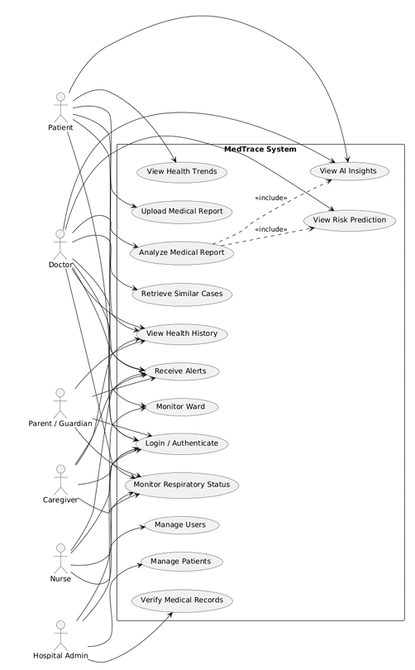
Figure 1: Use Case Diagram

SEQUENCE DIAGRAM
The Sequence Diagram describes how a medical report is uploaded and analyzed. The user signs in and uploads the report from the web application. The report is sent to the Node.js and Express backend, which checks the user's token and role and validates the file. The report content is then prepared for analysis. In the current prototype the analysis is performed by the Gemini model through the Google Generative AI SDK, which returns a structured result with the overview, key findings, abnormal values, recommendations and urgency. The design also includes OCR to extract text from scanned reports, NLP to process the clinical information, an ML engine to analyze the current report together with the patient's history, and a vector-search component that retrieves similar historical cases. These steps are part of the proposed intelligence layer. The result is saved with the patient's records and returned to the user, together with the medical disclaimer. If the AI service fails, the backend returns a handled error and the rest of the application continues to work.
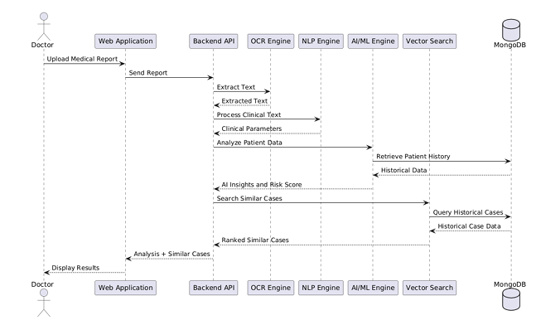
Figure 2: Sequence Diagram

4.2.3 STATE CHART DIAGRAM
A State Chart Diagram shows the states of an object and the transitions between them. In MedTrace it is used to describe the states of patient monitoring. After monitoring begins, the system continuously receives sensor signals and analyzes them to decide whether the patient's condition or activity pattern is normal or abnormal. A normal pattern returns the system to continuous monitoring. An abnormal pattern moves the system to the alert state, where an alert is generated and a notification is sent to the appropriate healthcare worker. When the worker acknowledges the alert, the system returns to continuous monitoring. The same pattern applies to the respiratory monitor and to the ward-level Wi-Fi CSI anomaly detector. In the current prototype this behavior is represented by the monitoring screens, and real sensor input is part of the future scope.

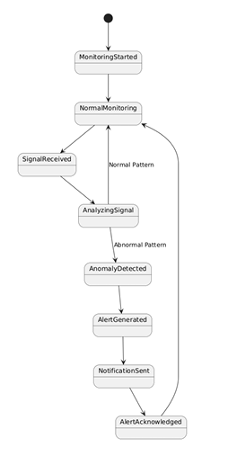
Figure 3: State Chart Diagram

4.2.4 ACTIVITY DIAGRAM
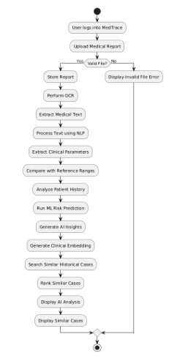
An Activity Diagram shows how work flows through a process, with its tasks, decisions and parallel paths. It is well suited to the medical report analysis workflow of MedTrace. The process starts with user authentication and report upload. The system validates the file and then extracts the text, using OCR for scanned content in the designed workflow. The text is processed with NLP, and clinical parameters are extracted and compared with reference ranges to identify abnormal values. The patient's history is then analyzed, a risk prediction is generated, AI insights are produced, and similar historical cases are searched. Finally, the results are displayed to the authorized user. The diagram includes decision points such as "Is the user authenticated?", "Is the file valid?" and "Are abnormal values found?". In the current prototype the analysis and abnormal-value identification are performed by the Gemini model, and the OCR, risk prediction and similar-case steps are the proposed extensions.
Figure 4: Activity Diagram

4.2.5 CLASS DIAGRAM
A Class Diagram shows the classes of the system, their attributes, methods and relationships. The main class is User, which holds attributes such as name, email, phone, password, role, hospitalName, department, professionalId, googleId and isActive, and methods such as register(), login(), resetPassword() and getProfile(). Patient, Doctor, Nurse and Caregiver specialize the User class, and in the implementation the role attribute separates the different kinds of user.
The Patient class holds the dateOfBirth, gender, bloodGroup, assignedDoctor, assignedCaretakers, medicalHistory and status. A Patient can have many Medical Reports, Vitals, Test Results, Medications, Appointments, Exercise Plans and Clinical Notes. Vitals store heart rate, blood pressure, temperature and the time of recording. The Medication class stores the name, dosage, frequency, start and end dates, prescribing doctor and a log of doses taken. The Appointment class links a patient and a doctor with a date and time, status, reason and notes. The ClinicalNote class stores a doctor's note linked to a patient and, optionally, an appointment. The ExercisePlan class stores exercises, frequency and a progress log.
The CaretakerAssignment class links a caregiver to a patient with a relationship, permissions and status. The NurseAssignment class links a nurse to a patient with the ward, shift and the head nurse who assigned it. The NurseTask class stores the task description, the assigned nurse, the assigning head nurse, due time and status. The Notification and Message classes store alerts and messages between users.
On the intelligence side, a Medical Report can produce an AI Analysis, and historical records can be used to retrieve Similar Cases. Monitoring Data is specialized into Respiratory Data and Wi-Fi CSI Data, both of which can generate Alerts. The relationships show that one patient can have many reports and records, a doctor can have many patients and appointments, a nurse can have many assignments and tasks, and one alert is linked to the monitoring data that caused it.

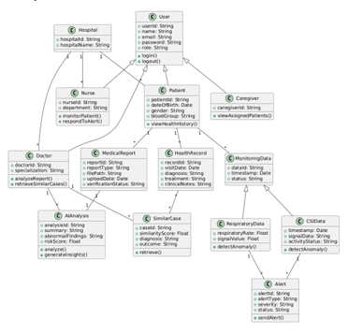

Figure 5: Class Diagram

4.2.6 OBJECT DIAGRAM
An Object Diagram shows a snapshot of instances of the classes at a particular moment. It illustrates a real scenario and helps to check the design against the data that is expected. In the MedTrace object diagram, a patient named John Thomas is registered in the system. A doctor is assigned to him, and he has a verified blood test report. The AI analysis result for this report lists the key findings and any abnormal values with a medical disclaimer.. The diagram shows how the objects are connected during system operation and confirms that the class structure and relationships correctly represent real patient data.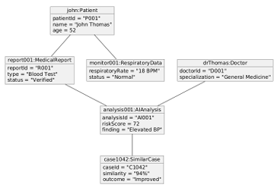
Figure 6: Object Diagram

4.2.7 COMPONENT DIAGRAM
A Component Diagram shows the system as a set of parts that can be replaced or updated independently. The client layer contains the React web application and a React Native mobile application, planned for patients and guardians. The backend layer contains the Node.js and Express API with the authentication and role-based authorization services, together with the modules for patients, vitals, medications, appointments, test results, caretakers, nurse assignments, nurse tasks, messages and notifications. The AI intelligence layer contains the Gemini-based report analysis in the current prototype, and the designed OCR, NLP, ML risk prediction, anomaly detection and similar-case retrieval components. The monitoring layer contains the designed ESP32 respiratory monitor and the Wi-Fi CSI monitor. MongoDB and Firebase provide data persistence, authentication and storage. The components communicate mostly through REST APIs, and Firestore listeners provide real-time updates. Because the AI and monitoring layers are separate from the core platform, the main platform keeps working even if one of them is unavailable.
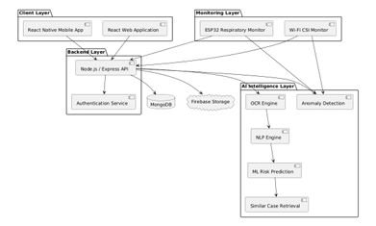
Figure 7: Component Diagram

4.2.8 DEPLOYMENT DIAGRAM
A Deployment Diagram shows the physical architecture of a system by showing how software components are placed on hardware nodes and how they communicate. In MedTrace, patients and guardians access the system through the mobile application, and doctors and nurses mainly use the web application in a browser. Both clients communicate with the Node.js backend over HTTPS. The web application is hosted on Vercel, which serves it with automatic SSL. The backend communicates with the AI services, MongoDB and Firebase. The ESP32-based respiratory monitoring devices and the Wi-Fi CSI receivers are designed to operate within the hospital network and to transmit monitoring data to the backend for analysis and alert generation. External services include the Gemini API for report analysis and an SMTP service for Nodemailer-based emails. In the current prototype the monitoring devices are represented by the interface, and their physical deployment is part of the future scope.
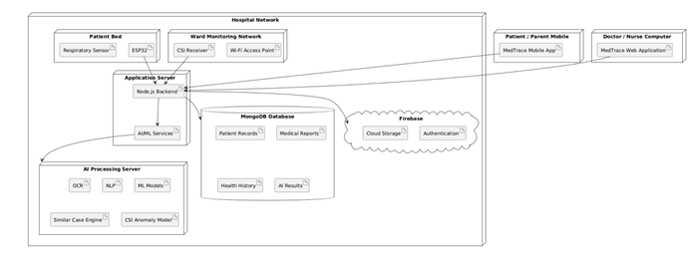
Figure 8: Deployment Diagram

4.3 USER INTERFACE DESIGN USING FIGMA

Form Name: Login Form

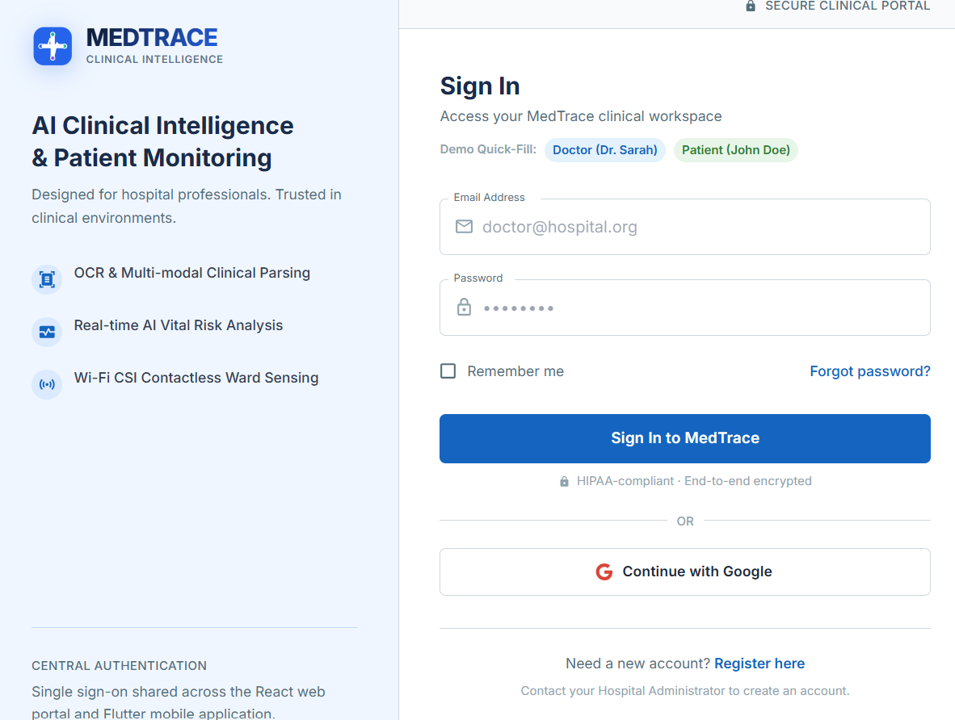

Medical Report Upload
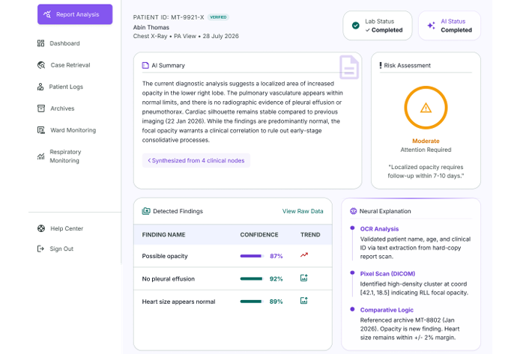

Hospital Dashboard

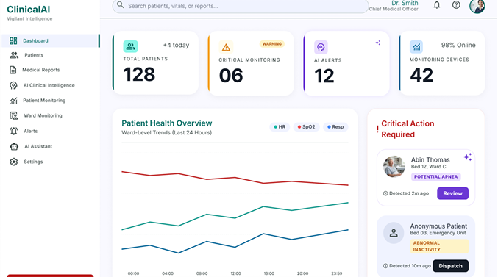

4.4 DATABASE DESIGN

4.4.1 Database Management System (DBMS)
MedTrace uses MongoDB, a NoSQL, document-oriented database, as its primary application database. It was chosen for its flexible schema and its ability to store nested JSON-like structures such as extracted clinical entities, AI findings and signal features, which vary from one report or sensor reading to another. Mongoose is used as the ODM to define schemas and validate data. Firebase Authentication manages user identity, Firebase Storage holds the uploaded report files (PDFs and images), and the database keeps only the storage path of each file. The design also allows vector search over report embeddings for similar-case retrieval. The data model is organized into five logical groups, and the collections are separated by responsibility and linked by ObjectId references.
How CampusPulse Uses DBMS:
- users – Stores user profiles and role information.
- patients – Stores the patient identity and demographic information.
- patient_profiles – Stores extended health information.
- medical_history – Stores diagnoses, symptoms, treatments and visit notes.
- wards – Stores hospital ward information.
- ward_patients – Stores patient-to-ward and bed assignments.

4.4.2 Normalization
In a NoSQL database, classical normalization is replaced by a hybrid strategy. Master data such as users, patients, wards and devices is stored in separate collections and linked through ObjectId references, so that details like a patient's name or a device's code are not duplicated. Data that is always read together with its parent is embedded as a JSON structure inside the parent document. Examples are the extracted_entities in report_extractions, the abnormal_findings and important_findings in ai_report_analysis, the input_features in ai_predictions, and the features in wifi_csi_readings. Time-based and growing data, such as vitals-like clinical parameters, respiratory readings, alerts and audit logs, is kept in separate collections so that documents do not grow without limit. This approach avoids the update anomalies of heavy denormalization and still gives fast reads for the common queries, such as a patient's reports with their analysis.

4.4.3 Sanitization
Sanitization is the process of cleaning and validating user input before it is processed or stored. In MedTrace this is achieved in the following ways:
- Mongoose Schema Validation: Enforces data types, required fields and enum values at the ORM layer.
- Server-side Input Validation: The Express API validates request data with express-validator before it reaches the database.
- Client-side Validation: React Hook Form and Yup validate form entries such as email, phone number and dates before submission.
- Role-Based Middleware: Ensures that users can only perform actions permitted by their role.
- JWT Verification: Every protected API call verifies the token and the user's role.
- File Upload Validation: Multer restricts the type and size of uploaded report files.
- Secure Passwords: Passwords are hashed with bcrypt, and identity is managed by Firebase Authentication.
- AI Output Handling: AI results are stored with the model name and confidence and labeled as decision-support information.
4.4.4 Indexing
Indexes reduce query time because MongoDB can locate documents without scanning the whole collection. The design uses the following indexes:
- Unique Index on users.email and patients.patient_code, and on monitoring_devices.device_code, so these values cannot repeat.
- Regular Indexes on the patient_id reference in medical_reports, clinical_parameters, ai_predictions, alerts and ward_patients, to retrieve a patient's records quickly.
- Compound Index on clinical_parameters using {patient_id, parameter_name, recorded_at}, to support trend queries for a single parameter over time.
- Compound Index on respiratory_readings using {patient_id, timestamp} and on wifi_csi_readings using {ward_id, timestamp}, for time-window queries on monitoring data.
- Compound Index on alerts using {status, severity, created_at}, to list new and critical alerts first.
- Vector Index on case_embeddings.embedding, for semantic similarity search of historical cases.
- Regular Index on audit_logs.{user_id, timestamp} to review user activity.

4.5 COLLECTION DESIGN
1. Collection name: users
Primary key: _id
Sl.No | Field Name | Data Type (Size) | Key Constraints | Description Of the Field
1 | user_id | ObjectId (24) | PRIMARY KEY, AUTO | Unique identifier for each user
2 | name | String (100) | NOT NULL | Full name of the user
3 | email | String (100) | UNIQUE, NOT NULL | Login email address
4 | phone | String (15) | NULLABLE | Contact number
5 | role | String (20) | NOT NULL, ENUM | Doctor, Nurse, Head Nurse, Patient, Caregiver, Guardian, Reception, Admin
6 | department_id | ObjectId (24) | NULLABLE | Department reference
7 | status | String (10) | NOT NULL, ENUM | Active or Inactive
8 | created_at | Timestamp | NOT NULL, DEFAULT NOW | Account creation time
2. Collection name: patients
Primary key: patient_ id
Foreign Key: userId references users(_id)
Sl.No | Field Name | Data Type (Size) | Key Constraints | Description Of the Field
1 | patient_id | ObjectId (24) | PRIMARY KEY, AUTO | Unique identifier for each patient
2 | patient_code | String (20) | UNIQUE, NOT NULL | Hospital patient code
3 | user_id | ObjectId (24) | FOREIGN KEY REFERENCES users(user_id), NULLABLE | Linked user account
4 | full_name | String (100) | NOT NULL | Patient's full name
5 | date_of_birth | Date | NOT NULL | Date of birth
6 | gender | String (10) | NOT NULL | Gender
7 | blood_group | String (5) | NULLABLE | Blood group
8 | phone | String (15) | NULLABLE | Contact number
9 | emergency_contact | String (100) | NULLABLE | Emergency contact details
10 | created_at | Timestamp | NOT NULL, DEFAULT NOW | Record creation date

3. Collection name: patient_profiles
Primary key: profile_ id
Foreign key: userId references patients (_id)

Sl. No | Field Name | Data Type  (Size) | Key Constraints | Description Of the Field
1 | profile_id | ObjectId (24) | PRIMARY KEY, AUTO | Unique identifier for the profile
2 | patient_id | ObjectId (24) | FOREIGN KEY REFERENCES patients(patient_id), UNIQUE | Linked patient
3 | height | Number (5,2) | NULLABLE | Height of the patient
4 | weight | Number (5,2) | NULLABLE | Weight of the patient
5 | allergies | Array of String | NULLABLE | Known allergies
6 | existing_conditions | Array of String | NULLABLE | Existing medical conditions
7 | current_medications | Array of String | NULLABLE | Current medications
8 | family_history | String (500) | NULLABLE | Family medical history

4. Collection name: jobdrives
Primary key: _ id
Foreign key: recruiterId references recruiters(_id)

Sl. No | Field Name | Data Type  (Size) | Key Constraints | Description Of the Field
1 | _id | ObjectId (24) | PRIMARY KEY, AUTO | Unique identifier for each drive
2 | recruiterId | ObjectId (24) | FOREIGN KEY REFERENCES recruiters(_id) | Link to the recruiter
3 | title | String (100) | NOT NULL | Job title / role name
4 | description | String (Large) | NOT NULL | Detailed job description
5 | ctc | Number (10) | NOT NULL | Annual CTC in INR
6 | minCGPA | Number (4,2) | NOT NULL | Minimum CGPA required
7 | eligibleBranches | Array of String | NOT NULL | List of eligible branches
8 | maxBacklogs | Number (2) | NOT NULL | Maximum backlogs allowed
9 | applicationDeadline | Date | NOT NULL | Last date to apply
10 | hasAptitudeTest | Boolean | DEFAULT FALSE | Whether Aptitude stage is included
11 | hasGD | Boolean | DEFAULT FALSE | Whether GD stage is included
12 | status | String (15) | ENUM, DEFAULT Pending | Draft, Pending, Open, Closed, OnHold, Rejected
13 | tpoFeedback | String (500) | NULLABLE | TPO feedback on hold or rejection
14 | submittedForApprovalAt | Timestamp | NULLABLE | Date drive was submitted for approval
15 | resubmittedCount | Number (2) | DEFAULT 0 | Number of times drive was resubmitted
16 | attachments | Array of Object | NULLABLE | Prep resources uploaded by recruiter
17 | createdAt | Timestamp | DEFAULT NOW | Drive creation timestamp

5. Table name: applications
Primary key: _ id
Foreign key: studentId references students(_id), driveId references jobdrives(_id)
Compound Index: {studentId: 1, driveId: 1}
Sl. No | Field Name | Data Type  (Size) | Key Constraints | Description Of the Field
1 | _id | ObjectId (24) | PRIMARY KEY, AUTO | Unique identifier for each application
2 | studentId | ObjectId (24) | FOREIGN KEY REFERENCES students(_id), COMPOUND INDEX | Student who applied
3 | driveId | ObjectId (24) | FOREIGN KEY REFERENCES jobdrives(_id), COMPOUND INDEX | Drive the student applied to
4 | appliedDate | Date | NOT NULL | Date of application submission
5 | status | String (30) | NOT NULL, INDEXED | Overall application status
6 | aiMatchScore | Number (4,3) | NULLABLE | Semantic match score (0–1) from SBERT

5.1. Embedded sub-document name: aptitude
Sl. No | Field Name | Data Type  (Size) | Key Constraints | Description Of the Field
1 | aptitude.status | String (20) | NULLABLE | Scheduled, Passed, Failed, Not Applicable
2 | aptitude.score | Number (5,2) | NULLABLE | Percentage score from the test
3 | aptitude.source | String (20) | DEFAULT unknown | csv_import or in_house_test
4 | aptitude.scheduledDate | Date | NULLABLE | Date of the test
5 | aptitude.testLink | String (255) | NULLABLE | Legacy field for external test URLs
6 | aptitude.markedBy | ObjectId (24) | FOREIGN KEY REFERENCES recruiters(_id) | Who marked the result
7 | aptitude.markedAt | Timestamp | NULLABLE | When the result was recorded

5.2. Embedded Sub-Document: gd
Sl. No | Field Name | Data Type  (Size) | Key Constraints | Description Of the Field
1 | gd.status | String (20) | NULLABLE | Scheduled, Shortlisted, Rejected, Not Applicable
2 | gd.scheduledDate | Date | NULLABLE | Date of the GD
3 | gd.markedBy | ObjectId (24) | FOREIGN KEY REFERENCES recruiters(_id) | Who marked the result
4 | gd.markedAt | Timestamp | NULLABLE | When the result was recorded
5 | election _ id | INT (11) | FOREIGN KEY  REFERENCES  Elections (election_id) | Election for which the vote has been casted
6 | casted_at | TIMESTAMP | DEFAULT CURRENT_TIMESTAMP | Timestamp when the vote was cast.

5.3 Embedded Sub-Document name: interview
Sl. No | Field Name | Data Type  (Size) | Key Constraints | Description Of the Field
1 | interview.status | String (15) | NULLABLE | Scheduled, Completed, Pending
2 | interview.result | String (15) | NULLABLE | Selected, Rejected, Waitlisted, Pending
3 | interview.scheduledDate | Date | NULLABLE | Date of the interview
4 | interview.timeSlot | String (30) | NULLABLE | Time slot of the interview
5 | interview.feedback | String (500) | NULLABLE | Recruiter feedback
6 | interview.markedBy | ObjectId (24) | FOREIGN KEY REFERENCES recruiters(_id) | Who marked the result
7 | interview.markedAt | Timestamp | NULLABLE | When the result was recorded

6. Collection name: schedules
Primary key: _ id
Foreign key: studentId references students(_id), driveId references jobdrives(_id)

Sl. No | Field Name | Data Type  (Size) | Key Constraints | Description Of the Field
1 | _id | ObjectId (24) | PRIMARY KEY, AUTO | Unique identifier for each drive
2 | recruiterId | ObjectId (24) | FOREIGN KEY REFERENCES recruiters(_id) | Link to the recruiter
3 | title | String (100) | NOT NULL | Job title / role name
4 | description | String (Large) | NOT NULL | Detailed job description
5 | ctc | Number (10) | NOT NULL | Annual CTC in INR
6 | minCGPA | Number (4,2) | NOT NULL | Minimum CGPA required
7 | eligibleBranches | Array of String | NOT NULL | List of eligible branches
8 | maxBacklogs | Number (2) | NOT NULL | Maximum backlogs allowed
9 | applicationDeadline | Date | NOT NULL | Last date to apply
10 | hasAptitudeTest | Boolean | DEFAULT FALSE | Whether Aptitude stage is included
11 | hasGD | Boolean | DEFAULT FALSE | Whether GD stage is included
12 | status | String (15) | ENUM, DEFAULT Pending | Draft, Pending, Open, Closed, OnHold, Rejected
13 | tpoFeedback | String (500) | NULLABLE | TPO feedback on hold or rejection
14 | submittedForApprovalAt | Timestamp | NULLABLE | Date drive was submitted for approval
15 | resubmittedCount | Number (2) | DEFAULT 0 | Number of times drive was resubmitted
16 | attachments | Array of Object | NULLABLE | Prep resources uploaded by recruiter
17 | createdAt | Timestamp | DEFAULT NOW | Drive creation timestamp

7. Collection name: recruiter_trust_scores
Primary key: _ id
Foreign key: recruiterId references recruiters(_id), driveId
Sl. No | Field Name | Data Type  (Size) | Key Constraints | Description Of the Field
1 | _id | ObjectId (24) | PRIMARY KEY, AUTO | Unique identifier
2 | recruiterId | ObjectId (24) | FOREIGN KEY REFERENCES recruiters(_id), UNIQUE | Linked recruiter
3 | domain | String (100) | NOT NULL | Company domain from website
4 | whoisData | Object | NULLABLE | Raw WHOIS lookup data
5 | mcaData | Object | NULLABLE | MCA registration snapshot
6 | trustScore | Number (3) | NOT NULL | Computed trust score (0–100)
7 | verifiedAt | Timestamp | DEFAULT NOW | Verification timestamp

8. Collection name: college_config
Primary key: _ id
Foreign key: recruiterId references recruiters(_id), driveId
Sl. No | Field Name | Data Type  (Size) | Key Constraints | Description Of the Field
1 | _id | ObjectId (24) | PRIMARY KEY, AUTO | Unique identifier
2 | branches | Array of String | NOT NULL | Active branches (e.g. CSE, IT, ECE)
3 | passoutYears | Array of Number | NOT NULL | Active passout years (e.g., 2026, 2027)
4 | seasonStart | Date | NULLABLE | Global placement season start date
5 | seasonEnd | Date | NULLABLE | Global placement season end date
6 | updatedBy | ObjectId (24) | FOREIGN KEY REFERENCES users(_id) | TPO who last updated
7 | updatedAt | Timestamp | DEFAULT NOW | Last update timestamp

9. Collection name: question_bank
Primary key: _ id
Foreign key: recruiterId references recruiters(_id)
Sl. No | Field Name | Data Type  (Size) | Key Constraints | Description Of the Field
1 | _id | ObjectId (24) | PRIMARY KEY, AUTO | Unique identifier for each question
2 | recruiterId | ObjectId (24) | FOREIGN KEY REFERENCES recruiters(_id), NULLABLE | Owner; NULL for curated bank questions
3 | questionText | String (Large) | NOT NULL | The MCQ question text
4 | options | Array of String | NOT NULL, EXACTLY 4 | The four answer options
5 | correctOption | Number (1) | NOT NULL, 0–3 | Index of the correct option (hidden from students)
6 | difficulty | String (10) | NOT NULL, ENUM | Easy, Medium, or Hard
7 | category | String (15) | NOT NULL, ENUM | Quantitative, Logical, Verbal, or Technical
8 | source | String (15) | NOT NULL, ENUM | Manual, curated or ai-generated
9 | status | String (15) | NOT NULL, DEFAULT approved | Draft, approved, rejected (drafts for AI review)
10 | timesUsed | Number (5) | DEFAULT 0 | How many tests this question has appeared in
11 | createdAt | Timestamp | DEFAULT NOW | Creation timestamp

10. Collection name: aptitude_tests
Primary key: _ id
Foreign key: recruiterId references recruiters(_id), driveId references jobdrives(_id)

Sl. No | Field Name | Data Type  (Size) | Key Constraints | Description Of the Field
1 | _id | ObjectId (24) | PRIMARY KEY, AUTO | Unique identifier for the test
2 | driveId | ObjectId (24) | FOREIGN KEY REFERENCES jobdrives(_id) | Associated job drive
3 | recruiterId | ObjectId (24) | FOREIGN KEY REFERENCES recruiters(_id) | Recruiter who created the test
4 | title | String (100) | NOT NULL | Name of the test
5 | durationMinutes | Number (3) | NOT NULL | Total allowed time in minutes
6 | questionIds | Array of ObjectId | NOT NULL | References to question_bank entries
7 | passingScore | Number (3) | NOT NULL | Passing percentage (e.g., 60)
8 | scheduledDate | Date | NOT NULL | When the test becomes available
9 | timeSlot | String (30) | NOT NULL | Allowed time window
10 | status | String (10) | DEFAULT DRAFT | Draft , Active or Closed
11 | generationMode | String (10) | NOT NULL | Manual. ai, curated or mixed
12 | shuffleQuestions | Boolean | DEFAULT TRUE | Per-student question randomization
13 | shuffleOptions | Boolean | DEFAULT TRUE | Per-student option randomization
14 | antiCheatEnabled | Boolean | DEFAULT TRUE | Enables fullscreen + tab-switch monitoring
15 | maxViolations | Number (2) | DEFAULT 3 | Violations allowed before auto-submit
16 | createdAt | Timestamp | DEFAULT NOW | Creation timestamp

11. Collection name: test_attempts
Primary key: _ id
Foreign key: testId references aptitude_tests(_id), studentId references students(_id), applicationId references applications(_id)

Sl. No | Field Name | Data Type  (Size) | Key Constraints | Description Of the Field
1 | _id | ObjectId (24) | PRIMARY KEY, AUTO | Unique identifier for the attempt
2 | testId | ObjectId (24) | FOREIGN KEY REFERENCES aptitude_tests(_id), COMPOUND INDEX | Test being attempted
3 | studentId | ObjectId (24) | FOREIGN KEY REFERENCES students(_id), COMPOUND INDEX | Student taking the test
4 | applicationId | ObjectId (24) | FOREIGN KEY REFERENCES applications(_id) | Linked application
5 | questionOrder | Array of ObjectId | NOT NULL | This student's shuffled question sequence
6 | optionOrder | Array of Array of Number | NOT NULL | Shuffled option indices per question
7 | answers | Array of Number | NULLABLE | Student's selected options in shuffled space
8 | score | Number (3) | DEFAULT 0 | Number of correct answers
9 | totalQuestions | Number (3) | NOT NULL | Total number of questions
10 | percentage | Number (5,2) | DEFAULT 0 | Score as a percentage
11 | result | String (10) | DEFAULT Pending | Pass, Fail or Pending
12 | startedAt | Timestamp | NULLABLE | Test start timestamp
13 | submittedAt | Timestamp | NULLABLE | Test submission timestamp
14 | autoSubmitted | Boolean | DEFAULT FALSE | Whether auto-submitted (timer or violation)
15 | violationCount | Number (2) | DEFAULT 0 | Number of anti-cheat violations detected
16 | violationLog | Array of Object | NULLABLE | Each entry: {eventType, timestamp}
17 | flagged | Boolean | DEFAULT FALSE | True if auto-submitted due to violations
18 | lastSavedAt | Timestamp | NULLABLE | Timestamp of last auto-save

12. Collection name: email_logs
Primary key: _ id
Foreign key: recruiterId references recruiters(_id), driveId references jobdrives(_id)

Sl. No | Field Name | Data Type  (Size) | Key Constraints | Description Of the Field
1 | _id | ObjectId (24) | PRIMARY KEY, AUTO | Unique identifier
2 | recipientEmail | String (100) | NOT NULL, INDEXED | Email recipient
3 | recipientId | ObjectId (24) | FOREIGN KEY REFERENCES users(_id) | Linked user
4 | emailType | String (20) | ENUM | Activation, Reminder, Result, Offer, Test
5 | subject | String (200) | NOT NULL | Email subject
6 | sentAt | Timestamp | NOT NULL | Send timestamp
7 | status | String (15) | ENUM | Sent, Failed, Opened, Bounced
8 | errorMessage | String (500) | NULLABLE | Error details if failed

CHAPTER 5

SYSTEM TESTING
  - INTRODUCTION
System testing is a phase in the Software Development Life Cycle (SDLC). In this phase, the complete and fully integrated MedTrace platform is examined to confirm that it meets the specified requirements. System testing uses a black-box approach to evaluate the functionality, security, usability and reliability of the system for all the user roles: Patients and Guardians, Caretakers, Doctors, Nurses, Head Nurses, Reception staff, and Hospital Administrators.
Unlike unit and integration testing, which focus on individual components and the connections between them, system testing checks how the React and TypeScript frontend, the Node.js and Express backend, the MongoDB and Firebase data services and the Gemini-based AI analysis work together as one system. This approach confirms that the software behaves as expected in a realistic hospital workflow.
The main goal of system testing for MedTrace is to find defects and to confirm that the system works correctly under different conditions, such as normal use, boundary values and error situations. The testing covers functional tests of the main workflows, validation checks on user input, security tests that confirm JWT-based authentication, protected routes and role-based access, and usability checks of the dashboards and navigation. It also covers the handling of failures, for example when the AI service does not respond. Because the AI output supports clinical decisions, the tests also check that every analysis result is shown with its medical disclaimer. Automated browser tests written with Playwright cover key workflows, and the remaining checks are carried out manually.
In MedTrace, system testing checks that users can register and log in, that patients can log vitals, book appointments with doctors, and upload medical reports and receive a structured AI analysis. It also checks that doctors can review patient information and history, that caretakers can see only the patients assigned to them, and that nurses and head nurses can manage duties, attendance, patient assignments and tasks within the permitted duty windows. The contactless respiratory-monitoring and Wi-Fi CSI anomaly-detection module is a prototype, so its testing is limited to checking the interface, and testing with real sensor data is part of the future scope.

.

TEST PLAN

A test plan is a detailed document that outlines the overall strategy, objectives, scope, resources, and schedule for testing CampusPulse. It serves as a roadmap for the testing process, ensuring systematic validation of functionalities to identify defects before deployment.The test plan defines the following testing levels: Unit Testing, Integration Testing, Validation (System) Testing, User Acceptance Testing (UAT), and Automation Testing. It includes key components such as test objectives, test scope, test deliverables, required testing environments, entry and exit criteria, and risk assessment. It identifies roles and responsibilities, ensuring efficient coordination among testers, developers, and stakeholders. The document also outlines the test execution schedule, tools and frameworks, reporting mechanisms, and defect tracking.

Unit Testing
Unit testing is a software testing method that focuses on verifying the functionality of individual components, functions, or modules in isolation to ensure they work correctly. It is typically performed by developers during the coding phase using automated testing frameworks like PHPUnit for PHP, JUnit for Java, or PyTest for Python. By executing test cases with predefined inputs and expected outputs, unit testing helps identify and fix bugs early, improving code quality and maintainability. It also promotes modular development, making the software easier to update and extend while serving as documentation for future developers.

Integration Testing
Integration testing is a systematic approach that focuses on building the program’s structure while simultaneously testing it to detect interface defects. It involves integrating unit-tested components according to the design and ensuring they function cohesively. Unlike unit testing, which examines individual components in isolation, integration testing evaluates how different modules interact, forming a complete system. However, debugging can be complex since pinpointing errors becomes challenging as the program size grows. Fixing one issue may introduce new ones, creating a repetitive cycle of testing and correction. After unit testing is completed, all modules are combined and tested to identify any inconsistencies in their interaction. Through this process, discrepancies in the program’s structure are resolved, leading to a more refined and stable system.

Validation Testing or System Testing

System testing is the final phase of the testing process, where the entire software system, including all forms, code, modules, and class structures, is thoroughly evaluated. This stage ensures that every aspect of the application functions correctly as a whole. It is commonly referred to as system testing or black box testing, where the primary focus is on validating the software’s functional requirements without examining the internal code structure. Using this approach, testers create input conditions to verify that the system meets all predefined requirements. Black box testing helps identify a wide range of issues, including missing or incorrect functionalities, interface defects, errors in data structures or external data access, performance bottlenecks, and problems related to initialization and termination. By systematically uncovering these defects, system testing ensures that the software is ready for deployment and meets user expectations.

Output Testing or User Acceptance Testing

User acceptance testing (UAT) is conducted to ensure that the software meets the organization's requirements and aligns with business needs. Throughout the development process, the software should remain adaptable to user feedback, allowing for modifications when necessary. This phase focuses on evaluating critical aspects such as input screen designs and output screen designs to ensure they function as expected. Testing is performed using carefully prepared test data, which plays a crucial role in validating the system's performance and accuracy. Once the test data is applied, the system is examined for potential errors, and any identified issues are corrected. This iterative process continues until the software meets all specified requirements, ensuring that it is fully functional and ready for deployment.
    - Automation Testing
Automation testing is a process where software and other computer products are tested automatically to ensure they meet strict standards and function as expected. It is designed to verify that the hardware or software performs precisely as intended by identifying errors, defects, and potential issues that may arise during development. Unlike manual testing, automation testing uses scripted sequences to examine the software’s functionality, allowing tests to be executed at any time of the day. After running the tests, the results are recorded and analyzed, providing insights into detected issues. These findings can also be compared with previous test results to track improvements and ensure consistency in software performance.
    - Playwright Testing
Playwright is an automation framework that helps me and others control web browsers and run thorough end‑to‑end tests of web applications. Playwright offers an API so that testers can write scripts in languages such as JavaScript, TypeScript, Python, Java and.NET. Playwright works with browsers, including Chromium, Firefox and WebKit which makes it handy for checking that a site behaves the same across different browsers. Playwright supplies features such as waiting, page navigation, element interaction, screenshots, video recording and network interception all of which let testers confirm that a web application functions well performs quickly and remains reliable.
Test Cases and Test Reports
Project Name: MedTrace - AI-Based Clinical Intelligence And Patient Monitoring System
Testing tool: Playwright (TypeScript), browser: Google Chrome. Seven automated test cases were executed; the code, execution screenshot and test report for each are given below.
Test Execution Summary
Test ID | Feature / Test | Spec file | Time | Result
Test_1 | Feature 1: Patient Registration | 01_auth.spec.ts:12 | 19.2s | Pass
Test_2 | Feature 2: Patient Login | 01_auth.spec.ts:39 | 6.4s | Pass
Test_3 | Feature 3: Patient Log Vitals | 02_patient_vitals.spec.ts:12 | 12.1s | Pass
Test_4 | Feature 4: Doctor Appointment Booking | 03_doctor_appointment.spec.ts:12 | 11.3s | Pass
Test_5 | Feature 5: Medical Report Upload & Analysis | 04_medical_report.spec.ts:13 | 9.9s | Pass
Test_6 | Feature 6: Nurses Active Check & Duty Management | 05_nurses_active_check.spec.ts:13 | 8.2s | Pass
Test_7 | Smoke Test | smoke.spec.ts:3 | 2.0s | Pass
Figure: Playwright HTML report – all tests executed
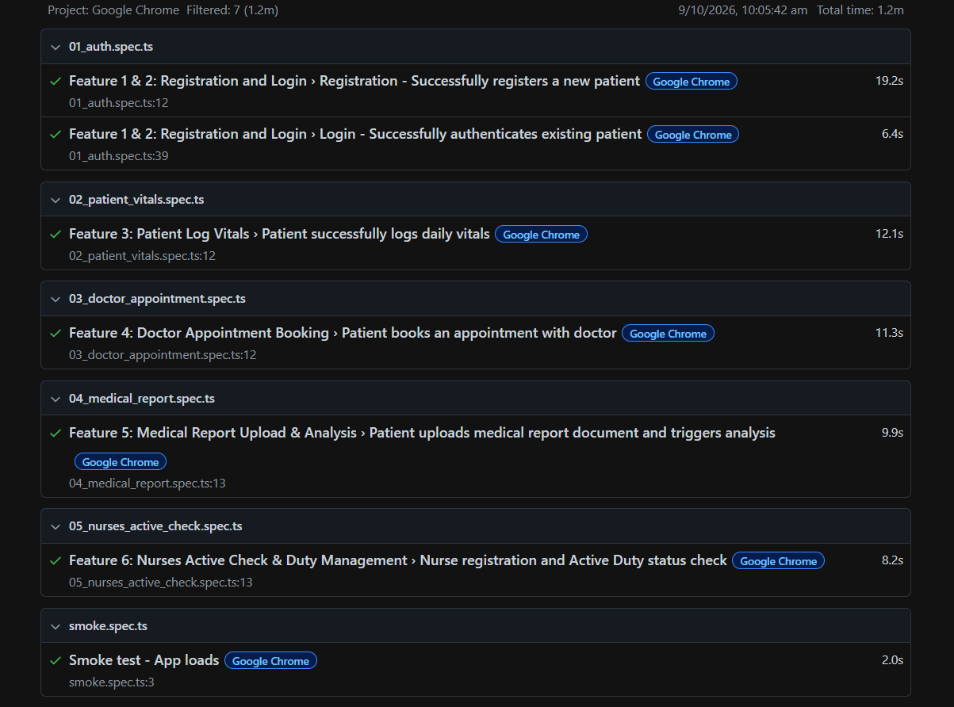

Test Case 1:
Code
import { test, expect } from '@playwright/test';

test.describe('Feature 1 & 2: Registration and Login', () => {
const timestamp = Date.now();
const testUser = {
name: `Test Patient ${timestamp}`,
email: `playwright.patient.${timestamp}@medtrace.test`,
phone: '+15552345678',
password: 'Password123!',
};

test('Registration - Successfully registers a new patient', async ({ page }) => {
await page.goto('/register');
await expect(page.locator('text=Create Your Account')).toBeVisible();

// Fill registration form
await page.locator('#reg-name').fill(testUser.name);
await page.locator('#reg-email').fill(testUser.email);
await page.locator('#reg-phone').fill(testUser.phone);
await page.locator('#reg-password').fill(testUser.password);

// Ensure role is Patient
const patientRoleTile = page.locator('div[role="radio"][aria-label*="Patient"]');
if (await patientRoleTile.isVisible()) {
await patientRoleTile.click();
}

// Agree to terms checkbox
await page.locator('#reg-agree-terms').check();

// Submit form
await page.locator('button[type="submit"]:has-text("Create Account")').click();

// Expect successful redirect to patient dashboard
await expect(page).toHaveURL(/\/dashboard\/patient/, { timeout: 15000 });
await expect(page.locator('text=Patient Workspace').or(page.locator('text=Welcome to MedTrace')).or(page.locator('text=Health Trends'))).toBeVisible({ timeout: 15000 });
});
});
Screenshot
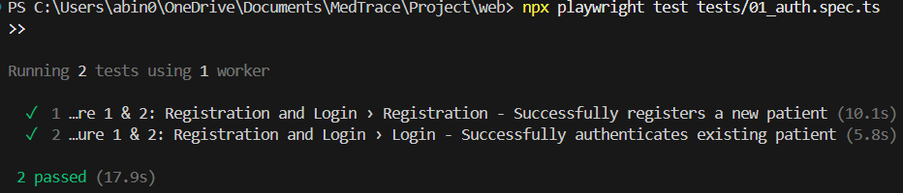
Test Report
Test Case 1
Project Name: MedTrace – AI-Based Clinical Intelligence And Patient Monitoring System
Feature 1: Patient Registration Test Case
Test Case ID: Test_1 |  |  | Test Designed By: Abin Thomas
Test Priority(Low/Medium/High): High |  |  | Test Designed Date: 07/10/2026
Module Name: Registration |  |  | Test Executed By: Mr. Binumon Joseph
Test Title: Verify a new patient can register |  |  | Test Execution Date: 07/10/2026
Description: End-to-end test of new patient registration through the sign-up form.
Pre-Condition: No account exists for the given email; application is running at localhost:4200
Step | Test Step | Test Data | Expected Result | Actual Result | Status (Pass/Fail)
1 | Navigate to /register | URL: localhost:4200/register | Registration page with "Create Your Account" displayed | Registration page displayed | Pass
2 | Enter full name | Test Patient <timestamp> | Input accepted | Input accepted | Pass
3 | Enter email address | playwright.patient.<timestamp>@medtrace.test | Input accepted | Input accepted | Pass
4 | Enter phone number | +15552345678 | Input accepted | Input accepted | Pass
5 | Enter password | Password123! | Input accepted (masked) | Input accepted | Pass
6 | Select "Patient" role tile (if shown) | Role: Patient | Patient role selected | Role selected | Pass
7 | Tick "Agree to terms" checkbox | - | Checkbox checked | Checkbox checked | Pass
8 | Click "Create Account" | - | Redirect to /dashboard/patient | Redirected successfully | Pass
9 | Verify dashboard content | - | "Patient Workspace", "Welcome to MedTrace" or "Health Trends" visible | Dashboard content visible | Pass
Post-Condition: Patient account created; user redirected to /dashboard/patient.

Test Case 2:
Code
import { test, expect } from '@playwright/test';

test.describe('Feature 1 & 2: Registration and Login', () => {
const timestamp = Date.now();
const testUser = {
name: `Test Patient ${timestamp}`,
email: `playwright.patient.${timestamp}@medtrace.test`,
phone: '+15552345678',
password: 'Password123!',
};

test('Login - Successfully authenticates existing patient', async ({ page }) => {
await page.goto('/login');
await expect(page.getByRole('heading', { name: 'Sign In' })).toBeVisible();

// Fill credentials
await page.locator('#login-email').fill(testUser.email);
await page.locator('#login-password').fill(testUser.password);

// Click submit
await page.locator('button[type="submit"]:has-text("Sign In to MedTrace")').click();

// Expect redirect to patient dashboard
await expect(page).toHaveURL(/\/dashboard\/patient/, { timeout: 15000 });
await expect(page.getByRole('button', { name: /Sign Out/i })).toBeVisible({ timeout: 15000 });
});
});
Screenshot

Test Report
Test Case 2
Project Name: MedTrace – AI-Based Clinical Intelligence And Patient Monitoring System
Feature 2: Patient Login Test Case
Test Case ID: Test_2 |  |  | Test Designed By: Abin Thomas
Test Priority(Low/Medium/High): High |  |  | Test Designed Date: 07/10/2026
Module Name: Login |  |  | Test Executed By: Mr. Binumon Joseph
Test Title: Verify an existing patient can log in |  |  | Test Execution Date: 07/10/2026
Description: Verify a registered patient can authenticate and reach the patient dashboard.
Pre-Condition: Patient account exists (created in Test_1); application is running at localhost:4200
Step | Test Step | Test Data | Expected Result | Actual Result | Status (Pass/Fail)
1 | Navigate to /login | URL: localhost:4200/login | "Sign In" heading displayed | Login page displayed | Pass
2 | Enter email address | playwright.patient.<timestamp>@medtrace.test | Input accepted | Input accepted | Pass
3 | Enter password | Password123! | Input accepted (masked) | Input accepted | Pass
4 | Click "Sign In to MedTrace" | - | Redirect to /dashboard/patient | Redirected successfully | Pass
5 | Verify "Sign Out" button | - | Sign Out button visible | Button visible | Pass
Post-Condition: Patient authenticated; user redirected to /dashboard/patient with Sign Out option available.

Test Case 3:
Code
import { test, expect } from '@playwright/test';

test.describe('Feature 3: Patient Log Vitals', () => {
const timestamp = Date.now();
const testPatient = {
name: `Vitals Test Patient ${timestamp}`,
email: `patient.vitals.${timestamp}@medtrace.test`,
phone: '+15553334444',
password: 'Password123!',
};

test('Patient successfully logs daily vitals', async ({ page }) => {
// 1. Register new patient
await page.goto('/register');
await page.locator('#reg-name').fill(testPatient.name);
await page.locator('#reg-email').fill(testPatient.email);
await page.locator('#reg-phone').fill(testPatient.phone);
await page.locator('#reg-password').fill(testPatient.password);
await page.locator('#reg-agree-terms').check();
await page.locator('button[type="submit"]:has-text("Create Account")').click();

// 2. Wait for Patient Dashboard
await expect(page).toHaveURL(/\/dashboard\/patient/, { timeout: 35000 });

// 3. Find and click "Log Vitals" button
const logVitalsBtn = page.locator('button:has-text("Log Vitals")').first();
await expect(logVitalsBtn).toBeVisible({ timeout: 10000 });
await logVitalsBtn.click();

// 4. Modal opens
await expect(page.locator('text=Log Physiological Vitals')).toBeVisible({ timeout: 5000 });

// 5. Fill vitals data
await page.locator('input[placeholder="120"]').fill('128');
await page.locator('input[placeholder="80"]').fill('84');
await page.locator('input[placeholder="72"]').fill('75');
await page.locator('input[placeholder="95"]').fill('98');
await page.locator('input[placeholder="98"]').fill('99');
await page.locator('input[placeholder="75"]').fill('72');

// 6. Submit vitals
const recordBtn = page.locator('button:has-text("Record & Analyze")');
await recordBtn.click();

// 7. Verify modal closes and reading is saved
await expect(page.locator('text=Log Physiological Vitals')).not.toBeVisible({ timeout: 10000 });
// Verify blood pressure card or vitals display updates with recorded values
await expect(page.locator('text=BLOOD PRESSURE').first()).toBeVisible({ timeout: 10000 });
});
});
Screenshot
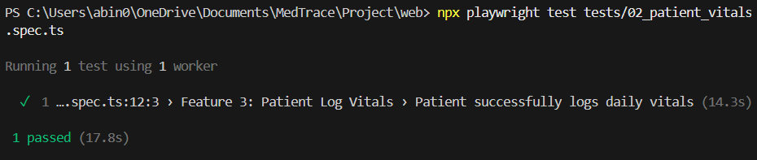
Test Report
Test Case 3
Project Name: MedTrace – AI-Based Clinical Intelligence And Patient Monitoring System
Feature 3: Patient Log Vitals Test Case
Test Case ID: Test_3 |  |  | Test Designed By: Abin Thomas
Test Priority(Low/Medium/High): High |  |  | Test Designed Date: 07/10/2026
Module Name: Patient Vitals |  |  | Test Executed By: Mr. Binumon Joseph
Test Title: Verify patient can log daily vitals |  |  | Test Execution Date: 07/10/2026
Description: Verify a patient can record vitals through the "Log Physiological Vitals" modal and see them on the dashboard.
Pre-Condition: Fresh patient account registered; patient dashboard loaded
Step | Test Step | Test Data | Expected Result | Actual Result | Status (Pass/Fail)
1 | Register new patient | Vitals Test Patient <timestamp> / patient.vitals.<timestamp>@medtrace.test / Password123! | Redirect to /dashboard/patient | Redirected successfully | Pass
2 | Click "Log Vitals" | - | Log Vitals button visible and clickable | Button clicked | Pass
3 | Verify modal opens | - | "Log Physiological Vitals" modal displayed | Modal displayed | Pass
4 | Enter vitals values | Fields (placeholder → value): 120→128, 80→84, 72→75, 95→98, 98→99, 75→72 | Inputs accepted | Inputs accepted | Pass
5 | Click "Record & Analyze" | - | Modal closes; reading saved | Modal closed | Pass
6 | Verify dashboard update | - | "BLOOD PRESSURE" card visible | Card visible | Pass
Post-Condition: Vitals reading saved; BLOOD PRESSURE card visible on dashboard.

Test Case 4:
Code
import { test, expect } from '@playwright/test';

test.describe('Feature 4: Doctor Appointment Booking', () => {
const timestamp = Date.now();
const testPatient = {
name: `Apt Patient ${timestamp}`,
email: `apt.patient.${timestamp}@medtrace.test`,
phone: '+15554445555',
password: 'Password123!',
};

test('Patient books an appointment with doctor', async ({ page }) => {
// 1. Register new patient
await page.goto('/register');
await page.locator('#reg-name').fill(testPatient.name);
await page.locator('#reg-email').fill(testPatient.email);
await page.locator('#reg-phone').fill(testPatient.phone);
await page.locator('#reg-password').fill(testPatient.password);
await page.locator('#reg-agree-terms').check();
await page.locator('button[type="submit"]:has-text("Create Account")').click();

// 2. Wait for patient dashboard
await expect(page).toHaveURL(/\/dashboard\/patient/, { timeout: 35000 });

// 3. Click "Book Appointment" button
const bookBtn = page.locator('button:has-text("Book Appointment")');
await expect(bookBtn).toBeVisible({ timeout: 10000 });
await bookBtn.click();

// 4. Modal opens
await expect(page.locator('text=Book Clinical Consultation')).toBeVisible({ timeout: 5000 });

// 5. Select doctor if needed or pick a slot
const slotChip = page.locator('text=10:30 AM').or(page.locator('text=02:00 PM')).first();
if (await slotChip.isVisible()) {
await slotChip.click();
}

// 6. Enter reason for visit
const reasonInput = page.locator('textarea[placeholder*="Describe symptoms"]');
await reasonInput.fill('Routine quarterly cardiovascular checkup and vitals assessment.');

// 7. Click Confirm Booking
const confirmBtn = page.locator('button:has-text("Confirm Booking")');
await confirmBtn.click();

// 8. Verify modal closes
await expect(page.locator('text=Book Clinical Consultation')).not.toBeVisible({ timeout: 10000 });

// 9. Verify toast or confirmation
await expect(
page.locator('text=Appointment booked').or(page.locator('text=Upcoming Appointments')).or(page.locator('text=Dr. Alexander Wright'))
).toBeVisible({ timeout: 10000 });
});
});
Screenshot
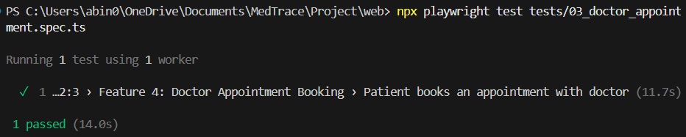
Test Report

Test Case 4
Project Name: MedTrace – AI-Based Clinical Intelligence And Patient Monitoring System
Feature 4: Doctor Appointment Booking Test Case
Test Case ID: Test_4 |  |  | Test Designed By: Abin Thomas
Test Priority(Low/Medium/High): High |  |  | Test Designed Date: 07/10/2026
Module Name: Appointment Booking |  |  | Test Executed By: Mr. Binumon Joseph
Test Title: Verify patient can book a doctor appointment |  |  | Test Execution Date: 07/10/2026
Description: Verify a patient can pick a slot, give a reason and confirm a booking through the "Book Clinical Consultation" modal.
Pre-Condition: Fresh patient account registered; patient dashboard loaded
Step | Test Step | Test Data | Expected Result | Actual Result | Status (Pass/Fail)
1 | Register new patient | Apt Patient <timestamp> / apt.patient.<timestamp>@medtrace.test / Password123! | Redirect to /dashboard/patient | Redirected successfully | Pass
2 | Click "Book Appointment" | - | Booking modal opens | Modal opened | Pass
3 | Verify modal title | - | "Book Clinical Consultation" displayed | Modal displayed | Pass
4 | Select an available time slot | Slot: 10:30 AM or 02:00 PM | Slot selected | Slot selected | Pass
5 | Enter reason for visit | Routine quarterly cardiovascular checkup and vitals assessment. | Input accepted | Input accepted | Pass
6 | Click "Confirm Booking" | - | Modal closes | Modal closed | Pass
7 | Verify confirmation | - | "Appointment booked", "Upcoming Appointments" or "Dr. Alexander Wright" visible | Confirmation visible | Pass
Post-Condition: Appointment booked; confirmation toast or Upcoming Appointments entry shown.
Test Case 5:
Code
import { test, expect } from '@playwright/test';
import path from 'path';

test.describe('Feature 5: Medical Report Upload & Analysis', () => {
const timestamp = Date.now();
const testPatient = {
name: `Report Patient ${timestamp}`,
email: `report.patient.${timestamp}@medtrace.test`,
phone: '+15556667777',
password: 'Password123!',
};

test('Patient uploads medical report document and triggers analysis', async ({ page }) => {
// 1. Register fresh Patient
await page.goto('/register', { waitUntil: 'domcontentloaded' });
await expect(page.locator('#reg-name')).toBeVisible({ timeout: 15000 });
await page.locator('#reg-name').fill(testPatient.name);
await page.locator('#reg-email').fill(testPatient.email);
await page.locator('#reg-phone').fill(testPatient.phone);
await page.locator('#reg-password').fill(testPatient.password);
await page.locator('#reg-agree-terms').check();
await page.locator('button[type="submit"]:has-text("Create Account")').click();
await expect(page).toHaveURL(/\/dashboard\/patient/, { timeout: 35000 });

// 2. Navigate to Medical Report Analysis page from Dashboard
const reportNavBtn = page.locator('button:has-text("AI Report Analysis")');
if (await reportNavBtn.isVisible()) {
await reportNavBtn.click();
} else {
await page.goto('/report/analysis');
}
await expect(page.locator('text=AI Medical Report Analysis')).toBeVisible({ timeout: 15000 });

// 3. Upload report file
const filePath = path.resolve('tests/fixtures/sample_blood_report.pdf');
const fileInput = page.locator('input[type="file"]');
await fileInput.setInputFiles(filePath);

// 4. Verify file preview shows the uploaded file name
await expect(page.locator('text=sample_blood_report.pdf')).toBeVisible({ timeout: 5000 });

// 5. Select Report Type if available
const reportTypeSelect = page.locator('div[role="combobox"]').or(page.locator('#mui-component-select-reportType')).first();
if (await reportTypeSelect.isVisible()) {
await reportTypeSelect.click();
await page.locator('li:has-text("Lab / Blood Test")').first().click();
}

// 6. Click Analyze button
const analyzeBtn = page.locator('button:has-text("Analyze with AI")');
await expect(analyzeBtn).toBeEnabled({ timeout: 5000 });
await analyzeBtn.click();

// 7. Verify progress / processing begins
await expect(page.getByRole('button', { name: /Analyzing Report/i })).toBeVisible({ timeout: 15000 });
});
});

Screenshot
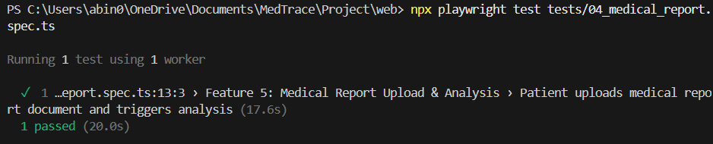
Test Report
Test Case 5
Project Name: MedTrace – AI-Based Clinical Intelligence And Patient Monitoring System
Feature 5: Medical Report Upload & Analysis Test Case
Test Case ID: Test_5 |  |  | Test Designed By: Abin Thomas
Test Priority(Low/Medium/High): High |  |  | Test Designed Date: 07/10/2026
Module Name: AI Report Analysis |  |  | Test Executed By: Mr. Binumon Joseph
Test Title: Verify patient can upload a medical report and trigger AI analysis |  |  | Test Execution Date: 07/10/2026
Description: Verify a patient can upload a PDF report and start AI analysis.
Pre-Condition: Fresh patient account registered; fixture file tests/fixtures/sample_blood_report.pdf available
Step | Test Step | Test Data | Expected Result | Actual Result | Status (Pass/Fail)
1 | Register new patient | Report Patient <timestamp> / report.patient.<timestamp>@medtrace.test / Password123! | Redirect to /dashboard/patient | Redirected successfully | Pass
2 | Open "AI Report Analysis" | Button, or URL: /report/analysis | "AI Medical Report Analysis" page displayed | Page displayed | Pass
3 | Upload report file | File: sample_blood_report.pdf | File accepted | File accepted | Pass
4 | Verify file preview | - | File name sample_blood_report.pdf shown | File name shown | Pass
5 | Select report type (if shown) | Lab / Blood Test | Report type selected | Type selected | Pass
6 | Click "Analyze with AI" | - | Button enabled; analysis starts | Analysis started | Pass
7 | Verify processing state | - | "Analyzing Report" button visible | State visible | Pass
Post-Condition: Report uploaded; analysis started (button shows "Analyzing Report").
Test Case 6:
Code
import { test, expect } from '@playwright/test';

test.describe('Feature 6: Nurses Active Check & Duty Management', () => {
const timestamp = Date.now();
const testNurse = {
name: `Nurse Florence ${timestamp}`,
email: `nurse.florence.${timestamp}@medtrace.test`,
phone: '+15557778888',
password: 'Password123!',
license: `RN-${timestamp.toString().slice(-6)}`,
};

test('Nurse registration and Active Duty status check', async ({ page }) => {
// 1. Navigate to Register
await page.goto('/register');
await expect(page.locator('text=Create Your Account')).toBeVisible();

// 2. Select "Nurse" role
const nurseRoleTile = page.locator('div[role="radio"][aria-label*="Nurse"]');
await nurseRoleTile.click();

// 3. Fill personal details
await page.locator('#reg-name').fill(testNurse.name);
await page.locator('#reg-email').fill(testNurse.email);
await page.locator('#reg-phone').fill(testNurse.phone);

// 4. Fill credentials for nurse
const specField = page.locator('#reg-specialization');
if (await specField.isVisible()) {
await specField.click();
await page.getByRole('option', { name: 'Nursing & Clinical Care' }).click();
}

const licenseInput = page.locator('#reg-license');
if (await licenseInput.isVisible()) {
await licenseInput.fill(testNurse.license);
}

const regDateInput = page.locator('#reg-registered-date');
if (await regDateInput.isVisible()) {
await regDateInput.fill('2026-01-01');
}

// 5. Fill password & terms
await page.locator('#reg-password').fill(testNurse.password);
await page.locator('#reg-agree-terms').check();

// 6. Submit registration
await page.locator('button[type="submit"]:has-text("Create Account")').click();

// 7. Redirect to nurse dashboard
await expect(page).toHaveURL(/\/dashboard\/nurse/, { timeout: 15000 });

// 8. Verify Nurse Rounds interface & Active duty status indicators
await expect(page.locator('text=Nurse rounds')).toBeVisible({ timeout: 10000 });
await expect(
page.locator('text=Active duty').or(page.locator('text=Off duty')).or(page.locator('text=Upcoming duty'))
).toBeVisible({ timeout: 10000 });

// 9. Verify Assigned patients / rounds roster section is displayed
await expect(page.getByRole('heading', { name: 'Assigned patients' })).toBeVisible({ timeout: 10000 });
});
});
Screenshot
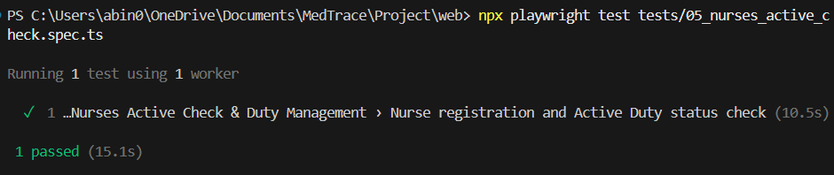
Test Report
Test Case 6
Project Name: MedTrace – AI-Based Clinical Intelligence And Patient Monitoring System
Feature 6: Nurses Active Check & Duty Management Test Case
Test Case ID: Test_6 |  |  | Test Designed By: Abin Thomas
Test Priority(Low/Medium/High): High |  |  | Test Designed Date: 07/10/2026
Module Name: Nurse Registration + Duty Status |  |  | Test Executed By: Mr. Binumon Joseph
Test Title: Verify nurse registration and Active Duty status |  |  | Test Execution Date: 07/10/2026
Description: Verify a nurse can register and the Nurse Rounds dashboard shows duty status and assigned patients.
Pre-Condition: No account exists for the given email; application is running at localhost:4200
Step | Test Step | Test Data | Expected Result | Actual Result | Status (Pass/Fail)
1 | Navigate to /register | URL: localhost:4200/register | "Create Your Account" displayed | Page displayed | Pass
2 | Select "Nurse" role | Role: Nurse | Nurse role selected | Role selected | Pass
3 | Enter personal details | Nurse Florence <timestamp> / nurse.florence.<timestamp>@medtrace.test / +15557778888 | Inputs accepted | Inputs accepted | Pass
4 | Select specialization | Nursing & Clinical Care | Option selected | Option selected | Pass
5 | Enter license and registration date | RN-<6 digits> / 2026-01-01 | Inputs accepted | Inputs accepted | Pass
6 | Enter password and agree to terms | Password123! | Input accepted; checkbox checked | Accepted | Pass
7 | Click "Create Account" | - | Redirect to /dashboard/nurse | Redirected successfully | Pass
8 | Verify Nurse rounds and duty status | - | "Nurse rounds" and "Active duty"/"Off duty"/"Upcoming duty" visible | Elements visible | Pass
9 | Verify roster | - | "Assigned patients" heading visible | Heading visible | Pass
Post-Condition: Nurse account created; Nurse rounds dashboard with duty status and assigned patients displayed.

Test Case 7:
Code
import { test, expect } from '@playwright/test';

test('Smoke test - App loads', async ({ page }) => {
await page.goto('/');
await expect(page).toHaveTitle(/MedTrace/i);
});
Screenshot
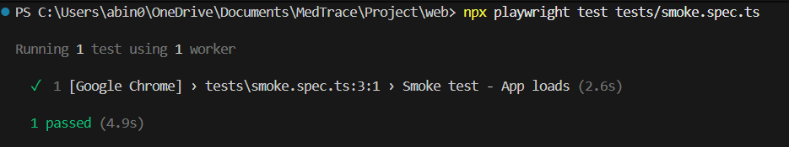
Test Report
Test Case 7
Project Name: MedTrace – AI-Based Clinical Intelligence And Patient Monitoring System
Smoke Test Test Case
Test Case ID: Test_7 |  |  | Test Designed By: Abin Thomas
Test Priority(Low/Medium/High): Medium |  |  | Test Designed Date: 07/10/2026
Module Name: Application Smoke Test |  |  | Test Executed By: Mr. Binumon Joseph
Test Title: Verify the application loads |  |  | Test Execution Date: 07/10/2026
Description: Basic check that the application loads and the page title contains "MedTrace".
Pre-Condition: Application is running at localhost:4200
Step | Test Step | Test Data | Expected Result | Actual Result | Status (Pass/Fail)
1 | Navigate to home page | URL: localhost:4200/ | Home page loads | Page loaded | Pass
2 | Verify page title | Title matches /MedTrace/i | Title contains "MedTrace" | Title matched | Pass
Post-Condition: Application home page loads with the expected title.

CHAPTER 6

IMPLEMENTATION

INTRODUCTION
The implementation phase is the part of the Software Development Life Cycle where the design and requirements of a system go from being ideas to real working software. It’s the moment when plans turn into something that people can actually use. This phase is often the hardest because it brings every idea from the design stage into the world, where things like hardware limits, software compatibility, network speed and how real users behave all come into play.

Writing code is part of what happens during implementation. It’s an organized process. It includes planning how the work will be done knowing the environment the software will run in picking the tools and programming languages writing code step by step testing it along the way and finally moving the software from the development setup to the live environment. When this is done well users can trust the system. They know it will work reliably keep their data safe and keep performing as needed over time. If implementation is done poorly even the best design will fail. Users will get frustrated. The software won’t meet its goals.

Moving from a system to a new one is especially challenging. The old system might be a process, an old application or just a bunch of separate tools. The people who use it every day will have concerns. They worry the new system might be harder to use. They worry about losing data or having to change how they do things. To deal with these worries implementation needs more than technical work. It needs communication about why the change is happening, proper training and a plan to switch over with as little disruption, as possible. The complex the system the more important these human and communication elements become.

IMPLEMENTATION PROCEDURES
Software implementation refers to the installation and configuration of the MedTrace platform in its intended environment, together with the verification that every module behaves as expected during use. The project was developed by a single student with guidance from the internal project guide, and the implementation followed an iterative approach, in which each module was built, tested and integrated before the next one was started.
Since MedTrace serves several user roles (Patients and Guardians, Caretakers, Doctors, Nurses, Head Nurses, Reception staff and Hospital Administrators), the implementation had to ensure that each role’s experience is clear, secure and consistent with the permissions defined in the design. The following principles guided the implementation:

- The system must be simple enough for a first-time user to navigate with little training.
- Every action must be protected by authentication and role-based access control, so that users cannot see or change data outside their scope.
- Failures in one part of the system, such as the AI service being temporarily unreachable, must not bring down the whole platform.
- All sensitive data, such as passwords, medical reports and patient records, must be stored securely, and secret keys must never be placed in the source code.
- AI results must always be shown as decision-support information with a medical disclaimer.
The implementation was carried out in clearly defined stages:
- Backend Development: Building the Node.js, Express and TypeScript API layer, including authentication, patient management, vitals, medications, appointments, test results, caretaker assignments, nurse assignments, nurse tasks, clinical notes, exercise plans, messages and administration.
- AI Microservice Development: Integrating the Gemini model through the Google Generative AI SDK to analyze uploaded medical reports and produce the structured result containing the overview, key findings, abnormal values, recommendations and urgency.
- Database Schema Implementation: Creating MongoDB collections, indexes, and embedded sub-documents inside the Applications collection.
- Frontend Development: Building the React and TypeScript dashboards for each role, together with the login, registration, password-reset and profile pages.Integration: Connecting the frontend to the backend through REST APIs, connecting the backend to the AI service, and adding Socket.IO for live alerts.
- Testing: Running unit, integration, and end-to-end tests using Jest, Pytest, and Playwright.
- Deployment: Hosting the frontend on Vercel, the backend and AI service on Render, and the database on MongoDB Atlas.
The implementation was successful, and the entire platform now runs as a fully functional, cloud-deployed application.

User Training
The purpose of user training is to help patients, guardians, doctors, nurses and administrative staff feel confident using MedTrace. Because MedTrace handles sensitive health information, users must trust that the system works correctly and that every action is saved properly.

The training approach for MedTrace is simple and complete. The role-based dashboards show each user only the tools that matter to them, which keeps the learning curve low. Patients and guardians only need to learn how to register, upload a report, read the AI summary, log vitals, track medications and book appointments. Doctors need to learn how to open authorized patient records, review the history and trends, use the AI analysis as decision support, and record clinical notes. Nurses and head nurses need to learn how to follow their duty schedule, mark attendance and manage assignments and tasks. Reception and administrative staff need to learn how to register patients, manage appointments, and maintain users and roles.

Training on the Application Software
Training is planned separately for each role, so that every group learns only what is relevant to it, and it covers every screen, form and workflow that the role uses.
- Patients and guardians learn how to register or sign in with Google, upload a medical report in a supported format, and read the AI analysis with its abnormal values and urgency. They also learn how to log vitals, view health trends, follow the medication schedule, book and view appointments, follow exercise plans, and grant or revoke caretaker access. They are taught that the AI summary does not replace the doctor’s advice.
- Caretakers learn how to view only the patients who have granted them access, and how to follow their medications, appointments and exercise plans.
- Doctors learn how to view their patients, review earlier reports, test results and trends, compare reports over time, use the AI analysis as decision support, record clinical notes, and manage appointments and prescriptions.
- Nurses learn how to check their duty status (active, upcoming or off duty), mark attendance within the duty window, view assigned patients, record vitals and update their task status.
- Head nurses learn how to schedule duties in advance, assign patients to nurses, allocate tasks to nurses who are on active duty, and monitor duty and task status.
- Reception staff learn how to register patients and manage appointments.
- Hospital administrators learn how to manage users and roles and how to oversee authorized access.
The training is given as a walkthrough on the live system and is supported by clear labels, inline help text and error messages that explain what went wrong and how to correct it. After one walkthrough, a user of any role should be able to use the features of that role with confidence.

System Maintenance
System maintenance for MedTrace is treated as a continuing effort, and it is organized into three categories: routine, corrective and adaptive maintenance.
Routine maintenance includes checking that database backups and exports are taken on schedule, reviewing the server and application logs to find errors early, and checking that password-reset emails are delivered. It also includes monitoring the usage and limits of the Firebase and Gemini API services, and keeping the npm packages up to date by applying security patches in a test environment before they are moved to production. API keys and secrets are rotated when needed and are kept only in environment variables.
Corrective maintenance starts whenever a user reports a bug or a bug appears during testing. Each fix is verified with the Playwright test suite and manual checks before it is merged, so that the new code does not create a regression elsewhere. Reported problems with AI results, such as a wrong or incomplete summary, are reviewed and the prompt or handling is improved.
Adaptive maintenance is carried out when new needs arise. For example, the connection of real respiratory sensors and Wi-Fi CSI hardware, the addition of a mobile application, or new AI features such as risk prediction and similar-case retrieval can be added without disturbing the existing modules, because the system has a modular folder structure and a clear separation between the frontend, the API and the AI layer.
A record is kept of every maintenance task, and the code is version-controlled with Git and GitHub, so that each change can be traced, reviewed and rolled back if something goes wrong.
    - Hosting
Hosting means making the MedTrace platform accessible over the internet, so that users can reach it from any device with a browser and an internet connection. The platform is designed to run on free-tier cloud services, which keeps the cost of a prototype deployment close to zero. The React web application is hosted on Vercel, which serves it over HTTPS with automatic SSL. The Node.js and Express backend runs as a separate web service on a Node hosting platform, with its environment variables set for the database connection, the JWT secrets, the email credentials and the Firebase and Gemini keys. Firebase provides authentication, Firestore and storage, and MongoDB provides the database for the backend models, with a database user and an access list configured. The deployment process is as follows: the code is pushed to GitHub, the database and Firebase project are prepared, the backend is deployed with its environment variables, and the frontend is deployed on Vercel with the backend API URL configured. Each tier is deployed independently, so a failure in one service, such as the AI service, does not stop the others. Access to the deployed application is provided through the Vercel URL, and a QR code of the same URL can be included in the report so that evaluators can open the live system quickly.
Procedure for hosting a website on Vercel, Render and MongoDB:
Step 1: Create accounts on free-tier platforms
Sign up for Vercel, a Node hosting service for the backend, Firebase and MongoDB Atlas, using your GitHub login where possible.
Step 2: Set up the MongoDB Atlas database
Create a free shared cluster, add a database user with a strong password, allow access from anywhere (0.0.0.0/0) for development, and copy the connection string.
Step 3: Set up the Firebase project
Create a Firebase project, enable Authentication (email and Google sign-in), Firestore and Storage, and copy the web app configuration.
Step 4: Deploy the Node.js backend on Render
Create a second web service, set the root directory to backend, choose Node as the runtime, and set npm install as the build command and npm start as the start command. Add all environment variables, including the AI service URL from Step 3 and the MongoDB URI from
Step 5: Get the Gemini API key
Create an API key for the Gemini model in Google AI Studio and keep it only in environment variables.
Step 6: Access your hosted website
Open the Vercel URL in any browser. The frontend, backend, AI service, and database are now connected end-to-end and accessible from any device.

Hosted Website: Vercel
Hosted Link: https://medtrace-khaki.vercel.app/

Hosted Link QR Code

Screenshot
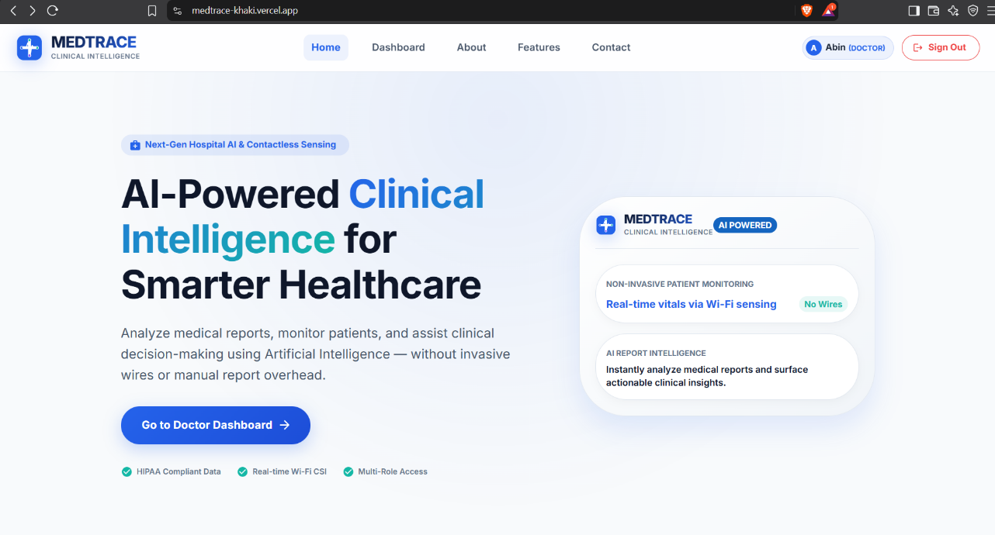

CHAPTER 7

CONCLUSION AND FUTURE SCOPE

CONCLUSION

MedTrace addresses the long-standing problem of scattered and hard-to-interpret patient information by bringing patients, guardians, caretakers, doctors, nurses, head nurses, reception staff and administrators onto a single, role-based digital platform. The system replaces paper files, loose reports and informal communication with a structured workflow. This workflow covers user authentication, medical report upload, AI-assisted analysis, vitals, test results, medications, appointments, exercise plans, clinical notes, caretaker access, nurse duty scheduling, patient assignments and task allocation. By using Google’s Gemini model, MedTrace turns an uploaded medical report into a structured summary with the key findings, abnormal values, recommendations and urgency, so that patients and guardians can understand their reports and doctors can review them quickly. The longitudinal health records and trend charts let doctors follow how a patient’s condition changes over time, and the AI output always appears with a medical disclaimer, because it is meant to support qualified healthcare professionals and not to replace them. The nursing module lets head nurses schedule duties in advance and assign tasks to nurses who are on active duty, which reduces the confusion of manual rosters. The caretaker authorization keeps access to patient information controlled, and JWT authentication, bcrypt password hashing and role-based access control protect the data. The platform is built on widely used, free-tier technologies, namely React, Node.js, Express, MongoDB and Firebase, and its main workflows are covered by Playwright automation tests. The contactless respiratory-monitoring and Wi-Fi CSI-based anomaly-detection module is included as a prototype interface that shows how non-invasive monitoring could be added in the future. Although MedTrace is an academic prototype for a single hospital and has not been clinically validated, its modular architecture makes it secure and easy to extend. Overall, MedTrace delivers organized records, clearer understanding of medical information and better coordination of care, and it provides a strong technical and research foundation for future development..
  - FUTURE SCOPE
- Real Contactless Monitoring – Integrate ESP32-based under-mattress respiratory sensors and Wi-Fi CSI-capable hardware, with data acquisition and signal processing, to replace the prototype interface with real measurements.
- Validation of Monitoring Models – Compare the respiratory estimates and anomaly detection results with reference measurements under proper ethical approval before using them in any clinical setting.
- OCR and NLP Pipeline – Add OCR for scanned reports and NLP for extracting clinical entities and parameters, so that report values are stored in a structured form for trend analysis.
- Machine-Learning Risk Prediction – Develop and validate models that estimate selected health risks from the patient’s history and clinical parameters, with the model version and confidence stored for every prediction.
- Similar-Case Retrieval – Create text embeddings of verified, de-identified reports and use vector search to retrieve similar historical cases for the doctor’s reference.
- Mobile Application – Build a React Native application for patients, guardians and caretakers, with offline access to schedules and records.
- Push Notifications – Add Firebase Cloud Messaging for medication reminders, appointment alerts and monitoring alerts on Android and iOS devices.
- Clinical Validation of AI Output – Evaluate the AI summaries with doctors, collect structured feedback, and improve the prompts and the handling of unsupported report types.
- Interoperability Standards – Support standards such as HL7 FHIR so that MedTrace can exchange data with existing hospital information systems and electronic health records.
- Wearable and Device Integration – Import vitals from wearable devices and bedside monitors to complement the manually entered readings.
- Multilingual Support – Provide report explanations and the user interface in regional languages such as Malayalam, to help patients and guardians understand their health information.
- Stronger Security and Compliance – Add full audit logging, encrypted storage of sensitive fields, backup and recovery procedures, and a review against applicable data-protection requirements before any real-world deployment.
- Microservices, Docker and CI/CD – Separate the API, AI and monitoring services, containerize the stack with Docker, and automate testing and deployment with GitHub Actions.
- Multi-Hospital Support – Add hospital-based data isolation and a super-admin dashboard so that several hospitals can use the platform.
- Wider Test Coverage – Extend the automated tests to unit and integration levels and add load and security testing.

CHAPTER 8

BIBLIOGRAPHY

REFERENCES:

- Learning React: Modern Patterns for Developing React Apps, Alex Banks and Eve Porcello, Second Edition, O’Reilly Media, 2020.
- Programming TypeScript: Making Your JavaScript Applications Scale, Boris Cherny, O’Reilly Media, 2019.
- Node.js Design Patterns, Mario Casciaro and Luciano Mammino, Third Edition, Packt Publishing, 2020.
- MongoDB: The Definitive Guide, Shannon Bradshaw, Eoin Brazil and Kristina Chodorow, Third Edition, O’Reilly Media, 2019.
- Software Engineering, Ian Sommerville, Tenth Edition, Pearson Education, 2015.
- UML Distilled: A Brief Guide to the Standard Object Modeling Language, Martin Fowler, Third Edition, Addison-Wesley, 2003.

WEBSITES:

- https://react.dev
- https://www.typescriptlang.org/docs
- https://mui.com/material-ui
- https://nodejs.org/en/docs
- https://expressjs.com
- https://mongoosejs.com/docs
- https://firebase.google.com/docs
- https://ai.google.dev/gemini-api/docs
- https://playwright.dev/docs
- https://recharts.org

CHAPTER 9

APPENDIX

Sample Code

recruiterController.js

coexport const MedicalReportPage: React.FC = () => {

const navigate = useNavigate();

const { user } = useAuth();

const fileInputRef = useRef<HTMLInputElement>(null);

const [file, setFile] = useState<File | null>(null);

const [dragOver, setDragOver] = useState(false);

const [loading, setLoading] = useState(false);

const [saving, setSaving] = useState(false);

const [progress, setProgress] = useState(0);

const [result, setResult] = useState<ReportSummary | null>(null);

const [error, setError] = useState<string | null>(null);

const [reportType, setReportType] = useState<ReportType>('lab');

const [reportDate, setReportDate] = useState('');

const [notes, setNotes] = useState('');

const [savedToCloud, setSavedToCloud] = useState(false);

const [snackOpen, setSnackOpen] = useState(false);

const [snackMsg, setSnackMsg] = useState('');

const validateAndSet = (f: File) => {

setError(null);

setResult(null);

setSavedToCloud(false);

if (!ACCEPTED.includes(f.type)) {

setError('Unsupported file type. Please upload a PDF or image (PNG, JPG, WEBP, HEIC).');

return;

}

if (f.size > MAX_MB * 1024 * 1024) {

setError(`File is too large. Maximum size is ${MAX_MB} MB.`);

return;

}

setFile(f);

};

const onFileChange = (e: React.ChangeEvent<HTMLInputElement>) => {

if (e.target.files?.[0]) validateAndSet(e.target.files[0]);

};

const onDrop = useCallback((e: React.DragEvent) => {

e.preventDefault();

setDragOver(false);

if (e.dataTransfer.files?.[0]) validateAndSet(e.dataTransfer.files[0]);

}, []);

const clearFile = () => {

setFile(null);

setResult(null);

setError(null);

setSavedToCloud(false);

if (fileInputRef.current) fileInputRef.current.value = '';

};

const handleAnalyze = async () => {

if (!file) return;

setLoading(true);

setError(null);

setResult(null);

setProgress(0);

setSavedToCloud(false);

// Fake progress animation while waiting

const iv = setInterval(() => {

setProgress((p) => (p < 88 ? p + Math.random() * 12 : p));

}, 400);

try {

const summary = await analyzeReport(file);

clearInterval(iv);

setProgress(100);

await new Promise((r) => setTimeout(r, 300));

setResult(summary);

// Auto-save to Firebase if user is logged in

if (user?.id) {

await handleSave(summary);

}

} catch (err: any) {

clearInterval(iv);

setError(err?.message || 'Analysis failed. Please try again.');

} finally {

setLoading(false);

}

};

const handleSave = async (summary?: ReportSummary) => {

if (!file || !user?.id || savedToCloud) return;

setSaving(true);

try {

await uploadReport({

uid: user.id,

patientId: user.patientId || `NOID-${user.id.slice(0, 8)}`,

file,

reportType,

reportDate: reportDate || undefined,

notes: notes || undefined,

analysisResult: summary || result || undefined,

});

setSavedToCloud(true);

setSnackMsg('Report saved to your health records ✓');

setSnackOpen(true);

} catch (err: any) {

setSnackMsg('Could not save report: ' + (err?.message || 'Unknown error'));

setSnackOpen(true);

} finally {

setSaving(false);

}

};

const isPdf = file?.type === 'application/pdf';

const urgency = result ? urgencyConfig[result.urgencyLevel] : null;

return (

<Box sx={{ minHeight: '100vh', backgroundColor: '#F8FAFC' }}>

<Navbar />

<Box

sx={{

background: 'linear-gradient(135deg, rgba(37,99,235,0.06) 0%, rgba(20,184,166,0.04) 100%)',

borderBottom: '1px solid #E2E8F0',

py: { xs: 4, md: 5 },

}}

>

googleAuthService.ts

export const verifyGoogleIdToken = async (idToken: string): Promise<GooglePayload | null> => {

try {

const ticket = await client.verifyIdToken({

idToken,

audience: process.env.GOOGLE_CLIENT_ID,

});

const payload = ticket.getPayload();

if (!payload || !payload.email) {

return null;

}

return {

googleId: payload.sub,

email: payload.email,

name: payload.name || payload.email.split('@')[0],

picture: payload.picture,

};

} catch (error) {

// Fallback: Decode Firebase ID token (issued by securetoken.google.com)

try {

const decoded: any = jwt.decode(idToken);

if (decoded && (decoded.email || decoded.user_id || decoded.sub)) {

return {

googleId: decoded.user_id || decoded.sub || 'google-user-' + Date.now(),

email: decoded.email,

name: decoded.name || decoded.email?.split('@')[0] || 'Google User',

picture: decoded.picture,

};

}

} catch {

// ignore

}

console.warn('[Google Auth Service] Token verification failed or demo token used:', error);

// Return mock verified google user for demo tokens / dev testing

if (idToken.startsWith('demo-google-token-')) {

return {

googleId: 'google-user-123456789',

email: 'doctor.demo@medtrace.ai',

name: 'Dr. Sarah Jenkins',

};

}

return null;

}

};

authController.js

const firebaseErrorMessage = (error: any): string => {
if (!error) return 'An unexpected error occurred. Please try again.';
const code = typeof error === 'string' ? error : error?.code;
const message = error?.message;

switch (code) {
case 'auth/email-already-in-use':
return 'An account with this email address already exists.';
case 'auth/invalid-email':
return 'Please enter a valid email address.';
case 'auth/weak-password':
return 'Password must be at least 6 characters.';
case 'auth/user-not-found':
case 'auth/wrong-password':
case 'auth/invalid-credential':
return 'Invalid email or password credentials.';
case 'auth/too-many-requests':
return 'Too many failed attempts. Please try again later.';
case 'auth/popup-closed-by-user':
return 'Google Sign-In was cancelled.';
case 'auth/network-request-failed':
return 'Network error. Please check your connection.';
case 'permission-denied':
case 'PERMISSION_DENIED':
return 'Firestore permission denied. Publish the project Firestore rules, then try again.';
default:
if (typeof message === 'string' && (message.includes('permission') || message.includes('Missing or insufficient'))) {
return 'Firestore permission denied. Publish the project Firestore rules, then try again.';
}
if (message) {
return code ? `Error [${code}]: ${message}` : message;
}
return 'An unexpected error occurred. Please try again.';
}
};

const withTimeout = <T>(promise: Promise<T>, ms = 1500): Promise<T> =>
Promise.race([
promise,
new Promise<T>((_, reject) => setTimeout(() => reject(new Error('timeout')), ms)),
]);
appointmentService.ts

xport const normalizeAppointment = (raw: any): Appointment => {
const id = raw._id || raw.id || `apt-${Date.now()}`;
const docObj = typeof raw.doctorId === 'object' && raw.doctorId !== null ? raw.doctorId : null;
const patientObj = typeof raw.patientId === 'object' && raw.patientId !== null ? raw.patientId : null;
const userObj = patientObj?.userId || null;

const rawDate = raw.dateTime ? new Date(raw.dateTime) : (raw.date ? new Date(raw.date) : new Date());
const dateStr = !isNaN(rawDate.getTime()) ? rawDate.toISOString().split('T')[0] : (raw.date || '');
const timeSlotStr = raw.timeSlot || (!isNaN(rawDate.getTime())
? rawDate.toLocaleTimeString([], { hour: '2-digit', minute: '2-digit' })
: '10:00 AM');

const notesStr: string = raw.notes || '';
const formatMatch = notesStr.match(/Format:\s*([^|]+)/i);
const linkMatch = notesStr.match(/Link:\s*([^|]+)/i);
const docNotesMatch = notesStr.match(/Notes?:\s*([^|]+)/i);

const consultationType = raw.consultationType || (formatMatch ? formatMatch[1].trim() : 'In-Person Consultation');
const meetingLink = raw.meetingLink || (linkMatch ? linkMatch[1].trim() : undefined);

return {
id,
patientId: patientObj?._id || patientObj?.id || raw.patientId || 'default',
patientName: userObj?.name || raw.patientName || 'Patient',
patientPhone: userObj?.phone || raw.patientPhone,
patientEmail: userObj?.email || raw.patientEmail,
doctorId: docObj?._id || docObj?.id || raw.doctorId || 'doc-1',
doctorName: docObj?.name || raw.doctorName || 'Dr. Specialist',
doctorSpecialization: docObj?.department || raw.doctorSpecialization || 'Clinical Medicine',
hospitalName: docObj?.hospitalName || raw.hospitalName || 'MedTrace General Hospital',
date: dateStr,
timeSlot: timeSlotStr,
consultationType: consultationType as any,
reason: raw.reason || 'General clinical consultation',
status: raw.status || 'pending',
doctorNotes: raw.doctorNotes || (docNotesMatch ? docNotesMatch[1].trim() : raw.notes),
meetingLink,
createdAt: raw.createdAt || new Date().toISOString(),
updatedAt: raw.updatedAt || new Date().toISOString(),
};
};
export const fetchPatientAppointments = async (patientId: string): Promise<Appointment[]> => {
try {
const res = await api.get('/api/appointments', {
params: { patientId },
});
if (res.data?.success && Array.isArray(res.data?.appointments)) {
return res.data.appointments
.map(normalizeAppointment)
.sort((a: Appointment, b: Appointment) => new Date(b.date).getTime() - new Date(a.date).getTime());
}
return [];
} catch (err: any) {
console.warn('fetchPatientAppointments error:', err);
return [];
}
};
export const fetchDoctorAppointments = async (doctorId?: string, doctorName?: string, status?: Appointment['status']): Promise<Appointment[]> => {
try {
const params: Record<string, string> = {};
if (doctorId) params.doctorId = doctorId;
if (status) params.status = status;

const res = await api.get('/api/appointments', { params });
if (res.data?.success && Array.isArray(res.data?.appointments)) {
let list = res.data.appointments.map(normalizeAppointment);
if (doctorName && !doctorId) {
const cleanName = doctorName.toLowerCase().trim();
list = list.filter((a: Appointment) =>
a.doctorName.toLowerCase().includes(cleanName) || cleanName.includes(a.doctorName.toLowerCase())
);
}
return list.sort((a: Appointment, b: Appointment) => {
if (a.status === 'pending' && b.status !== 'pending') return -1;
if (b.status === 'pending' && a.status !== 'pending') return 1;
return new Date(b.date).getTime() - new Date(a.date).getTime();
});
}
return [];
} catch (err) {
console.warn('fetchDoctorAppointments error:', err);
return [];
}
};

Screen Shots

