Beyond beneficial information: enhancing initial adoption of digital records and best practices among small firms - Evidence from Nigeria
Abiola Oyebanjo
- This brief delves into the findings of a pilot study exploring how the introduction of digital methods for record-keeping, provided with personalized support to small firms in Nigeria can enhance the adoption of digital records and financial best practices.
- Providing small firms with additional micro-consulting when giving them digital technology for record-keeping improves the probability that they will take steps to use it for the first-time by 95 percent, compared to providing them only with information on the benefits.
- The adoption of digital record-keeping methods by small firms exhibit more precise recall of their profits.
- This policy brief emphasizes the conditions necessary to improve the initial adoption of record-keeping apps and improve financial best practices among informal and small firms.

Policy Motivation
The study sample is Lagos, a city of 16 million people, the second largest city in Africa, and has over 500 markets as recorded by the state government with a projection of over 1,000 markets. The informal sector is the highest supplier of labour with over 5 million firms out of a about 7.5 million firms in the city. The urban, open-air trading market is an integral part of the city of Lagos. Along with being a center of commerce, the markets in Lagos also showcase the political, ethnic, and gender-based dynamics that characterize the city of Lagos as a whole.
Extensive data from three pilot studies conducted since 2019 consistently reveals a prevailing trend, with over 70-90% of businesses across more than 100 markets in Lagos relying on paper records. In urban settings with high economic activities, these businesses often resort to paper-based methods, citing perceived costs in time, attention, and mental effort. Despite its widespread use, this practice lacks systematization, precision, and accuracy, rendering it inadequate for effective data analytics. Consequently, it may impede precision, decision-making mechanisms necessary for growth potential and the establishment of fruitful business partnerships.
The ultimate goals of government institutions, private investors, and nonprofits involved in providing loans and business support to small firms are to offer assistance tailored to their needs. It is crucial to understand the most effective ways to support small firms . Without additional and personalized support, examining their business records and patterns over time in a more precise manner may prove counterproductive . This study aims to provide clarity on how to encourage firms to embrace it as first-time adopters and whether these efforts would improve firms' financial best practices.

Overview of the research
Several studies in economics have explored the impact of business training on the economic performance of small firms. However, these studies often focus less on the effectiveness of additional micro-consulting, involving activities such as visiting firms, providing strategic support such as how to interpret records. We also do not know whether firms have genuinely adopted these best practices and how it applies to the adoption of technology specifically.. Furthermore, there is a lack of understanding regarding whether providing firms with digital record-keeping leads to more accurate records compared to other methods commonly used by small firms, such as memory and paper.

The research examined a cohort of 376 firms divided into two WhatsApp groups, both initially exposed to record-keeping training and subsequently provided with an app. The study encompassed 40 markets, initially engaging 1,936 firms in Lagos, and concluded in December 2023, culminating in a stakeholder meeting. We attempted to contact all firms, successfully reaching 1,036 deliberately, as we aimed to randomize those with active phones. Some firms chose not to join the WhatsApp group, labeled as "unwilling." Additional analysis indicates that these unwilling firms are not systematically different from those who joined, primarily opting out due to concerns about the process and the timing of the training conflicting with their existing schedules. For instance, both willing and unwilling firms had a 67 percent and 64 percent record-keeping rate at the beginning of the project respectively.

One group additionally received in-person support(treatment 1), while the other did not (treatment 2). The division of these groups was randomly conducted using standard computer programs. The research team consisted of five full-time training associates and a training manager who coordinated their activities. The training and evaluation that was implemented via structured text, embedded Youtube videos and periodic quizzes on Whatapp. Additionally, the training associates were responsible for managing a few firm owners and conducted bi-weekly cross-sectional data collection on firm behaviors, such as profit and salary payments. The training associates utilized virtual methods for individual communication with assigned firms, in addition to in-person visits for micro-consulting.
In summary, the experiment included the folowubg participants. :
Group | Treatment1 | Treatment2 | Total
Unwilling | 311 | 354 | 665
Willing (Whatsapp) | 207 | 169 | 376

The main training method were vidoes which was videos on YouTube to measure engagement. We also introduced text and quizzes. This approach applied to both groups. Training includes profit calculation, separating business from personal funds, maintaining records, understanding sales journals. Following the training, training associates actively conducted meetings with firms in the micro-consulting arm only for a more intensive, detailed, and personalized analysis of their records and record-keeping practices.

Key Findings

Firms in the micro-consulting arm of the WhatsApp group indicated an increased likelihood of downloading and utilizing a record-keeping app for the first time compared to firms with only beneficial information. The latter group received only basic information about the app and other training on record-keeping for a three-month period. Despite receiving all the necessary support to understand the training and being assigned training associates, these firms did not have the opportunity for in-person visits from the associates to provide detailed explanations or additional insights about the app. For both women and men, there were significant differences in receiving this intervention, leading to a 15 percent improvement in first-move adoption for women and a notable 35.5 percent improvement for men. In general, microconsulting improved the probability that firms will take steps to adopt record-keeping technology for the first-time improved by 95 percent.

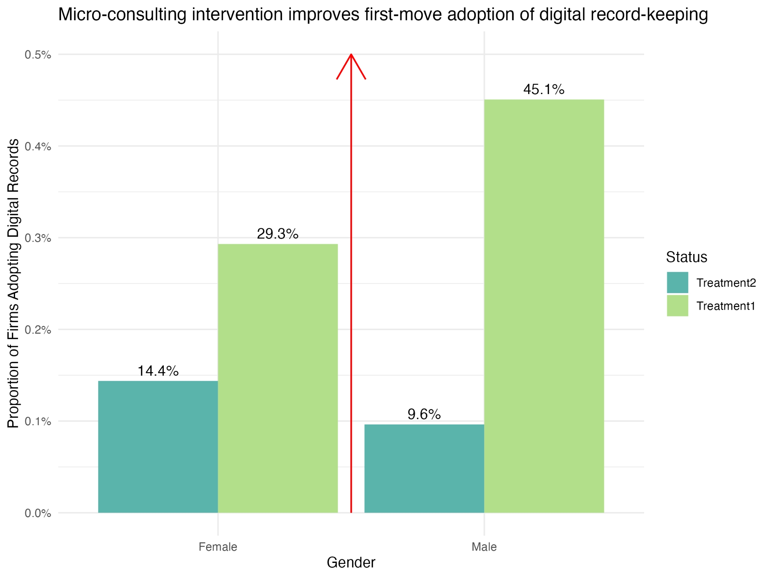
Firms that joined the training group adhere to best financial practices than firms who are unwilling, though both are similar in attributes. Firms who did not join the training were treated as control group to test best practices intervention because they opted out due to lack of trust in the training process and not on business related differences. They simply were sceptical to the time it took for them to accept to join and the time the training started. After extensive four-month training on beneficial and specific information on best practices such as separating business records, not taking busines products home and separating personal funds from business, we find evidence to support that the odds of these groups keeping to practices increases

Firms that utilize digital methods for record-keeping exhibit a higher degree of precision when recalling their profits over an extended period. During the endline data collection, firms were asked to recall their profits for a single product over a 3-week period. Those employing digital methods demonstrated 98 percent precision, while those relying on paper methods were 75 percent precise. It is crucial to emphasize that precision, denoting the ability to obtain consistent results over time, is not synonymous with accuracy, which pertains to the extent to which firms can ascertain the true value of their profits. Nevertheless, even though profit measurement can be influenced by volatility over time, this finding provides a foundation to believe that digital methods may reduce recall bias more effectively than paper methods, particularly for specific needs such as stock management, which may face challenges with paper records.

Policy Implications

The study indicates that offering small firms beneficial information about adopting digital records is less effective when they do not receive additional in-person support. This support should encompass information about the benefits of digital records and guidance on maintaining records, calculating profits, and adhering to best practices.
These findings have several implications for policies in developing countries that aim to promote the adoption of technology:
- In light of the study's findings, the optimal policy would lead to a 97 percent increase in the adoption of technology for record-keeping, surpassing the efficacy of merely providing traditional training or introducing the technology to firms.
- The optimal policy involves offering firms willing to embrace technology simple training on financial best practices, as opposed to general record-keeping. This approach has demonstrated improvements in firms' adherence to these practices compared to those that do not participate.
- These results carry implications for the precision of firms' profit reporting. Policymakers and nonprofits interested in enabling firms to track their profits, especially in specific features like stock management, should recognize that digital methods have shown greater precision than paper or memory. However, it is crucial for policies to acknowledge that the benefits of record-keeping on paper for firms may differ from those experienced with technology. This distinction suggests that target beneficiaries may need to be adjusted accordingly.

For further information about this research and engagement with the IGC team, please get in touch with Abiola Oyebanjo (oyebanjoabiola@gmail.com)

References

Anderson, S. J., Lazicky, C., & Zia, B. (2019). Measuring the unmeasured:
Combining technology and behavioral insights to improve measurement of business
outcomes. World Bank Policy Research Working Paper, (8836).

Bruhn, M., Karlan, D., & Schoar, A. (2018). The impact of consulting services on
small and medium enterprises: Evidence from a randomized trial in mexico.
Journal of Political Economy, 126 (2), 635–687.

Bruhn, M., & Zia, B. (2011). Stimulating managerial capital in emerging markets:
The impact of business and financial literacy for young entrepreneurs. World
Bank Policy Research Working Paper, (5642).

De Mel, S. J., McKenzie, D. J., & Woodruff, C. (2007). Measuring microenterprise
profits: Don’t ask how the sausage is made (Vol. 4229). World Bank Publications.

Drexler, A., Fischer, G., & Schoar, A. (2014). Keeping it simple: Financial literacy
and rules of thumb. American Economic Journal: Applied Economics, 6 (2),
1–31.

Fafchamps, M., McKenzie, D., Quinn, S., & Woodruff, C. (2012). Using pda
consistency checks to increase the precision of profits and sales measurement in
panels. Journal of Development Economics, 98 (1), 51–57.
McKenzie, D., & Woodruff, C. (2008). Experimental evidence on returns to capital and access to finance in Mexico. The World Bank Economic Review, 22(3), 457-482.
McKenzie, D., & Woodruff, C. (2017). Business practices in small firms in
developing countries. Management Science, 63 (9), 2967–2981.

