Fundamentals of data analytics with tableau

Project title: Analysing housing prices in metropolitan areas of india

Naan mudhalvan project

**NM2023TMID20425**

Team members:

1. A.AROWIN

2. G.DHILIPKUMAR

3. I.ABI PRAKASH

4. A.AMERTHIYA PREM

DEPARTMENT OF MATHEMATICS

SREE SEVUGAN ANNAMALAI COLLEGE

DEVAKOTTAI

SIVAGANGAI- 630302

**ANALYSING HOUSING PRICES IN METROPOLITAN AREAS OF INDIA**

INTRODUCTION:

Description of project:

House price prediction can help the developer determine the selling price of a house and can help the customer to arrange the right time to purchase a house. There are three factors that influence the price of a house which include physical conditions, concept and location.

Uses:

Regression algorithms, on the other hand, predict the continuous value i.e. the expected price of a house; the number of votes that a party is likely to get.

~~PROBLEM DEFINITION & DESIGN THINKING~~

EMPATHY MAP: First we make a empathy map for a group idea .To create a empathy map from mural web site and logic with email account and search the templates that you wanted to create. 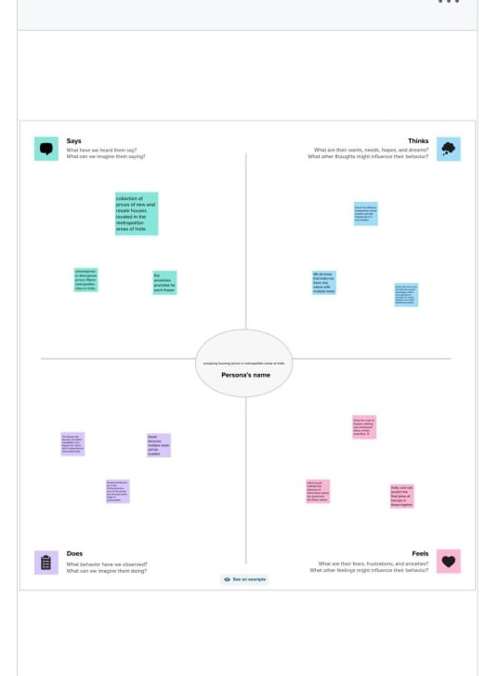

BRAINSTORMING MAP:

Then make a brainstorm map with mural website. I brainstorm we discussed the

define problem and understand the problem. First we have defined what are the

problems and types in the question box. Then it is a group idea and write in the

box as person1, person2 and person 3. Now three person give different idea for

the same problem. Take best three idea and type in last box.

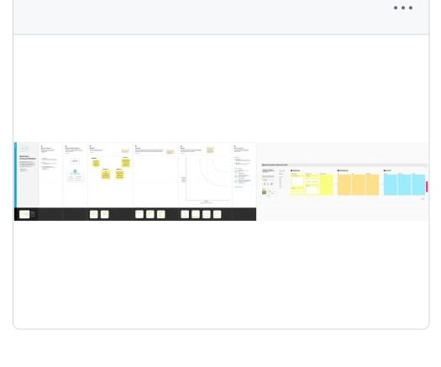

PROCEDURE FOR TABLEAU PROJECT:

Before opening the tableau desktop we had download the dataset for your

project .after download the dataset we open the tableau desktop After opening

the selected link connect to data, select the “more” option and select the dataset.

It opens in the data source, now we arranged the data and select the "Analysing house prices in metropolitan areas of India".

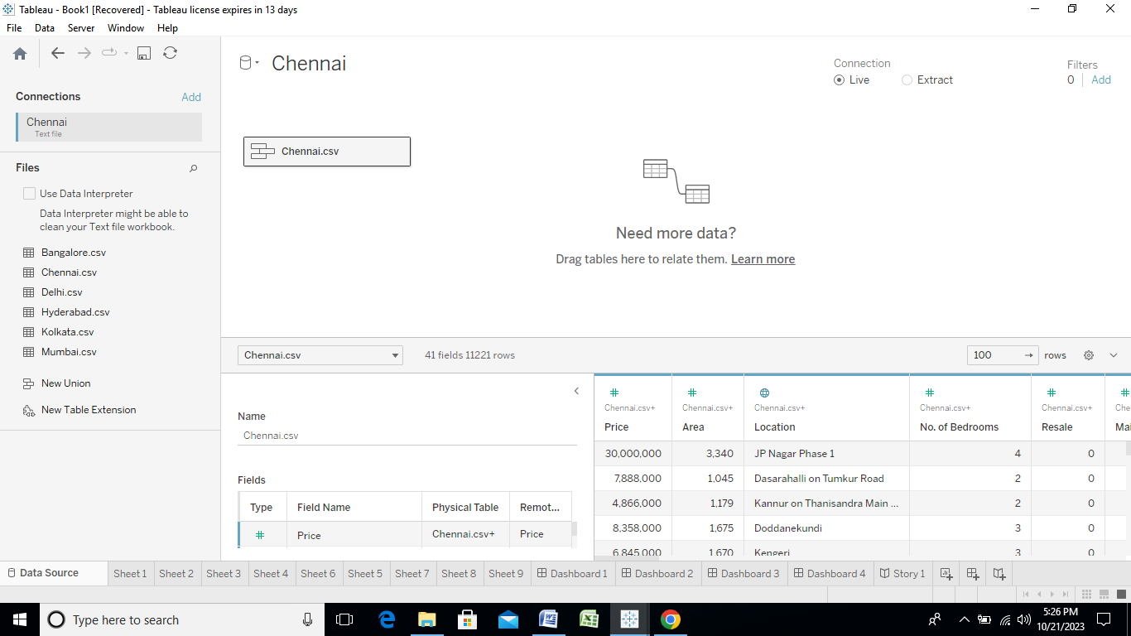

We have arrange your project cover per catogery his first miles covered catogery is second,month wise uppor miles analys third weeksecond, month wise Uber miles analysis is third, week wise

Uber miles analysis is fourth, quarter wise Uber miles analysis is fifth, month wise

Uber trips is sixth, quarter wise Uber trips analysis Seventh, hours wise Uber trips

analysis is final.

We have made 8 analysis sheets .The next bargraph is show the latitude and longtitude.

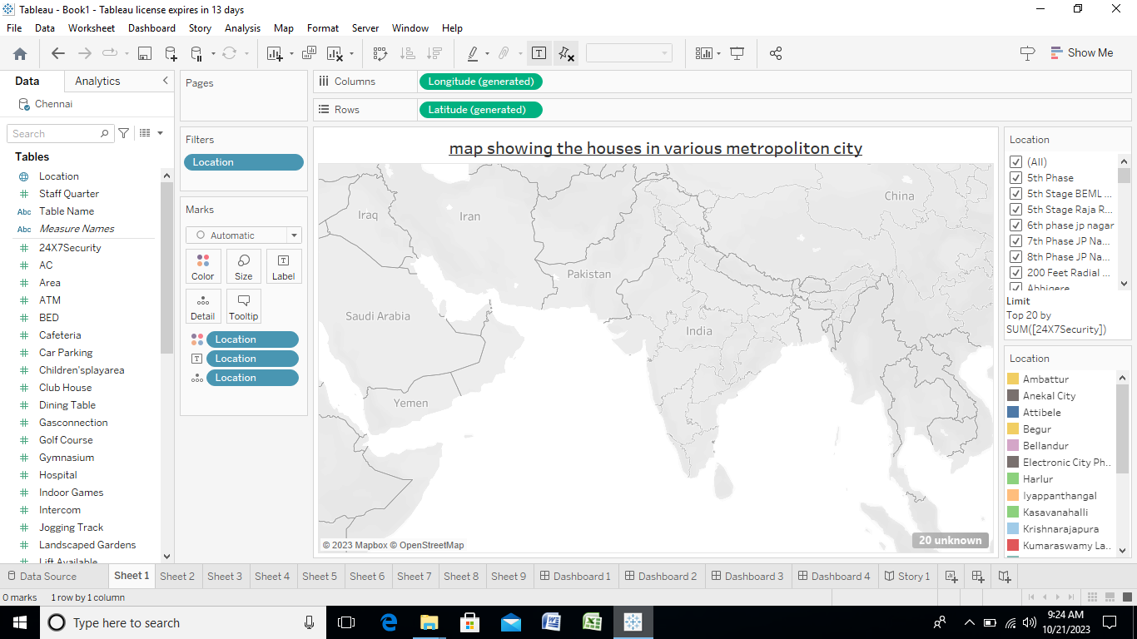

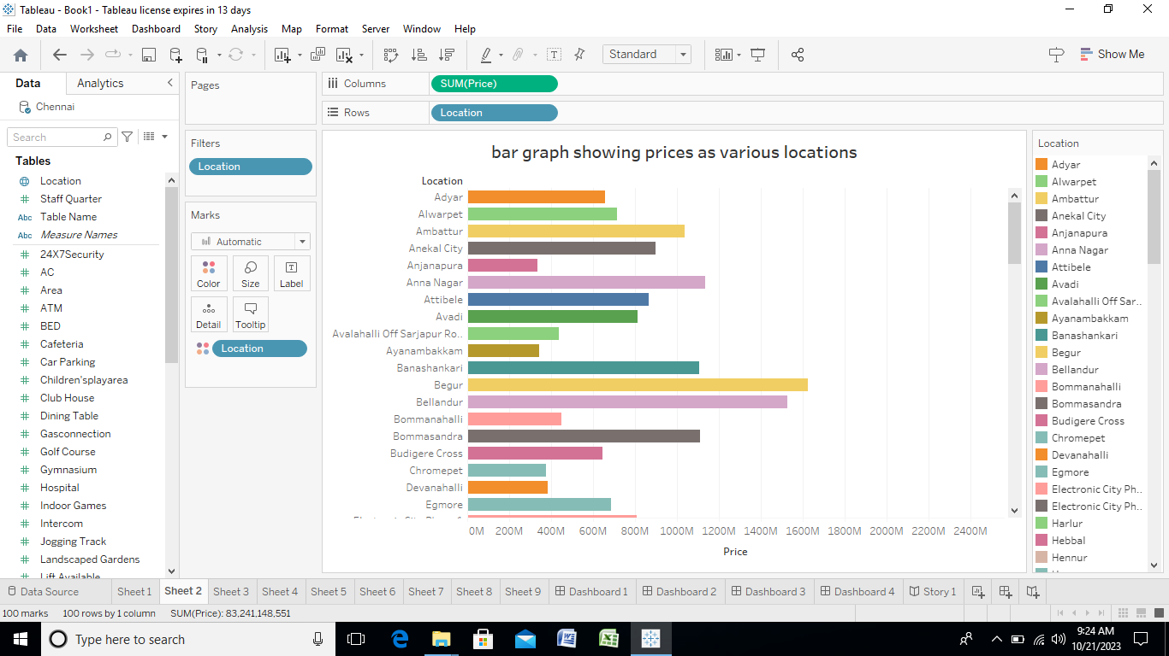

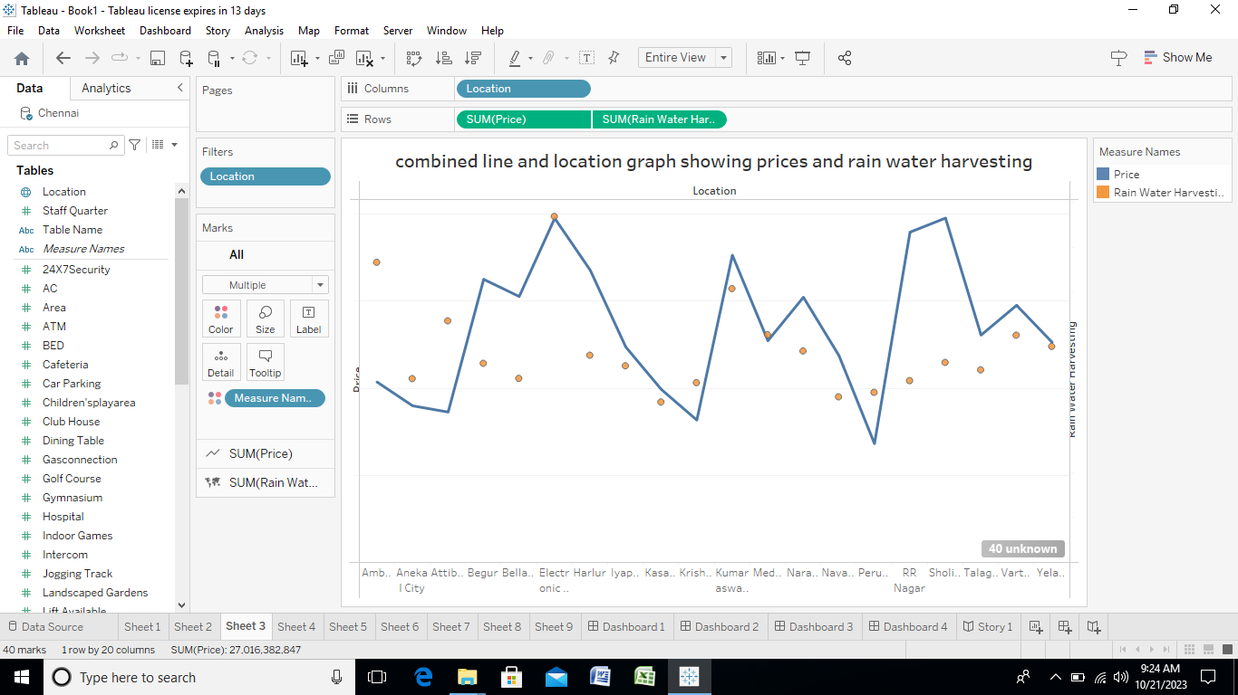

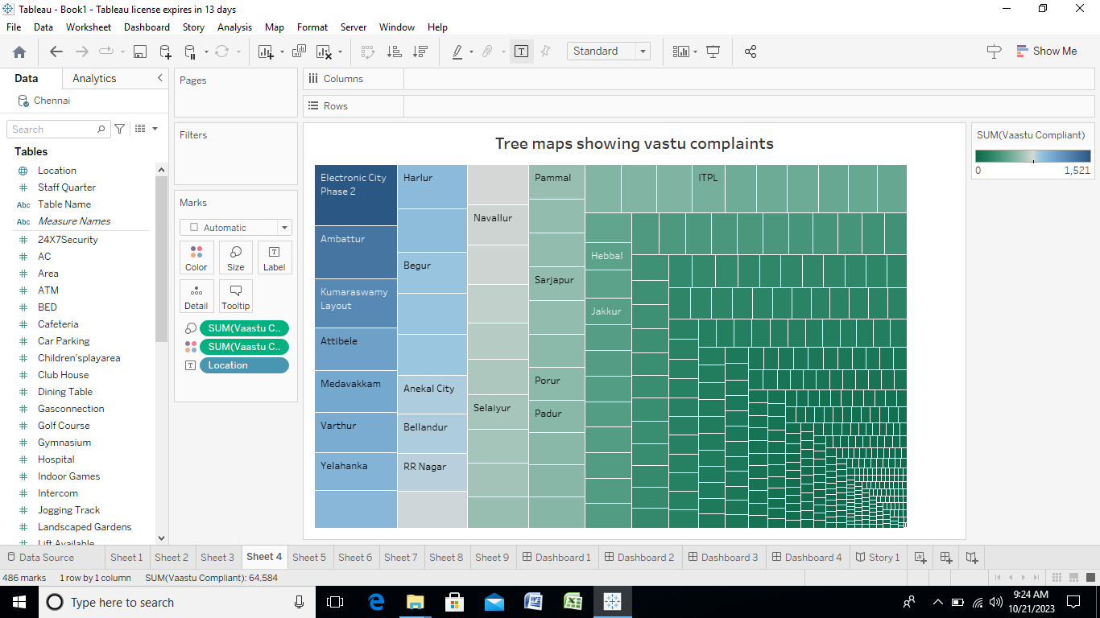

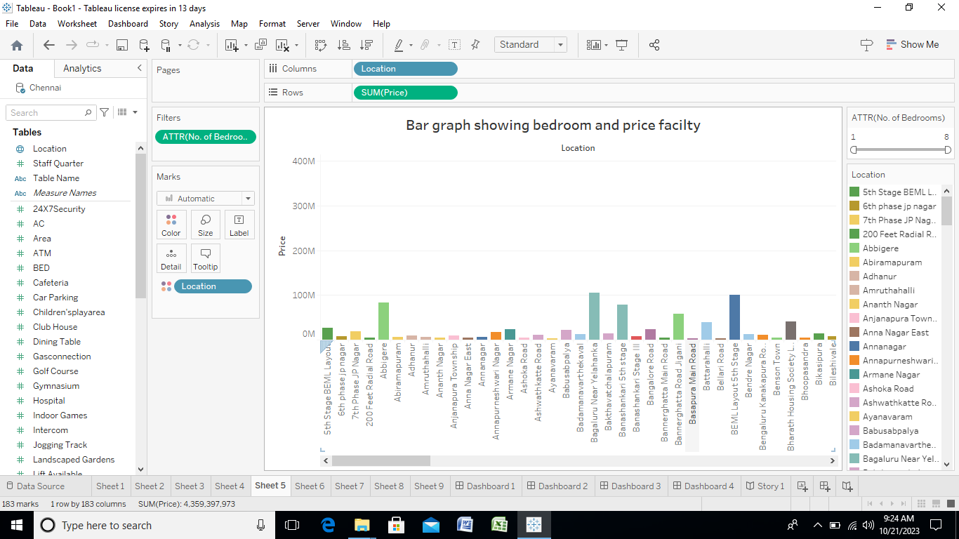

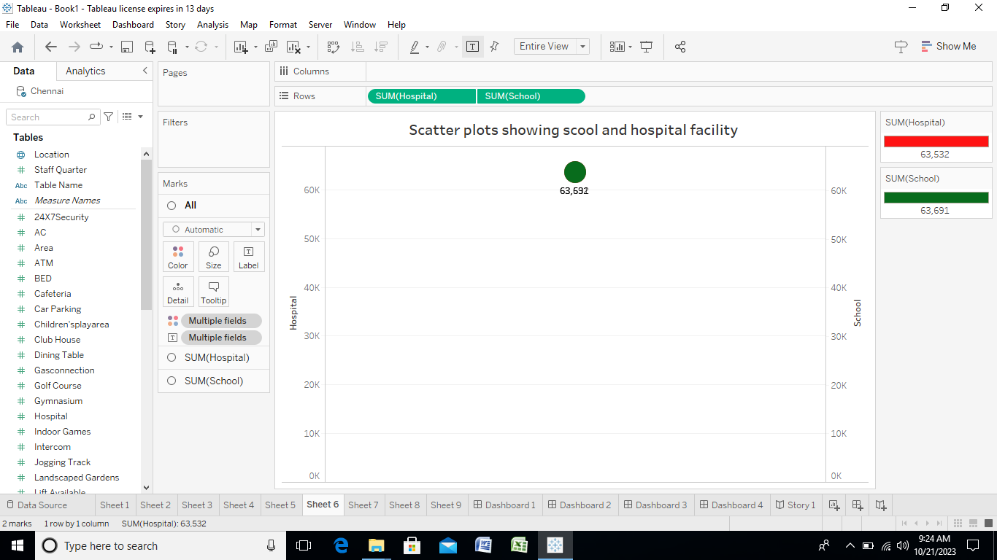

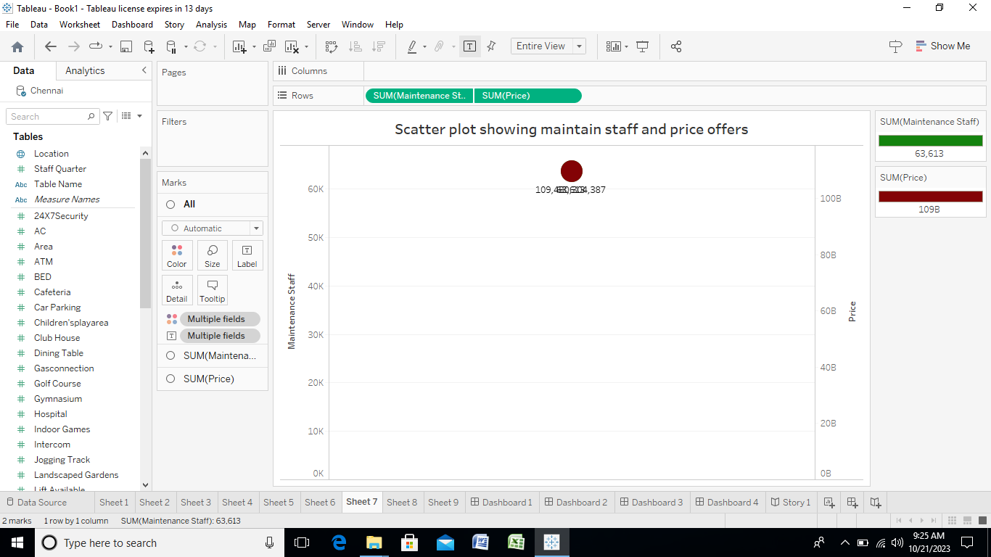

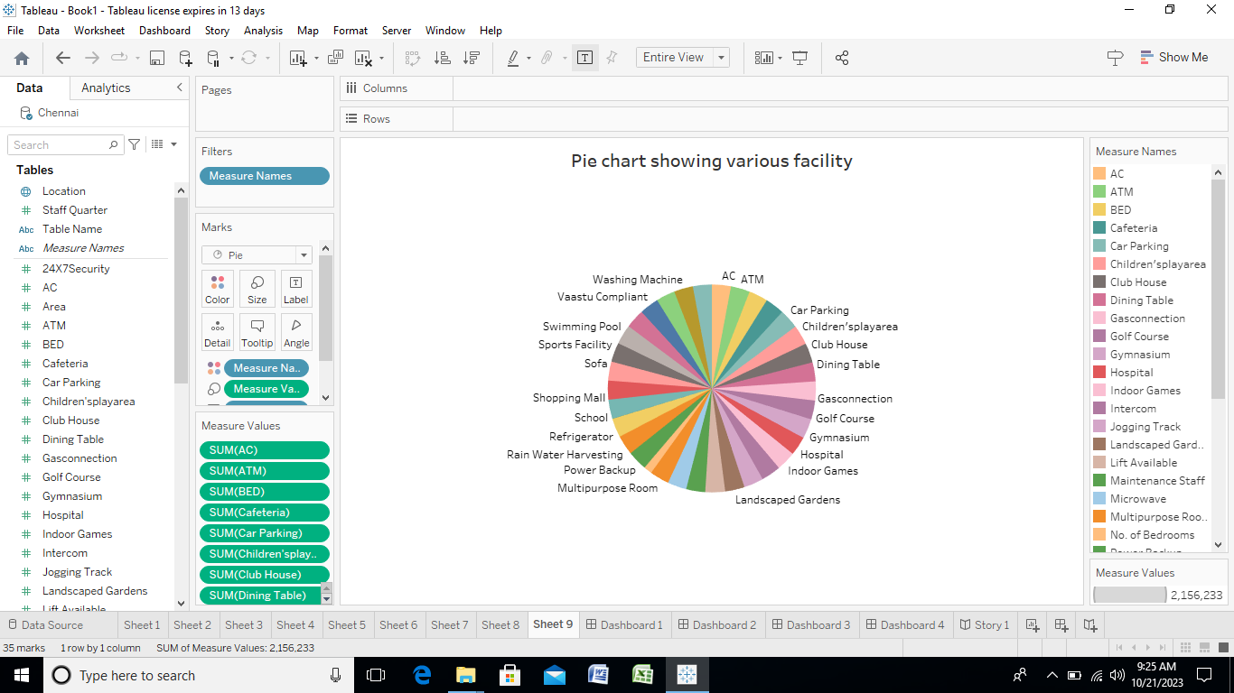

Afterfinishing the analysis data, add a dashboard.In the dashboard we can combine more sheets in single dashboard.The dashboard contains the combine of sheet that we created.

Result:

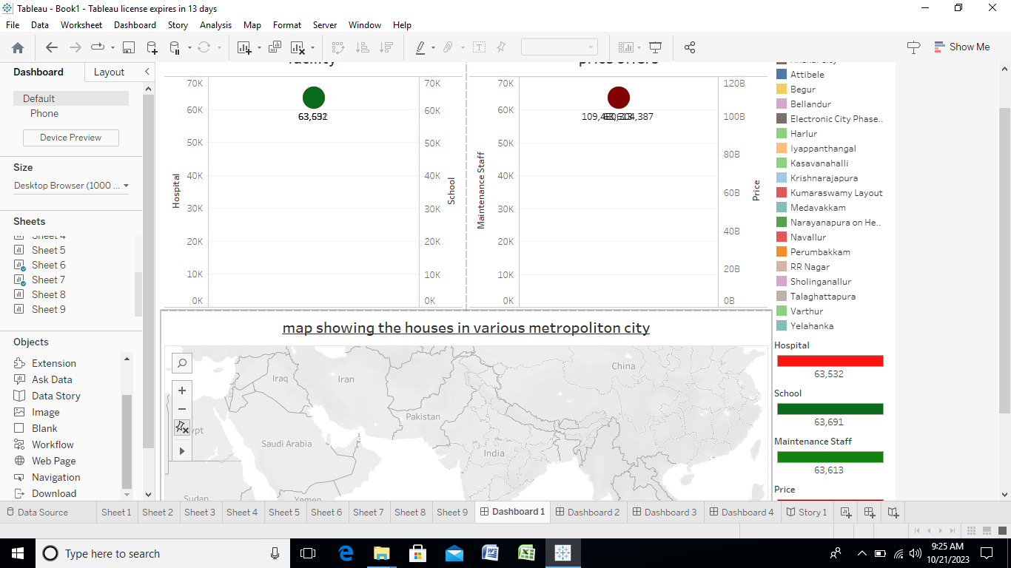

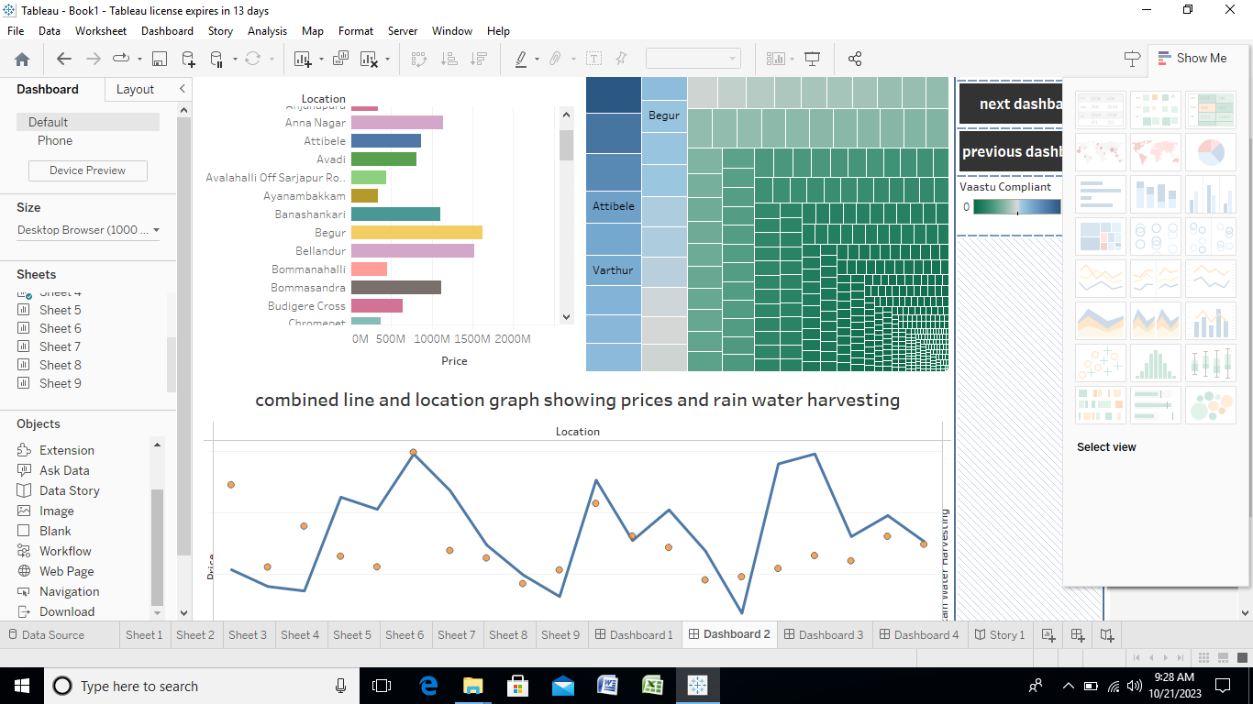

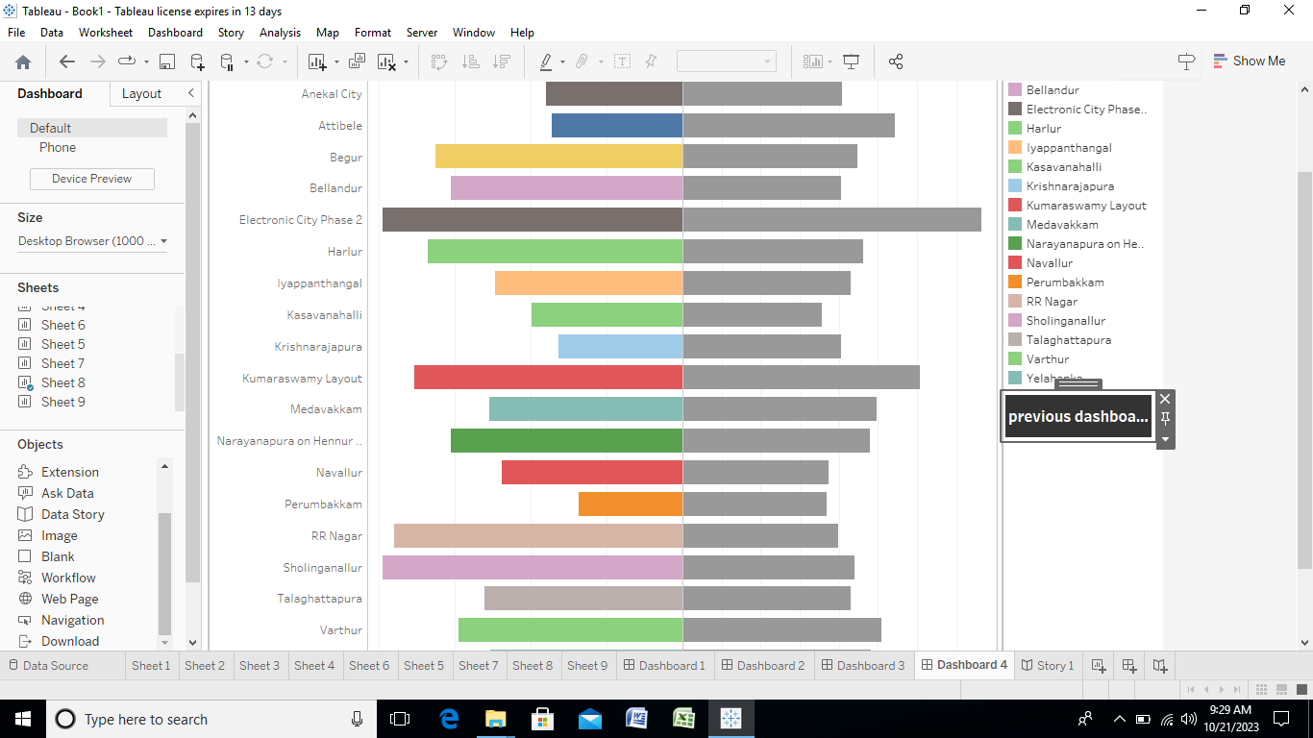

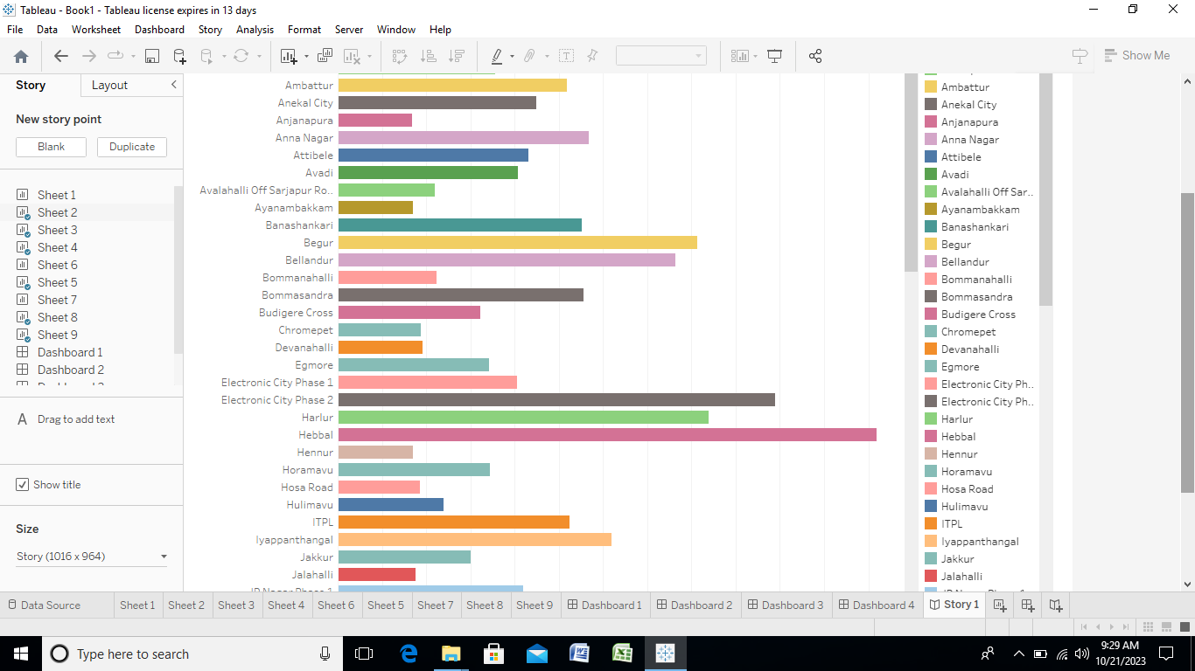

Advantages:

Here are some of the key advantages and disadvantages of house prices in Indian metropolitan areas: Advantages: Appreciation Potential: House prices in metropolitan areas often have a higher potential for long-term appreciation due to population growth, economic development, and urbanization.

Disadvantages:

It doesn't predict future prices of the houses mentioned by the customer. Due to this, the risk in investment in an apartment or an area increases considerably. To minimize this error, customers tend to hire an agent which again increases the cost of the process.

Applications:

This visualizing and analyzing is very easier to analyses the

data of the air transportation network and it helps in making business decision.

Conclusion:

The tableau desktop is very useful to analyses the large number of data

in one screen. We have learn how to analyses the data, how visualizing the

data and how to create a dashboard and story.Our project is unlocking insight into the global air transportation network and has more 10 sheets, 2 dashboards and 1 story.

Future scope:

The upcoming housing market in 2023 will be a sellers' market. It is anticipated that the prices of the housing market will rise for some time due to the growing demand for houses coupled with limited supply. Generation Y will be initiating real estate investments for the first time this year.

Thank you!