Hello,

This is a test Proof of Concept. The given name in the form is Zinia Faisal and the address is Shyamoli, Dhaka. Other things are to be added later.

Have a nice day!

Regards,

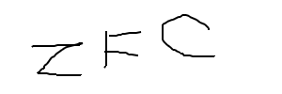

_____________

Signature