CprE 381 – Computer Organization and

Assembly-Level Programming

Proj-B Report

Lab Partners _______Abhilash Tripathy_________

_________Abir Mojumder__________

Section / Lab Time _________________________

Submit a typeset pdf version of this on Canvas by the due date. Refer to the highlighted language in the Proj-B instructions for the context of the following questions.

- [Part 0] How are instruction and data memory initialized in the simulation? How does MARS interface with ModelSim?

- [Part 0] In the MIPS skeleton VHDL, how is a halting / termination condition detected? What MIPS assembly instruction does this correspond to?

- [Part 1 (a)] Modify the provided spreadsheet to include the list of M instructions to be supported in this phase alongside their binary Instruction OPcodes and Funct fields, if applicable. Create a separate column for each binary bit. Inside this spreadsheet, create a new column for the N control signals needed in your single-cycle processor implementation. The end result should be an M*N table where each row corresponds to the output of the control logic module for a given instruction. [You can attach the spreadsheet as a separate file, with a single spreadsheet for all Phase I and Phase II instructions.]

- [Part 1 (b)] Implement the control logic module using whatever method and coding style you prefer. Create a testbench to test this module individually, and show that your output matches the expected control signals from part 1a). [Please include waveforms and explanations.]

The Opcode and Funct are in the following sequence:
Addi,add,addiu,addu,and,andi,lui,lw,nor,xor,xori,or,ori,slt,slti,sltiu,sltu,sll,srl,sra,sllv,srlv,srav,sw,sub,subu.

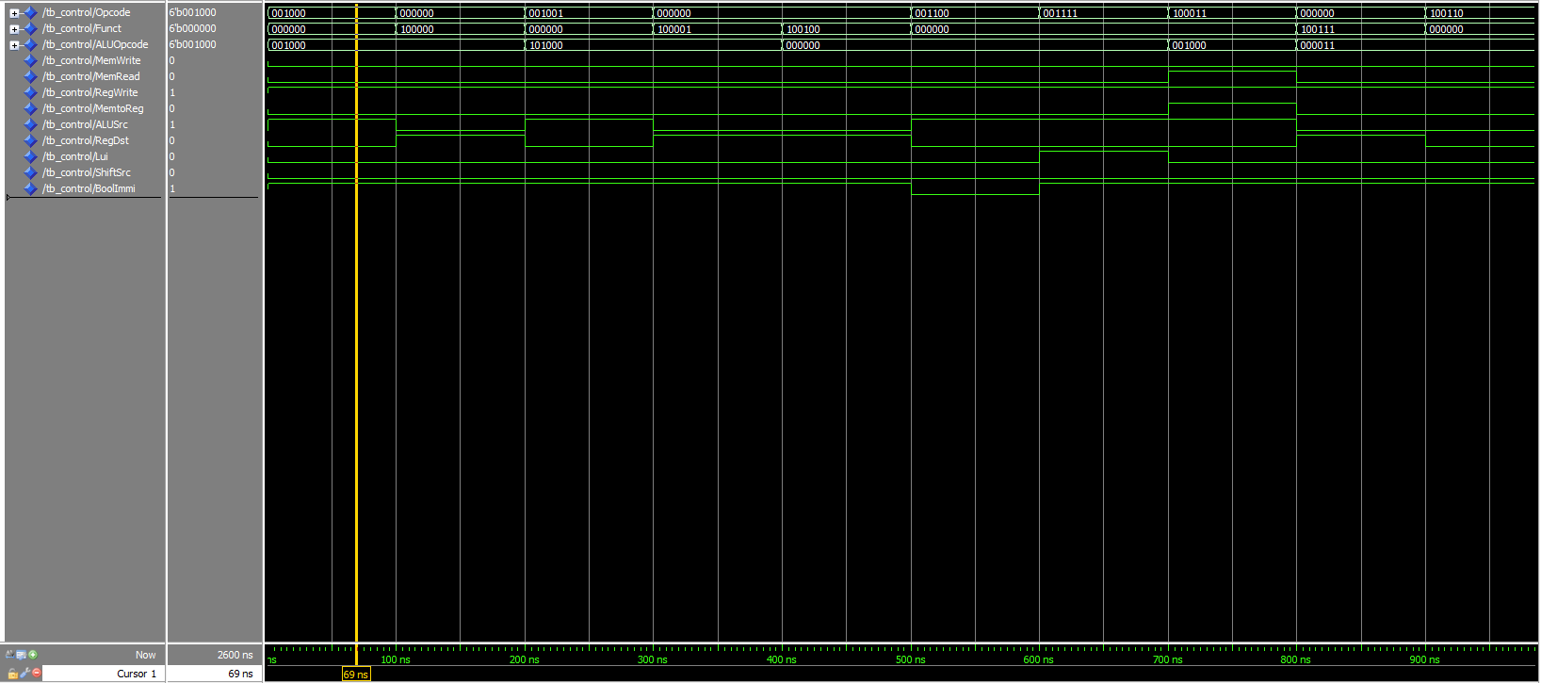

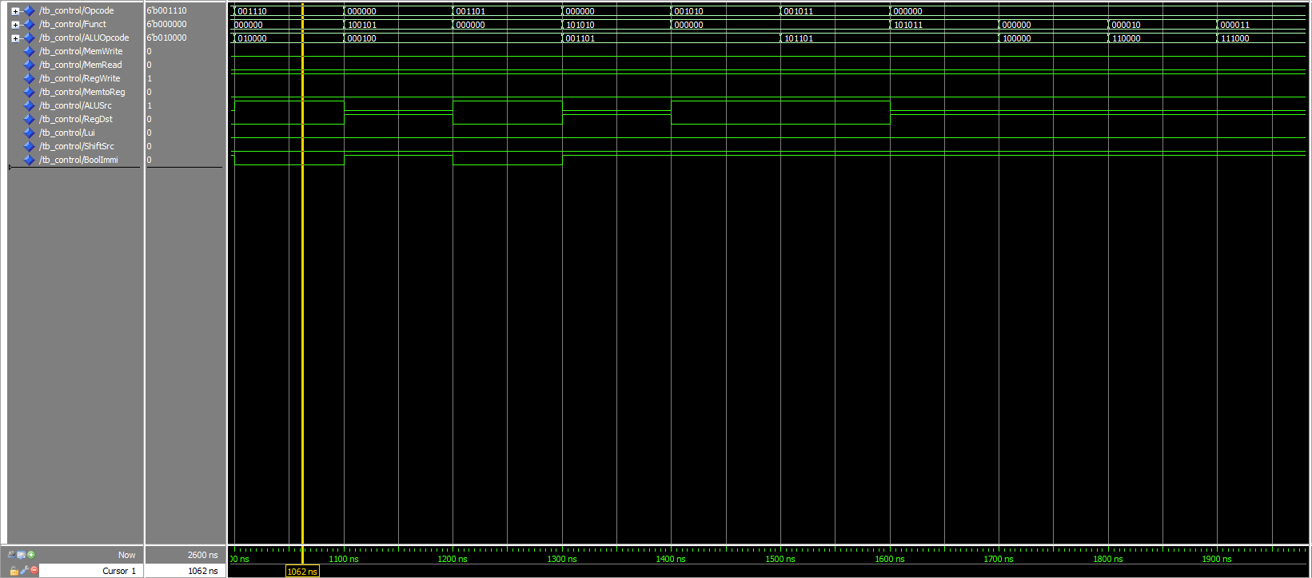

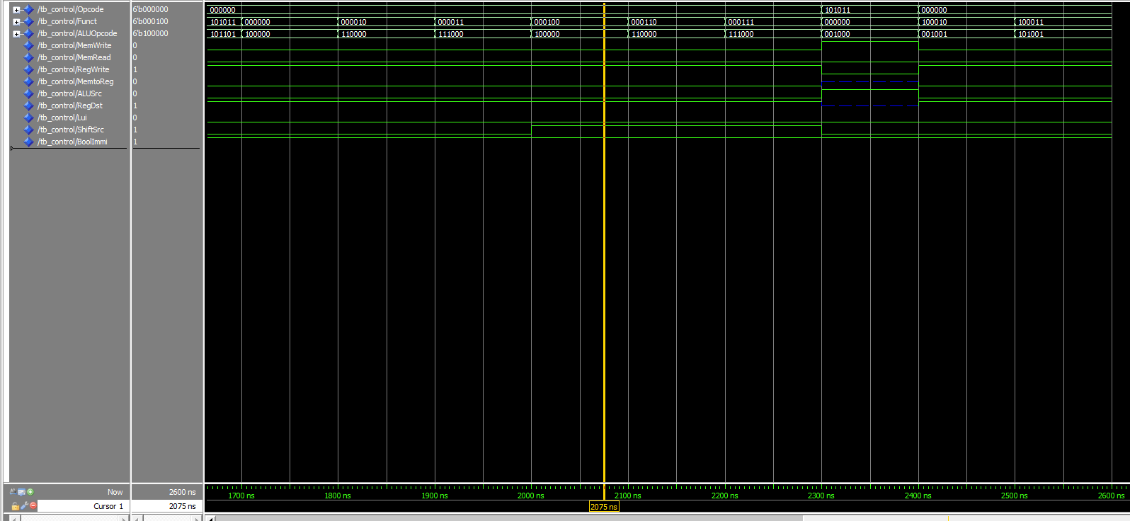

Aside from the known control signals from textbook specifications, there are 3 new controls for phase 1; Lui, ShiftSrc, and BoolImmi. The Lui control is set to 1 when the lui instruction executes, this is used so that a separate 16 bit left shifter can be used as write input to the register file.

ShiftSrc is used to choose sll and sllv type shift amount for the ALU. When this control is 0, the Instruction’s [10-6] bits are used for shiftamt and when set to 1 (for v-type shifts) which takes lower 5 bits of Register file read data 1 as the shiftamt.

BoolImmi is Set to 1 for all instructions except for immediate Boolean types (andi, ori, xori). This control signal is connected to the sign input of 16-bit immidiate extender. When 0 it does a zero extension, when 1 it will do a sign extension.

- [Part 2] In your writeup, provide your schematic for this part, describe what challenges (if any) you faced in implementing this module.

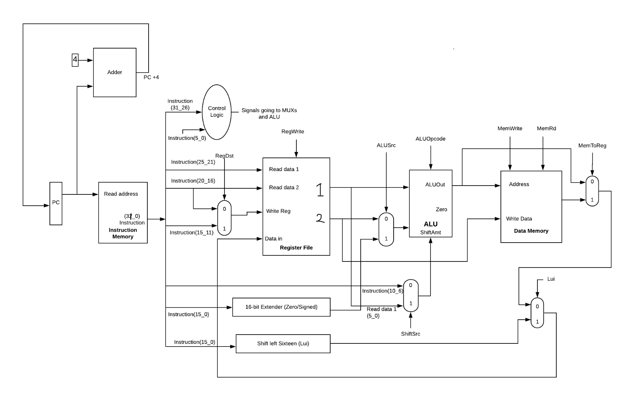

- [Part 4 (a)] Describe these possibilities as a function of the different control flow-related instructions.

- [Part 4 (c)] Update your processor schematic for the instruction fetch logic and any other datapath modifications needed for control flow instructions. In your writeup, describe what additional control signals are needed.

The control flow needs to support the beq, bne, jump, jump and link, and jump register instructions. When these instructions execute, the PC updates differently. When Beq or Bne is called, a sign extended immediate value gets shifted left by 2 bits, and gets added to PC + 4, this added value is the new PC.

For Jump and Link, we need to be able to write to register 31, in addition to taking 26 lower bits of the instruction, shift left by 2 bits, this new 28bit value is concatenated to the upper 4 bits of PC + 4 value, to form a new 32 bit value that gets written to the PC register. This is common for both Jump and Jal. However, for Jump Register, we read the PC value from one of the registers from our register file (Port: Read data 1), this is then written to the PC register

The extra controls for phase 2 we need are: Beq, Bne, Jump and JumpType. The JumpType control chooses the source for the new PC value (the Jal/J and JR instruction); when it is set to 1, it reads from Register file : read data 1 and writes to PC.

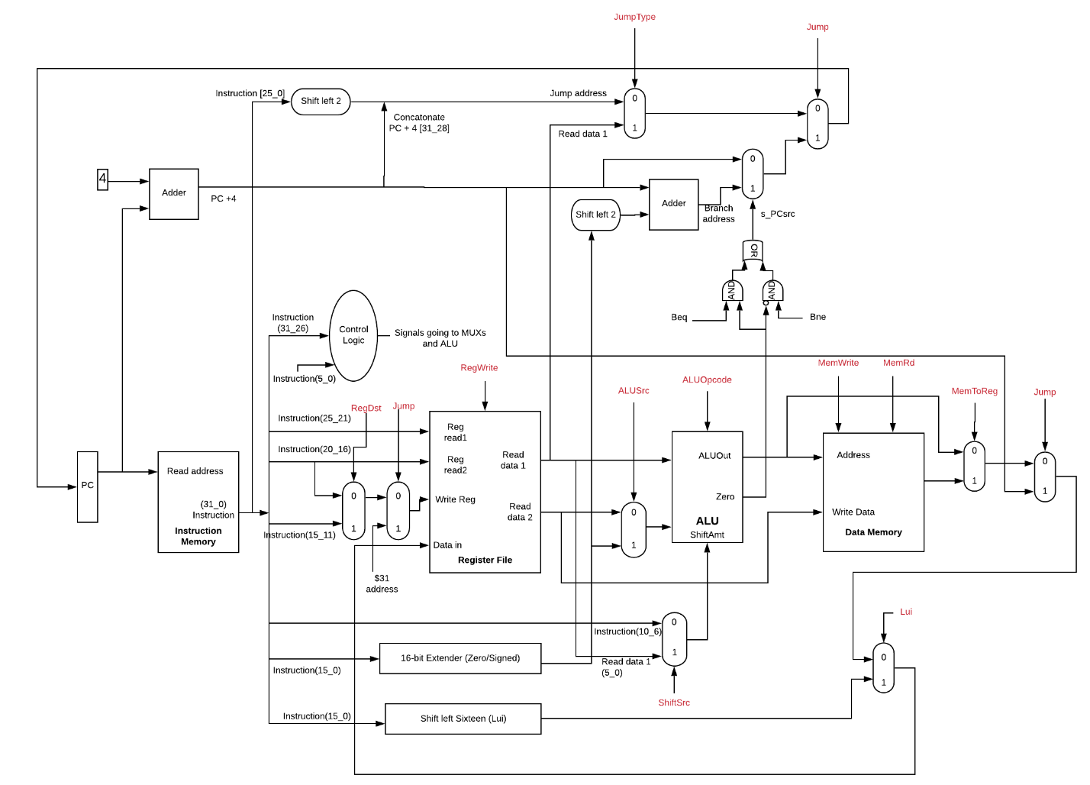

- [Part 4 (d)] Include ModelSim waveforms, and describe how the execution of the control flow possibilities corresponds to the waveforms in your writeup.
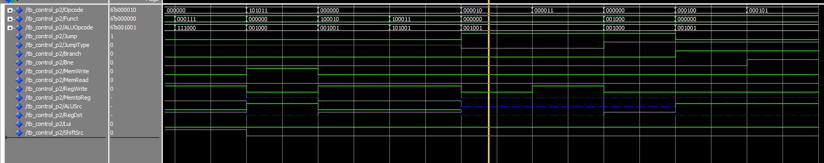

- [Part 5 (a)] In your writeup, show the ModelSim output for the individual instruction tests, and provide a discussion of result correctness. It may be helpful to also annotate the waveforms directly.

- [Part 5 (b)] In your writeup, show the ModelSim output for the Bubblesort test, and provide a discussion of result correctness. It may be helpful to also annotate the waveforms directly.
Loading of values in temporary registers starts at cycle 3
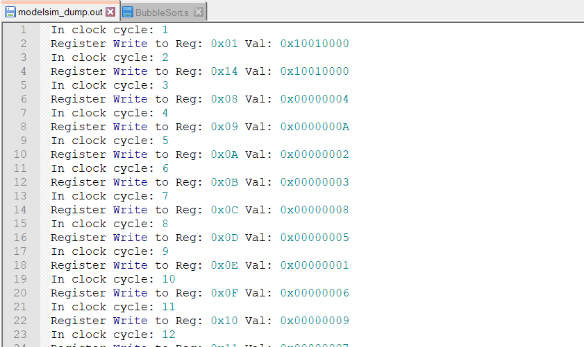

Loading of values at cycle 486 after all elements have been sorted
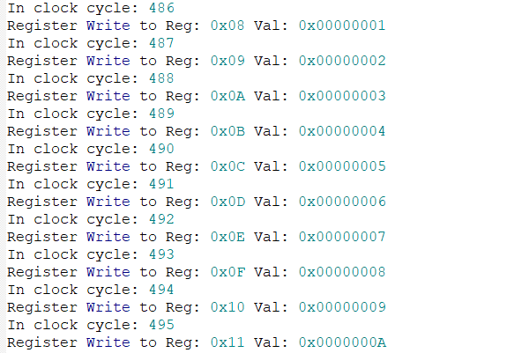

Unsorted: Register 8 through 17 contains all elements of the unsorted array
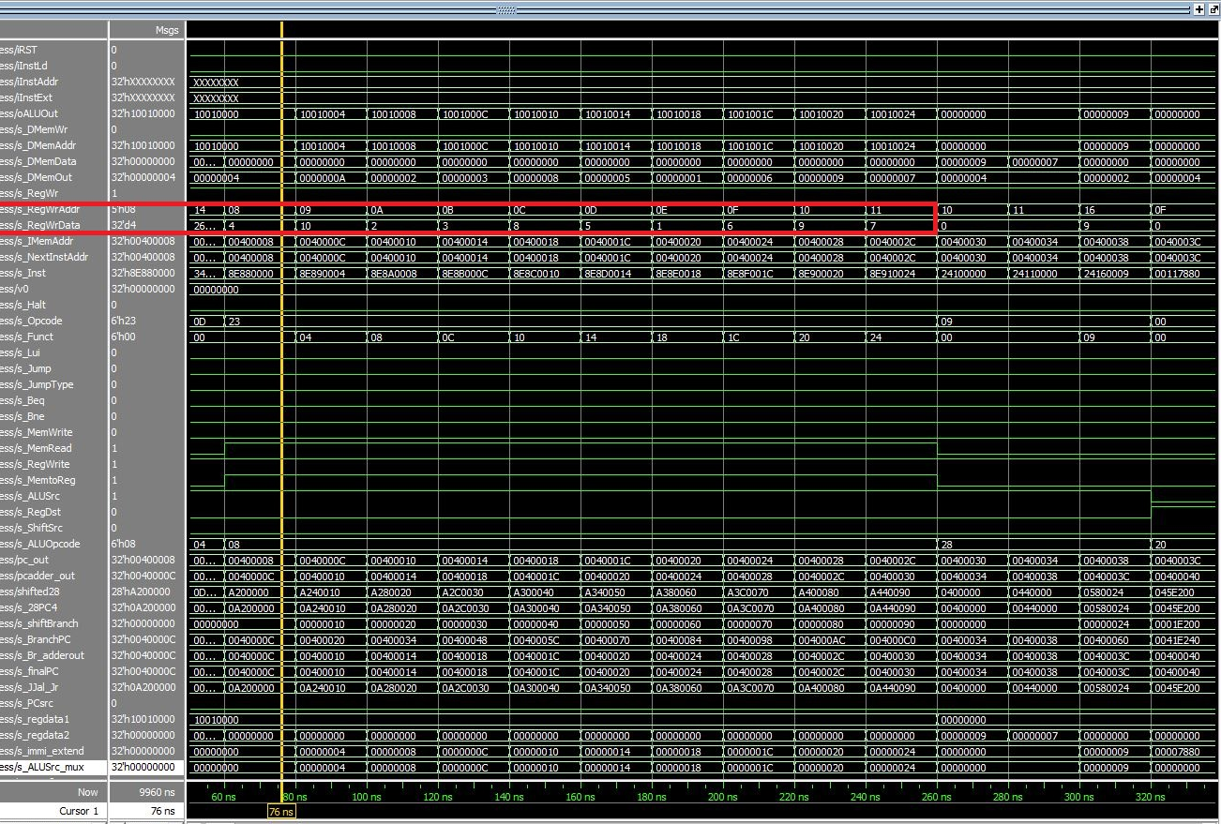

We can see i and j counters are being initialized to 0 and register 16 is being initialized (size-1)
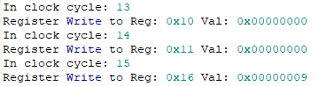

If we go to the respective cycles in the waveform (13, 14, 15), we see that these values have been initialized properly
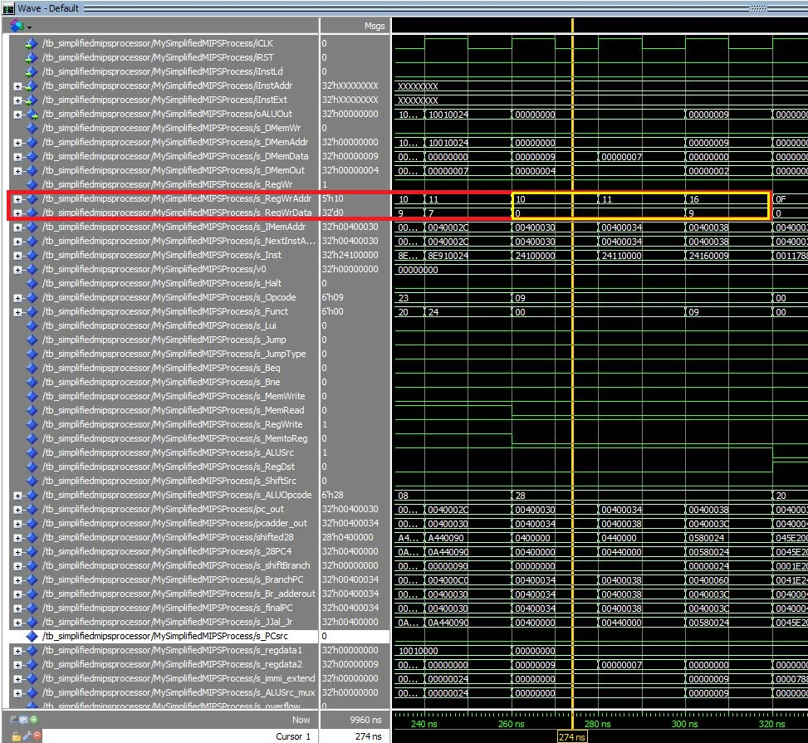

Below we can see how the comparison happens in the waveform
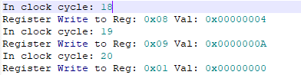

So we can see that in cycles 18, 19, and 20 the registers are being compared.
Since the value in register
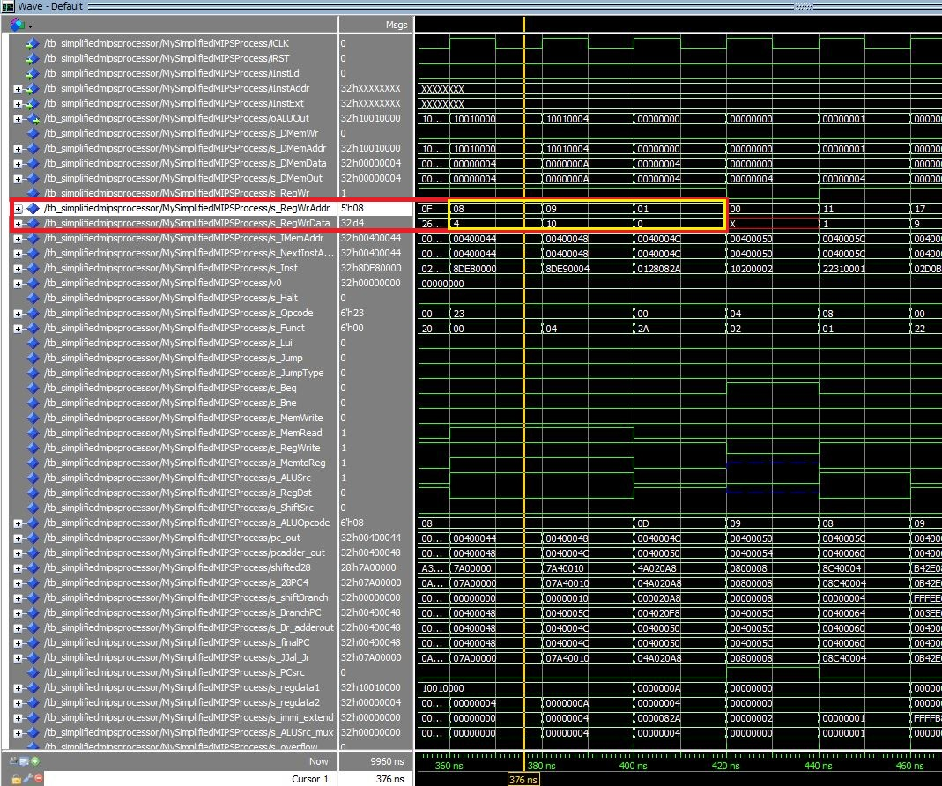

Sorted: Register 8 through 17 store the sorted elements in order
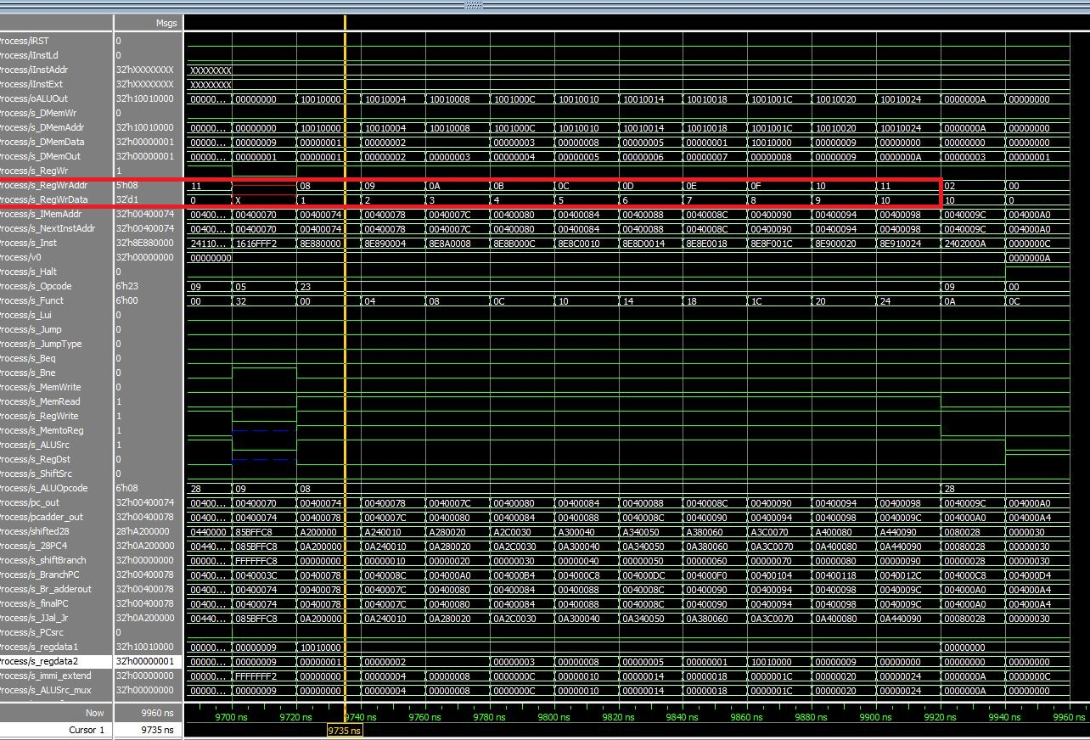

- [Part 5 (c) BONUS] In your writeup, show the ModelSim output for the Mergesort test, and provide a discussion of result correctness. It may be helpful to also annotate the waveforms directly.

- [Part 7] Report the maximum frequency your processor can run at and determine what your critical path is. Draw this critical path on top of your top-level schematic. In your writeup, briefly discuss your critical path results. What components would you focus on to improve the frequency?
Maximum frequency: 26.37mhz
The highlighted path in our processor below represents the critical datapath:
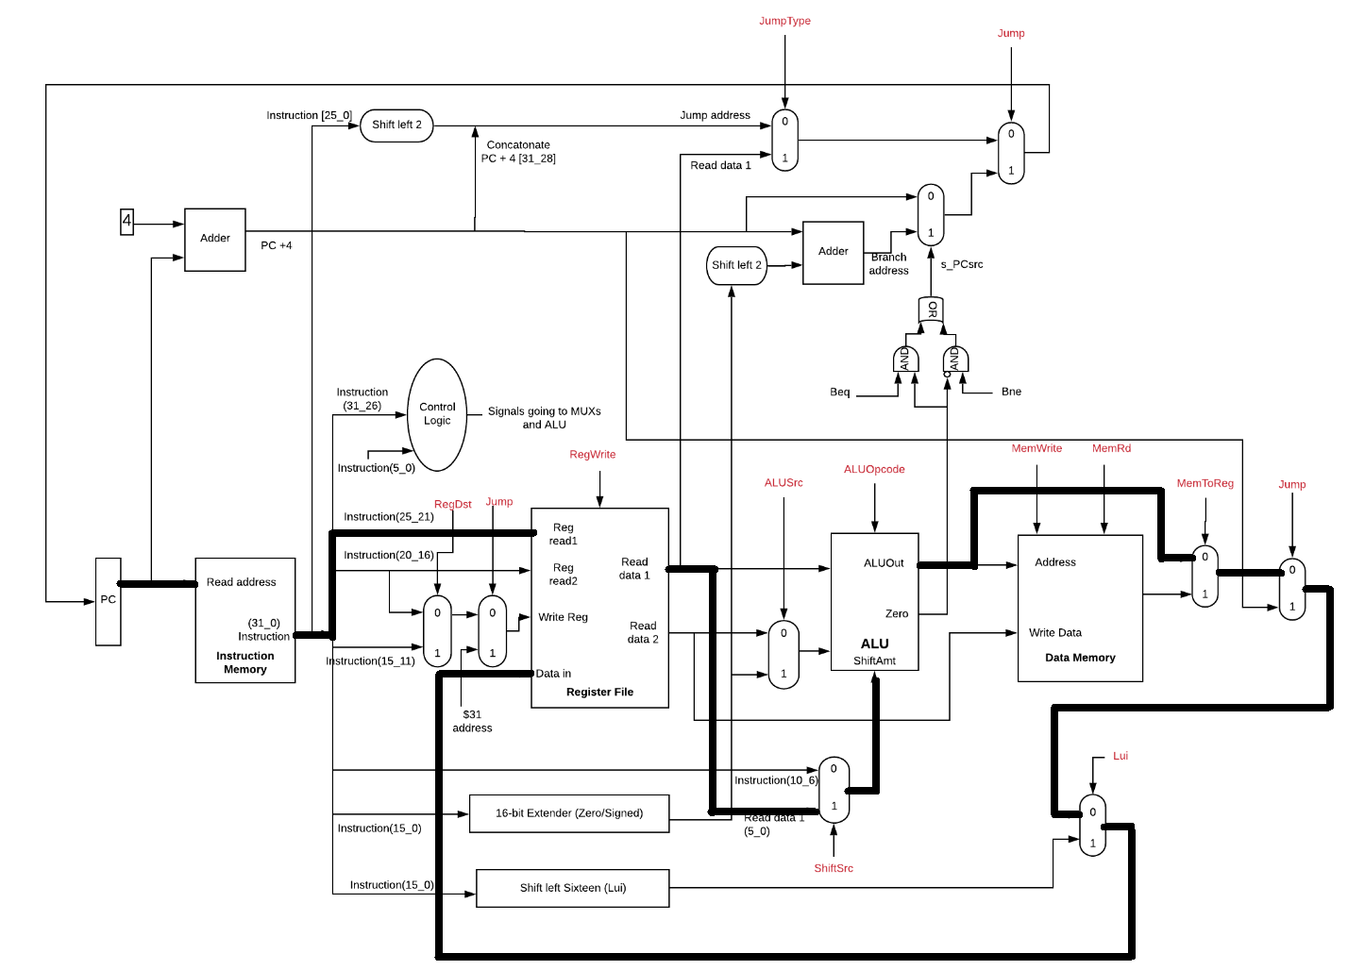
Our original datapath according to the timing.txt file includes both parts of shifting and loading. However, this is because the synthesis does not recognize that bot shifting and memory components will never be used at the same time. Therefore, based on our theoretical knowledge we can conclude that the critical datapath is of load word instruction since the path accesses the memory module as well and also writes the value back to the registers.
To improve our efficiency, we must focus on or shifting component since it seems to take a lot of processing time

- [Feedback] You must complete this section for your lab to be graded. Please complete each column separately for each team member; I expect it to take roughly 10 minutes (do not take more than 20 minutes).

  - How many hours did you spend on this lab?

Task | During lab time |  | Outside of lab time
Team Initials | A.T | A.M | A.T. | A.M.
Reading lab | 40 mins | 50 mins | 1 hour | 1 hour
Pencil/paper design | 30 mins | 30 mins | 3 hour | 2 hour
VHDL design |  |  | 2 hour | 4 hour
Assembly coding |  |  | 3 hours | 1 hour
Simulation |  |  | 7 hours | 11 hours
Debugging |  |  | 6 hours | 5 hour
Report writing |  |  | 1 hour | 1 hour
Other:
Total | 1 hour 10 mins | 1 hour 20 mins | 23 hours | 25 hours

  - If you could change one thing about the lab experience, what would it be? Why?
Make more resources available.

  - What was the most interesting part of the lab?
Mars simulation

