CprE 381 – Computer Organization and

Assembly-Level Programming

Proj-C Report

Lab Partners _____Abhilash Tripathy ____

________Abir Mojumder____

Section / Lab Time ___________5______________

Submit a typeset pdf version of this on Canvas by the due date. Refer to the highlighted language in the Proj-C instructions for the context of the following questions.

- [Part 0] Come up with a global list of the datapath values and control signals that are required during each pipeline stage.

- [Part 1 (a)] Draw a simple schematic showing how you could implement stalling and flushing operations given an ideal N-bit register.

- [Part 1 (b)] Show that values that are stored in the initial IF/ID register are available as expected four cycles later, and that new values can be inserted into the pipeline every single cycle. [Please include waveforms and explanations.]

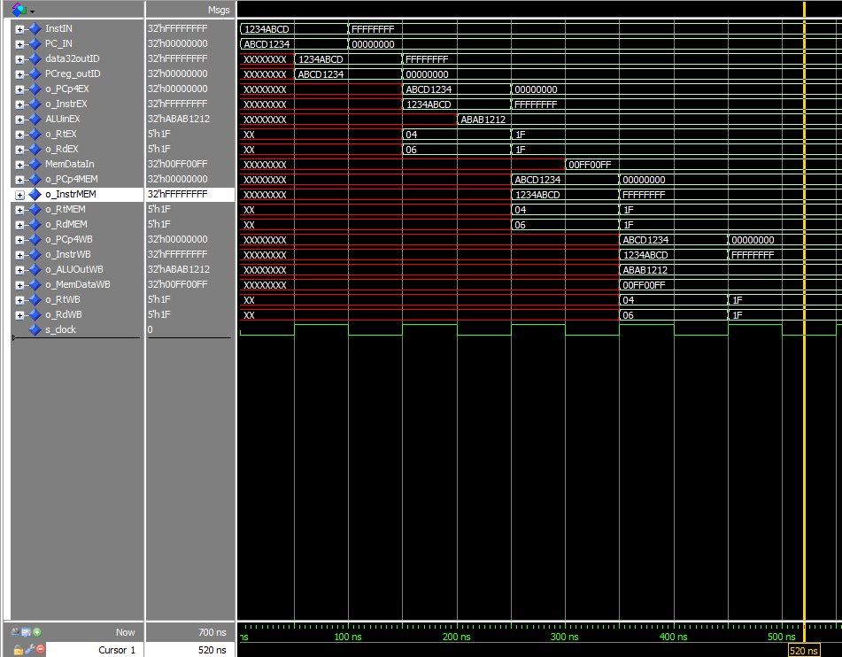

We can see the instruction and PC value propagating, and after 4 cycles it is visible in the write back stage (o_InstrWB). A second instruction is fed in cycle 2 and we can see that propagating too. Rt and Rd values also move stage to stage after each cycle. (other signals are hidden to avoid clutter)

- [Part 2] In your writeup, provide your schematic for this part, describe what challenges (if any) you faced in implementing this module.

- [Part 3 (a)] In your writeup, show the ModelSim output for the individual instruction tests, and provide a discussion of result correctness. It may be helpful to also annotate the waveforms directly.

- [Part 3 (b)] In your writeup, show the ModelSim output for the modified Bubblesort test, and provide a discussion of result correctness. It may be helpful to also annotate the waveforms directly.

- [Part 4] Report the maximum frequency your software-scheduled pipelined processor can run at and determine what your critical path is (specify each module/entity/component that this path goes through).

- [Part 5 (a)] Of the MIPS instructions supported for Project Part B, list which instructions produce values, and what signals in the pipeline these correspond to.

Produces: Addi, add, addiu, addu, and, andi, xor, xori, or, ori, slt, slti, sltiu, sltu, sll, srl, sra, sllv, srlv, srav, subu, jal, lui

- [Part 5 (b)] List which of these same instructions consume values, and what signals in the pipeline these correspond to.
Addi, add, addiu, addu, and, andi, xor, xori, or, ori, slt, slti, sltiu, sltu, sll, srl, sra, sllv, srlv, srav, subu, jal
(all the instructions that produce values in question h consume values from either rs or rt, except for lui)

- [Part 5 (c)] Come up with a generalized list of potential data dependencies. From this generalized list, select those dependencies that will require forwarding (write down the corresponding pipeline stages that will be forwarding and receiving the data), and those dependencies that will require hazard stalls.

- [Part 6] Write a more generalized series of data forwarding and hazard detection logic equations based on the result from part 5).

For forwarding unit, we consider the three conditions of regWrite signals from the different phases (MEM and WB).
We check if:
(MEM_regWr='1') and (WB_regWr='0')
(MEM_regWr='0') and (WB_regWr='1')
(MEM_regWr='1') and (WB_regWr='1')

In the first condition, we only forward MEM stage’s value (i.e. if the register address matches).
In the second condition, we only forward WB stage’s value (i.e. if the register address matches).
In the third condition, we only forward MEM stage’s value since MEM will hold the newer instruction (if the register address matches).

Here EX_rs holds the register address value of rs
MEM_regWr holds the regWrite signal of the MEM phase
WB_regWr holds the regWrite signal of the WB phase
in_MEMregAddr holds final destination register address of the MEM phase
in_WBregAddr holds final destination register address of the WB phase
if (MEM_regWr='1') and (WB_regWr='0') then
if(in_MEMregAddr=EX_rs) then forward the final value of the matching register in the MEM phase to EX stage
if(in_MEMregAddr=ID_rs) then forward the final value of the matching register in the MEM phase to ID stage

elsif (MEM_regWr='0') and (WB_regWr='1') then
if (in_WBregAddr=EX_rs) then forward the final value from the WB phase to EX stage
if (in_WBregAddr=ID_rs) then forward the final value from the WB phase to ID stage

elsif (MEM_regWr='1') and (WB_regWr='1') then
if (in_MEMregAddr=EX_rs) and (in_WBregAddr/=EX_rs) then forward MEM stage value to EX stage
elsif (in_MEMregAddr/=EX_rs) and (in_WBregAddr=EX_rs) then forward MEM stage value to WB stage
elsif (in_MEMregAddr=EX_rs) and (in_WBregAddr=EX_rs)
then forward MEM stage value to EX stage since MEM stage holds the carries instruction
else fwd_EX_A<="00";
{similar logic used for registers from ID stage as well when both regWrite signals are high}

{similarly, the same logic is used for ‘rt’ registers from EX and ID stages to check if forwarding is required}

Inputs the hazard detection accepts,
in_EXregAddr : register address of the final destination register in the EX phase
EX_memRead : signal to detect if the EX stage is a load instruction
in_ID_rs : register address of the rs register in the ID phase
in_ID_rt register address of the rt register in the ID phase
in_PCsrc : signal that denotes whether branch is happening (‘1’ if there is branch happening, ‘0’ if not)
in_Jump: signal that denotes whether jump is happening (‘1’ if there is jump happening, ‘0’ if not)
IDEX_flush : output signal to denote whether to flush ID/EX pipeline or not
IDEX_stall : output signal to denote whether to stall ID/EX pipeline or not
IFID_flush : output signal to denote whether to flush IF/ID pipeline or not
IFID_stall : output signal to denote whether to stall IF/ID pipeline or not
PC_stall : output signal to denote whether to stall the PC register or not

if (EX_memRead='1') and ((in_EXregAddr=in_ID_rs) or (in_EXregAddr=in_ID_rt)) then
IFID_flush ='0'
IFID_stall ='1'
IDEX_flush ='1'
IDEX_stall ='0'
PC_stall ='1'

elsif (in_PCsrc ='1') or (in_Jump ='1') then
IFID_flush='1'
IFID_stall ='0'
IDEX_flush ='0'
IDEX_stall ='0'
PC_stall ='0'
else
IFID_flush ='0'
IFID_stall ='0'
IDEX_flush ='0'
IDEX_stall ='0'
PC_stall ='0'
Every time there is a data hazard in which the value of the previous instruction is most updated value(for eg: there is a lw instruction and the value has not been written to the register for the next instruction to use), the process statement will enter the first if condition and set its output signals accordingly.
If there is hazard because of the branch instruction, the process statement will enter the elsif condition and set its output signals accordingly.
If there is hazard caused because of lw and the subsequent instruction is the branch instruction, the process statement prioritize the lw hazard and will enter the first condition and set its output signals accordingly. As soon as this lw hazard is no longer there, the branch instruction will follow though (since the IF/ID and PC were stalled) and flush the IF/ID to delete nullify the unwanted instruction.

- [Part 7] Provide a high-level schematic drawing of the interconnection between components for the MIPS Hardware-scheduled pipelined Processor.

- [Part 8 (a)] In your writeup, show the ModelSim output for the individual instruction tests and Bubblesort test (the original from Project Part B), and provide a discussion of result correctness. It may be helpful to also annotate the waveforms directly.

- [Part 8 (b)] In your writeup, show the ModelSim output an application that attempts to exhaustively test the forwarding and detection logic in your pipeline, and provide a discussion of result correctness. It may be helpful to also annotate the waveforms directly.

- [Part 10] Report the maximum frequency your processor can run at and determine what your critical path is. Draw this critical path on top of your top-level schematic. In your writeup, briefly discuss your critical path results. What components would you focus on to improve the frequency?

- [Feedback] You must complete this section for your lab to be graded. Please complete each column separately for each team member; I expect it to take roughly 10 minutes (do not take more than 20 minutes).

  - How many hours did you spend on this lab?

Task | During lab time |  | Outside of lab time
Team Initials | - T. | A.M. | A. T. | A.M
Reading lab | 2 hours | 1 hour | 3 hours | 3 hours
Pencil/paper design |  |  | 6 hours | 6 hours
VHDL design |  |  | 10 hours | 10 hours
Assembly coding |  |  | 4 hours | 4 hours
Simulation |  |  | 6 hours | 6 hours
Debugging |  |  | 7 hours | 7 hours
Report writing |  |  | 3 hours | 3 hours
Other:
Total | 2 hours | 1 hour | 39 hours | 39 hours

  - If you could change one thing about the lab experience, what would it be? Why?
Lab is too long, not enough TAs available for feedback

  - What was the most interesting part of the lab?
Building the forwarding unit and pipelining.

