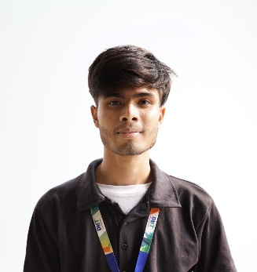
Resume
Of
Abir Ahammed
Present Address : 2A Kalabagan Lake Circus Road, Dhanmondi, Dhaka.
Mobile : 01921123184
Email : abirrohitahmed@gmail.com
Career Goal :
Seeking a challenging position as a Web Developer where I can leverage my developing knowledge and Technical Skills to contribute to the growth and success of a dynamic organization while continuing to enhance my expertise in Web Development.

Academic Qualification :
Secondary School Certificate (S.S.C)
Institute : Uttarda High School
Group : Science
Result : GPA – 4.89 (Out Of 5)
Board : Cumilla
Passing Year : 2020
Higher Secondary Certificate (H.S.C)
Institute : Civil Aviation School & College
Group : Science
Result : GPA-4.17 (Out Of 5)
Board : Dhaka
Passing Year : 2022

Computer Skill :
Canva, Microsoft Word, Excel Wordpress etc.
Language Proficiency :
- Bengali : My Mother Tongue (Bangla).
- English : I Have Successfully Writing, Speaking in English.
Personal Interest :
Reading Book & Newspaper, Playing Cricket, Racing Games, Listening Music, Watching Movies And Travelling etc.
Professional Ability
- Ability to Work in a Team & Leadership.
- Fast Learner.
- Intelligent, Hardworker, Jolly Minded & Always Cheerful.
Personal Information
Name : Abir Ahammed
Father’s Name : Iqbal Ahammed
Mother’s Name : Asma Begum
Date Of Birth : 27/06/2004
Nationality : Bangladeshi (By Birth)
BR Number : 20041917252024984
Religion : Islam
Material Status : Unmerried
Blood Group : B+
Gender : Male
Hight :5’6”
Permanent Address : Vill : Pechra, P.O : Dombaria, P.S : Lakshman, Dist : Cumilla
Decleration :
I do hereby declare that all the statement made above is true, correct and complete to the best of knowledge.

Abir Ahammed Date : …………………….

