**Features**  
  
Features are listed below.  **High**, **Medium** and **Low** are used to indicate the importance of each feature.

|  |  |  |  |
| --- | --- | --- | --- |
| Feature ID | Description | Priority | Requester |
| FID01 | Web based and accessible from devices (with internet connection) such as desktop, laptop, mobile and tablet PCs. | High |  |
| FID02 | Only valid and authorized users will have access. | High |  |
| FID03 | Manage staff, sales, order, table and food item: Add, delete, update staff info, food items, items price, equipment’s and ingredients. Approve order, table, . | High |  |
| FID04 | Place order, request for reserve table and payment. | High |  |

**Use Cases**  
  
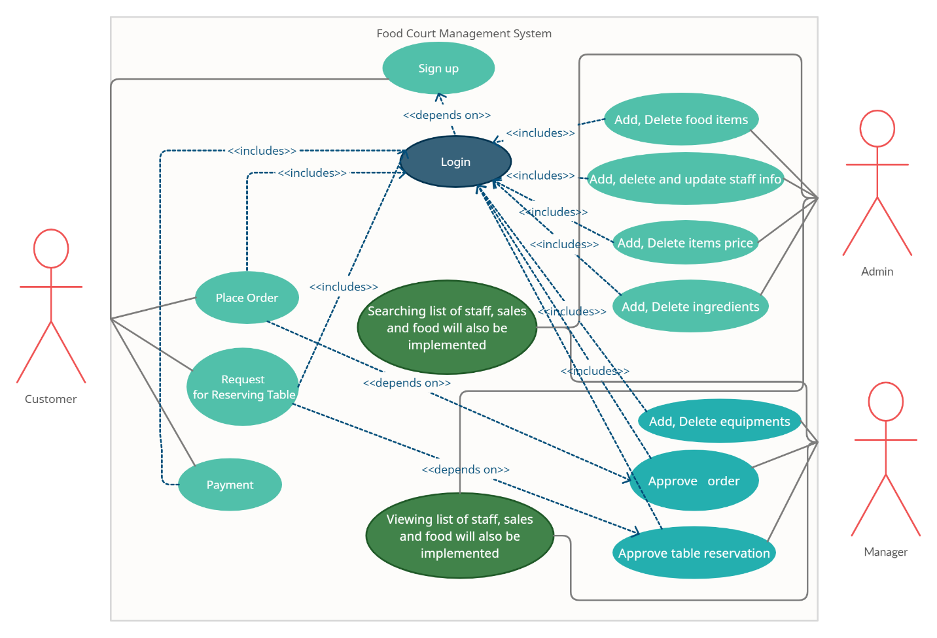

|  |  |
| --- | --- |
| **FID02 - Authentication and validation** | |
| **FID02_UC01** - User authentication | |
| **Brief Description** | The user opens up the application and the application shows the login form for access. |
| **Pre-condition/s** | * User is not logged in already * Already have a valid account |
| **Priority** | High |
| **Actor/s** | Users of all classes. |
| **Main Success Scenario** | 1. User opens up the web portal 2. The system displays a login form 3. User enters his/her user id and password 4. The system matches user credentials against its date store 5. The system then redirects user to the appropriate page based on user class. |
| **Alternative Scenario** | * The system cannot find a match for the user and re-displays the login form with an error message and suggest to signup. * The system runs into internal error (i.e. database unavailable) and notifies user and asks the user to contact administrator. |
| **Notes/Questions** | Must need clarification on dashboard for each user type. |

|  |  |
| --- | --- |
| **FID03 - Staff, sales, order, table and food item data management** | |
| **FID03_UC01** - Add new staff | |
| **Brief Description** | User wants to add a new staff and the system displays form to add staff data. |
| **Pre-condition/s** | * User must be logged in * User must have authorization to add staff |
| **Priority** | High |
| **Actor/s** | ADMIN, MANAGER |
| **Main Success Scenario** | 1. The system displays a form with all the necessary fields required to collect staff information. These fields will be Name, Date of Birth, Present Address, Permanent Address, E-mail Id, Contact Number, Training Information, Promotion Information, Experience Information and so on. 2. The system automatically generates an staff ID to the new employer. 3. The ‘must be filled’ fields are marked with a red asterisk. 4. If a ‘must be filled’ field is bypassed an immediate warning with a red text is displayed underneath the information box. 5. Authentication for email. 6. Authentication for contact number. 7. When all the information is put the system generates a successful operation message and updates all the information properly in the database. |
| **Alternative Scenario** | * The system is unable to store the information in database and generates operation not complete message. |
| **Notes/Questions** | The system will not store information from incomplete form. A form will be incomplete when all the ‘must be filled’ fields are not filled. |
|  | |
|  | |
| **FID03_UC02** - View staff list | |
| **Brief Description** | The system will display staff information |
| **Priority** | High |
| **Actor/s** | ADMIN, MANAGER |
| **Main Success Scenario** | 1. The user can generate a list of staffs based on different view requirement 2. The staff list will be displayed in a single organized page |
| **Alternative Scenario** | * The system is unable to extract staff information from the database and generates error message |
| **Notes/Questions** | The types of views must be mentioned |
|  | |
| **FID03_UC03** – **Add food item** | |
| **Brief Description** | User wants to add a new food item and the system displays form to food item data. |
| **Pre-condition/s** | * User must be logged in * User must have authorization to add food item |
| **Priority** | High |
| **Actor/s** | ADMIN |
| **Main Success Scenario** | 1.The system displays a form with all the necessary fields required to collect food item information. These fields will be Name, Price  2.The system automatically generates a food ID to the new food item.  3.The ‘must be filled’ fields are marked with a red asterisk.  4.If a ‘must be filled’ field is bypassed an immediate warning with a red text is displayed underneath the information box.  5.When all the information is put the system generates a successful operation message and updates all the information properly in the database. |
| **Alternative Scenario** | The system is unable to store the information in database and generates operation not complete message. |
| **Notes/Questions** | The system will not store information from incomplete form. A form will be incomplete when all the ‘must be filled’ fields are not filled. |
| **FID03_UC04** - **View food item list** | |
| **Brief Description** | The system will display food item information |
| **Priority** | High |
| **Actor/s** | ADMIN, MANAGER |
| **Main Success Scenario** | 1.The user can generate a list of food item based on different view requirement  2.The food item list will be displayed in a single organized page |
| **Alternative Scenario** | * The system is unable to extract staff information from the database and generates error message |
| **Notes/Questions** | The types of views must be mentioned |
| **FID03_UC05** – **Approve Order** | |
| **Brief Description** | User wants to approve order and the system displays form to approve order data. |
| **Pre-condition/s** | * User must be logged in * User must have authorization to approve order |
| **Priority** | High |
| **Actor/s** | MANAGER |
| **Main Success Scenario** | 1.The order list will be displayed in a single organized page  2.The user can select approve or deny order. |
| **Alternative Scenario** | The system is unable to operate and generate operation not complete message. |
| **Notes/Questions** | The system will not change order information. |
| **FID03_UC06** – **Approve Table** | |
| **Brief Description** | User wants to approve table and the system displays form to approve table data. |
| **Pre-condition/s** | * User must be logged in * User must have authorization to approve table |
| **Priority** | High |
| **Actor/s** | MANAGER |
| **Main Success Scenario** | 1.The table list will be displayed in a single organized page  2.The user can select approve or deny table. |
| **Alternative Scenario** | The system is unable to operate and generate operation not complete message. |
| **Notes/Questions** | The system will not change table information. |

|  |  |
| --- | --- |
| **FID04 - Place order, request for reserve table and payment**. | |
| **FID04_UC01** – Place Order | |
| **Brief Description** | User wants to place order and the system displays form to place order data. |
| **Pre-condition/s** | * User must be logged in * User must have authorization to place order |
| **Priority** | High |
| **Actor/s** | CUSTOMER |
| **Main Success Scenario** | 1.The food list will be displayed in a single organized page  2.The user can select food item. 3.The user can confirm order and system will generate an order successful massage and an order request will be generated. |
| **Alternative Scenario** | * The system is unable to operate and generate operation not complete message. |
| **Notes/Questions** | The system will not change order information. |
| **FID04_UC02** – **Reserve Table** | |
| **Brief Description** | User wants to reserve table and the system displays form to reserve table data. |
| **Pre-condition/s** | * User must be logged in * User must have authorization to reserve table |
| **Priority** | High |
| **Actor/s** | CUSTOMER |
| **Main Success Scenario** | 1.The table list will be displayed in a single organized page  2.The user can select table. 3.The user can request table and system will generate table request successful massage and table request will be generated. |
| **Alternative Scenario** | * The system is unable to operate and generate operation not complete message. |
| **Notes/Questions** | The system will not change table information. |
| **FID04_UC03** – **Payment** | |
| **Brief Description** | User wants to make payment and the system displays form to payment option data. |
| **Pre-condition/s** | * User must be logged in * User must have authorization to make payment. |
| **Priority** | High |
| **Actor/s** | CUSTOMER |
| **Main Success Scenario** | 1.The payment list will be displayed in a single organized page  2.The user can select payment type.. 3.The user can confirm payment and system will generate payment successful massage and payment will be generated. |
| **Alternative Scenario** | * The system is unable to operate and generate operation not complete message. |
| **Notes/Questions** | The system will not change payment information. |