🏗️ Circuit Architecture
1. Vote Counter (YesVotes Subcircuit)
- Converts each 1-bit vote into a 4-bit number using Bit Extenders.
- Uses cascaded 4-bit Adders to calculate the total YES votes.
- Outputs a 4-bit binary count.
2. Display Module
- Displays the total number of YES votes using a Hex Digit Display.
3. Decision Logic
Implements:
$$PASS=C_{2}+P\overset{‾}{C_{2}}C_{1}C_{0}$$
using only:
- NOT gates
- AND gates
- OR gates
The output is connected to an LED indicating whether the proposal is approved.

Example Test Cases:
  - Majority
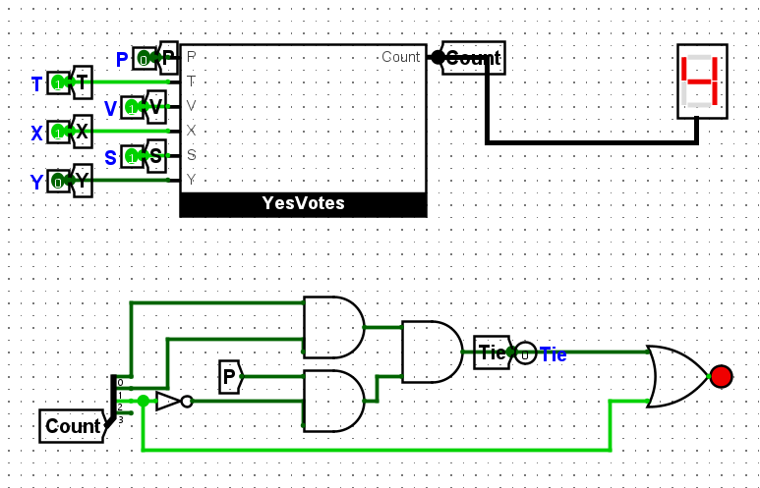
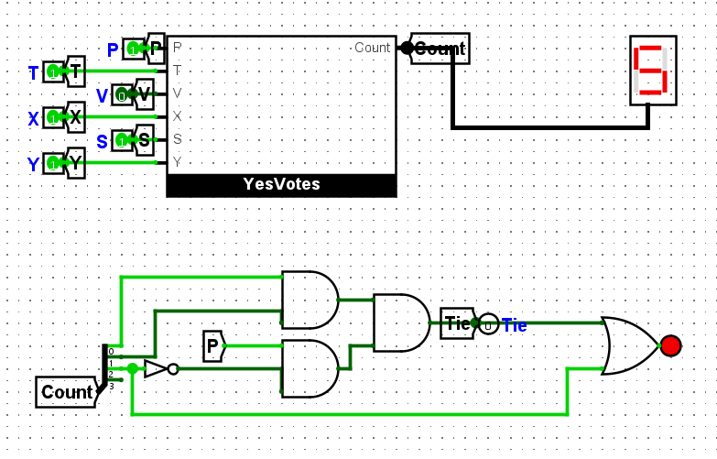
  - Minority
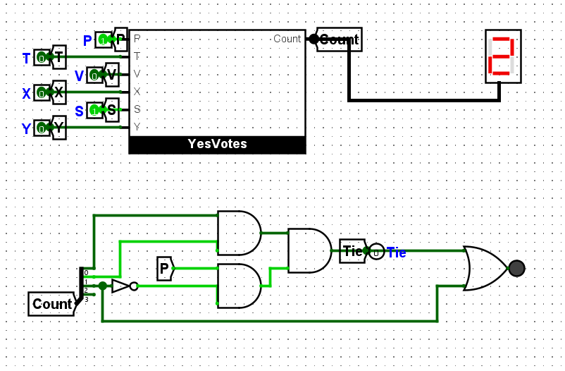
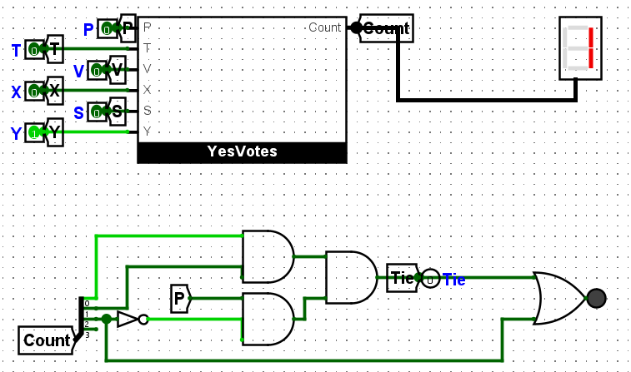
  - Tie-breaker
