Project Design Phase
Solution Architecture

Date | 29 September 2026
Team ID | SWTID-2026-3564
Project Name | Auto Ticket Classification using Flow Designer
Maximum Marks | 4 Marks

Solution Architecture:
Solution architecture is a complex process – with many sub-processes – that bridges the gap between business problems and technology solutions. Its goals are to:
- Find the best tech solution to solve existing business problems.
- Describe the structure, characteristics, behavior, and other aspects of the software to project stakeholders.
- Define features, development phases, and solution requirements.
- Provide specifications according to which the solution is defined, managed, and delivered.

Solution Architecture Diagram – Auto Ticket Classification using Flow Designer:

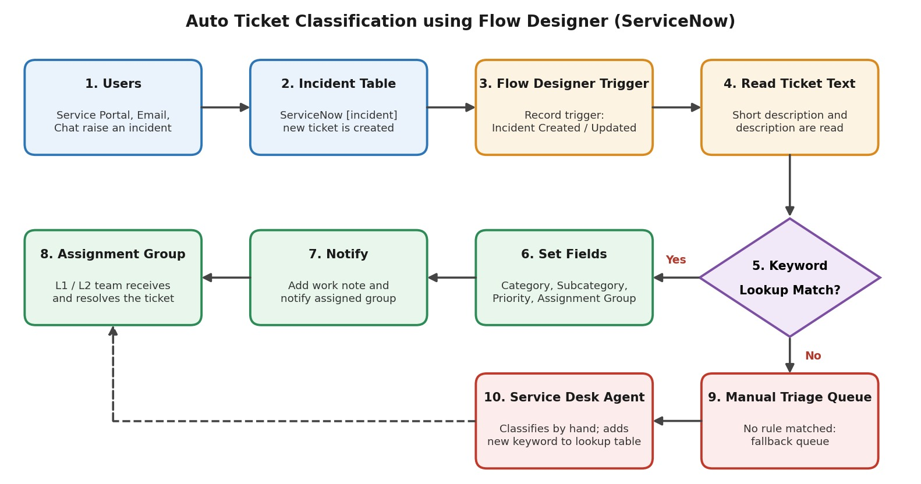
Figure 1: Architecture and data flow of automatic ticket classification using Flow Designer
Data flow:
- Users raise an incident through the Service Portal, email or chat, and it is stored in the ServiceNow incident table.
- A Flow Designer flow with a record trigger (Incident Created / Updated) starts automatically.
- The flow reads the short description and description and matches the text against an editable keyword lookup table.
- If a match is found, the flow sets the category, subcategory, priority and assignment group, adds a work note and notifies the assigned L1 / L2 group.
- If no match is found, the ticket goes to a manual triage queue where a service desk agent classifies it and adds the new keyword to the lookup table, so the flow improves over time.

