**Simulations:**

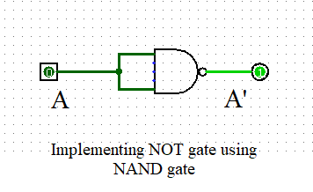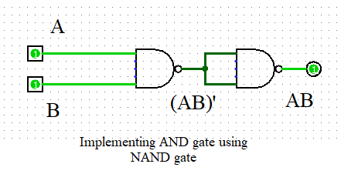

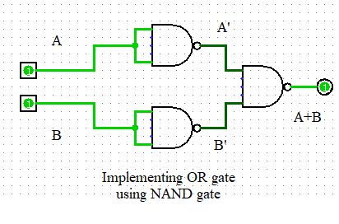

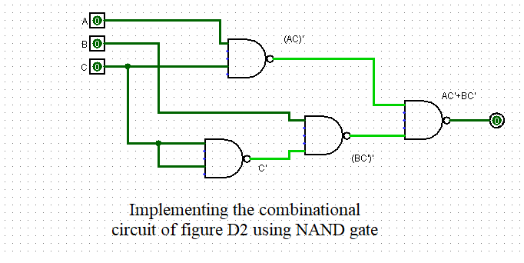

**Truth Table of Figure D2**

|  |  |  |  |
| --- | --- | --- | --- |
| **A B C** | **I1 = AC** | **I2 = BC’** | **F = I1 + I2** |
| **0 0 0** | **0** | **0** | **0** |
| **0 0 1** | **0** | **0** | **0** |
| **0 1 0** | **0** | **1** | **1** |
| **0 1 1** | **0** | **0** | **0** |
| **1 0 0** | **0** | **0** | **0** |
| **1 0 1** | **1** | **0** | **1** |
| **1 1 0** | **0** | **1** | **1** |
| **1 1 1** | **1** | **0** | **1** |
|  |  |  |  |