**Simulations:**

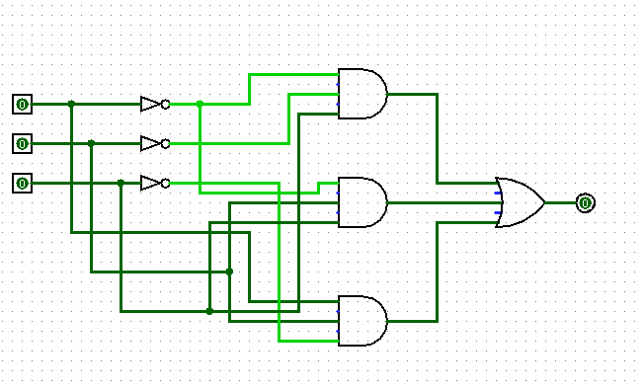

**Fig-9: 1st Canonical Form: A’B’C+A’BC’+ABC’**

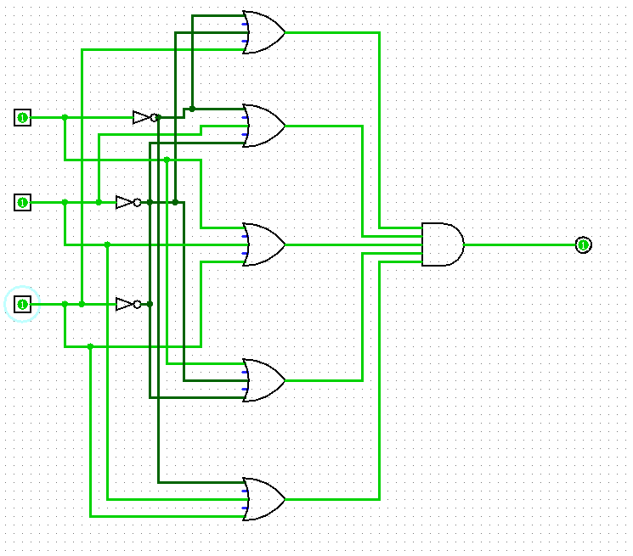

C

B

A

**Fig-10: 1st Canonical Form: (A+B+C) (A+B’+C’) (A’+B+C) (A’+B+C’) (A’+B’+C’)**