**SIMULATIONS of Lab-5**

**Abir Al Mahdi Akhand**

**ID: 2221699642**

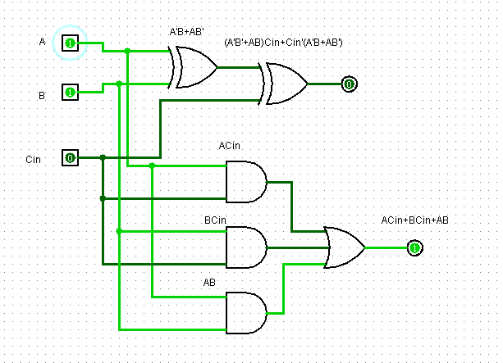

Figure: Full Adder Circuit

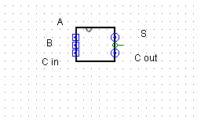

Figure: Full Adder Subcircuit

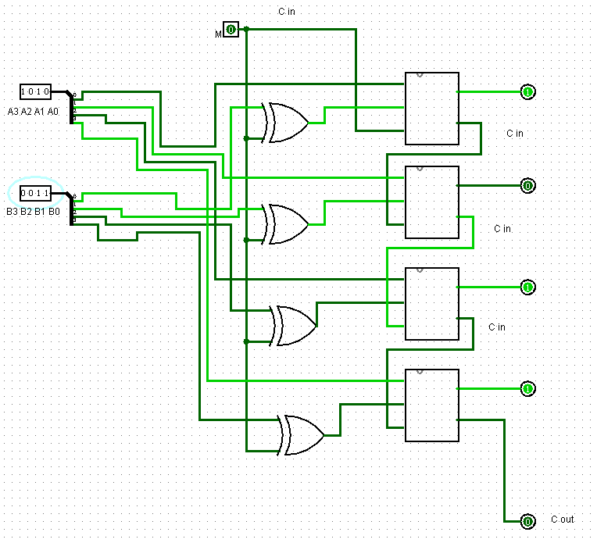

Figure: 4-bit binary Adder-Subtractor

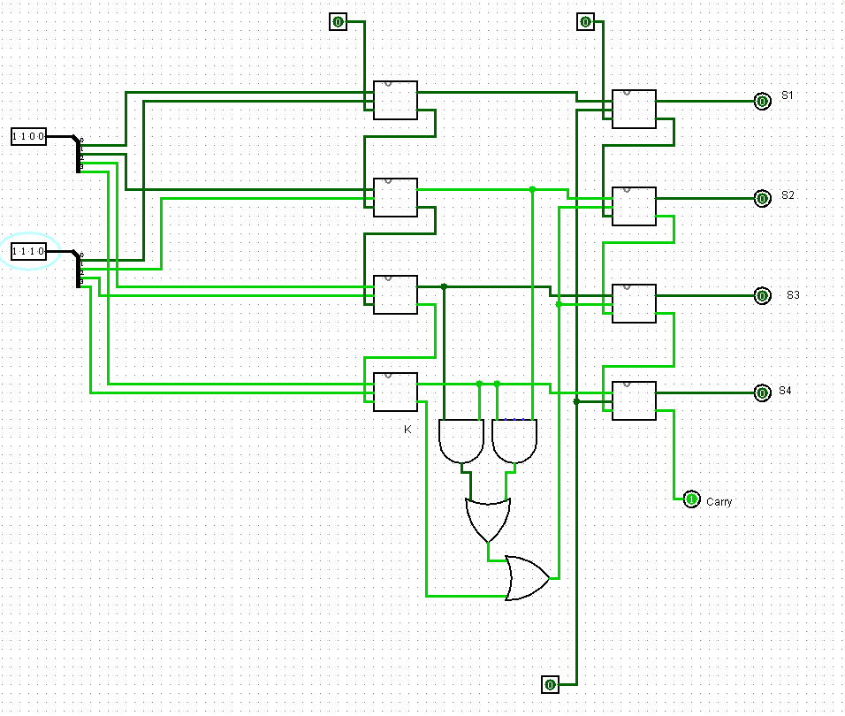

Figure: BCD Adder