**Abir Al Mahdi Akhand,**

**ID-2221699642, CSE231L.15**

**Simulations:**

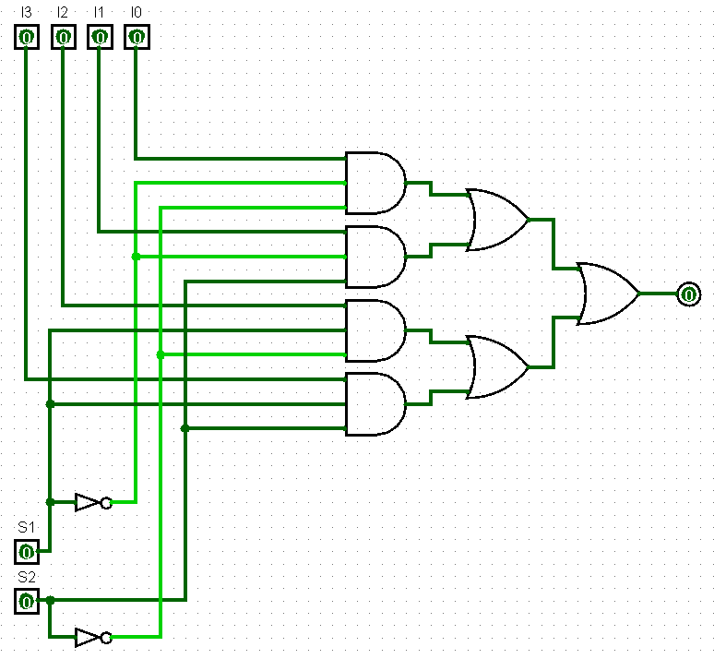

**Figure: 4:1 MUX Circuit**

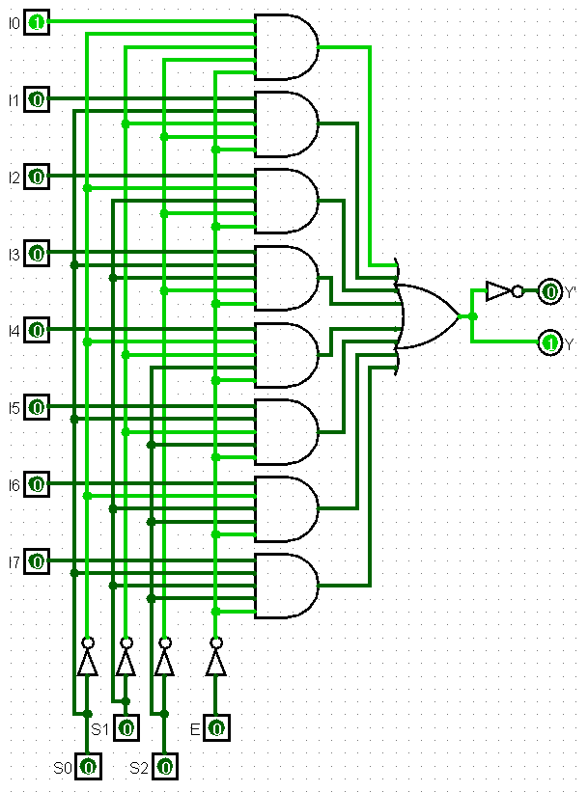

**Figure: 8:1 MUX Circuit**

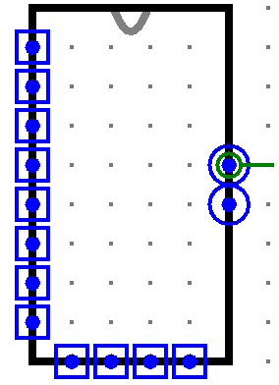

**Figure: 8:1 MUX IC**

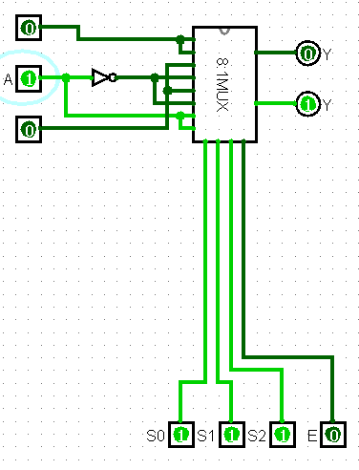s

**Figure: Expression of D.2 using 8:1 MUX IC**