**Simulations by**

Abir Al Mahdi Akhand, ID-22216199642

CSE231L.15 (SMMA)

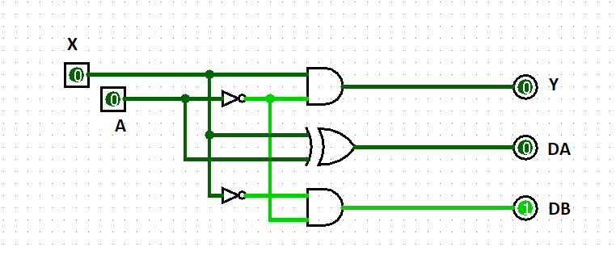

**Fig-4: Combinational Circuit of Synchronous Sequential Circuit**

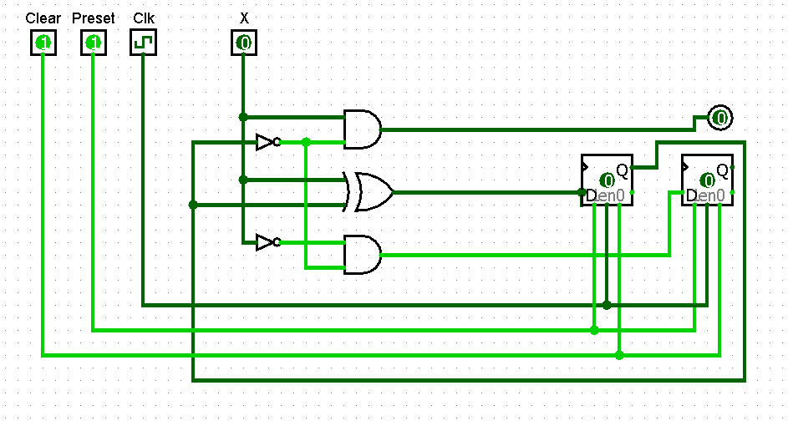

**Fig-5: Combinational element and storage circuit; Synchronous Sequential Circuit**