We have built this project using ASP.NET, an MVC based framework developed by Microsoft.

There are many frameworks in market which gives their own type of foundations over which we could develop our webapp. Laravel(PHP) and django(python) are examples of such popular frameworks. Among all these we chose ASP.NET which is built on C#. Our main reason for choosing this was its robustness as it is developed by a leading tech giant and also our familiarity with C# which we have learned in one of our courses.

.NET is a developer platform made up of tools, programming languages, and libraries for building different types of applications. ASP.NET extends the .NET platform with tools and libraries specifically designed for building web apps. The major extensions which are of use to us are:

* Processing web requests in C#
* Web-page templating language.
* Libraries for common web patterns like MVC(will be discussed below in more detail)
* Authentication system that includes databases and templates for login-logout including multi-factor and external authentication.
* Editor extensions like syntax highlighting, code completion and other which helps in easy development.

The MVC pattern or architecture we mentioned earlier stands for Model View Controller. An architecture is the fundamental structure or discipline based on which a software is built. A webapp(a kind of software) built on MVC pattern can be decomposed into these three modules which makes development and management easier.

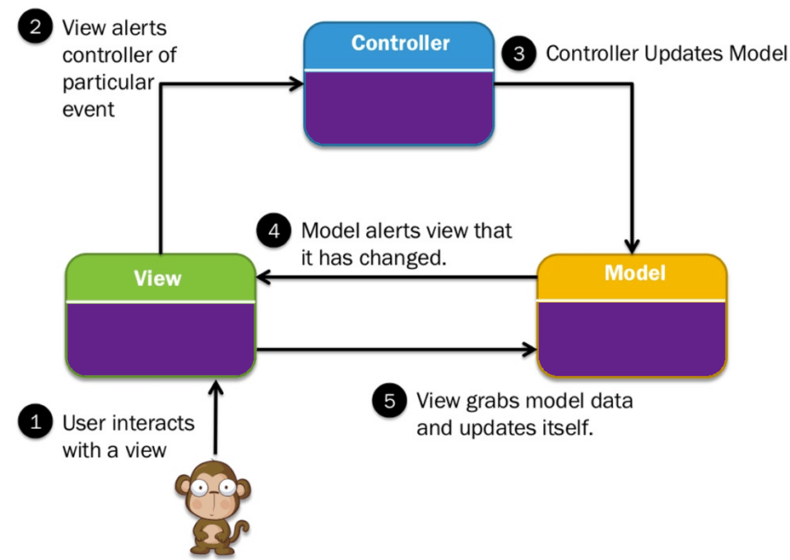Figure 1: MVC architecture

* Model means the data structure used in the project. ASP.NET uses relational database in object model for data manipulation and again updates the database based on the objects. This helps developers operate on the database using C# methods which is fairly easier than using pure SQL.
* View is the part of webapp that the client interacts with. ASP.NET provides its own templating language called Blazer that helps write html dynamically and also perform queries.
* Controller is the main logic that relates the action performed by user to the changes in our model. It is purely written in C#. Controller handles requests and after some processing in the Model returns responses to the clients via views.

MVT is another design pattern which stands for Model-View-Template. In this pattern, the controller part is taken care by the framework but the views are responsible for returning the right data. Django uses MVT architecture to build web apps.

Other tools used:

Visual Studio IDE: Microsoft provides their own Integrated Development Environment(IDE) for software development. It provides wide variety of development, debugging and testing tools. It is also highly optimized for development using ASP.NET. Its community version is free to use.

GitHub: GitHub is a version control system. Github stores projects and allows easy collaboration of team members with proper access control. GitHub is completely free. We mostly use the Git command line tool.

System Overview:

Our system, Equipment Seeker, is designed to allow all general equipments be available to the general public. The following are the main features of our system:

* Registration and Login

Users need to be registered so that our system can keep track of all clients and deliver optimum service. They must provide unique username and password which they can use to login to our system when our software needs to be used the next time.

* + Stimilus/response:

Stimilus: User fills the registration or login form

Response: Registration form registers user and login form logs the user in if the form is valid.

* + Functional requirement:

A valid form must redirect the user to home page. Otherwise user must be informed of the error for them to try again.

* Search equipment

User can seach the system using keywords for required item or brand.

* + Stimilus/Response:

Stimilus: User enters keywords or fills out the advanced search form

Response: Most matching result according to query must be displayed to the user

* + Functional requirement:
    - A search bar to search instantly using keywords
    - An advanced search form that allows search by date, price and similar other properties.
* Cart

Cart keeps track of item the user is buying.

* + Stimilus/Response:

Stimilus: User selects item to add or remove to and from the cart

Response: Quantity and total price in the cart changes respectively

* + Functional requirement:
    - Specified amount of quantity can be added to or removed from the cart
    - Total price of the items in cart must be displayed
* Payment

User can make payment using a popular digital currency service.

Functional requirement:

* + Secure and robust payment system must be available to the user
* Inventory management

This feature is for admins so that they can manage the stock from background.

Functional requirement:

* + Admins must be able to add and remove stock in bulk and keep track of date added/updated and its price.
  + Admins must be able to view non-sensitive information of the clients.
  + They are able to view past transactions in the system.