



**ONLINE REVIEW SENTIMENTAL ANALYSIS**

## **PROJECT – II REPORT**

***Submitted By***

**ASHWIN D** - **713521AM008**

**VISHAL R** - **713521AM058**

**VISHWA N** - **713521AM059**

**NITHISH KUMAR S** - **713521AM503**

*in partial fulfilment for the award of the degree of*

**BACHELOR OF TECHNOLOGY**

*in*

**ARTIFICIAL INTELLIGENCE & MACHINE LEARNING**

**SNS COLLEGE OF TECHNOLOGY, COIMBATORE - 35**

**(**AN AUTONOMUS INSTITUTION)

**April 2025**

## **BONAFIDE CERTIFICATE**

Certified that this Project Phase II Report titled “**ONLINE REVIEW SENTIMENTAL ANALYSIS**” is a Bonafide work of

**1.ASHWIN D (713521AM008)**

**2.VISHAL R (713521AM058)**

**3. VISHWA N (713521AM059)**

**4.NITHISH KUMAR S (713521AM503)**

who carried out the Project work under my supervision. Certified further, that to the best of my knowledge the work reported herein does not form part of any other project report or dissertation on the basis of which a degree or award was conferred on an earlier occasion on this or any other candidate.

## **PROJECT GUIDE** **HEAD OF THE DEPARTMENT**

#### **Ms.S.RAJARAJESWARI M.TECH** **Dr.S.ANGEL LATHA MARY ME.,PhD.,**

Assistant Professor, Head of the Department,

Department of AIML Department of IT & AIML,

SNS College of Technology, SNS College of Technology,

Coimbatore-641035. Coimbatore-641035.

Submitted for the Viva-Voice examination held at SNS College of Technology, on _______________

Internal Examiner External Examiner

# **ABSTRACT**

The exponential growth of e-commerce has generated vast amounts of user- generated data, such as product reviews, which provide valuable insights into customer experiences and sentiments. This project, E-Commerce Reviews Sentiment Analysis, aims to leverage Natural Language Processing (NLP) techniques to analyze customer reviews, predict sentiment, and classify emotions. By processing a dataset containing columns such as ID, Product Name, Review, and Rating, the system identifies unique products, provides sentiment insights, and categorizes emotions like happiness, sadness, anger, and surprise. The methodology involves cleaning raw review data, applying sentiment analysis tools like VADER and BERT, and visualizing the results using graphs. Advanced features include searching products, displaying the number of reviews, and categorizing emotions for deeper insights. The integration of machine learning with NLP ensures accurate sentiment classification, providing e-commerce platforms with actionable insights to improve customer satisfaction and decision-making. This project not only demonstrates the power of NLP in sentiment analysis but also enhances user engagement by offering a robust and intuitive interface for analyzing product feedback. The outcomes can benefit businesses by identifying customer needs, improving products, and enhancing overall service quality

# **ACKNOWLEDGEMENT**

We express our reverential gratitude to the management of SNS College of Technology for providing

us with all sorts of supports for the completion of our project work.

We thank our beloved Director **Dr. V.P. Arunachalam M.E., Ph.D**. and all the member of SNS

College of Technology at this high time for providing us with plethora of facilities to complete the project

successfully.

We deem it a very great privilege to express my profound thanks to our beloved Principal

**Dr. S. Chenthur Pandian M.E., Ph.D**. who has been a bastion of moral strength and a source of incessant

encouragement to me.

We express our sincere thanks to **Dr. L M Nithya M.E., Ph.D**. Professor & Dean of (CSE, IT & AIML) department for her valuable guidance and suggestions.

We express our sincere gratitude and thanks to **Dr.S.Angel Latha Mary M.E., Ph.D**.Head of

Department (IT & AIML) for her constant support and guidance.

We take immense pleasure to express our heartfelt thanks to our project coordinator

**Mr.D.Vikneshkumar M.E., (Ph.D).** Assistant Professor, Department of Information Technology for his

valuable guidance.

We take this opportunity to express our heart full gratitude to our project guide **Ms.S.Rajarajeswari MTech.** Assistant Professor, Department of Artificial Intelligence and Machine Learning for his involvement to make our project successful.

We also thank all our Teaching faculty members and non-teaching staff members of Artificial

Intelligence & Machine Learning Department and all our fellow students who stood with us to do our

project work successfully. We also extend warm thanks to our beloved parents.

**CHAPTER 1**

**INTRODUCTION**

## **OVERVIEW**

In the rapidly evolving digital landscape, e-commerce platforms have become a cornerstone of modern retail, connecting businesses with customers globally. Platforms like Flipkart, Amazon, and others generate immense amounts of user-generated data in the form of reviews, which serve as critical indicators of customer satisfaction and product performance. However, manually analyzing these reviews to extract meaningful insights is not only labor-intensive but also prone to errors.

E-Commerce Reviews Sentiment Analysis addresses this challenge by employing Natural Language Processing (NLP) techniques to automate the analysis of customer reviews. This project aims to bridge the gap between raw customer feedback and actionable insights by predicting the sentiment of reviews and categorizing emotions such as happiness, sadness, anger, and surprise. By leveraging sentiment analysis, businesses can gain a deeper understanding of customer opinions, identify areas for improvement, and enhance their offerings.

The importance of this project lies in its ability to:

1. Automate the extraction of valuable insights from large datasets.
2. Provide businesses with actionable metrics to improve customer satisfaction.
3. Empower customers by ensuring their feedback translates into meaningful change. Through advanced methodologies such as sentiment analysis tools (e.g., VADER, BERT), emotion classification, and interactive visualizations, this project showcases how artificial

intelligence can revolutionize e-commerce by transforming raw data into a powerful decision-

making resource.

## **Need for E-Commerce Reviews Sentiment Analysis**

Customer reviews are a critical aspect of e-commerce platforms, providing businesses with direct feedback about their products and services. However, as the number of reviews grows, manually analyzing them becomes increasingly challenging, leading to underutilization of valuable customer insights. This project, E-Commerce Reviews Sentiment Analysis, addresses the pressing need to efficiently process and interpret these reviews to improve customer satisfaction and business performance.

#### **Key Reasons Highlighting the Need for This Project:**

1. **Volume of Reviews**:
   * E-commerce platforms generate millions of customer reviews daily, making manual analysis impractical.
   * Automated sentiment analysis provides a scalable solution for processing large volumes of reviews.

#### Understanding Customer Sentiments:

* + Businesses often fail to capture the true sentiment behind customer reviews, such as identifying dissatisfaction masked by polite language or sarcasm.
  + This project utilizes NLP to accurately classify sentiments and emotions, ensuring no feedback is overlooked.

#### Enhanced Decision-Making:

* + Insights derived from sentiment analysis enable businesses to make informed decisions regarding product improvements, customer service enhancements, and marketing strategies.

#### Emotion Analysis for Deeper Insights:

* + Mapping reviews to specific emotions like happiness, sadness, anger, and surprise provides a deeper understanding of customer experiences.
  + Emotion analysis helps identify not just whether customers are satisfied, but also why they feel a certain way.

#### Competitive Advantage:

* + Businesses leveraging sentiment analysis gain a competitive edge by identifying trends, addressing issues promptly, and delivering tailored solutions to customers.

#### Targeted Interventions:

Sentiment analysis helps in identifying negative sentiments early, enabling companies to intervene and resolve issues before they escalate, improving customer service quality.

#### Personalized Responses

By understanding the sentiment behind reviews, businesses can tailor their responses to customers, making them feel heard and valued.

#### Content Strategy Optimization:

By analyzing the tone and sentiment of reviews, businesses can adapt their marketing campaigns to resonate better with their audience.

#### Product Sentiment-Based Segmentation:

Businesses can segment their audience based on positive, negative, or neutral sentiment and customize offers and communications accordingly.

#### Identifying Emerging Needs:

By analyzing customer sentiment, companies can detect unmet needs and emerging trends, helping them innovate and stay ahead in the market.

#### Predictive Analytics:

Sentiment analysis can be used in conjunction with other analytics tools to forecast future trends and consumer behavior.

#### Adoption of NLP Technologies:

This project offers the opportunity to leverage advancements in NLP, making it a relevant and forward-thinking application of AI technologies to solve real-world business problems.

## **Purpose of the Online Review Sentimental Analysis**

The primary purpose of the E-Commerce Reviews Sentiment Analysis project is to provide businesses and customers with meaningful insights derived from customer feedback. By leveraging Natural Language Processing (NLP) and Machine Learning techniques, the project aims to automate the analysis of reviews, identify sentiments, and uncover underlying emotions to facilitate data-driven decision-making.

#### Key Purposes:

1. **Automating Review Analysis:**
   * Reduce the manual effort required to sift through large volumes of customer reviews by automating the sentiment analysis process.
   * Enable businesses to process thousands of reviews in real-time with high accuracy.

#### Enhancing Customer Experience:

* + Understand customer opinions more effectively to identify pain points and areas of satisfaction.
  + Use insights to tailor products, services, and customer support to better meet customer expectations.

#### Supporting Business Decision-Making:

* + Provide actionable metrics that help businesses improve product quality, optimize marketing strategies, and enhance customer service.
  + Assist in identifying trends, common complaints, and features appreciated by customers.

#### Emotion Classification for Deeper Insights:

* + Map customer feedback to specific emotions (e.g., happiness, sadness, anger, surprise) to gain a holistic understanding of customer experiences.
  + Prioritize feedback based on emotional intensity, addressing urgent concerns promptly.

#### Empowering Customers and Businesses:

* + Empower customers by ensuring their feedback is analyzed and used to bring meaningful improvements.
  + Equip businesses with tools to stay competitive in the fast-paced e-commerce market.

#### Scalability and Accessibility:

* + Build a scalable system that can handle diverse datasets and adapt to multiple e-commerce platforms.
  + Make sentiment analysis accessible for businesses of all sizes, from startups to large corporations.

#### Connecting Communities:

* By making it easier for people to communicate across language barriers, the software fosters stronger social connections and reduces the isolation that the deaf and hard-of-hearing community might experience.

#### Building Empathy and Understanding:

* Facilitating interactions between sign language users and non-users helps promote empathy and understanding of the challenges that the deaf and hard-of- hearing community faces.

#### Real-Time Translation:

* + The AI software can automatically translate sign language into text or speech in real-time, eliminating the need for human interpreters in many situations, making it more efficient and scalable.

#### Cost and Time Efficiency:

* + By reducing the reliance on interpreters, the software offers a more cost- effective solution for sign language translation, especially in scenarios where interpreters might not be readily available.

#### AI Integration:

* + The software leverages advancements in artificial intelligence (AI), machine learning, and natural language processing (NLP) to recognize and interpret various sign language gestures and translate them into understandable formats.

#### Continuous Improvement:

* + As AI models are trained with more data, the software will continue to improve its accuracy and fluency, ensuring that it adapts to different regional sign languages and individual signing styles.

#### Cross-Cultural Communication:

* + Sign language varies by region and country. Advanced AI software can help bridge these regional differences and facilitate communication between sign language users from different cultural backgrounds.

#### Multilingual Support:

* + In addition to supporting sign language, the software can be designed to support multiple spoken languages, making it easier to communicate with people from different linguistic backgrounds.

#### Wide-Ranging Application:

* + The software can be applied in a variety of settings, including public spaces, virtual meetings, customer service interactions, and personal use, making it a versatile tool for both personal and professional environments.

#### Adaptive to Different Devices:

* + The software can be integrated into mobile phones, tablets, and computers, ensuring that sign language translation is available across multiple platforms.

## **DOMAIN OVERVIEW**

### **PYTHON:**

Python is selected as the core programming language for this project primarily due to its simplicity, readability, and vast ecosystem of libraries that enable rapid development of complex AI and machine learning applications. Python’s syntax is intuitive and clean, which not only makes the code more readable but also helps developers focus on logic and problem-solving rather than getting bogged down in complicated syntax.

Moreover, Python supports a wide range of libraries and frameworks, which makes it the go-to choice for AI-based projects. Libraries like **TensorFlow**, **Keras**, **PyTorch**, and **OpenCV** provide powerful tools and modules for machine learning, deep learning, and computer vision, respectively. TensorFlow and Keras, for instance, are widely used for building and training deep learning models, and PyTorch is preferred for research and model development due to its dynamic computation graph. **OpenCV** simplifies the implementation of computer vision techniques, crucial for gesture recognition and real-time video processing.

Python also has robust support for data manipulation and analysis through libraries like **NumPy** and **Pandas**, which are essential for preprocessing and transforming data before feeding it into machine learning models. Python’s wide compatibility with various platforms and its active community make it a reliable and future-proof choice for any machine learning or AI project. Additionally, Python offers easy integration with web and mobile applications, allowing this project to scale and be accessed across different devices and platforms.

The versatility of Python in handling tasks ranging from natural language processing to real-time image analysis, combined with its user-friendly environment, ensures that the project remains maintainable, extendable, and highly efficient. Whether it’s for building machine learning models, performing data analysis, or developing user-friendly interfaces, Python provides all the tools necessary for the smooth execution of the Real-Time Real-Time Sign Languageproject.

### **MACHINE LEARNING FRAMEWORKS: TENSORFLOW/KERAS:**

TensorFlow and Keras are chosen as the machine learning frameworks for this project due to their robust features, ease of use, and widespread adoption in the field of artificial intelligence.

**TensorFlow** is an open-source deep learning framework developed by Google, known for its flexibility, scalability, and performance. It provides a comprehensive ecosystem for building, training, and deploying machine learning models, making it ideal for complex tasks like gesture recognition and sign language interpretation. TensorFlow is optimized for both research and production, offering support for distributed computing, deployment across different platforms, and integration with various hardware accelerators like GPUs and TPUs.

**Keras**, which is now integrated into TensorFlow, is a high-level API designed for fast model development and experimentation. Keras simplifies the process of building deep learning models by providing an easy-to-use interface for defining and training neural networks. Its user-friendly design allows for quick prototyping, which is essential in rapidly developing and fine-tuning machine learning models for real-time applications like sign language recognition. Keras supports a wide range of pre-built layers and models, as well as tools for customization, which significantly reduces development time.TensorFlow’s support for integration with other frameworks, tools, and platforms also allows for smooth deployment in different environments, including mobile devices, where accessibility and real-time performance are crucial. Thus, TensorFlow/Keras provides an ideal framework for this project’s objectives, ensuring a seamless and efficient machine learning pipeline for real-time sign language translation.

#### **Visual Studio Code (VS Code):**

Visual Studio Code is a highly popular, open-source code editor developed by Microsoft, known for its versatility, speed, and user-friendly interface. VS Code supports a wide range of programming languages, including Python, and is widely used for AI and machine learning development. It provides essential features such as syntax highlighting, debugging, version control integration, and extensions, making it suitable for managing complex projects like the ONLINE REVIEW SENTIMENTAL ANALYSIS Software. Its ability to work seamlessly with Python libraries and frameworks (like TensorFlow and OpenCV) allows for efficient development, testing, and deployment of machine learning models.

#### **1.4.4 Jupyter Notebooks:**

Jupyter Notebooks is an open-source, interactive web application that allows for the creation and sharing of documents that contain live code, equations, visualizations, and narrative text. It is widely used in data science and machine learning for experimentation, model training, and visualization. In the context of the Real-Time Real-Time Sign Languageproject, Jupyter Notebooks provides an ideal environment for prototyping and testing machine learning algorithms and computer vision models. Its interactive interface makes it easy to visualize data, experiment with different models, and fine-tune performance, ensuring that the system performs optimally before moving to production.

#### **Interactive Computing :**

* + - * + Live Code Execution: You can write code (in languages like Python, R, Julia, etc.) and execute it directly within the notebook. The output of the code appears immediately below the cell.
        + Data Visualization: Jupyter allows easy integration with visualization libraries such as Matplotlib, Seaborn, Plotly, and others. You can generate interactive plots and charts within the notebook.

#### **Multi-Language Support:**

* + - * + Language Kernels: Although Jupyter is most commonly used with Python, it supports multiple programming languages through "kernels." These kernels allow users to run code in languages such as R, Julia, Scala, and more.
        + Flexibility: This makes Jupyter a versatile tool, supporting a wide range of applications across different programming languages.

#### **Markdown Support:**

* + - * + Rich Text Formatting: Jupyter Notebooks support Markdown, which allows you to include formatted text, images, links, and mathematical equations. This enables users to provide explanations, document the analysis process, and create more readable reports.
        + LaTeX for Mathematical Equations: LaTeX syntax is supported for rendering complex mathematical equations and formulas.

#### **Easy Sharing and Collaboration:**

* + - * + Export and Share Notebooks: Notebooks can be shared easily as .ipynb files, which can be opened in other Jupyter environments. They can also be exported to formats like HTML, PDF, or slides for presentations.
        + JupyterHub: For collaboration, multiple users can work on a shared Jupyter environment through platforms like JupyterHub.

#### **Integration with Data Science Libraries:**

* + - * + Data Science Tools: Jupyter integrates well with Python’s data science ecosystem, such as Pandas (for data manipulation), NumPy (for numerical computing), SciPy (for scientific computing), and TensorFlow or PyTorch (for machine learning).
        + Data Importing and Analysis: You can load datasets from various sources (CSV, Excel, SQL databases, APIs) and perform data cleaning, transformation, and analysis within the notebook.

#### **NumPy:**

NumPy (Numerical Python) is a powerful library designed for numerical and matrix operations, and it is fundamental in any machine learning or computer vision project. It provides support for large, multi-dimensional arrays and matrices, along with a collection of high-level mathematical functions to operate on these arrays. In this project, NumPy is used to efficiently process and manipulate numerical data such as the pixel values of images during the gesture recognition process. It supports vectorized operations, which enable performing multiple operations simultaneously, thus speeding up computation, a crucial aspect when handling real- time image and gesture processing in the Real-Time Sign Languagesystem. NumPy also integrates seamlessly with other libraries such as TensorFlow and PyTorch, allowing for smooth data transfer between different stages of the machine learning pipeline.

**NumPy** (Numerical Python) is an open-source Python library that provides support for large, multi-dimensional arrays and matrices, along with a wide collection of mathematical functions to operate on these arrays. It is the fundamental package for scientific computing in Python and is widely used for tasks such as data analysis, numerical computations, and machine learning.

At the core of NumPy is the **ndarray**, an n-dimensional array object that is efficient for storing large datasets. These arrays are more efficient and faster than traditional Python lists, making NumPy a powerful tool for working with large amounts of data. NumPy also provides a variety of mathematical operations that can be performed element-wise on arrays, such as linear algebra, statistical analysis, and Fourier transforms, among others.

In addition to its computational power, NumPy integrates seamlessly with other scientific computing libraries in Python, like Pandas for data manipulation, Matplotlib for data visualization, and SciPy for advanced mathematical functions. Its popularity in the data science and machine learning communities stems from its efficiency, versatility, and the speed it offers in handling large data operations.

### **PANDAS:**

Pandas is an open-source data manipulation and analysis library that provides data structures like Series and DataFrame, which are highly efficient for handling structured data. In the context of this project, Pandas will be utilized to manage and preprocess sign language gesture datasets. It allows for easy data cleaning, transformation, and organization, enabling the system to efficiently work with large amounts of data. For instance, it helps in labeling gestures, splitting datasets into training and testing sets, and transforming raw data into usable formats for machine learning models. With features like handling missing data, merging multiple data sources, and performing group-based operations, Pandas ensures that the dataset is prepared in a format suitable for further analysis and model training, making it an indispensable tool for data handling in the project.

**Pandas** is an open-source Python library that provides high-performance, easy-to-use data structures and data analysis tools. It is primarily used for data manipulation, cleaning, and analysis, and is one of the most essential libraries in the data science ecosystem. The core data structures in Pandas are **Series** (1-dimensional) and **DataFrame** (2-dimensional), which allow for efficient handling and manipulation of large datasets.

Pandas excels at handling structured data, including data from CSV files, SQL databases, Excel spreadsheets, and other file formats. It offers a wide range of functionalities, such as data alignment, merging, reshaping, and aggregation. With built-in methods for handling missing data, performing group operations, and filtering or selecting data, Pandas makes it easy to manipulate and explore datasets.

Its seamless integration with other libraries like NumPy for numerical operations and Matplotlib for visualization further enhances its usefulness. Pandas is widely used in fields like data analysis, finance, scientific computing, and machine learning, as it allows users to quickly and efficiently preprocess and analyze data, making it a cornerstone tool for modern data science workflows.

## **CHAPTER 2 LITERATURE SURVEY**

The field of sentiment analysis and emotion detection in e-commerce reviews has been a subject of extensive research and development. Several studies and technologies have contributed to the evolution of automated review analysis, leveraging advanced Natural Language Processing (NLP) and Machine Learning (ML) techniques. This literature survey explores existing approaches, their methodologies, and limitations to highlight the novelty and significance of the E-Commerce Reviews Sentiment Analysis project.

**2.1 Sentiment Analysis of Product Reviews Using NLP Techniques**

* **Authors**: Pang et al. (2002)
* **Summary**: This study demonstrated the use of machine learning algorithms like Naive Bayes and Support Vector Machines (SVM) to classify product reviews into positive and negative sentiments. The work introduced basic text preprocessing methods such as tokenization, stop-word removal, and feature extraction.
* **Limitation**: Focused only on binary sentiment classification without delving into nuanced emotions or multi-class sentiments.

#### **Emotion Recognition in Text Using Lexicon-Based Approaches**

* **Authors**: Mohammad et al. (2013)
* **Summary**: This research utilized emotion lexicons such as NRC Emotion Lexicon to classify text into basic emotions (e.g., joy, anger, sadness). It highlighted the importance of using pre-defined word-emotion associations for text analysis.
* **Limitation**: The approach struggled with context and sarcasm, limiting its effectiveness in complex sentences.

#### **Deep Learning for Sentiment and Emotion Analysis**

* **Authors**: Kim (2014)
* **Summary**: This paper introduced the use of Convolutional Neural Networks (CNNs) for sentiment analysis. The model excelled in learning high-level features from textual data, outperforming traditional methods.
* **Limitation**: CNNs required large datasets for effective training and lacked temporal awareness of sequential text data.

#### **Aspect-Based Sentiment Analysis for E-Commerce Reviews**

* **Authors**: He et al. (2017)
* **Summary**: This research focused on aspect-based sentiment analysis, which classified sentiments based on product aspects (e.g., quality, price, delivery). It highlighted the importance of identifying specific product features driving customer sentiments.
* **Limitation**: Aspect-based methods were computationally expensive and required labeled datasets for each aspect.

## **CHAPTER 3 WORKDONE IN PHASE II**

## **EXISTING SYSTEM**

The current approaches for analyzing e-commerce product reviews rely on either manual methods or basic automated tools that have significant limitations. These systems provide elementary insights into customer opinions, which are often insufficient for understanding nuanced sentiments or predicting customer satisfaction effectively.

Existing Approaches:

1. **Manual Review Analysis:**
   * Customer feedback is analyzed manually by customer service teams or business analysts.
   * Insights are derived based on word frequency and recurring themes in reviews.
   * Limitations:
     + Highly time-consuming and prone to human errors.
     + Not scalable for platforms with millions of reviews.
2. **Keyword-Based Sentiment Analysis:**
   * Uses predefined lexicons to identify positive or negative keywords in reviews (e.g., "good," "bad").
   * Sentiment is assigned based on the presence of these keywords.
   * Limitations:
     + Fails to capture context, sarcasm, or mixed sentiments (e.g., “The product is good, but the delivery was terrible.”).
     + Does not classify emotions beyond simple sentiment polarity.
3. **Aspect-Based Sentiment Analysis:**
   * Focuses on specific product features (e.g., quality, delivery) and assigns sentiments to these aspects.
   * Limitations:
     + Requires predefined aspects for analysis.
     + Computationally expensive and unsuitable for real-time applications.

## PROPOSED SYSTEM

The E-Commerce Reviews Sentiment Analysis project proposes an advanced, automated system that leverages Natural Language Processing (NLP) and Machine Learning (ML) techniques to analyze customer reviews. The proposed system aims to overcome the limitations of existing methods by providing scalable, context-aware, and emotion-sensitive sentiment analysis tailored for e-commerce platforms.

#### **Features of the Proposed System:**

1. **Real-Time Sentiment Analysis**:
   * Automatically processes customer reviews to classify them into sentiments:

Positive, Neutral, or Negative.

* + Combines rule-based (e.g., VADER) and deep learning-based (e.g., BERT) approaches for enhanced accuracy.

#### Emotion Detection:

* + Maps customer reviews to specific emotions such as Happiness, Sadness, Anger, Surprise, Disgust, and Fear for deeper insights.
  + Helps businesses understand the intensity and nature of customer feedback.

#### Searchable Product Insights:

* + Enables users to search for products by name or ID.
  + Displays the list of unique product names, their corresponding IDs, and review counts.

#### Review Analysis and Visualization:

* + Provides a breakdown of sentiment and emotion distribution for selected products.
  + Visualizes analysis results using graphs (e.g., pie charts, bar charts) to simplify decision-making.

#### Scalable and Multilingual:

* + Capable of analyzing large volumes of reviews in real-time.
  + Handles multi-language or mixed-language reviews, ensuring global applicability.

#### Exportable Reports:

* + Generates and exports sentiment analysis results into CSV files for further use in business intelligence.

#### Integration with Review Platforms:

* + The system integrates with various online review platforms such as Amazon, Yelp, TripAdvisor, and social media channels like Twitter or Facebook, collecting reviews from diverse sources.

#### Context-Aware Sentiment Analysis:

* + The system utilizes advanced NLP techniques, such as transformers (e.g., BERT, GPT), to accurately capture the nuances in language, including sarcasm, negation, and context, ensuring more accurate sentiment classification.

#### Entity Recognition:

* + The system can recognize and analyze entities such as product names, brand names, and features within the review, offering deeper insights into what specific aspects customers are discussing.

#### Historical Data Analysis and Reporting:

* + Historical Review Analysis: The system can analyze historical data to detect patterns in customer feedback, providing valuable insights for long-term decision- making.
  + Report Generation: Automated report generation, allowing businesses to download or share periodic reports summarizing sentiment trends, most discussed topics, and areas of concern.

#### Sentiment Filtering and Segmentation:

* + Customizable Filters: Businesses can apply filters based on sentiment, time, or other parameters (e.g., geographic location, user demographics) to segment and focus on specific types of reviews.
  + Segmentation by Demographics: The system can categorize reviews based on customer segments (age, location, etc.) to analyze sentiment trends among different demographics.

#### Actionable Insights and Recommendations:

* + Recommendation Engine: Based on the sentiment analysis, the system can suggest actionable steps to improve products, services, or customer relations, such as offering promotions for positive feedback or addressing issues raised in negative reviews.
  + Sentiment-Driven Strategy Recommendations: The system provides businesses with insights on how to adapt marketing strategies, improve customer service, or introduce new features based on customer sentiment.

## **Advantages of the Proposed System:**

#### Scalability:

* + Processes large datasets efficiently, making it suitable for platforms with high review volumes.

#### Context-Aware Analysis:

* + Uses advanced NLP techniques to understand review context, sarcasm, and multi- faceted opinions.

#### Comprehensive Insights:

* + Goes beyond simple sentiment classification by mapping reviews to specific emotions for better customer understanding.

#### Improved Decision-Making:

* + Provides actionable insights to improve products, services, and customer satisfaction strategies.

#### User-Friendly Interface:

* + Simplifies interaction with the system through intuitive search, analysis, and visualization tools.

#### Cost-Effective:

* + Relies on open-source tools and libraries, making it accessible to businesses of all sizes.

#### Improved Customer Insights:

* + Actionable Feedback: The system helps businesses understand the sentiments behind customer reviews, providing clear insights into customer satisfaction, dissatisfaction, and emotions. By analyzing trends in feedback, companies can make data-driven decisions to enhance their products, services, and customer experience.
  + Granular Analysis: Aspect-based sentiment analysis enables businesses to understand which specific features (e.g., product quality, customer service) are driving positive or negative sentiments, offering detailed insights for targeted improvements.

#### Real-Time Monitoring:

* + Immediate Alerts: The system processes reviews in real-time, enabling businesses to track customer sentiment as soon as new reviews are posted. This quick feedback loop allows businesses to respond promptly to negative reviews or capitalize on positive feedback.
  + Proactive Issue Resolution: Negative reviews or emerging issues can be detected immediately, allowing businesses to take proactive measures (e.g., contacting customers, offering resolutions) before problems escalate.

#### Better Decision Making:

* + Data-Driven Decisions: By analyzing sentiment trends and patterns, businesses can make more informed strategic decisions, whether it's improving a product, adjusting marketing strategies, or enhancing customer service efforts.
  + Market Positioning: The system helps businesses track their reputation compared to competitors by analyzing reviews from multiple sources, enabling more effective competitive positioning and differentiation in the market.

#### Enhanced Customer Experience:

* + Personalized Engagement: With insights into specific customer needs and concerns, businesses can tailor their responses and offers, creating a more personalized experience. Positive feedback can be used to reinforce brand loyalty, while negative feedback can be addressed to improve the overall experience.
  + Customer Sentiment Monitoring: By monitoring customer sentiment over time, businesses can assess the impact of new features, product updates, or marketing campaigns on customer satisfaction, ensuring that their offerings resonate well with their target audience.

## **Work Done in Phase II**

#### **Data Collection:**

Reviews are scraped from e-commerce platforms (e.g., Flipkart) using tools like BeautifulSoup or Selenium, or loaded from a pre-existing dataset.

#### **Data Preprocessing:**

Cleans the review data by removing stop words, punctuation, and special characters.

Handles mixed-language reviews and tokenizes text for further processing.

#### **Sentiment and Emotion Analysis:**

VADER: Quickly analyzes sentiment polarity (Positive, Neutral, Negative) for short texts.

BERT: Provides context-aware sentiment analysis for complex reviews and maps them to emotions.

#### Search and Selection:

* + - * + Users can search for products by name or ID to narrow down the focus for analysis.
        + Displays the number of reviews and detailed review text for the selected product.

#### **Aspect-Based Sentiment Engine**

* Extracted aspects using spaCy (POS tagging for nouns).
* Used TextBlob to analyze polarity of text segments and assign sentiment to extracted aspects.

#### **Web App Development**

* Built interactive pages using Flask and Bootstrap.
* Home page for product selection; results page for showing insights.
* Integrated responsive chart visualizations with Matplotlib (backend) and Chart.js (frontend).

**AI Chatbot Feature**

* Used Google Gemini API to create an AI-powered chatbot.
* Integrated chatbot as a floating icon on result page with toggle functionality.
* Used Flask-SocketIO for real-time query handling.

#### **Error Handling and Dependency Management**

* Resolved compatibility issues with NumPy 2.0 and dependent packages.
* Handled environment issues via conda/virtualenv setup.
* Optimized Flask app for smooth UI experience.

## **BLOCK DIAGRAM**

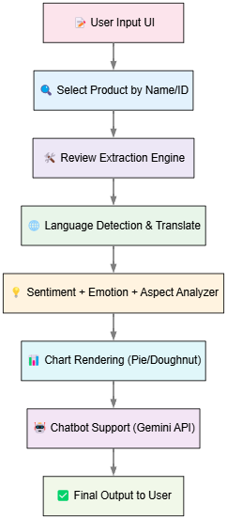

**Fig 2.1 :** Block Diagram

## **CHAPTER 4 SYSTEM REQUIREMENTS**

## **LIST OF MODULES**

The E-Commerce Reviews Sentiment Analysis project is designed with modular components to ensure scalability, flexibility, and ease of maintenance. The following are the key modules implemented in this project:

#### Product Search and Selection

**Purpose**: Enables users to search for products by name or ID and displays a list of unique products along with their respective IDs and the number of reviews.

#### Key Functions:

* + search_product(query): Finds products matching the search term.
  + display_product_list(): Displays the list of unique product names and IDs.

#### Review Analysis

**Purpose**: Processes and analyzes customer reviews to determine sentiment and emotional intensity.

#### Key Functions:

* + analyze_sentiment(review): Uses tools like VADER and BERT to classify reviews as Positive, Neutral, or Negative.
  + classify_emotion(review): Maps reviews to specific emotions such as Happiness, Sadness, Anger, Fear, Surprise, and Disgust.

#### Data Preprocessing

**Purpose**: Cleans and prepares raw review data for analysis.

#### Key Functions:

* + clean_text(text): Removes stop words, punctuation, and special characters from the reviews.
  + tokenize_reviews(): Splits reviews into tokens for further analysis.

#### Visualization

**Purpose**: Provides graphical representations of sentiment and emotion analysis results.

#### Key Functions:

* + plot_sentiment_pie(sentiment_data): Displays sentiment distribution in a pie chart.
  + plot_emotion_bar(emotion_data): Displays emotion distribution in a bar graph.

#### Review Display

**Purpose**: Outputs the list of all reviews for a selected product and provides an option to view individual reviews.

#### Key Functions:

* + display_reviews(product_id): Retrieves and displays all reviews for the given product ID.
  + show_review_count(product_id): Shows the total number of reviews for a product.

#### Report Generation

**Purpose**: Exports analysis results into a CSV file for further use.

#### Key Functions:

* + export_to_csv(sentiment_data, emotion_data, product_id): Saves the sentiment and emotion analysis results for a selected product.

#### Model Integration

**Purpose**: Implements pre-trained models for sentiment and emotion analysis.

#### Key Functions:

* + load_vader_model(): Initializes the VADER sentiment analysis tool.
  + load_bert_model(): Loads the BERT model for advanced context-aware analysis.

## **CHAPTER 5 CONCLUSION AND FUTURE WORKS**

* 1. **CONCLUSION**

The E-Commerce Reviews Sentiment Analysis project presented in this phase successfully demonstrates the integration of Natural Language Processing (NLP), Machine Learning (ML), and Deep Learning (DL) to address the growing demand for understanding customer feedback in the e-commerce domain. Through the implementation of various AI models and web development frameworks, the system transforms raw product reviews into meaningful insights for both customers and businesses.

Unlike conventional review systems that rely solely on star ratings and simple keyword matching, our system leverages transformer-based models to classify sentiment with high precision. It enhances the customer experience by automatically detecting and translating multilingual reviews to English, enabling broader accessibility. The project not only classifies review polarity into positive, neutral, and negative but also identifies emotional tones such as joy, sadness, and anger, providing a deeper understanding of customer satisfaction.

Aspect-Based Sentiment Analysis adds further depth by linking sentiments to specific product features like battery, camera, or delivery service, enabling sellers to address component-specific issues. These insights are visualized in real-time using interactive Pie and Doughnut charts, providing users with an intuitive and digestible presentation of complex data. The use of Flask for backend logic and Bootstrap for frontend design ensures a seamless user experience on both desktop and mobile devices.

A unique and futuristic aspect of this project is the integration of an AI-powered chatbot using Google Gemini API. This chatbot not only helps users interact with the system but also serves as a smart assistant that can respond to natural language queries related to product sentiments and emotions.

Overall, the system demonstrates the potential of modern AI techniques to revolutionize how online reviews are analyzed and interpreted. It lays the foundation for scalable and intelligent sentiment analysis platforms that can evolve with user needs and technology trends.

## **FUTURE WORK**

To extend the capabilities of this system beyond Phase I and make it production-ready, several enhancements can be introduced. These include both technical improvements and new features that offer more value to users:

1. **Real-time Review Streaming**  
   Integration with real-time APIs to continuously fetch new product reviews from Flipkart, Amazon, or other marketplaces. This would enable dynamic updates to sentiment dashboards.
2. **Voice-Based Review Input**  
   Enable users to submit audio reviews. Speech-to-text conversion would then allow the system to analyze spoken feedback using the existing NLP pipeline.
3. **User Profile Sentiment Mapping**  
   Link reviews with user profiles to determine how different customer demographics (age, region, frequency of purchase) perceive a product.
4. **Cross-Platform Aggregation**  
   Combine reviews from multiple platforms (e.g., Amazon, Flipkart, Snapdeal) into a unified analysis dashboard. This would allow broader trend detection and better product comparison.
5. **Multimodal Sentiment Analysis**  
   Add capabilities to analyze video and image-based reviews using computer vision models in conjunction with text analysis.
6. **Mobile Application Development**  
   Create Android and iOS versions of the platform using frameworks like Flutter or React Native to reach more users.
7. **Product Recommendation System**  
   Incorporate recommendation algorithms based on sentiment history, user preferences, and commonly praised aspects.
8. **Knowledge-Based AI Chatbot Enhancement**  
   Extend the chatbot’s capabilities to include FAQs, intelligent product recommendations, and domain-specific answers by building a connected knowledge base.
9. **Data-Driven Business Insights Dashboard**  
   Develop admin panels for sellers/brands that provide aggregated sentiment and emotion trends, aspect-wise satisfaction rates, and predictive analytics.
10. **Integration with CRM and Marketing Tools**  
    Feed analysis outputs into customer relationship management tools for personalized follow-up, campaigns, or service improvements.

## **REFERENCES**

1. Pang, B., & Lee, L. (2008). Opinion Mining and Sentiment Analysis. Foundations and Trends in Information Retrieval.
2. Hutto, C. J., & Gilbert, E. E. (2014). VADER: A Parsimonious Rule-Based Model for Sentiment Analysis of Social Media Text.
3. Devlin, J., Chang, M. W., Lee, K., & Toutanova, K. (2018). BERT: Pre-training of Deep Bidirectional Transformers for Language Understanding.
4. Vaswani, A., Shazeer, N., Parmar, N., Uszkoreit, J., Jones, L., Gomez, A. A., Kaiser, Ł., & Polosukhin, I. (2017). Attention is All You Need.
5. Hutto, C. J., & Gilbert, E. E. (2014). VADER: A Parsimonious Rule-Based Model for Sentiment Analysis.
6. Devlin, J., Chang, M. W., Lee, K., & Toutanova, K. (2018). BERT: Pre-training of Deep Bidirectional Transformers.
7. Vaswani, A., et al. (2017). Attention Is All You Need.
8. Python Libraries Documentation: Pandas, NumPy, Matplotlib, Hugging Face Transformers.
9. E-Commerce Datasets from Kaggle and other open-source repositories.

## **APPENDIX I SOFTWARE SPECIFICATION**

**A1.1 TOOLS AND TECHNOLOGY**

* + **Machine Learning Frameworks:** NLTK (Natural Language Toolkit)**Programming Languages:** Python
  + **User Interface Development:** Tkinter or PyQt
  + **Development Tools:** Visual Studio Code, Jupyter Notebooks
  + **Data Management:** NumPy, Pandas
  + **Version Control:** Git

## A1.2 HARDWARE SPECIFICATION

* + **Processor:** i5 or AMD Ryzen 5
  + **SSD:** 512 GB
  + **RAM:** 8GB
  + **GPU:** Nivida GTX or RTX 1650

## **APPENDIX II SCREENSHOTS AND SOURCE CODE**

**A2.1 SCREENSHOTS**

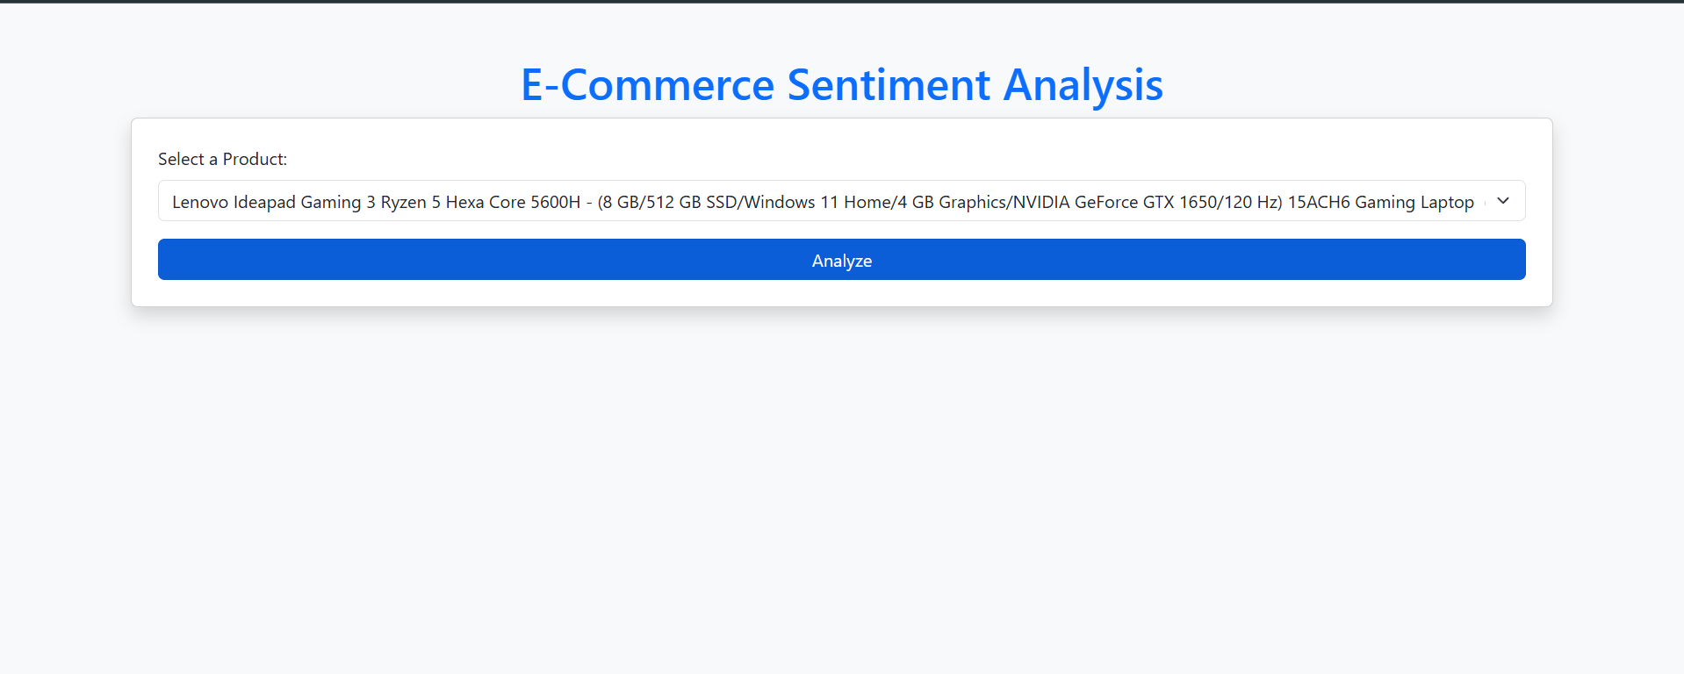

**Fig A2.1:** Landing Page

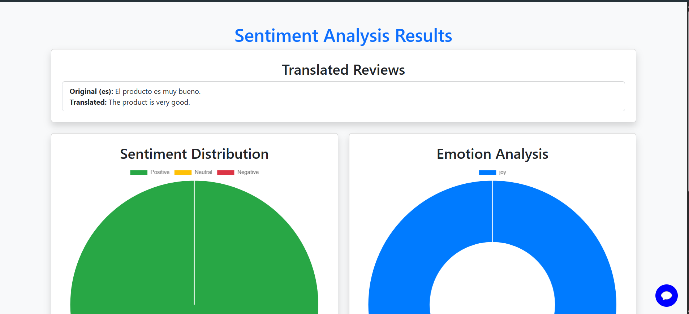

**Fig A2.2: Result Page**

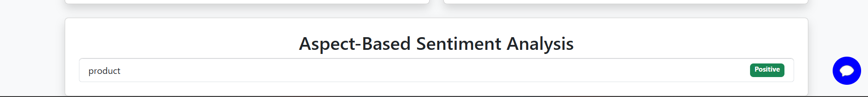

**Fig A2.3:** Aspect Analysis

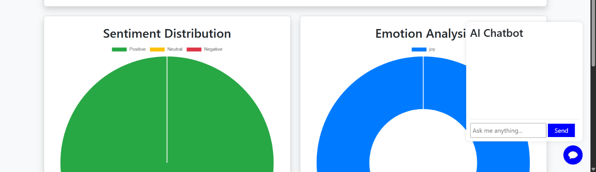

**Fig A2.4:** AI Chat bot

## **A2.2 SOURCE CODE**

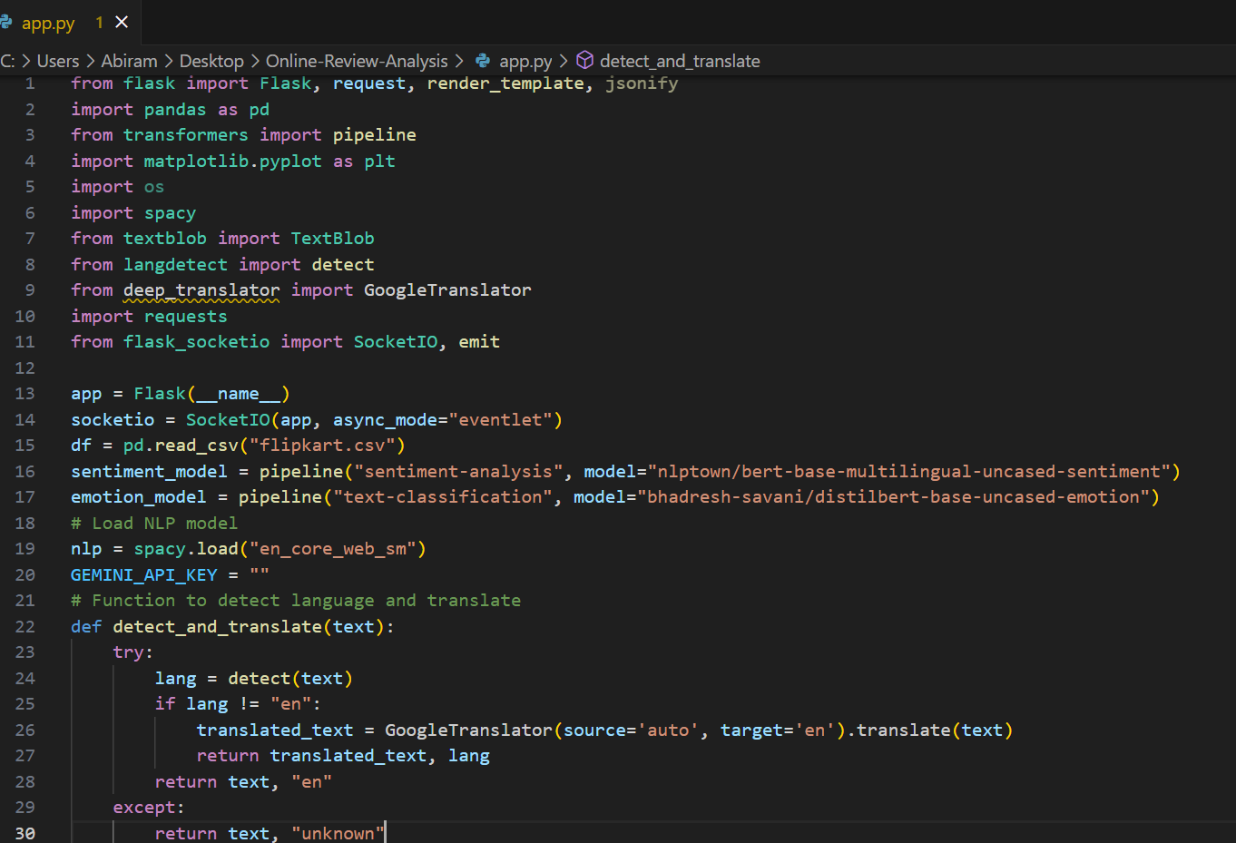

**Fig A2.2.1:** App.py

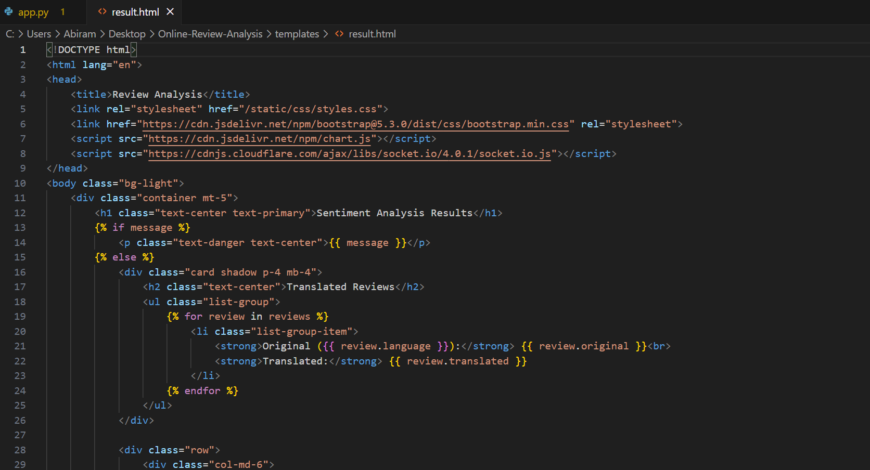

**Fig A2.2:** Online review Result Page