A Novel Approach for Vehicular Accident Detection and Rescue Alert System using IOT with Convolutional Neural Network

|  |  |
| --- | --- |
| R.Sathya  Assistant Professor, Department of IT  Kongunadu College of Engineering and Technology  Trichy, Tamil Nadu, India.  *sathyaphdkncet@gmail.com* | S.Ananthi  Assistant Professor, Department of CSE  Sri Eshwar College of Engineering,  Coimbatore.  *ananthi.s@sece.ac.in* |
| M.R.S Abirame  Student, Department of IT  Kongunadu College of Engineering and Technology  Trichy, Tamil Nadu, India.  *abiramevishnu730@gmail.com* | R.Nikalya  Student, Department of IT  Kongunadu College of Engineering and Technology  Trichy, Tamil Nadu, India.  *nikalyar26@gmail.com* |
| A.Madhupriya  Student, Department of IT  Kongunadu College of Engineering and Technology  Trichy, Tamil Nadu, India.  *ayirpuhdam.a@gmail.com* | M.Prithiusha  Student, Department of IT  Kongunadu College of Engineering and Technology  Trichy, Tamil Nadu, India.  *prithiusha06@gmail.com* |

***Abstract*—** **Road accidents are become a big concern for the public. This study describes a system for preventing accidents that involves alcohol detection with a MQ3 alcohol sensor, followed by a message alert to a rescue worker or family members. An SW-420 vibration sensor is used by the detecting component to identify any unusual vibrations that might result from a collision. Supervised deep learning CNN methods go along with this. The front camera of the car is utilized to take a picture of the accident scene for the deep learning accident prediction model. After a collision is discovered, communication is transmitted to the closest evacuation facility utilizing GPS and GSM modules. Once the Vehicle is involved in a collision following vehicle will be get notified through VANET. The alcohol sensor will then determine if the driver has consumed alcohol or not and if they need to operate the vehicle in an emergency when they are intoxicated. Then, as a result of driving too fast, multiple accidents occurred. So, when the car exceeds the speed limit, an immediate warning will be sent through GSM Module. Finally, Accident analysis device can be used for smart cities using supervised deep learning CNN methods.**

**Keywords—** ***Internet of Things (IOT), MQ3 Alcohol Sensor, GSM, speed limit, GPS, CNN and Accident Detection.***

1. INTRODUCTION

In our world, everything and anything is now reachable, particularly through transportation. Transportation has changed over time, progressing since the middle Ages wagons towards the space vehicles of the 20th millennium and beyond. Its rapid development can be attributed to either encouraging business or the requirement for rapid transportation. Although many people believe that transportation is a major benefit to humanity, others are concerned that it can become a problem because of excessive vehicle speeds and a lack of respect for traffic safety regulations.

In our daily lives, we see that the number of accidents worldwide is raising the death toll. According to government statistics, accidents are said to be the cause of 140,000 reported fatality cases per year. According to statistics, rescue efforts that are delayed are the primary cause of death for accident victims. We therefore, used GSM and an MQ3 alcohol detector in our proposed system to keep an eye on the car in order to solve this issue.

When a vehicle is involved in an accident, an immediate message will be sent to the registered contact details. Once an accidental event occurs the following vehicle will be get notified through VANET. If the driver is intoxicated, the notification will appear instantaneously to the owner or the emergency crews. In parallel, the notice will be delivered if the car is involved in another accident. A prompt SMS sent to the registered mobile phone number when the automobile exceeds the predetermined limit.

1. EXISTING METHODOLOGY

This study describes research on the detection, localization, reporting, modeling, and analysis of traffic accidents. Accident detection systems based on smart phones have been reported in several studies. This study Rajesh, G. et al [1], introduces a system that really can identify traffic incidents and immediately transmit an emergency SMS to the appropriate control centre. It suggested Bhakat, A. et al [2], a smart accident detection and rescue technology that employs the IoTs (Internet of Things) and an system with artificial intelligence to simulate the intellectual functions that the human brain (AI). They Choi, J.G and Kong [3], suggested a smart accident detection and rescue technology that employs an artificial intelligence system and the Internet of Things (IoTs) to simulate the intellectual functions that a human brain (AI). A combination of an accelerometer and an ultrasonic sensor is proposed for accident analysis Zou. X et al [4].

A modified Haddon matrix is suggested to offer various insights on the next wave of road safety studies during the intelligent, networked, and automated vehicular technology. In order to report a traffic collision more quickly, the proposed operating principle of the system is based on Convolutional networks and deep learning techniques Harikrishnan. A et al [5]. Many lives could be saved by using this system. Whenever an accident is detected, the process utilizes GPS to find and notify a nearby hospital. In this paper Wegmeth L et al [6], they suggest a machine-learning (ML) framework based on multiple in-vehicle sensors for automatic car accident detection. Their study concentrates on the detection of actual driving collisions utilizing cutting-edge feature extraction techniques and standard automotive sensors.

Inter-vehicle communication techniques like VANET (Vehicular Ad-hoc Network) and IoV (Internet of Vehicles) may be able to assist vehicles in reporting incidents via each other when a reliable Internet connection is only accessible to some nearby vehicles. It suggested Comi, A et al [7], a descriptive statistic will be used to determine which methods of data mining are appropriate for evaluating road accidents, as well as to identify their most important root causes and frequent trends. They proposed M. U. Ghazi and M. A. Khan Khattak et al [8], the system effectively distributing emergency warnings is a big challenge as a result of the several issues caused by this high traffic density. The dynamic character of the network makes using VANETs for data transfer is exceptionally difficult.

The proposed method T. Yuan et al [9], based on the GIS and Firefly Clustering techniques, can aid in the detection of city road "black spots" other than the contributes to lowering car accidents and preserving sustainable urban development. It says that B. Du, L. Yu, X. Hu et al [10], timely accurate traffic accident prediction has a great deal of potential to preserve public safety and reduce financial losses. That represents Z. Huang and S. Gao et al [11], the suggested method offers considerable benefits for large-scale urban passenger hotspots in terms of clustering speed, accuracy, and visualization. They have used Fang and D. Yan [12], the prediction of driver attention is developing into a critical research issue for driving systems that are similar to human beings.

This research is aimed to forecast the driver's focus in scenarios that involve crashes (DADA). A method suggests, Singh, G. Pal, M et al [13], a descriptive analysis will be employed to identify which data mining approaches are best for evaluating road accidents, as well as to highlight their most significant underlying causes and common patterns. It suggests Zhang, X. Rane et al [14], have used Regular monitoring enables early machine failure detection, which is presenting advantages for industrial automation excellent process control. It proposed Goerlandt.F,Li and Reniers [15], suggests that it is a vital to suggest practical accident prevention strategies in this paper in accordance with the pertinent safety protection criteria and the current state of every industry.

The Proposed method M. Mythili et al [16], is to present an elegant and safe biometric attendance technique for smart classroom using fingerprint sensor. If the instructor is not present in the classroom through the GSM module, an SMS alarm is issued to the appropriate class in-charge. The suggested approach R. Sathya et al [17], is built upon different image processing method for detection stage and recognition system using support vector machine for offline signature verification. Author Sathya et al., [18] proposed a robust SSVM+Hybrid LUCNN concept has been established to recognize the vehicle number plates for intelligent transportation systems. By tracking machine tool status, the suggested study Sathya et al [19] created an intellectual (IoT) tool state supervising scheme to find construction tradeoffs related to sustainability and the best machining settings.

1. *PROPOSED ACCIDENT ANALYSING SYSTEM*

The major aim of this Proposed System is to develop a real-time application that utilizes GSM and MQ3 Alcohol sensors to detect and reduce accidents. This intended to incorporate three modules in this research. When a vehicle is involved in an accident, an SMS alert is immediately sent over GSM to the registered phone number. The novel proposed Accident Analyzing scheme Architecture is exposed in Fig. 1. Some accidents occurred as a result of drunk driving. So, we can quickly identify if a person has consumed alcohol or not with the use of an MQ3 Alcohol Sensor.

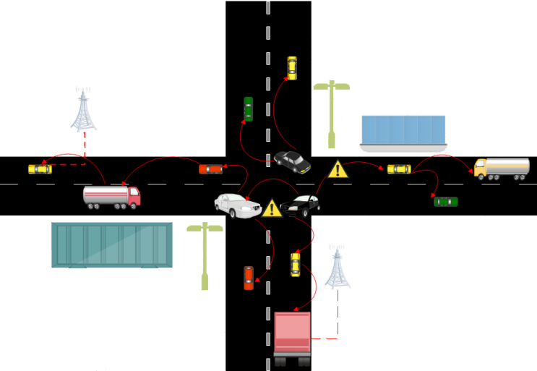

Figure 1. The overall proposed Accident Analyzing System Architecture

The information will be sent to the rescue officer or relatives as soon as alcohol is noticed. In order to warn them not to drive by their relatives. Finally, accidents may occasionally occur as a result of over speeding. Consequently, we must set the speed limit at 80 km/h. The enrolled mobile number will be notified the moment the speed exceeds the limit using Vehicle Speed Sensors and Engine Control Module Sensors. This effort will contribute to fewer accidents, which will lead to fewer fatalities.

1. *Hardware Elements Used in the Sensing Phase and Accident Detection Phase*

* *VANET*

A vehicle ad hoc network technique is made up of several moving or stationary cars that are connected by a wireless network (VANET). VANETs were primarily used until recently to improve driver comfort and safety in moving cars. Through the VANET, the vehicles in the road were connected in a wireless medium. The function of VANET will be shown in Fig.2. This will help us to transmit the alert signal through waves. The VANET will be connected with the RSU (Road Side Unit). Once the motor starts VANET will be activated through RSU.

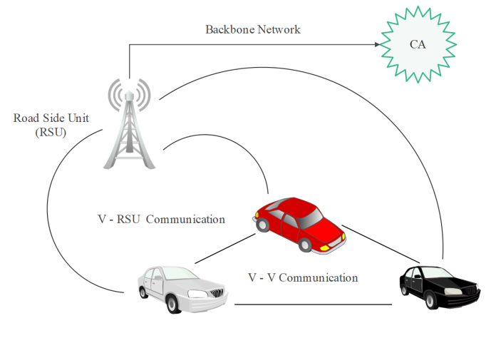

Figure 2. The Function of VANET

* *MQ3 Alcohol Sensor*

The presence of alcohol gas is detected [21], using this low-cost semiconductor sensor. This sensor's sensitive SnO2 has a conductivity that is lower than that of pure air. Its conductivity rises when alcohol concentration is detected. Both analogue and digital output are provided by this module. It can easily be connected to microcontrollers like the Raspberry PI, Arduino boards, and others. If the person is boozed while driving then the immediate message will be sent to the rescue officers or relatives.

* *Radio Frequency Identification*

RFID uses electromagnetic combination in the radio range region of the electromagnetic band to uniformly recognize a object or human being. It will be sent the signal through the Radio Waves. Each and every vehicle will have an individual RFID Tag to receive the signals from the accident vehicle to alert the upcoming vehicle.

* *Engine Control Module and Vehicle Speed Sensors*

The actuators in a combustion engine are managed by an ECU, also indicated to an ECM, to ensure optimum engine performance. Then, the conventional speedometer is replaced by a speed sensor. It rotates while being plugged into an electrical connector that can send a signal to a computer. In this manner, the sensor offers data for calculating your car's speed. It also displays whether you need to change the transmission speed or shift levels.

* *GSM Module (SIM900A)*

The GSM module is switched on if the deep learning model identifies an accident, and using location tracking, the data is delivered as a text message to the neighborhood emergency centre. The message and together, the CGI is sent. These message is a base transceiver station's globally unique identifier. MNC, LAC, CI and MCC (Mobile Country Code) are its four component sections (Cell Identification). With the aid of GPS, the CGI may be used to monitor the location.

*B. Software Elements*

In this instance, Tensor Flow serves as the backend while Keras serves as the neural network API. Tensor Flow is a full open resource Artificial Intelligence platform. Tensor Flow provides a vast, comprehensive network of methods, databases, and group of people properties that let researchers shove the limitations of machine learning and implementers will quickly and effectively create and organize machine learning origins.

1. *Implementation of Proposed System*

The suggested concept consists of two stages, sensing stage and avoidance stage. An Arduino Uno is connected to the sensors for the preventative phase, according to the block diagram shown in Fig.3.

**Step 1:** The Arduino Uno is interfaced with the alcohol Sensor (MQ3), the SW 420 range of vibration sensor, and the GSM module for sending messages (L293D motor driver).

**Step 2:** Using a USB cable, the raspberry pi module receives the outcome of the SW 420 range of this sensor. If the output is indicated as logic high, that will turn on because it is connected to the raspberry pi module. The scene is captured by this proposed module, and using the deep network layer created in the component layer, the image is compared with the predetermined dataset.

**Step 3:** After the boozed person rides a vehicle and met with an accident the immediate message will be sent to rescue team.

**Step 4:** When the speed limit is beyond the range the immediate Alert notification will be sent to the relatives or rescue team.

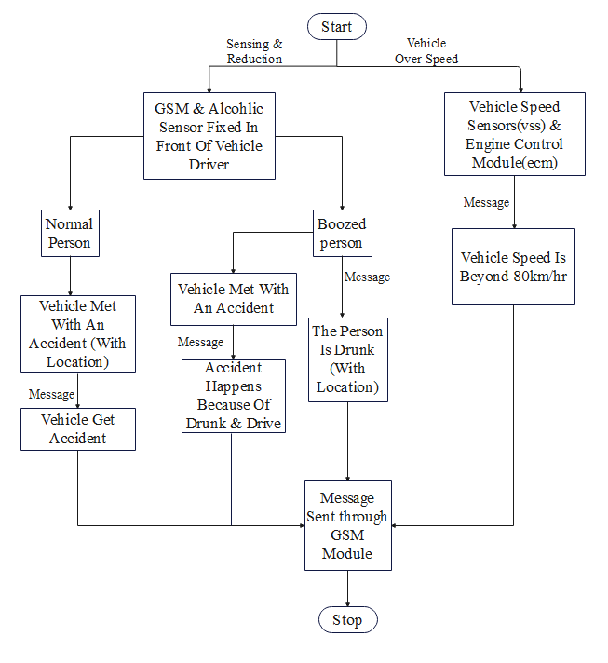

Figure 3. Flowchart of Alcohol sensing and accident detection

1. *Experimental Results*

*A. Results of Vehicle Accident Sensing*

The sensing phase includes accident identification, detection and tracking with using of deep network layer and intimation of vehicle accident incidences to the close by rescue centre. The function of the system will be clearly shown in Fig.4. The SW420 vibration sensor is used to establish collision detection. When an aberrant jerk or vibration is detected that exceeds the predetermined threshold, the sensor output spikes, activating the buzzer. We have set the threshold value at 80000 for prototype demonstration reasons. The rescue squad will then receive the alarm message instantly.

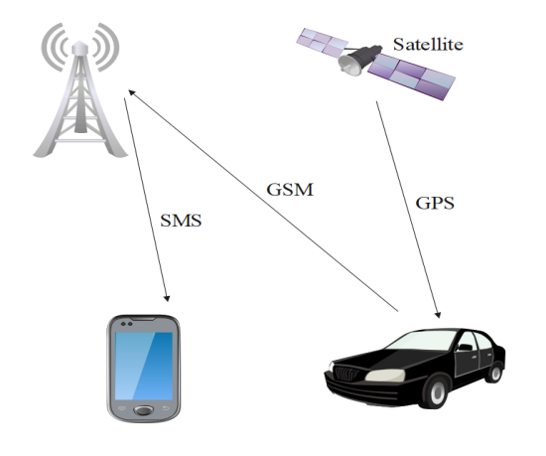

Figure 4. Accident Sensing

1. *Results of Vehicle Accident detection*

Internal initialization has set the MQ3 sensor's threshold to 500 ppm. The GSM will be activated through RSU whenever the alcohol concentration exceeds the threshold. The chosen mobile number will then receive the alert message via GSM. The Alcohol detection of the system will be shown in Fig.5. The identical thing has been shown with an L293D motor driver. An alcohol-based hand sanitizer has been employed for testing purposes; when it is detected, a notice is delivered.

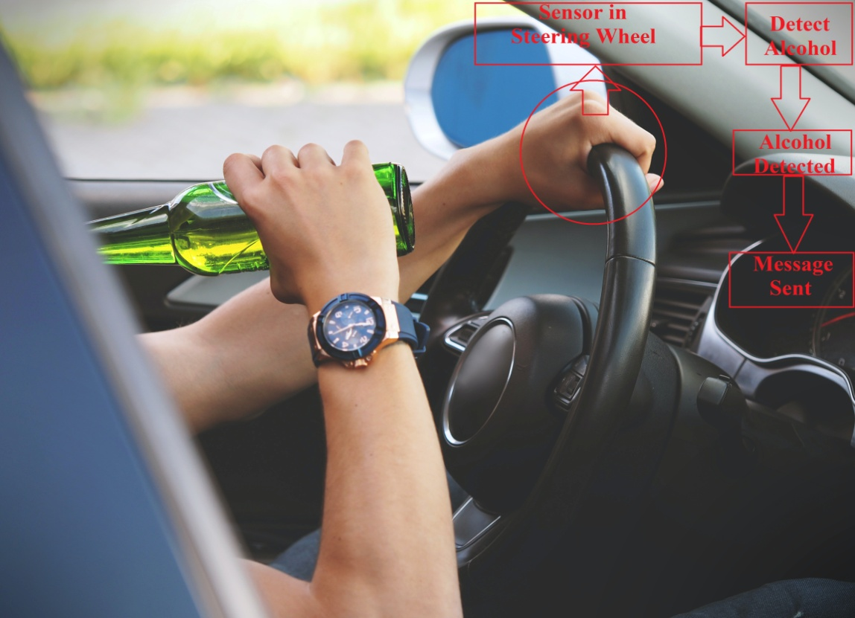

Figure 5. Alcohol detection flow

1. *Results of Speed Alert Detection*

The RSU will trigger the Engine Control Module and Vehicle Speed Sensor when the automobile exceeds the speed limit 80km/h. The limit of the vehicle fixed is shown in Fig.6. The GSM Module will then activate the two sensors. The rescue squad will immediately receive an alert message if the GSM Module detects vibration.

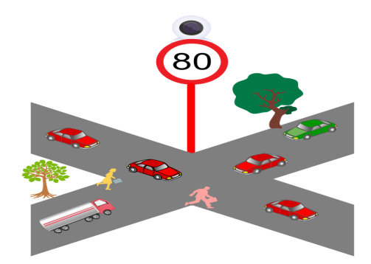

Figure 6. Speed Alert

1. *Results of Accident Recognition using CNN*

It is suggested that a deep learning Convolutional neural network be applied to each frame of a motion picture that has been trained to distinguish between accident- and non-accident-related video frames. It has been determined that Convolutional Neural Networks [20], provide a quick and reliable method for classifying photos. For comparatively smaller datasets, CNN-based image classifiers have achieved accuracy levels of above 95% and need less preprocessing than other image classifying techniques.

1. *Hardware Implementation*

PIC micro controller of PIC16F877A microchip, Power supply, MQ3 alcohol sensor, GPS module, GSM module, LCD display, RFID, SW 420 vibration antenna, engine control module, and vehicle speed control are some of the hardware's other components. The hardware implementation of the Accident sensing and Accident detection phase is shown in Fig.7.

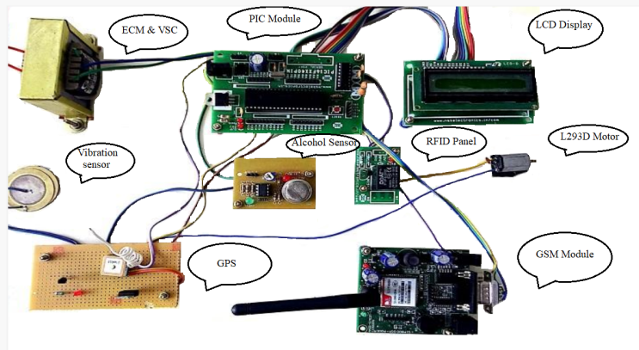

Figure 7. Experimental Setup of Accident sensing and Accident detection phase

1. *CONCLUSION AND FUTURE WORK*

In comparison to the current systems, the proposed approach is significantly more dependable and may be more efficient. We are able to track, monitor, and determine the whereabouts of both people and vehicles. The key benefit of this research is that it allows us to prevent the loss of life by stopping drunk drivers from operating vehicles and alerting them to a speed alert. When compared to the current methodology, the innovative accident sensing and vehicle accident detection method offers greater accuracy. In the future, if a vehicle is stolen, we will be able to track its location in real-time using a GPRS module.

*References*

[1] Rajesh, A.R. Benny, A. Harikrishnan, J.J. Abraham, N.P. John, “A Deep Learning based Accident Detection System”. In- Proceedings of the 2020 International Conference on Communication and Signal Processing pp. 1322–1325, 28–30th July 2020.

2. A. Bhakat, N. Chahar, V. Vijayasherly, “Vehicle Accident Detection and Alert System using IoT and Artificial Intelligence” In: Proceedings of the 2021 Asian Conference on Innovation in Technology, pp. 1–7, 27–29th August 2021.

3. J.G. Choi, C.W. Kong, G. Kim, S. Lim, “Car crash detection using ensemble deep learning and multimodal data from dashboard cameras”. In: Expert Scheme for Young Scientists and Technologists Appl. 183, 115400 in 2021.

4. X. Zou, H.L. Vu, H. Huang, Fifty Years of “Accident Analysis & Prevention: A Bibliometric and Scientometric Overview” Anal. Prev. 144, 105568 in 2020.

5. A. Harikrishnan, J.J. Abraham, N.P. John, “A Machine learning based Accident Detection System”. In: Proceedings of the 2021 International Conference on Communication and Signal Processing, pp. 1325–1327, 28–30th July 2021.

6. H.H. Pour, F. Li, L. Wegmeth, C. Trense, R. Doniec, M. Grzegorzek, R. Wismüller “A Machine Learning Framework for Automated Accident Detection Based on Multimodal Sensors” Sens. 2022, pp. 1–21 in 2022.

7. A. Comi, A. Polimeni, C. Balsamo “Road Accident Analysis with Data Mining Approach: Evidence from Rome” Transp. Res. Procedia 2022, 62, 798–805 in 2022.

8. M. A. Khan Khattak, A. W. Malik, M. U. Ghazi, M. S. Ramzan, and B. Shabir “Emergency message dissemination in vehicular networks: A review”, In: IEEE Access, vol. 8, pp. 38606–38621 in 2020.

9. T. Yuan, T. Shi, and X. Zeng “Identifying urban road black spots with a novel method based on the firefly clustering algorithm and a geographic information system,” Sustainability, vol. 12, pp. 2091 in 2020.

10. B. Du, L. Sun, L. Han, W. Lv, and X. Hu "Deep spatiotemporal graph convolutional network for traffic accident prediction” Neurocomputing, vol. 423, pp. 135–147, Jan. 2021.

11. Huang. Z, Gao.S, Cai. C, Zheng. H and Pan. Z, "A rapid density method for taxi passengers hot spot recognition and visualization based on DBSCAN+" Scientific Reports, vol. 11, pp. 1-13 in 2021.

12. Fang. J, Yan. D, Qiao. J, and Xue. J “DADA: Driver attention prediction in driving accident scenarios” IEEE Trans. Intell. Transp.Syst., early access, with doi: 10.1109/TITS.2020.3044678 in Jan1 2021.

13. G. Singh, M. Pal, Y. Yadav, T. Singla "Deep neural network-based predictive modeling of road accidents" Neural Comput. Appl. 2020, pp 12417–12426, 2020.

14. X. Zhang, K.P.Rane, I. Kakaravada, M. Shabaz Research on "vibration monitoring and fault diagnosis of rotating machinery based on IOT" Nonlinear Eng. 2021, pp. 245–254 in 2021.

15. F. Goerlandt, J.Li, G. Reniers "Virtual Special Issue: Mapping Safety Science" Reviewing Safety Research. Saf. Sci. 2021, pp. 105278 in 2021.

16. M. Mythili, R. Sathya, N. Gayathri, M. Yogeshwaran and S. Madhanbabu, "A Novel Framework for Smart Classroom Lecture Attendance Management System using IOT" in 3rd International Conference on Smart Electronics and Communication, 2022, pp. 519-525, doi: 10.1109/ICOSEC54921.2022.9952053.

17. R. Sathya, S. Ananthi, R. Rupika, N. Santhiya, and K. Lavanya, "Average Intensity Sign Feature-based Offline Signature Verification for Forgery Detection using Machine Learning" International Conference on Augmented Intelligence and Sustainable Systems 2022, pp. 325-330, doi: 10.1109/ICAISS55157.2022.10010812.

18. Sathya Ramasamy, Ananthi Selvarajan, Vaidehi Kaliyaperumal, and Prasanth Aruchamy “A hybrid location-dependent ultra CNN based vehicle number plate recognition approach for intelligent transportation systems” Concurrency and Computation: Practice and Experience, Jan 2023, doi: 10.1002/cpe.7615.

19. V. N. Kumar, G. Singh, S. Rudresha, and S. Sampath Kumar, "Tool condition monitoring by quality during the micro milling process by using Internet of things and Artificial Intelligence" 6th International Conference on Electronics, Communication and Aerospace Technology in 2022, pp. 01-04, doi: 10.1109/ICECA55336.2022.10009545.

20. Pandiaraja. P, Muthumanickam. K, “Convolutional Neural Network-Based Approach to Detect COVID-19 from Chest X-Ray Images” In: Lecture Notes in Networks and Systems, vol 370. Pp. 231-245, 2022.

21. P. Vijayalakshmi, K. Muthumanickam, G. Karthik, S. Sakthivel, “Diagnosis of Infertility from Adenomyosis and Endometriosis through Entroxon Based Intelligent Water Drop Back Propagation Neural Networks” Journal of Intelligent & Fuzzy Systems, vol. 43, no. 3, pp. 2243-2251, 2022.