BA Flex Standards
Goals:
How many times have you gone into debug a piece of CF code and spent most of your time just figuring out what the code is trying to do. As we begin developing new functionality in Flex, we have a rare opportunity at a clean slate. If we can all get on the same page before we have a ton of code written, we will all benefit. The goal here is for all of our code to look the same so that maintenance will be easier. A secondary goal is that with more modular code, we will have an opportunity for re-use. By following the BA conventions it will be easier to dive into each others code. By following OO standards (via Mate) and techniques we can hopefully achieve smaller Classes (files) with more concise methods that are easier to understand.
Resources:
- http://mate.asfusion.com/page/documentation
- In FB3: Help -> Help Contents [or http://livedocs.adobe.com/flex/3/langref/]
- \\Backupserver2\File_Server_Root\FLEX_Doco\flex
  - \\Backupserver2\File_Server_Root\FLEX_Doco\flex\f3as3\f3as3_slides_19Jun08 checkout objects_Slides.pdf and syntax_slides.pdf
- LOCAL SDKS: \\Backupserver2\File_Server_Root\Software\adobe\sdks

BA Variables and Naming Conventions:
Variables
Use camelCase starting with Lower.
Underscore for private: private var _acData:ArrayCollection;
For variables that come from CF use a consistent String all the way through.
- So in CF it might be Bugget_Association -> Flex private var _bBudgetAssociation -> Bound to a property of a value object bBudgetAssociation.
Prefix variable names with Data or Object type:
- Datatype
  - ac -> Arraycollection
  - arr -> Array
  - b -> Boolean
  - dt -> Date
  - e -> event
  - i -> int
  - n -> Numeric
  - o -> Object
  - ro -> RemoteObject
  - s -> String
  - so -> SharedObject private var _soUserItems:SharedObject;
- Object
  - btn -> button
  - chk -> checkbox
  - cmb -> comboBox
  - dg -> dataGrid
  - dgCol -> dataGridColumn
  - dp -> dataProvider
  - inp -> textInput
  - lbl -> label
  - txt -> textArea
- Function Names
  - For <resultHandlers> in of remoteObject calls in the MainEventMap.mxml: use [remote method name]Handler as the method name. ie. for a vo named gridData that is getting populated by a cf function getGridData, getGridDataHandler() would be the method name.

FLEX Project Implementation. The BA way using Mate:
Use the empty shell checked into CVS [Base] as our starting point for all Projects: AwayX\FlexDev\_ProjectTemplate\_ProjectTemplate.zip. Create a new folder in FlexDev and then Unzip this into you’re the folder. Then Use FB to create a new project.

- Flex src folder structure and what they are used for.
  - components: This folder holds reusable code such as item renderers or utility functions. If you write some generic code that could be used in other projects, check it in to the _ProjectTemplate/src/components folder in CVS. If it is specific to your project (a custom renderer perhaps) it does not need to get added here.
  - events: the classes in this folder are essentially place holder for custom events that pass through the MATE framework. We should create separate classes for different event types when possible.
  - maps: we can probably stay with one Event map and One Model Map (for injectors). There may be situations where we want to create multiples of these.
    - MainEventMap.mxml
      - When loading app data on creationComplete(), use one RemoteObject call to return all necessary data if possible. For multiple objects use a struct of structs.
      - For passing data to an event, pass the entire event object instead of the individual properties. Be sure to document the necessary properties though.
    - ModelsMap.mxml
  - models: All of our business logic should go in to Classes in this directory. Most projects should have multiple classes or managers to take care of business logic. We can try some object modeling techniques to help with this. One giant manager is hard to maintain.
  - Views: holds views. The only logic (actionScript) in the view pages should be to handle user gestures and dispatch events.
    - Use initListeners() method to register all click handlers for the view:
/* datgrid row ENTER key or doubleclick*/
this.dgItems.addEventListener(KeyboardEvent.KEY_DOWN,enterRow,false,0,true);

  - vos (value objects)
    - Mapping an Fx vo to a cfc object in Flex 4
    - Settings.as, gridData.as
    - Create strong typing that helps compiler catch errors and improves performance
- Libs/version.txt -> include Mate version as well as SDK used to compile app.
- Mate -> the standard BA events in the MainEventMap.xml. Also, the use of the ModelMap.mxml
- Settings Object in Flex and CF.
- What logic should go in a Manager Object. When to create a manager Object.
- What is a value object and why use it.
- What should go in a view page and what should not. Best practice on defining event handlers in view pages.

FLEX Coding and OO Standards and practices
For a good example of a MATE implementation using accepted OO techniques: http://mate.asfusion.com/assets/content/examples/intranet/srcview/ . You can get the source locally here: \\Backupserver2\File_Server_Root\FLEX_Doco\intranet.zip

- Use getters and setters as properties:
[Bindable (event="dataChanged")]
public function get acData():ArrayCollection
{
return _acData;
}
public function set acData(ac:ArrayCollection):void
{
this._acData = ac;
dispatchEvent(new Event('dataChanged'));
}
- Line break and indent statements and methods:
if( !headings )
{
properties.push( value );
}
OR
public function set settings(s:Settings):void
{
this._settings = s;
}
- Declare Event listeners in View Pages on creationcomplete():
public function initListeners():void /* ALSO ADDS SELECTION COLUMN TO dgItems*/
{
/* filter button add click and key down events*/ btnFilter.addEventListener(MouseEvent.CLICK,filter,false,0,true) btnFilter.addEventListener(KeyboardEvent.KEY_DOWN,enterButton,false,0,true);
}
- IMPORTANT REMINDER: Use RemoteClass notation to bind Flex Vos to CF vos (_ProjectTemplate example): [RemoteClass(alias="mvc.Models._ProjectTemplate.GridData")]
- PresentationModel Design Pattern http://martinfowler.com/eaaDev/PresentationModel.html
http://code.google.com/p/mate-examples/wiki/PresentationModel

FLEX AsDoc Documentation
http://livedocs.adobe.com/flex/gumbo/html/WSd0ded3821e0d52fe1e63e3d11c2f44bb7b-7fe7.html

FlexDocs: \\Backupserver2\FlexDocs

- MXML
  - <--- comment hereà Three dashes open the comment and 2 dashes close it.
  - UI objects nee an ID in order to get included in ASdoc
  - For events in Event Map EventHandlers Include: <!---
@see #MainService
** RemoteInvoke: MainService
@see com.models.SettingsManager#setAppSettings()
** Handler: SettingsManager.setAppSettings -->
  - For Event Map Remote Object Builders include the CF path <!--- MainService : mvc.models.Reports.BudgetReport -->
- AS
  - /** double star */ Two stars ** open the comments and one closes it.
  - Only Public Methods get included

- ASDoc SetUp
  - Run -> EXTERNAL TOOLS -> OPEN EXTERNAL TOOLS DIALOG
  - 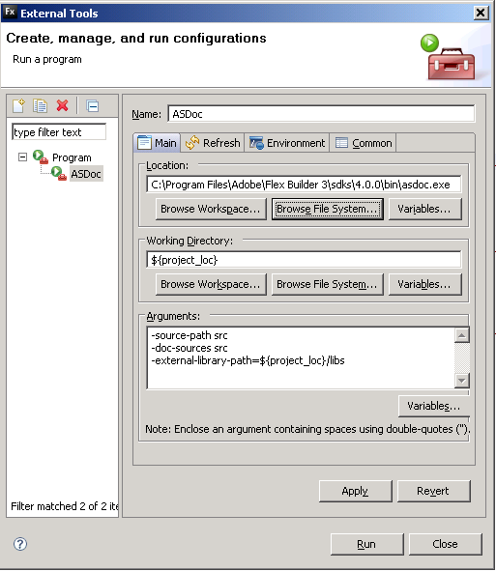
C:\Program Files\Adobe\Flex Builder 3\sdks\4.0.0\bin\asdoc.exe
${project_loc}
-source-path src
-doc-sources src
-external-library-path=${project_loc}/libs
- _

